The University of Azad Jammu and Kashmir
Department of Software Engineering
Software Configuration Management Technologies (ST – 1206)
Lab Task # 07
Creating and Merging a Pull Request on GitHub
Name | Syeda Darain Zahra Naqvi
Roll No. | 2025-SET-41
Lab Instructor | Engr. Fahad Nisar
Semester | Spring 2026
Session | 2025 – 29
GitHub Username | darainasif144-stack
Repository | https://github.com/darainasif144-stack/2025-SET-41

Objective
To create a pull request from feature-branch into the main branch on GitHub, review it for merge conflicts, and merge the code.

Prerequisites
Lab 6 was completed: the repository has a main branch (with main-file.txt) and a feature-branch (with feature-file.txt), both pushed to GitHub.

Step 1: Open a Pull Request
The repository page shows the banner "feature-branch had recent pushes". Clicking Compare & pull request opens the pull request form.
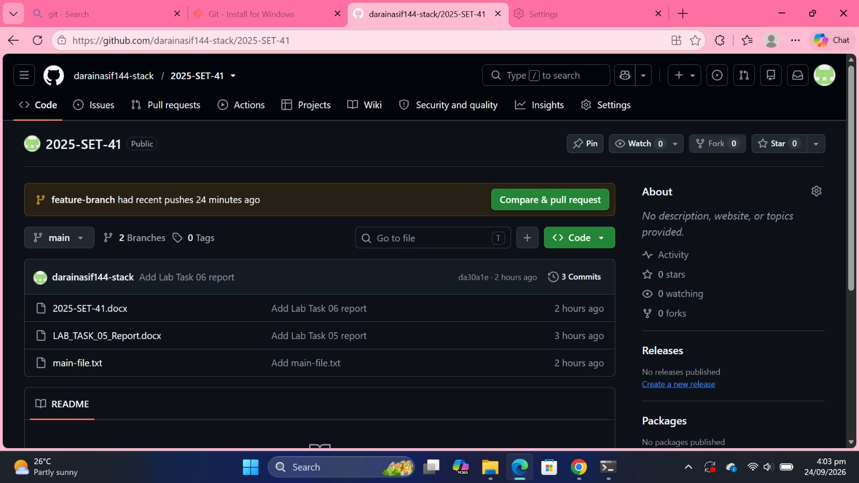
Figure 1: Repository page with the "Compare & pull request" banner
The base was set to main and compare to feature-branch. The title "Merge feature-branch into main" and a short description were added. GitHub shows "Able to merge" before the pull request is created.
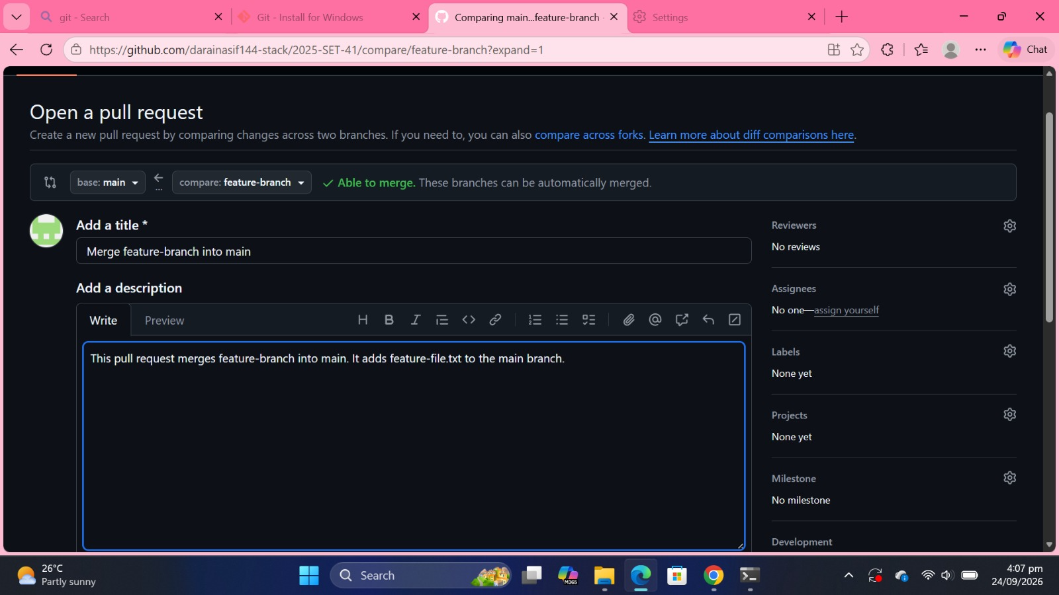
Figure 2: Open a pull request form: base main, compare feature-branch, title and description

Step 2: Review for Merge Conflict
After creating the pull request (#1), GitHub reports "No conflicts with base branch. Merging can be performed automatically." The files are different on each branch, so there is no conflict.
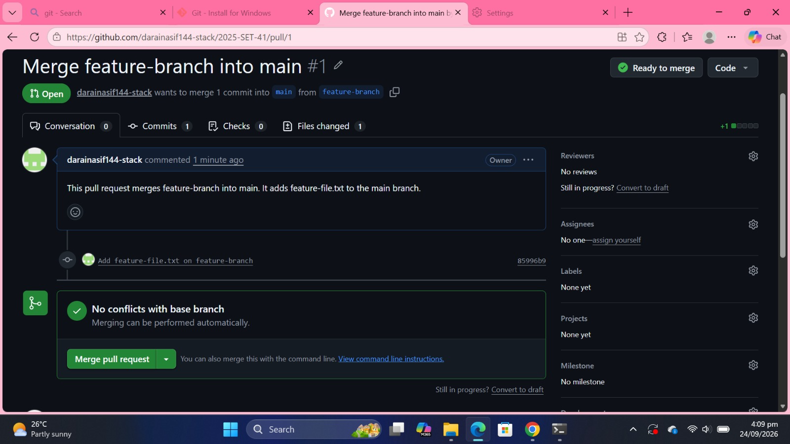
Figure 3: Pull request #1 showing no conflicts with the base branch

Step 3: Merge the Pull Request
Merge pull request was clicked, which opens the merge commit message with the Confirm merge button.
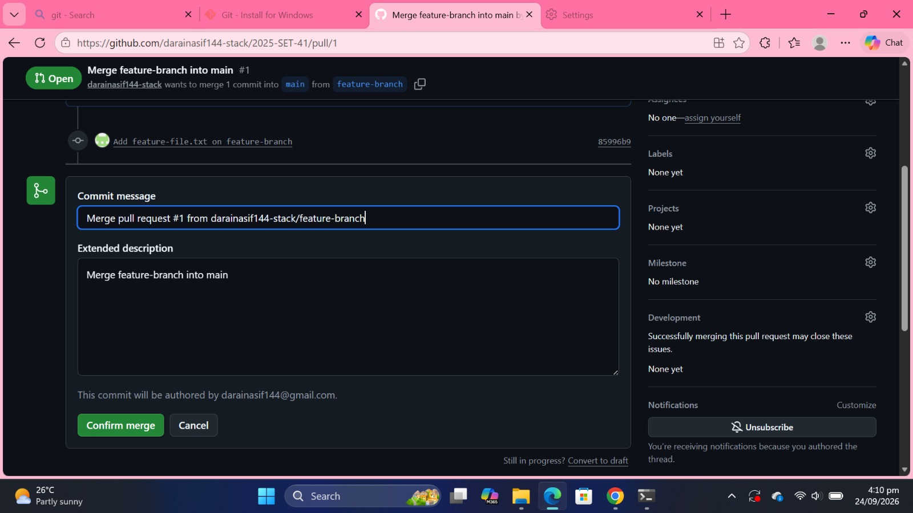
Figure 4: Confirm merge screen
After Confirm merge was clicked, GitHub shows the purple Merged badge and the message "Pull request successfully merged and closed".
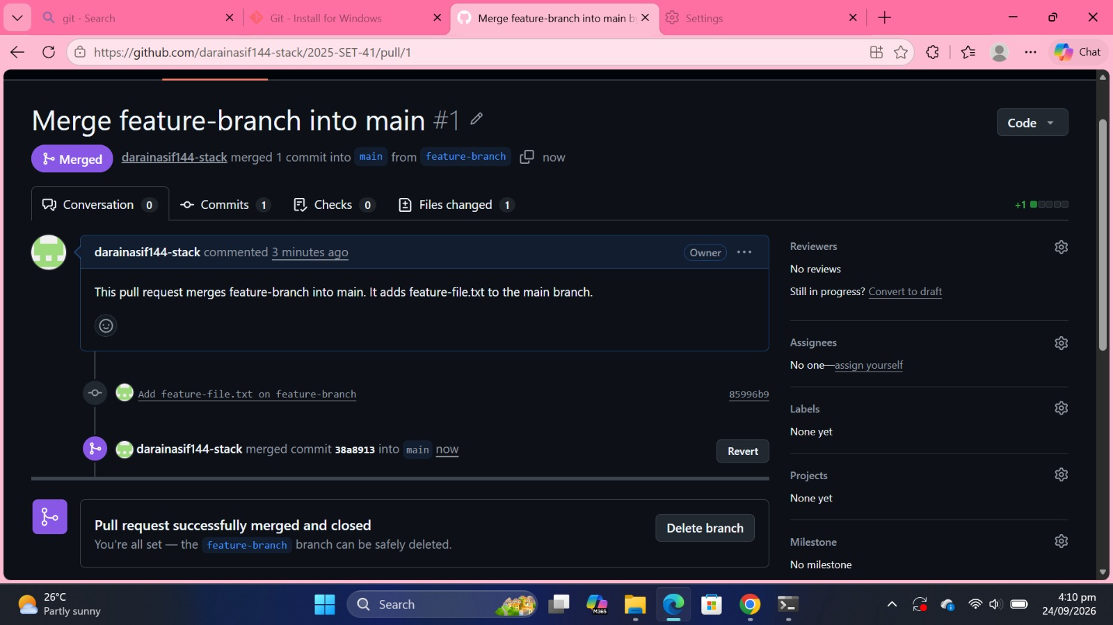
Figure 5: Pull request #1 successfully merged and closed

Step 4: Verify the Merge
On the Code tab, on the main branch, both main-file.txt and feature-file.txt are now present. The latest commit is the merge of pull request #1 from feature-branch.
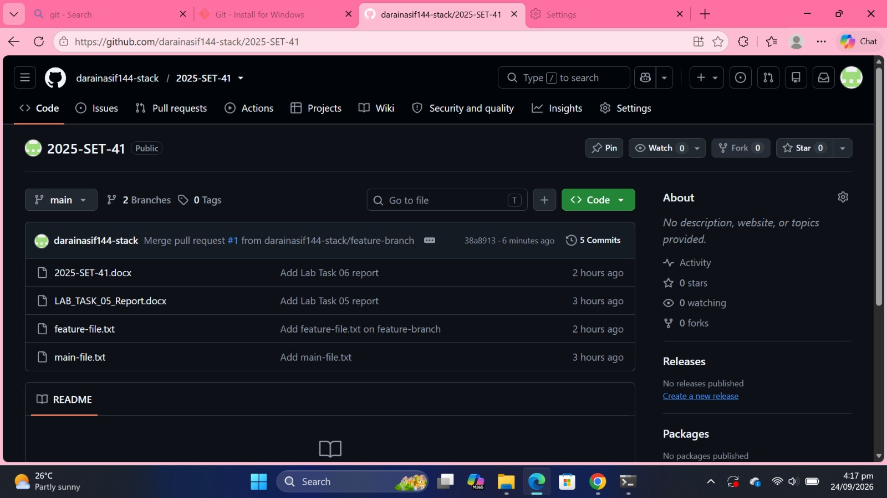
Figure 6: main branch now contains both main-file.txt and feature-file.txt

Conclusion
A pull request was opened from feature-branch into main, checked for conflicts (none were found), and merged. The main branch now contains the files from both branches.

