The University of Azad Jammu and Kashmir
Department of Software Engineering
Software Configuration Management Technologies (ST – 1206)
Lab Task # 05
Creating a GitHub Repository and Cloning a Public Repository
Name | Syeda Darain Zahra Naqvi
Roll No. | 2025-SET-41
Lab Instructor | Engr. Fahad Nisar
Semester | Spring 2026
Session | 2025 – 29
GitHub Username | darainasif144-stack
Repository | https://github.com/darainasif144-stack/2025-SET-41

Objective
To create a GitHub account, set up a public repository, connect it to a local folder, and clone an existing public repository from GitHub.

Step 1: Create a GitHub Account
A GitHub account was created. The profile page below shows the username darainasif144-stack.
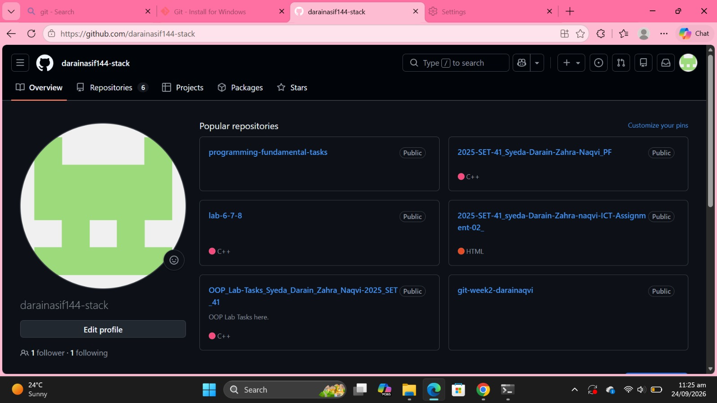
Figure 1: GitHub profile page showing username darainasif144-stack

Step 2: Create a Public Repository on GitHub
A new public repository named 2025-SET-41 was created using the + icon → New repository.
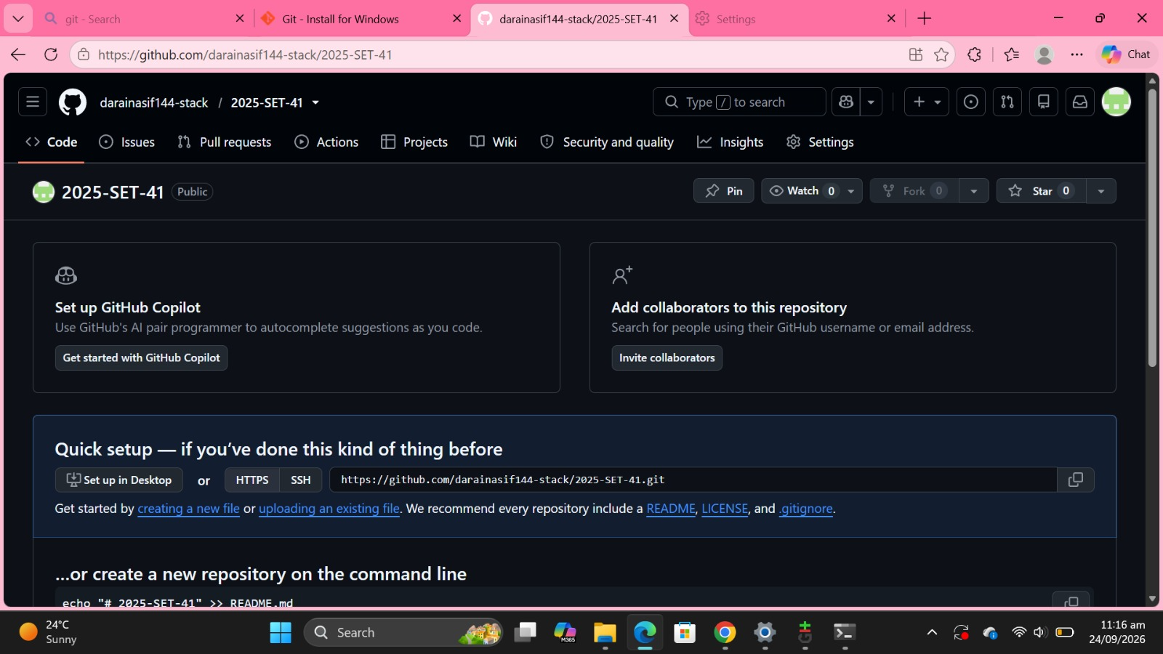
Figure 2: Newly created public repository 2025-SET-41

Step 3: Connect the Remote Repository to a Local Folder
A local folder named 2025-SET-41 was created on the Desktop and initialised as a Git repository.
Command(s): git init
Figure 3: Local folder initialised with git init
The GitHub repository was then added as the remote named origin, and the remote URL was verified for both fetch and push.
Command(s): git remote add origin https://github.com/darainasif144-stack/2025-SET-41.git; git remote -v
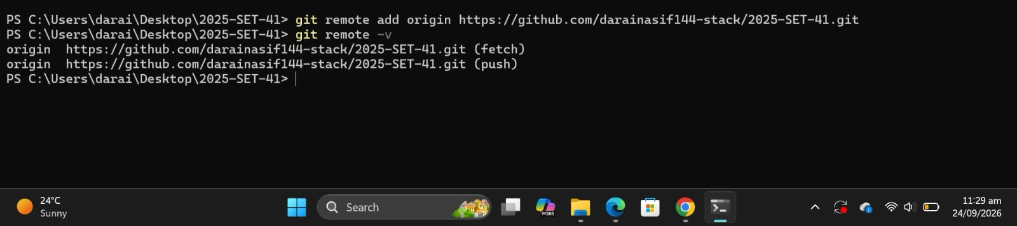
Figure 4: git remote -v showing origin for (fetch) and (push)

Step 4: Clone a Public GitHub Repository
The public repository octocat/Hello-World was cloned to the local machine.
Command(s): cd ..; git clone https://github.com/octocat/Hello-World.git
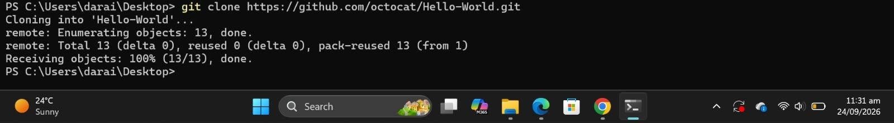
Figure 5: Cloning the public Hello-World repository
After entering the cloned folder, the commit history was displayed. The repository contains three commits.
Command(s): cd Hello-World; git log --oneline
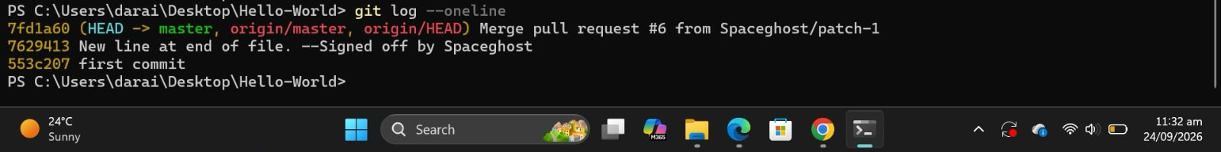
Figure 6: Commit history of Hello-World shown by git log --oneline

Conclusion
A public GitHub repository was created and linked to a local folder using git init and git remote add origin. An existing public repository (Hello-World) was cloned and its commit history was viewed with git log --oneline. This report is uploaded to the public repository linked above.

