The University of Azad Jammu and Kashmir
Department of Software Engineering
Software Configuration Management Technologies (ST – 1206)
Lab Task # 08
Pulling Remote Changes to Your Local Repository
Name | Syeda Darain Zahra Naqvi
Roll No. | 2025-SET-41
Lab Instructor | Engr. Fahad Nisar
Semester | Spring 2026
Session | 2025 – 29
GitHub Username | darainasif144-stack
Repository | https://github.com/darainasif144-stack/2025-SET-41

Objective
To make a change directly on GitHub (the remote), pull it into the local repository, and verify that the remote and local copies are in sync.

Prerequisites
Lab 7 was completed: the main branch on GitHub contains both main-file.txt and feature-file.txt after the pull request merge.

Step 1: Make a Change Directly on GitHub
On the main branch, a new file named remote-change.txt was created on GitHub with the content "This file was created directly on GitHub".
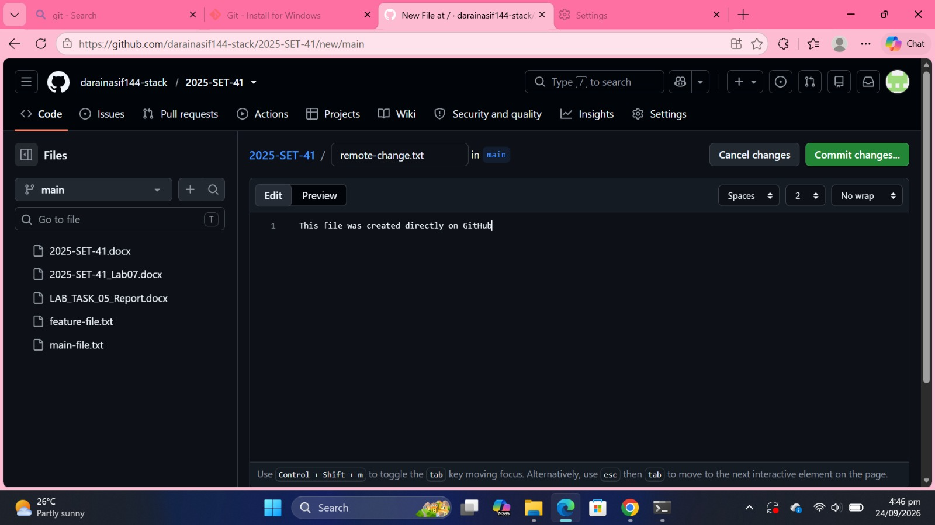
Figure 1: Creating remote-change.txt on the main branch on GitHub
The file was committed directly to main with the message "Add remote-change.txt from GitHub". It now appears in the repository file list.
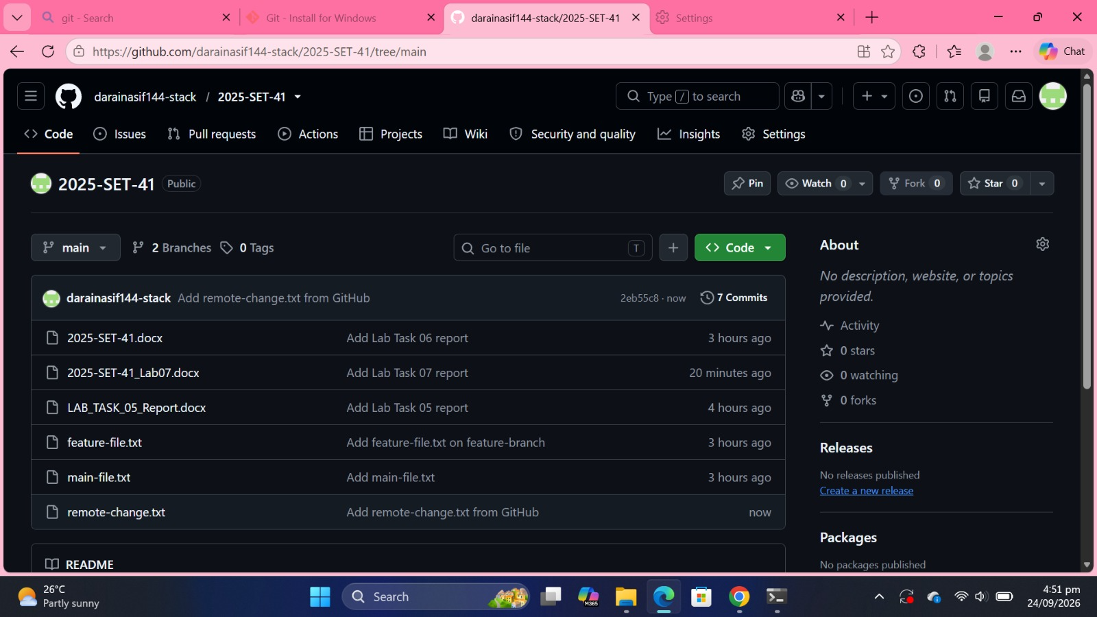
Figure 2: remote-change.txt committed on GitHub (main branch)

Step 2: Check the Local Repository Before Pulling
In the local folder, git checkout main was run and the text files were listed. remote-change.txt does not exist locally yet; only main-file.txt and feature-file.txt are present.
Command(s): git checkout main; dir *.txt
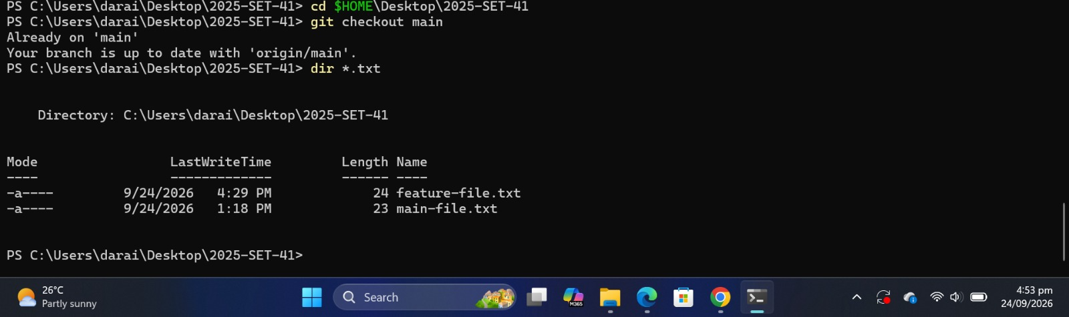
Figure 3: Local repository before pulling: remote-change.txt is not present

Step 3: Pull the Remote Changes
git pull origin main downloaded the new commit from GitHub. The output shows remote-change.txt created (1 file changed, 1 insertion).
Command(s): git pull origin main
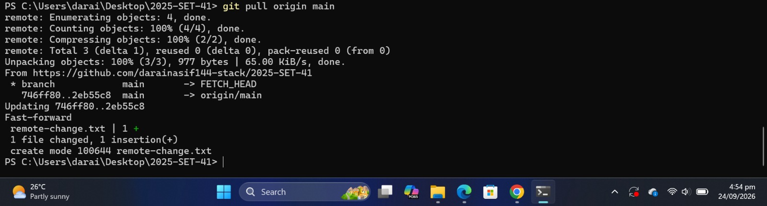
Figure 4: git pull origin main fetching remote-change.txt from GitHub

Step 4: Verify the Change Locally
After the pull, remote-change.txt appears in the local folder and its content matches what was added on GitHub.
Command(s): dir *.txt; Get-Content remote-change.txt
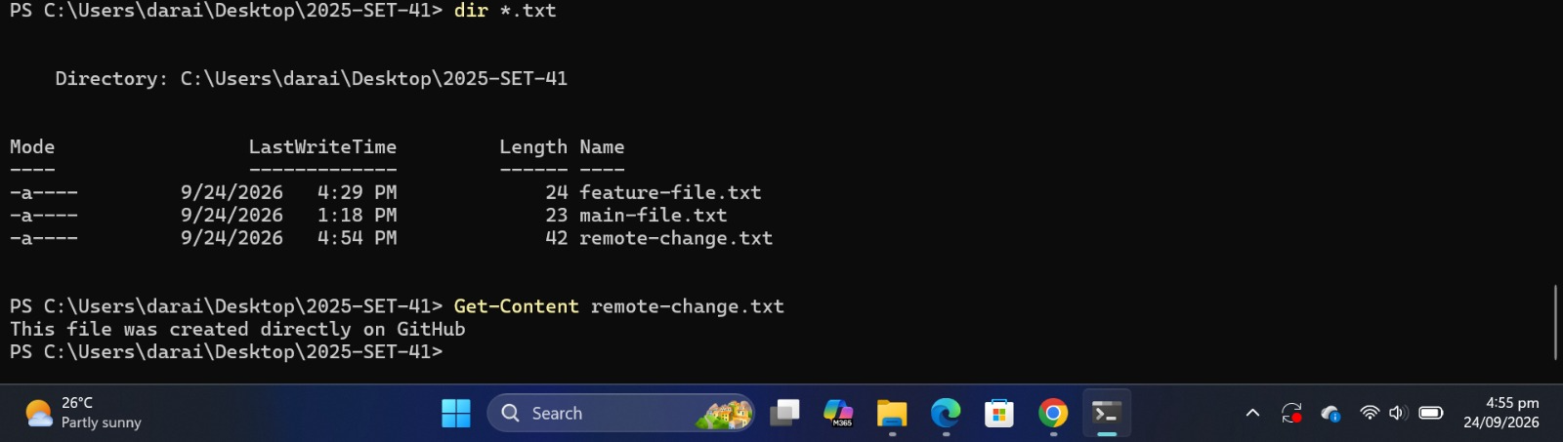
Figure 5: remote-change.txt now exists locally with the same content
The commit history shows the commit made on GitHub ("Add remote-change.txt from GitHub") at the top, with local main and origin/main at the same commit, so both copies are in sync.
Command(s): git log --oneline
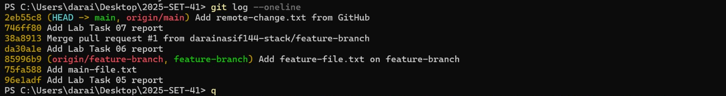
Figure 6: git log --oneline showing the commit made on GitHub

Conclusion
A file was created directly on GitHub, and git pull origin main brought it into the local repository. The file and the commit history now match on both sides, so the remote and local copies are in sync.

