The University of Azad Jammu and Kashmir
Department of Software Engineering
Software Configuration Management Technologies (ST – 1206)
Lab Task # 06
Pushing Code to a Remote Repository (Main and Feature Branches)
Name | Syeda Darain Zahra Naqvi
Roll No. | 2025-SET-41
Lab Instructor | Engr. Fahad Nisar
Semester | Spring 2026
Session | 2025 – 29
GitHub Username | darainasif144-stack
Repository | https://github.com/darainasif144-stack/2025-SET-41

Objective
To push local code to the remote GitHub repository on the main branch, create a new branch locally, push it to the remote, and verify that both branches exist on GitHub.

Step 1: Push Code to the Main Branch
Inside the 2025-SET-41 folder, the file main-file.txt was created, committed and pushed to the main branch.
Command(s): git branch; Set-Content main-file.txt "This is the main file"; git add main-file.txt; git commit -m "Add main-file.txt"; git branch -M main; git push -u origin main
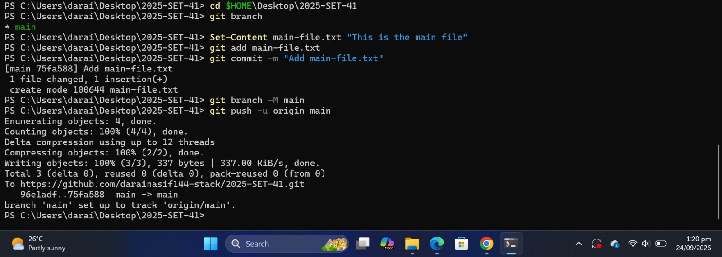
Figure 1: Creating main-file.txt, committing it, and pushing to origin main
On GitHub, main-file.txt appears on the main branch.
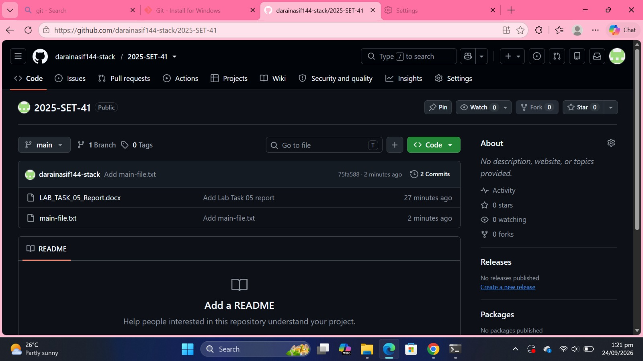
Figure 2: main-file.txt visible on the main branch on GitHub

Step 2: Create a New Branch and Push Code
A new branch named feature-branch was created locally, feature-file.txt was added and committed on it, and the branch was pushed to the remote.
Command(s): git checkout -b feature-branch; Set-Content feature-file.txt "This is a feature file"; git add feature-file.txt; git commit -m "Add feature-file.txt on feature-branch"; git push -u origin feature-branch
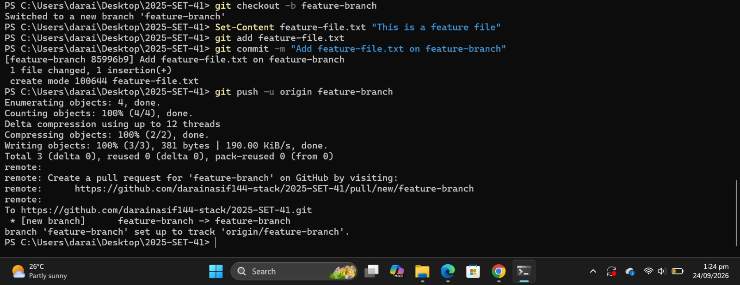
Figure 3: Creating feature-branch, committing feature-file.txt, and pushing the branch

Step 3: Verify Both Branches on GitHub
The Branches page on GitHub lists both main (default) and feature-branch.
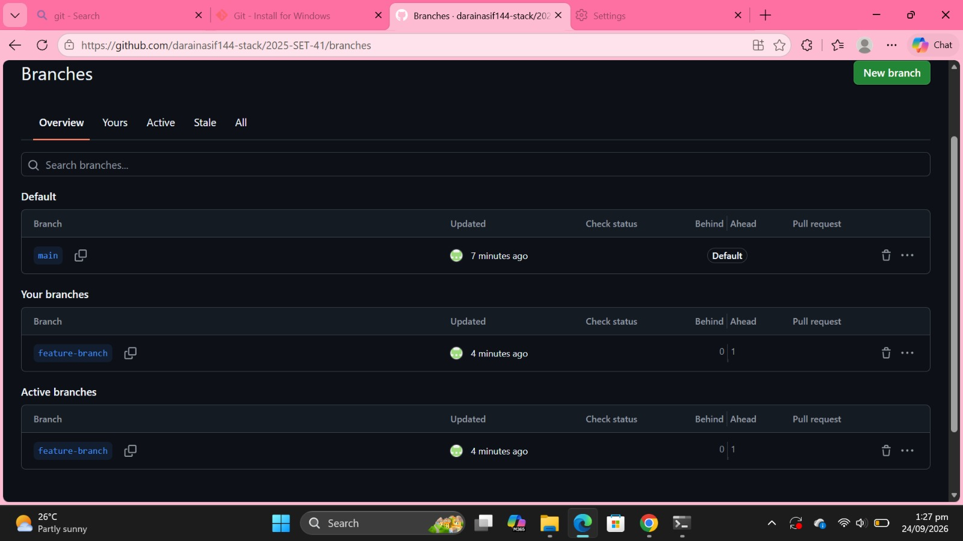
Figure 4: Both main and feature-branch exist on GitHub
After switching to feature-branch, feature-file.txt is present.
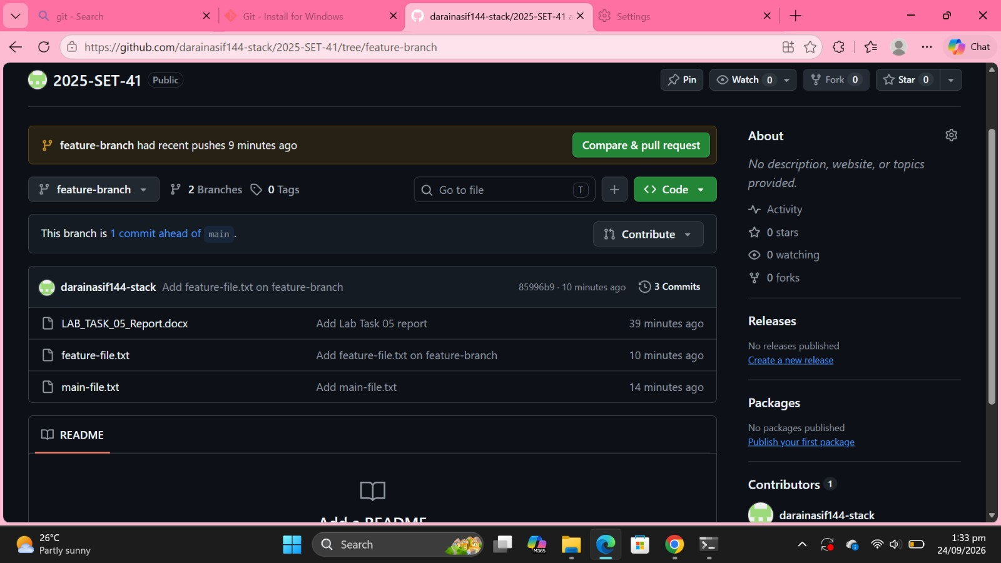
Figure 5: feature-branch contains feature-file.txt
After switching back to main, feature-file.txt is not present; only main-file.txt is there (LAB_TASK_05_Report.docx is the earlier Lab 5 submission).
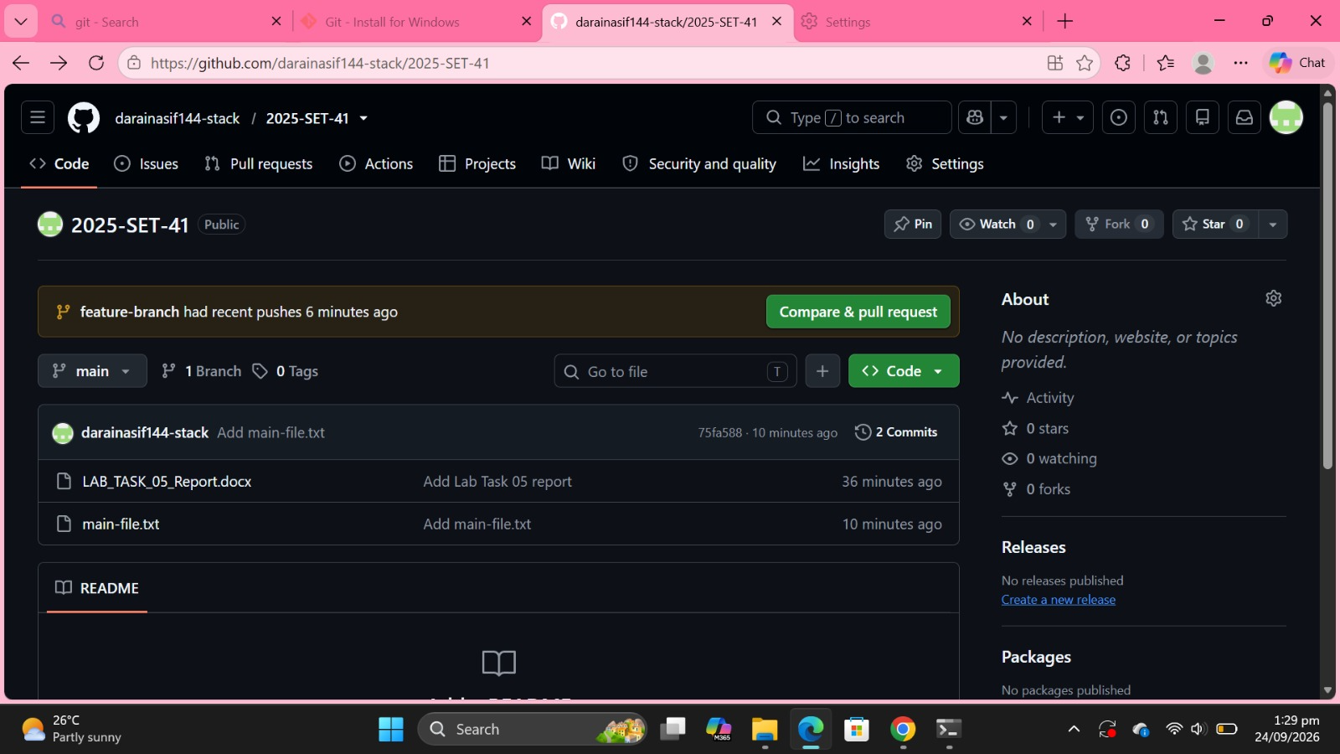
Figure 6: main branch does not contain feature-file.txt

Conclusion
Code was pushed to the main branch, a new feature-branch was created and pushed, and it was verified on GitHub that feature-file.txt exists only on feature-branch while main contains main-file.txt.

