CS 3130 Design and Analysis of Algorithms Fall 2018
T E S T # 2
[125 points]
----------------------------------------------------------------------------------------------------------
Name: .
Important: this is an closed-books/open-notes test. It should be completed within 75 minutes.
- (a) [12 points] In the sequence below, the character means ‘insert into a priority queue’ operation; the asterisk ‘*’ means ‘extract the maximum from a priority queue’ operation. Show the heap in the end of each operation.
T H U R * * S D A * Y *
(b) [8 points] Use a bottom-up construction algorithm to build a heap from the following keys:
T H U R S D A Y

- [6 points] Given a heap with 30 nodes (total).
How many leaves does it have? | How many internal nodes does it have? | What is its height?

- [10 points] Sort the following items with the help of LSD radix sort (assume that the first word is at the top of the pile, and the last word is at its bottom):
785, 169, 465, 769, 185, 709, 439, 102, 732
Original list: Sorted by Sorted by Sorted by
character #3: character #2: character #1:

- Write two versions of a function to determine the depth of a node with the largest key in BST (use pseudocode). Clearly indicate function’s parameters.
- [7 points] Non- recursive function | - [7 points] Recursive function
In problems ## 5 – 6 assume that external nodes (leaves) are NOT empty, but also store key values.
- [4 points] Given a set of items: {10, 15, 24, 6, 1, 17, 30} that may arrive in any order, show two BSTs built from these items: with the height 3 and with the height 2. How many leaves will each of these trees have?
6. (a) [3 points] What is the minimum and maximum value of the height of a BST with 30 internal nodes? | (b) [3 points] What is the minimum and maximum number of leaves in a BST with 30 internal nodes?
- [10 points] Find the 6th smallest element in a sequence <F, I, R, S, T, N, A, M, E>: in the table below show the progress of the algorithm for solving a selection problem and provide necessary explanations. DO NOT SORT the array.
7.
(a) [4 points] Build a BST by inserting each new node as a leaf, from the following keys:  <25, 35, 28, 15, 32, 30, 40, 20, 10, 18> | (c) [11 points] Insert an item with a key ‘34’  at the root of a tree that is the answer in part (a).
(b) [4 points] Use the method described in our textbook to delete an item with a key ‘25’ from the tree that is the answer in part (a). Explain in words what you are doing.

- [12 points]
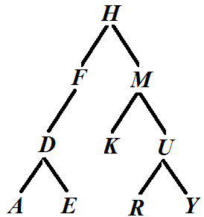 | Show the results of different types of traversals for the tree shown on the left:  In Order: ;  Pre Order: ;  Post Order: .
- (a) [6 points] Fill in the following table:
 | Efficiency class | Stable? (Y/N) | In-place? (Y/N)
Heapsort
Counting sort
LSD radix sort

(b)[4 points] Assuming that there are n items in a heap, indicate the time efficiency of the following operations:
Name of operation | Efficiency | Name of operation | Efficiency
Insert an item into a heap |  | Bottom-up construction of a heap
Delete an item with the maximum key from a heap and restore a heap structure |  | Top-down construction of a heap.

- [6 points] Assuming that there are n items in a BST, what can you say about efficiency of the following operations on a BST?
Name of operation | Efficiency | Name of operation | Efficiency
Insert an item at a leaf level into a BST |  | Find a successor of a given node in a BST.
Delete an item from a BST |  | Insert an item at a root of a BST.
Rotation in a BST. |  | In Order Traversal

- [8 points] Insert an item with the key value 35 into a 2-3-4 tree shown below.

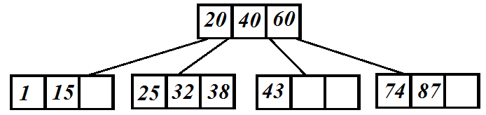
Problems for extra points.
#1. [10 points] Perform Counting Sort on the following array: A=<1, 3, 5, 3, 2, 1, 5, 3, 1, 2, 1, 4, 5>. Show the original and updated array of counters, the sorted array B and how elements of array A took positions in the array B.
Original array of counters: | Updated array of counters:

 | B[1] | B[2] | B[3] | B[4] | B[5] | B[6] | B[7] | B[8] | B[9] | B[10] | B[11] | B[12] | B[13]
A[i] →
{In the bottom line of the last table show names of elements, not their values: A[3] rather than 5 etc.}

#2. [5 points] A chocolate bar consists of squares. You have to break it into (n*m) separate square pieces. What is the minimum number of breaks that you need? Explain your answer.

