


Nchat
Secure Messenger Company
Real-time chats · NCoin wallet · Music · Games · NStore
PROJECT DESCRIPTION
Team: Leonard Bronskiy, Khondamir Artikov,
Roman Morgunov, Alisher Karavanov
Reviewer: Dr. Shirin Noekhan
Date: Saturday 3.10.2026
School: Digital technologies – cohort 3
American University of Technology · Fall 2026



1 Introduction

Nchat
Nchat is a company that builds a secure desktop messenger. It was founded in 2026 by four students of the American University of Technology in Tashkent: Leonard Bronskiy, Khondamir Artikov, Roman Morgunov and Alisher Karavanov.
The same team created Hawk PMC Mission Control in the previous semester. With Nchat the team moved from a fictional military company to a product people use every day. The idea is simple: friends and teams should be able to talk instantly, and nobody, not even the company, should be able to read their messages.
Nchat is written entirely in Java. A JavaFX desktop client talks to a Spring Boot server in real time, and message contents are protected with AES-256-GCM encryption.

Corporate Profile & Scale
Nchat is organised like a real technology company. Its work is split between six departments with four positions each, 24 positions in total. Messaging is the core product; Wallet, Music, Games and Store add services on top of it; Security protects all of them.
The product is one Gradle build with three modules: the client, the server and a shared module with the domain model. The code is open source under the Apache License 2.0, so every founder has equal rights to it. More than 30 classes are covered by 32 automated tests, which GitHub Actions runs on every change.
The company’s first goal is a stable release for students of the university by the end of the Fall 2026 semester.

Provided Services
Nchat brings everyday communication and small digital services together in one application:
- Messaging — private and group chats with instant delivery, roles and read-only channels.
- Wallet — NCoin, a virtual in-app currency friends send each other with a note.
- Music — tracks shared right in a chat and playlists built together.
- Games — quick games played inside a conversation, starting with tic-tac-toe.
- Store — NStore, a catalog of mini-apps and bots to install, search and rate.
- Security — encryption of messages and local history, safe accounts and incident response.
NCoin is a virtual currency with no real-money value, so the Wallet service needs no banking license.

2 Departments
Like Hawk PMC, Nchat relies on a clear structure. Each department has its own mission, its own part of the code and four positions.
Department | Mission | Code package
Messaging | Private and group chats, the core product | uz.nchat.common.model
Wallet | NCoin balances and transfers | uz.nchat.common.wallet
Music | Tracks in chats and shared playlists | uz.nchat.common.music
Games | Games inside chats | uz.nchat.common.games
Store | NStore mini-app catalog | uz.nchat.common.store
Security | Encryption and account safety | uz.nchat.common.crypto

Messaging Department
The cornerstone of the company and the reason people install Nchat. The department builds private chats, group chats and the real-time delivery that connects every client to the server. It owns the rules of who may write where: in a private chat both people are equal, in a group the Owner, Admins and Members have different rights.
It also keeps the client fast and pleasant to use, and makes sure groups stay safe. Moderators react to reports, and the team adds features such as read receipts, “typing…” indicators and replies step by step.
Roles:
- Product Lead
- Backend Developer
- Client Developer
- Moderator

Wallet Department
The Wallet Department runs NCoin, the virtual currency of Nchat. Every new wallet starts with a welcome bonus of 100 NCoin, and users can send coins to friends right from a chat, with a note such as “for pizza”.
The department sets limits, keeps the full history of every transfer and watches for suspicious activity. When a user tries to send more than they have, the transfer is refused with a clear message instead of failing silently.
Roles:
- Wallet Manager
- Payments Developer
- Fraud Analyst
- Support Agent

Music Department
The Music Department makes it possible to share a track in a chat and to build playlists together. A shared track appears in the conversation with its artist, title and length, and it is saved in the encrypted history like any other message.
Playlists belong to their owner, who can invite friends to edit them. The department also takes care that music shared in Nchat may legally be shared.
Roles:
- Music Curator
- Audio Developer
- Licensing Manager
- Playlist Editor

Games Department
The Games Department brings short games into conversations, so friends can play without leaving the chat. The first game is tic-tac-toe on a 3×3 board, with turns, win detection and draws.
All games share one structure, so new turn-based games such as battleship or checkers can be added quickly. The department also plans tournaments and leaderboards for the community.
Roles:
- Game Designer
- Game Developer
- QA Tester
- Community Manager

Store Department
The Store Department runs NStore, the catalog of mini-apps and bots that work inside Nchat, similar to an app store on a phone. Users browse apps by category, search them by name or description, install and uninstall them.
Only users who installed an app can rate it, from one to five stars, and the best-rated apps are shown first. Every new app is checked by an App Reviewer before it appears in the catalog.
Roles:
- Store Manager
- App Reviewer
- Platform Developer
- Developer Relations

Security Department
The Security Department protects users, their messages and their data. The local message history is already encrypted with AES-256-GCM: every message is encrypted with its own random IV, and any change to the stored file is detected.
Next, the department will add end-to-end encryption with an X25519 key exchange, so the server only ever sees ciphertext, and BCrypt hashing for passwords. It also prepares the response plan for incidents.
Roles:
- Security Lead
- Crypto Engineer
- Risk Analyst
- Incident Responder

3 Technical Overview

Architecture
Clients talk only through the server, and both sides share one domain model. The client keeps its own encrypted files on disk.
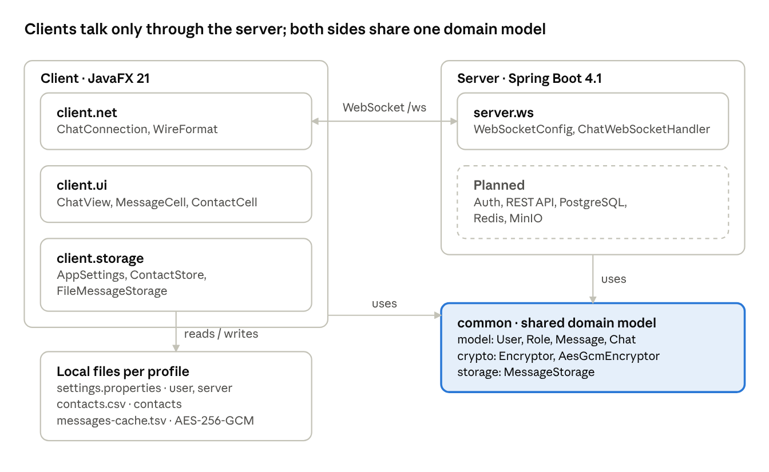

Technology
Layer | Technology | Why
Language | Java 21 (LTS) | Records, virtual threads
Server | Spring Boot 4.1 | Supported until July 2027
Client | JavaFX 21 + AtlantaFX | Same GUI stack as PMC
Database | PostgreSQL, Redis | Message history, online status
Build and CI | Gradle, GitHub Actions | Tests on every change
License | Apache 2.0 | Equal rights for all founders

Course Requirements
All five steps carried over from PMC are implemented in plain Java in the common and client modules.
Step | Requirement | Implementation in Nchat
1 | Conditions, loops, methods, arrays, classes | if / else, ternaries, switch; for, for-each and while loops; arrays such as the 3×3 tic-tac-toe board; more than 30 classes
2 | Inheritance, abstract classes, interfaces | Message, Chat, Department and TurnBasedGame hierarchies; interfaces Encryptor, MessageStorage and Game
2 | Overriding and polymorphism | preview(), canWrite(), getMission() overridden per type; the chat feed, the encryptor and the storage are used through their base types
3 | Three files for different entities | settings.properties (user), contacts.csv (Contact), messages-cache.tsv (Message)
3 | Four try-catch types; multiple catches with finally | IOException, NumberFormatException, URISyntaxException, GeneralSecurityException; FileMessageStorage.load(); custom InsufficientFundsException
4 | GUI | JavaFX client with dark theme; six screens sketched for QA
5 | Packages and subpackages, calls across packages | uz.nchat.client with ui, net, storage; uz.nchat.common with model, wallet, music, games, store

Roadmap
- October — accounts and login, private chats on the server, message history in PostgreSQL.
- November — group chats with roles, receipts and “typing…”, files; Wallet, Games and Store in the client.
- December — end-to-end encryption, load test, deployment and the final defense.

