NixChat — Project Description
Oct 2, 2026 · Team NixChat
NixChat is an open-source desktop messenger written in Java: a JavaFX client and a Spring Boot server exchange messages in real time, and message contents are encrypted with AES-256-GCM.

Project overview
Project | NixChat — secure desktop messenger
Team | Leonard Bronskiy, Khondamir Artikov, Roman Morgunov, Alisher Karavanov
Reviewer | Dr. Shirin Noekhan
School | Digital technologies – cohort 3
Semester | 3rd semester, Fall 2026
Language & stack | Java 21, JavaFX 21, Spring Boot 4.1, Gradle
License | Apache License 2.0

Introduction
NixChat lets people exchange private and group messages instantly, while the server only relays data it cannot read. The goal is a Telegram-level experience for the core features: instant delivery, read receipts, groups, files and encryption.
Last semester the team built PMC (Hawk PMC Mission Control), a JavaFX application with login, roles and a shooting range. For the 3rd semester the topic changed to a messenger, and the requirements from PMC (Steps 1–5) carry over to the new project.
The messenger was chosen because it covers what a real product needs: networking, multithreading, a database, security and a desktop GUI. Ideas that worked in PMC move with it: layered architecture, role-based access and password hashing.

Architecture
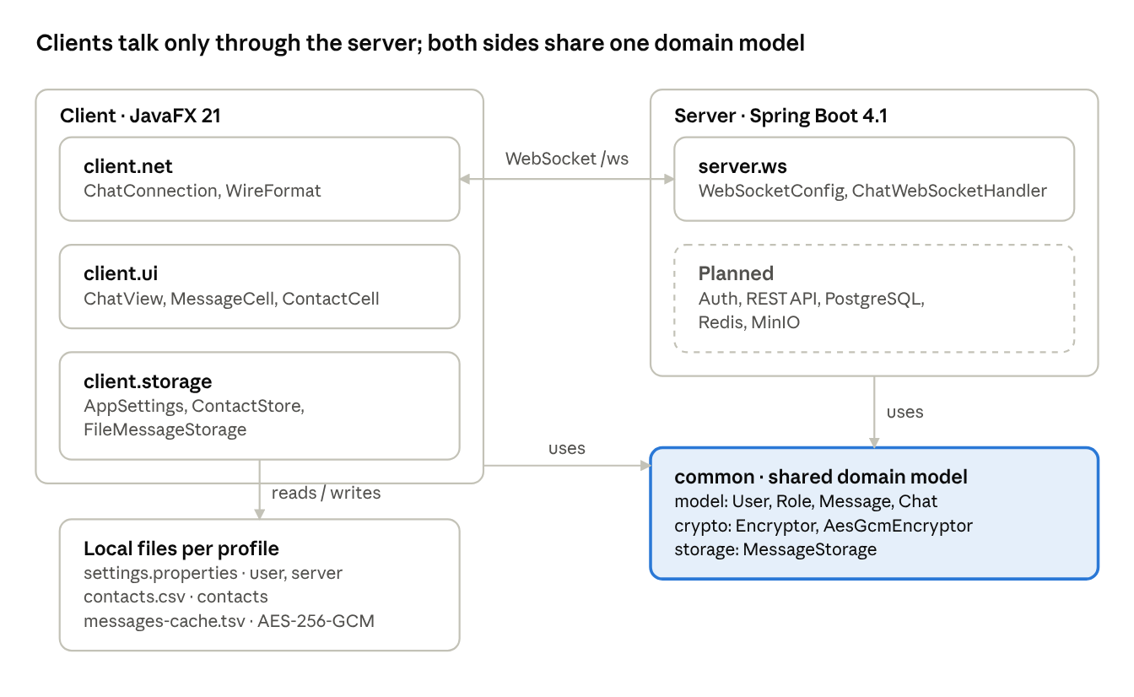
NixChat architecture · client, server, shared module, local files
The project is one Gradle build with three modules. common holds the domain model and encryption in plain Java and is used by both sides; the client keeps its own encrypted files on disk.

Features
The shared chat room, local history and contacts work today; private chats, accounts and end-to-end encryption are next.
Feature | Status | Notes
Real-time messaging over WebSocket | Done | One shared room, every client receives each message instantly
Desktop client with dark theme | Done | JavaFX 21 + AtlantaFX: contacts sidebar, message feed, input bar
Local message history | Done | Encrypted with AES-256-GCM, survives restarts
Contacts list | Done | Everyone you talked to, sorted by last activity
Profiles on one computer | Done | --profile=alice keeps separate settings and history
Domain model for chats | Done | Private and group chats with Owner / Admin / Member roles (not yet on the server)
Registration and login | Planned | Spring Security, JWT, PostgreSQL
Private and group chats on the server | Planned | Per-chat delivery instead of one shared room
Delivery and read receipts, "typing…" | Planned
File and image sharing | Planned | MinIO storage, 50 MB limit (already enforced in FileMessage)
End-to-end encryption | Planned | X25519 key exchange + AES-256-GCM
Edit, delete, reply, forward | Planned

User roles
What a user may do depends on the chat type: in a private chat both people are equal, in a group the role decides.
Role | Where | Can post | Add members | Remove members | Appoint admins
Participant | Private chat | Yes, unless the chat is blocked | — | — | —
Owner | Group | Yes | Yes | Admins and members | Yes
Admin | Group | Yes | Yes | Members only | No
Member | Group | Yes; no in read-only (channel) mode | No | No | No
A private chat holds exactly two users; a group holds up to 200. The rules live in PrivateChat.canWrite(), GroupChat.canWrite() and Role.canManage().

Departments
Like Hawk PMC, NixChat is run as a company of six departments, each with a mission and four positions. Messaging is the core product; Wallet, Music, Games and Store each add one service on top of it, and Security protects all of them.
Department | Mission | Positions
Messaging | Private and group chats that deliver every message instantly | Product Lead, Backend Developer, Client Developer, Moderator
Wallet | NixCoin, the in-app virtual currency: balances and transfers between friends | Wallet Manager, Payments Developer, Fraud Analyst, Support Agent
Music | Sharing tracks in chats and building playlists together | Music Curator, Audio Developer, Licensing Manager, Playlist Editor
Games | Quick games friends play right inside a chat | Game Designer, Game Developer, QA Tester, Community Manager
Store | NixStore, a catalog of mini-apps and bots users install into NixChat | Store Manager, App Reviewer, Platform Developer, Developer Relations
Security | Encryption, account safety and the response to incidents | Security Lead, Crypto Engineer, Risk Analyst, Incident Responder
In the code every department is a subclass of the abstract Department class, and NixChatCompany lists all six. Each service has its own package with a first working feature:
- Wallet (common.wallet): every new wallet gets 100 NixCoin; users send coins to each other with a note. A transfer larger than the balance throws the custom checked exception InsufficientFundsException.
- Music (common.music): tracks, shared playlists with invited collaborators, and TrackMessage, a new message type that also goes into the encrypted local cache.
- Games (common.games): the Game interface, the abstract TurnBasedGame and a full tic-tac-toe with win and draw detection on a 3×3 array.
- Store (common.store): publishing mini-apps, search, categories, install and uninstall, 1–5 star ratings and a top-rated list.
NixCoin is a virtual currency with no real-money value, so the Wallet needs no banking license.

Security
Message contents on disk are already encrypted with AES-256-GCM; end-to-end encryption between users is the main goal of the semester.
- Local cache. Each message in messages-cache.tsv is encrypted with a random 12-byte IV and a 128-bit authentication tag. A wrong key or an edited file is detected, and the broken line is skipped instead of crashing the app.
- Interchangeable encryption. The Encryptor interface has two implementations: AesGcmEncryptor and NoOpEncryptor for debugging. The settings file decides which one is used.
- End-to-end (planned). Clients agree on a key with X25519 and encrypt with AES-256-GCM, so the server stores and relays only ciphertext.
- Passwords (planned). Hashed with BCrypt by Spring Security. This replaces the PBKDF2 code from PMC and fixes its issues: salts mixed up between users and hashes compared without a constant-time check.
- Input limits. Usernames are 3–32 characters (letters, digits, _, -), messages up to 4,096 characters, files up to 50 MB; the server drops oversized messages.

Course requirements
All five steps carried over from PMC are implemented in plain Java in the common and client modules. File-level details are in docs/REQUIREMENTS.md in the repository.
Step | Requirement | Implementation in NixChat
1 | Conditions, loops, methods, arrays, classes | if/else if, ternaries and a switch expression; for-each, indexed for and while loops; arrays SIZE_UNITS, IMAGE_EXTENSIONS, byte[] buffers; 25+ classes
2 | 2 inheritance examples | Message → TextMessage, FileMessage, SystemMessage; Chat → PrivateChat, GroupChat
2 | 2 abstract classes with implemented methods | Message (format(), isFrom()), Chat (addParticipant(), isParticipant())
2 | 2 interfaces with implementations | Encryptor → AesGcmEncryptor, NoOpEncryptor; MessageStorage → InMemoryMessageStorage, FileMessageStorage
2 | 3 method overrides | preview() in each message type; canWrite() / getTitle() in each chat type; format() in TextMessage and SystemMessage
2 | 3 polymorphism examples | Feed renders List<Message> through format(); Encryptor chosen from settings; MessageStorage field holds a FileMessageStorage; canWrite() on a Chat[] array
3 | 3 files for different entities | settings.properties (user and settings), contacts.csv (Contact), messages-cache.tsv (Message)
3 | 4 different try-catch types | IOException reading settings; NumberFormatException for the port; URISyntaxException for the server address; GeneralSecurityException when decrypting the cache
3 | One try with multiple catches and finally | FileMessageStorage.load(): NoSuchFileException, IOException, RuntimeException, finally prints load statistics
4 | GUI (JavaFX allowed if the whole team knows it) | JavaFX 21: NixChatApp, ChatView, MessageCell, ContactCell; screen sketches prepared for QA
5 | Main package and a package with a subpackage | uz.nixchat.client with .ui, .net, .storage; uz.nixchat.common.model with .message, .chat
5 | Calls across packages | NixChatApp calls AppSettings.load(), WireFormat.decode(), Protocol.wsUrl(), ChatView.showMessage()
The logic is covered by 32 unit tests (./gradlew test), which run on every push in GitHub Actions.

Team areas and roadmap
The work splits into four areas, one per team member, so everyone can build in parallel.
Area | Scope
Server core | Registration, login, users, chats, REST API, PostgreSQL
Server real-time | WebSocket delivery per chat, online status, receipts, Redis
Client | JavaFX screens: login, chat list, conversation, groups, settings
Security & infrastructure | End-to-end encryption, Docker, CI, tests, deployment
Open question: which team member takes which area.
- October — accounts and login, private chats on the server, chat history in PostgreSQL.
- November — group chats with roles, receipts and "typing…", file sharing.
- December — end-to-end encryption, load test, deployment, final presentation.

