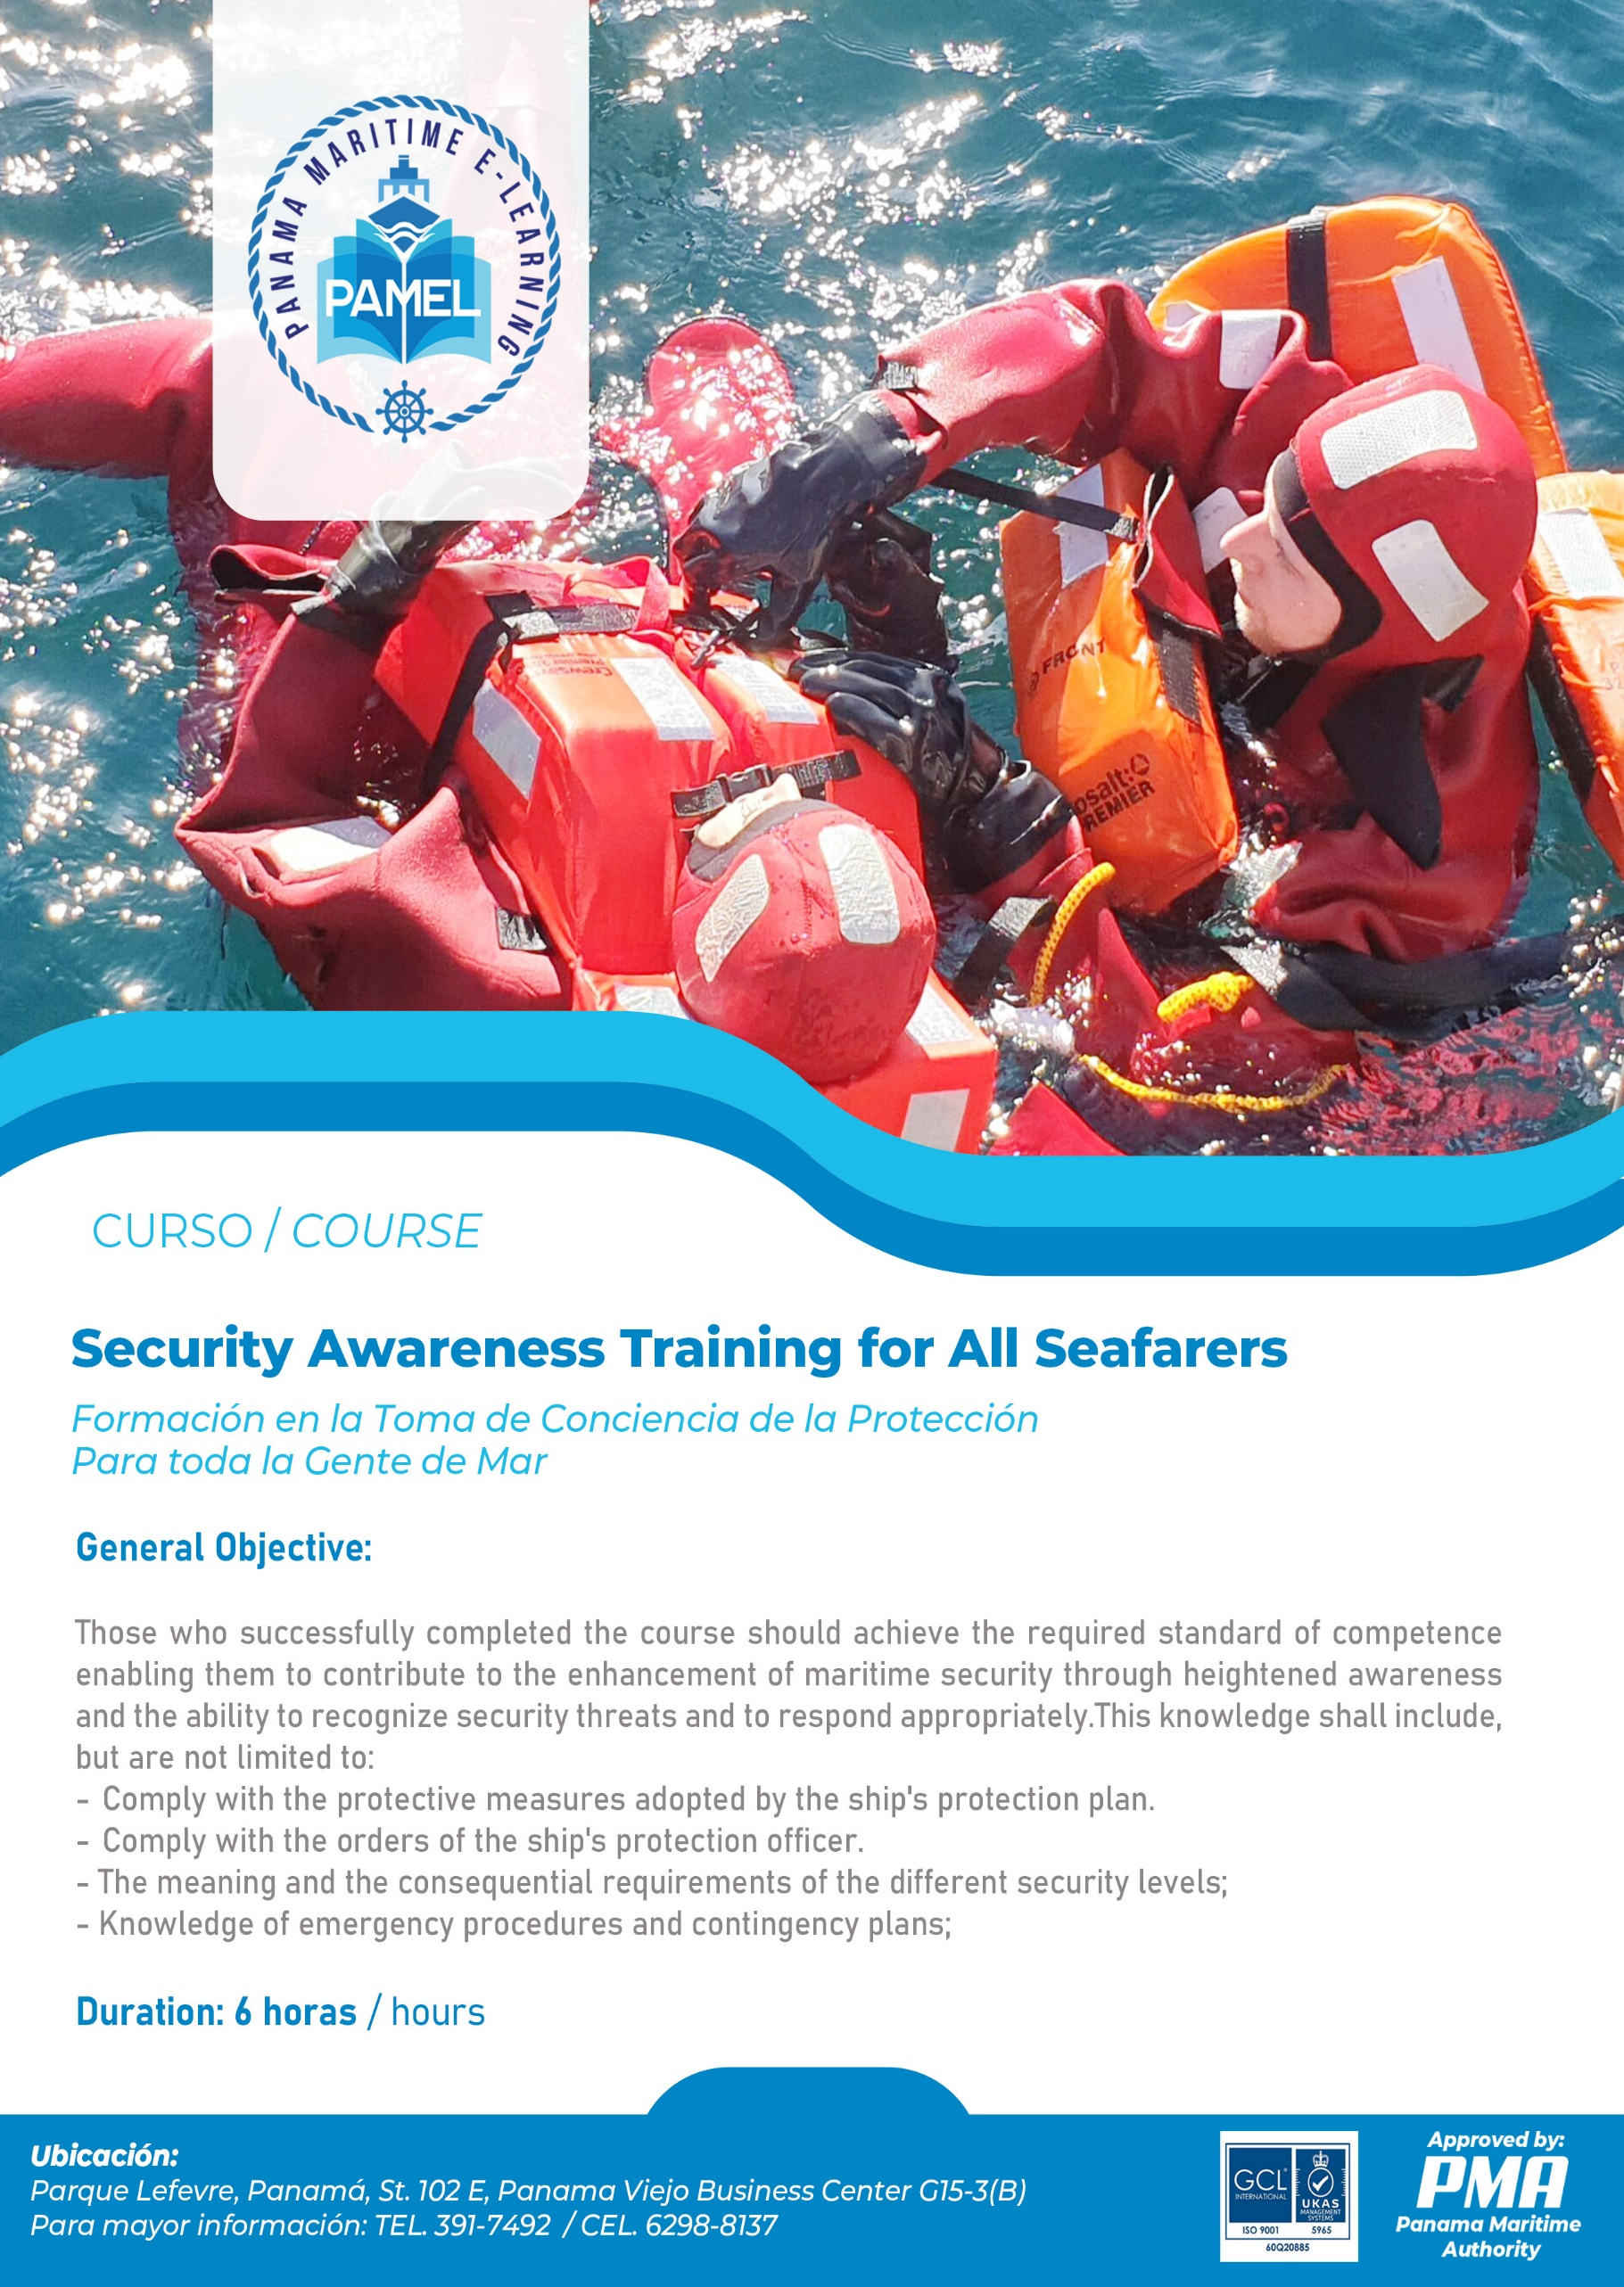

MANUAL OF THE TRAINING COURSE

SECURITY AWARENESS TRAINING FOR ALL SEAFARERS

Regulation VI/6, paragraphs 1-3, Section A-VI/6, paragraph 4 and Table A-VI/6-1 of the International Convention on Standards of Training Certification and Watchkeeping of Seafarers STCW 1978, as amended (Convention STCW´78, as amended) and the STCW Code.

This course provides mandatory minimum standards of competence in Security Awareness Training for all Seafarers in accordance with the provisions of the Section A-VI/6, paragraph 4 and Table A-VI/6-1 of the STCW Code.

COURSE OUTLINE
SECURITY AWARENESS TRAINING FOR ALL SEAFARERS
SUBJECT AREA |  | COURSE DURATION (TIME)
N° | Denomination | Lecture hours | Practice hours (Workshops)
Knowledge, Understanding, and Proficiency.
1. | Introduction.  1.1. Course overview.  1.2. Competence to be achieved.  1.3. Current security threats and patterns.  1.4. Ships and port operations and conditions. | 0.5 | -
2. | Maritime Security Policy (1.0 hours)  2.1. Awareness of relevant international conventions, PBIP Code and recommendations.  2.2. Knowledge of relevant government legislation and regulations.  2.3. Definitions.  2.4. Handling sensitive security-related information and communications. | 1.0 | -
3. | Security Responsibilities.  3.1. Contracting Governments.  3.2. The Company.  3.3. The Ship.  3.4. The Port Facility (PF).  3.5. Ship Security Officer (SSO).  3.6. Company Security Officer (CSO).  3.7. Port Facility Security Officer (PFSO).  3.8. Seafarers with designed security duties.  3.9. Port facility personnel with designed security duties.  3.10. Other personnel. | 1.0 | -
4. | Threat identification, recognition, and response.  4.1. The recognition and detection of weapons, dangerous substances, and devices.  4.2. Recognition, on a non-discriminatory basis, of persons who pose potential security risks.  4.3. Techniques used to circumvent security measures. | 1.0 | -
5. | Ship Security actions.  5.1. Actions required by the different security levels.  5.2. Reporting security incidents. | 0.75 | -
6. | Preparation for Emergencies, Exercises and Practices.  6.1. Knowledge of contingency plans for security events and threats.  6.2. Exercises and practices. | - | 0.75
7 | EXAM | 1.0 | -
SUB-TOTAL |  | 5.25 | 0.75
TOTAL |  | 6.0
COURSE TIMETABLE

Period | Day 1
1st Period | - Introduction (0.5 hr).  - Maritime Security Policy(1.0 hr).
2nd Period | - Security Responsibilities. (1.0 hr).  - Threat identification, recognition, and response. (1.0 hr).
3rd Period | - Ship Security actions. (0.75 hr).  - Preparation for Emergencies, Exercises and Practices. (0.75 hr).
4th Period | - Exam (1.0 hr).

Note: Please bear in mind that any timetable is subject to variation, depending on the general need of the trainees and local circumstances).

- Introduction

  - Course overview

As with other training courses the starting point should be a brief statement of the purpose of the course, a short review of the timeline, an introduction of participants, determination of knowledge and experience levels, and a brief description of the teaching facility.

  - Competencies to be achieved

The aim of the course is stated, competences of the course are reviewed, and the outcome of the learning objectives is made clear; namely, that “the expected learning outcome is that the trainee.”
Instructors should emphasize that no one is being trained to fight or similarly respond to security threats but rather that trainees should be able to contribute to the enhancement of maritime security through heightened awareness and the ability to recognize security threats and to respond appropriately.

  - Current security threats and patterns

Current threats to maritime security should be summarized in order to provide a basis for understanding of the recent conventions and legislation in this area and to fully grasp the importance of the training provided by this course. Personnel receiving this training must clearly sense the reality of today’s security issues. Some may have adopted a mindset that places the problem of security in the past or in such a remote corner that it appears distant or irrelevant. Before continuing on with the course this mindset should be identified and addressed.

Piracy and armed attacks continue to occur on an all too frequent basis. Attacks occur mostly in port areas whereas piracy by definition usually occurs on ships at sea. In fact, the United Nations Convention on the Law of the Sea, Article 101, defines piracy as any of the following acts: illegal acts of violence or detention or any act of depredation committed for private ends by the crew or the passengers of a private ship or private aircraft and directed on the high seas against another ship or aircraft or against persons or property on board such ship or aircraft. It also includes such acts against a ship, aircraft, person or property in a place outside of the jurisdiction of any State.

Terrorism usually involves violence or the threat of violence by extremist groups seeking to gain political objectives by other than democratic means. Various types of bombs or bomb threats may be employed or hijacking may be the method by which the terrorist group hopes to make a statement. Increasingly terrorists are acting in connection with extremist religious sects that promote suicidal behavior. Contraband smuggling, a criminal activity, may result in large financial loss to the ship-owner whose ship is being used by the smugglers. Often drugs are the commodity being smuggled and they may be brought on board in a number of creative ways such as in luggage, stores, on or in a person’s body, or in electronic equipment to name a few. Weapons are also a frequent item associated with smuggling and they too find their way on board in creative ways such as cargo containers.

Cargo theft, an age-old problem, continues to plague the maritime industry and causes financial losses in staggering amounts. Prevention is normally the most effective method of dealing with this security threat. Although there may not be violence or political issues involved in most cargo theft cases, this matter remains high on the list of security threats and requires solutions discussed in this course. Instructors should convey that cargo theft is only one of the various threats to the security of cargo. Other such security threats should be discussed during this section of the course.

Collateral damage occurs when a nearby fire, explosion, or attack results in damage to a ship or facility. While the damage is sometimes unintended, the costs are nevertheless real. There are measures that may minimize the consequences of this type of damage.

1.4 Ship and port operations and conditions

This section of the course should provide trainees with sufficient understanding of the larger transportation and logistics context in which maritime operations occur to render them able to effectively undertake their security responsibilities. A basic understanding of the general patterns and mechanisms of cargo and passenger movement through international and intermodal transportation chains is essential for those who are charged with enhancing maritime security. Discussion of the operational interfaces between maritime and other modes is a central component of this segment of the course. Trainees should also be exposed to the fundamentals of cargo tracking and related information systems in the context of security.

- Maritime Security Policy

  - Awareness of relevant international conventions, codes, and recommendations

Trainees should appreciate the attempts by international bodies to minimize, stop, or otherwise control threats to security in maritime transportation. The International Maritime Organization (IMO) has adopted a number of resolutions and conventions to this end. For example, Resolution A.545(13)-Measures To Prevent Acts Of Piracy And Armed Robbery Against Ships was signed in 1983. In 1985 came IMO Resolution A.584 (14) - Measures To Prevent Unlawful Acts Which Threaten Safety Of Ships And Security Of Passengers (this was later reviewed in November of 2001 with IMO Resolution A.924(22)). Then in 1986 the IMO approved MSC/Circ.443 - Measures To Prevent Unlawful Acts Against Passengers And Crew On Board Ships. In 1988 came the Convention for the Suppression of Unlawful Acts against the Safety of Maritime Navigation (SUA) treaties aimed at ensuring that appropriate judicial action is taken against persons committing unlawful acts against ships which would include the seizure of ships by force, acts of violence against persons on board ships, and placing devices on board a ship which are likely to destroy or damage it. The convention obliges contracting governments either to extradite or prosecute alleged offenders. The SUA came into effect on March 1, 1992.

Following the tragic events in New York and Washington on September 11, 2001 the twenty-second session of the International Maritime Organization, in November of 2001, unanimously agreed to the development of new measures relating to the security of ships and of port facilities for adoption by a Conference of Contracting Governments to the International Convention for the Safety of Life at Sea, 1974 in December of 2002 (the Diplomatic Conference). This timetable of little more than a year represents a landmark achievement for the IMO and provides a clear indication of the gravity of the situation as well as the intention to protect world shipping against security incidents and threats.

The meeting of the Diplomatic Conference in December of 2002 resulted in amendments to SOLAS 74. These amendments enter into force on July 1, 2004. A brief summary of these amendments should be carried out with mention of changes to Chapter V but with emphasis on the changes to Chapter XI, Regulations 3 and 5 and the new Chapter XI-2 Regulations 1-13 and the ISPS Code. Since portions of the ISPS Code will be studied in more depth in later sections of the course, the summary here can be brief.

  - Awareness of relevant government legislation and regulations

It would be helpful for trainees to understand that some governments have acted on a national level to produce legislation and/or regulations concerned with measures to enhance maritime security. Instructors may wish to use the Maritime Transportation Security Act of 2002 (MTSA 2002) and the Customs-Trade Partnership Against Terrorism (C-TPAT) as examples, or may elect to use some other nation's legislation to illustrate the focus of this section of the course.

  - Definitions

Trainees will need a working knowledge of several terms found in SOLAS Chapter XI-2 Regulation 1 and in the ISPS Code Part A section 2. These terms may well need clarification from an experienced instructor in order for trainees to reach the necessary level of understanding. For instance, it might require emphasis or other clarification by the instructor to establish that the Ship Security Officer is a person on board the ship and in that sense it may be impossible for a Company Security Officer to also act as the Ship Security Officer.
  - Handling sensitive security-related information and communications

Trainees should understand that certain information and communications will be considered security sensitive and that the level of sensitivity may change, as do levels of security 1, 2, and 3.

Heretofore benign conversations may result in disastrous consequences and all personnel will need to appreciate the risk of security leaks through communication by improper methods or to the wrong persons.

- Security Responsibilities

This section is intended to give trainees a clear picture of the proportions of the maritime security system conceived of by the IMO and to show how the various entities will work together to form an efficient and effective whole.

  - Contracting governments

SOLAS Chapters XI-1 and XI-2 discuss the roles of the contracting governments and their obligations in the overall scheme to enhance maritime security. A brief understanding of this will help the trainee to comprehend how and why their own governments have acted and how they may experience the port state control exercised by another government.

  - Recognized Security Organizations

Recognized Security Organizations are defined in SOLAS Chapter XI-2 Regulation 1 part 1.16 and discussed throughout Parts A and B of the ISPS Code. The trainee should understand how and when an RSO may take on the security-related activities of a contracting government.

  - The company

The company is defined by SOLAS Chapter XI-1 and is given numerous obligations under Chapter XI-2 and the ISPS Code from Continuous Synopsis Records to the maintenance of the International Ship Security Certificate. Trainees would benefit greatly from a clear understanding of the role of the company and the support that they should expect from the company.

  - The ship

The term ship as used here means a ship to which Chapter XI of SOLAS applies. Various segments of Chapter XI and the ISPS Code discuss the persons, activities, plans, documentation and so forth that a ship will be exposed to in a security context. All trainees will need to understand these requirements as they relate to this important cornerstone of a maritime transportation system.

  - The port facility
The Port Facility is defined in SOLAS Chapter XI-2 Regulation 1 part 1.9 and is the location where a ship/port interface takes place. As such, numerous duties and activities are assigned to the Port Facility. All trainees should understand the role of the Port Facility in maintaining the security of a maritime transportation system.

  - Ship Security Officer, Company Security Officer, Port Facility Security Officer, Seafarers with designated security duties, Port facility personnel with designated security duties, and Other personnel

Trainees should understand the role of each of these various persons and know what to expect from each in terms of authority and responsibility. The ISPS Code Parts A and B clearly delineate the functions, duties, and training requirements for each of these categories of personnel. In the end these are the very people that will make the security plans work and will recognize areas for improvement. They will each need to appreciate their own role as well as that played by the others.

- Threat Identification, Recognition, and Response

  - Recognition and detection of weapons, dangerous substances and devices

The focus of this session is on the characteristics and potential effects of prohibited weapons; explosives; chemical, biological, and radiological devices; substances and compounds that pose a hazard to personnel and/or ships and facilities, and related topics.

  - Recognition, on a non-discriminatory basis, of persons posing potential security risks

Instructors should explain suspicious patterns of behavior, while emphasizing the importance of avoiding racial profiling and ethnic stereotyping. Examples of suspicious behaviors include:

    - Unknown persons photographing vessels or facilities.
    - Unknown persons attempting to gain access to vessels or facilities.
    - Suspicious individuals establishing businesses or roadside food stands either adjacent or in proximity to facilities.
    - Unknown persons loitering in the vicinity of ships or port facilities for extended periods of time.
    - Unknown persons telephoning facilities to ascertain security, personnel, or standard operating procedures.
    - Vehicles with personnel in them loitering and perhaps taking photographs or creating diagrams of vessels or facilities.
    - Small boats with personnel on board loitering and perhaps taking photographs or creating diagrams of vessels or facilities.
    - Suspicious general aviation aircraft operating in proximity to vessels or facilities.
    - Suspicious persons who may be carrying bombs or participating in suicide squad activities.
    - Unknown persons attempting to gain information about vessels or facilities by walking up to personnel or their families and engaging them in a conversation.
    - Suspicious vendors attempting to sell merchandise.
    - Unknown or suspicious workmen trying to gain access to facilities to repair, replace, service, or install equipment.
    - Suspicious emails on Internet, public affairs attempting to obtain information regarding the facility, personnel, or standard operating procedures.
    - Suspicious package drop-offs/attempted drop-offs.
    - Anti-national sentiments being expressed by employees or vendors.
    - Anti-national pamphlets or flyers distributed to employees or placed on windshields in parking lots.
    - Repeated or suspicious out-of-ordinary phone calls.
    - Recreational boaters posing as mariners in distress to attract assistance from other vessels.

  - Techniques used to circumvent security measures

Trainees should be cautioned that no security equipment or measure is infallible. They should be apprised of the known techniques that can be employed to evade security systems and controls, such as the disabling of alarm systems, picking of locks, jamming of radio signals, etc.

- Ship Security Actions

In general, the “ship security actions” section of this course is material that both the Ship Security Officer and the Company Security Officer should be very familiar with. The Port Facility Security Officer will need a slightly different level of understanding and the model course for Port Facility Security Officer varies in that respect. Parts A and B of the ISPS Code are helpful in organizing material to be conveyed in this section of the course. Instructors should indicate that this section of the course is where ideas, plans, and preparation turn into actions and procedures.

  - Actions required by different security levels

The instructor should convey the different types of security measures that should be considered for ships at sea and those in port as they respond to security incidents and the various security levels that may be set. Feedback from or discussion among the trainees will help in deciding whether or not the necessary knowledge is being conveyed. Trainees may benefit from an in class creation of a checklist detailing the appropriate generic actions given various conditions.

Participants are not expected to acquire detailed technical or scientific knowledge concerning the theoretical underpinnings of the operation of security equipment. The objective is to ensure familiarity with the capabilities and appropriate deployment of such devices and systems. The Company Security Officer and the Port Facility Security Officer may well be in the position to influence the purchase and installation of security equipment. Instructors are encouraged to discuss this possibility as well as the resultant additional level of knowledge with trainees.

  - Reporting security incidents

Trainees will appreciate that all security incidents must be reported in accordance with specific reporting requirements. It may be helpful to for instructors to provide several sample security incidents and have the class or individuals explain how they would go about reporting these incidents.

- Emergency Preparedness, Drills, and Exercises

  - Contingency planning

This portion of the course is concerned with incident response planning for a variety of contingencies associated with terrorism and other criminal activities that may arise in the maritime setting.
Appropriate action to be taken in the case of bomb threats, explosions, piracy, hijackings, and similar events should be discussed.

  - Security drills and exercises

It should be conveyed to course participants that the objective of drills and exercises is to ensure that shipboard personnel are proficient in all assigned security duties at all security levels and in the identification of any security related deficiencies, which need to be addressed. Trainees should learn that the effective implementation of the provisions of the ship security plan requires that drills be conducted at least once every three months. In addition, in cases where more than 25 percent of the ship’s personnel have been changed, at any one time, with personnel that have not previously participated in any drill on that ship within the last 3 months, a drill should be conducted within one week of the change. These drills should test individual elements of the plan such as:

    - Damage to, or destruction of, the ship or of a port facility, e.g. by explosive devices, arson, sabotage or vandalism;
    - Hijacking or seizure of the ship or of persons on board;
    - Tampering with cargo, essential ship equipment or systems or ship’s stores;
    - Unauthorized access or use, including presence of stowaways;
    - Smuggling weapons or equipment, including weapons of mass destruction;
    - Use of the ship to carry those intending to cause a security incident and/or their equipment;
    - Use of the ship itself as a weapon or as a means to cause damage or destruction;
    - Attacks from seaward while at berth or at anchor; and
    - Attacks while at sea.

Various types of exercises that may include participation of Company Security Officers, Port Facility Security Officers, relevant authorities of Contracting Governments as well as Ship Security Officers, if available, should be carried out at least once each calendar year with no more than 18 months between the exercises. These exercises should test communications, coordination, resource availability, and response.

These exercises may be:

    - Full scale or live;
    - Tabletop simulation or seminar; or
    - Combined with other exercises held such as search and rescue or emergency response exercises.

- Evaluation
Evaluation is a way of finding out if learning has taken place. It enables the assessor (instructor), to ascertain if the leaner has gained the required skills and knowledge needed at a given point towards a course or qualification.
The purpose of evaluation is to:
- Assist student leaning;
- Identify student’s strengths and weaknesses;
- Asses the effectiveness of a particular instructional strategy;
- Asses and improve the effectiveness of curriculum programs;
- Asses and improve teaching effectiveness.

Upon successful completion of the examination which is carried out during and at the end of the course, the trainee will be awarded relevant course completion certificate issued by the training center.

