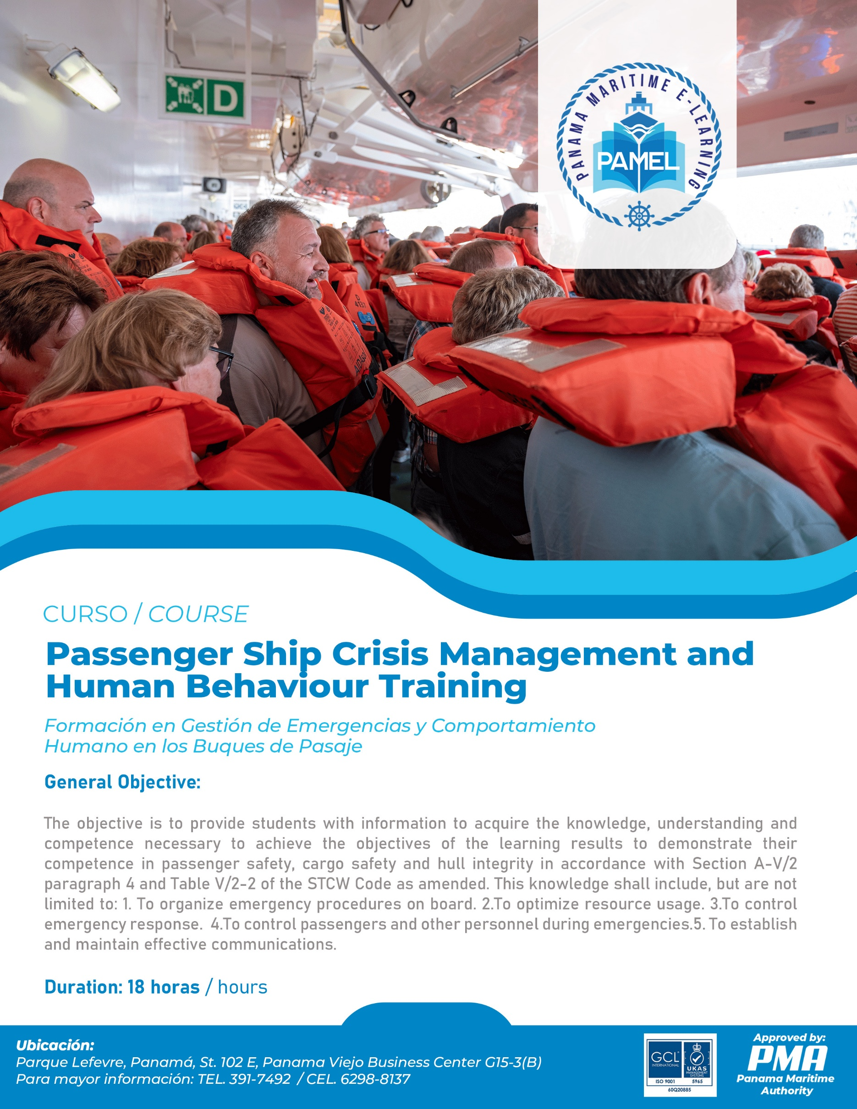

MANUAL OF THE TRAINING COURSE
PASSENGER SHIP CRISIS MANAGEMENT AND HUMAN BEHAVIOR TRAINING

Regulation V/2, Section A-V/2, paragraph 4 and Table A-V/2-2 of The International Convention on Standards of Training Certification and Watchkeeping of Seafarers STCW 1978, as amended (Convention STCW´78, as amended) and the STCW Code.

This course provides mandatory minimum standards of competence in Passenger Ship Crisis Management and Human Behavior Training in accordance with the provisions of Section A-V/2, paragraph 4 and Table A-V/2-2 of the STCW Code.

COURSE OUTLINE
PASSENGER SHIP CRISIS MANAGEMENT AND HUMAN BEHAVIOR TRAINING

SUBJECT AREA |  | COURSE DURATION (TIME)
N° | Denomination | Lecture Hours | Practice hours (workshops)
Knowledge, Understanding and Proficiency.
 | Course Introduction  Past and recent accidents or disaster on board passenger ships.  Explain the training requirement governed by Regulation V/2, paragraph 8 of the 1978 STCW Convention, as amended and flag state regulations. | 0.5
1. | Organize shipboard emergency procedures  1.1. Elements shipboard emergency procedures.  1.1.1. General design and layout of the ship  1.1.1.1. Describe the project and the overall configuration of the vessel.  1.1.2. Safety regulations  1.1.2.1. To review safety standards related to the emergency on board.  1.1.3. Emergency plans and procedures.  1.1.3.1. Describe the content of on-board emergency plans and their corresponding procedures.  1.1.3.2. Explain the instructions and procedures contained in the emergency plan.  1.2. The importance of principles for the development of shipspecific emergency procedures including:  1.2.1. The need for pre-planning and drills of shipboard emergency procedures.  1.2.1.1. Explain the importance of pre-planning and emergency simulation on board.  1.2.1.2. Plan exercises from different emergency scenarios according to onboard emergency procedures.  1.2.2 The need for all personnel to be aware of and adherence to pre-planned emergency procedures as carefully as possible in the event of an emergency situation.  1.2.2.1. Explain the need for the staff to know and adhere to planned emergency procedures as carefully as possible in the event of an emergency situation.  1.2.2.2. Evaluate the challenges of slowly and quickly raising an emergency, including its consequences. | 0.5 | 1.0
2. | Optimize the use of resources  2.1. Ability to optimize the use of resources, taking into account:  2.1.1. The possibility that resources available in an emergency may be limited.  2.1.1.1. Determine the capacities and limitations of available resources (i.e. human resources, equipment, and procedures) to respond to emergencies.  2.1.2. The need to make full use of personnel and equipment immediately available and, if necessary, to improvise.  2.1.2.1. Determine the ability of staff to take over if other team members are disabled or missing.  2.1.2.2. Apply short-term strategies in case some equipment is unavailable or malfunctioning.  2.2. Ability to organize realistic drills to maintain a state of readiness, taking into account lessons learnt from previous accidents involving passenger ships; debriefing after drills.  2.2.1. Execute realistic drills according to the planned emergency response.  2.2.2. Search for external emergency response equipment to help address the emergency.  2.2.3. Prepare reports after the drill to touch base on the need of improvements. | 3.0
3. | Control response to emergencies  3.1 Ability to make initial assessment and effective response to emergency situations in accordance with established emergency procedures  Leadership skills  3.1.1. Effectively assess and response to the emergency  3.2 Ability to lead and direct others in emergency situations, including the need:  Stress handling  3.2.1. To set an example during emergency situations.  3.2.1.1. Acquires complete situational awareness.  3.2.1.2. Demonstrate tolerance under pressure in challenging situations.  3.2.1.3. Consider suggestions/ideas from other team members.  3.2.2. To focus decision making, given the need to act quickly in an emergency.  3.2.2.1. Decide firmly based on established contingency and emergency plans.  3.2.3. Motivate, encourage, and calm passengers and other staff members.  3.2.3.1. Maintain effective communications when transmitting relevant information.  3.3. Ability to identify the development of symptoms of excessive personnel stress and other members of the ship's emergency team.  3.3.1. Determine the symptoms of excessive personal stress and those of other members of the ship's emergency team.  3.4. Understanding that stress generated by emergency situations can affect the performance of individuals and their ability to act on instructions and follow procedures.  3.4.1. Determine the effects of stress generated by emergencies.  3.4.2. Manage excessive personal stress and those of other members of the ship's emergency situations. | 2.0 | 5.0
4. | Control passengers and other personnel during emergency situations  Human behaviour and responses  4.1. Ability to control passengers and other personnel in emergency situations, including:  4.1.1 Awareness of general reaction patterns of passengers and other personnel in emergency situations, including the possibility that:  4.1.1.1. Generally it takes some time before people accept the fact that there is an emergency situation.  4.1.1.1.1 Describe the general reaction patterns of passengers and other personnel during the different phases of the emergency.  4.1.1.1.2 Describe the sources of information that the reaction of passengers and staff may be based on.  4.1.1.1.3 Provide actions to be taken to make warnings and instructions an effective emergency.  4.1.1.2. Some people may panic and not behave with a normal level of rationality, that their ability to comprehend may be impaired and they may not be as responsive to instructions as in non-emergency situations.  4.1.1.2.1 analyze the factors influencing the reaction of passengers and other personnel during the emergency.  4.1.2 Awareness that passengers and other personnel may, inter alia:  - Describe the actions passengers and other personnel could take when the emergency is confirmed.  - Describe the impact of the physical and psychological aspects of the emergency on passengers and other personnel.  - Explain how stress affects the reaction of passengers and other personnel during the emergency.  - Analyze the different behavioral responses of passengers and other personnel during the emergency impact phase.  4.1.2.1 Start looking for relatives, friends and/or their belongings as a first reaction when something goes wrong 4.1.2.2 Seek safety in their cabins or in other places on board where they think that they can escape danger.  4.1.2.1.1 Explain that the search parties are assigned to ensure that all areas are evacuated.  4.1.2.2 Seek safety in your cabins or other places on board where you believe you may escape danger.  4.1.2.3. Tend to move to the upper side when the ship is listing.  4.1.2.3.1. Explain that survival vessels may not be usable at the top of the ship when on one side.  4.1.2.3.2. Explain the danger of sliding down from the top side to the lower side of the ship.  4.1.3 Appreciation of the possible problem of panic resulting from separating families.  4.1.3.1. Describe the different assumptions about human behavior that may hinder the evacuation phase of passengers and personnel in emergency times.  4.1.3.2. Explain the following categories of response to human behavior during the evaluation phase. | 3.0
5. | Establish and maintain effective communications  5.1. Ability to establish and maintain effective communications, including:  5.1.1 Clear and concise instructions and reports.  5.1.1.1. Use elementary language to give clear and concise instructions and reports when communicating basic instructions to passengers.  5.1.2 Exchange of information with, and feedback from, passengers and other personnel.  5.1.2.1. Explain the importance of using the closed loop communication style.  5.2. Relevant information to passengers and other personnel during an emergency situation.  5.2.1. Language or languages appropriate to the principal nationalities of passengers and other personnel carried on the particular route.  5.2.1.1. Identify the appropriate language or languages for the main nationalities of passengers.  5.2.2. Possible need to communicate during an emergency by some other means, such as by demonstration, or by hand signals or calling attention to the location of instructions, muster stations, life-saving devices or evacuation routes, when oral communication is impractical.  5.2.2.1. Identify another means of communication with passengers during an emergency when oral communication is not practical.  5.2.2.2. Communicate safety instructions to passengers using other means of communication.  5.2.3 Language in which emergency announcements may be broadcast during an emergency or drill to convey critical guidance to passengers and to facilitate crew members in assisting passengers.  5.2.3.1. Identify the languages that can be used to transmit warnings during emergencies.  5.2.3.2. Issue an emergency announcement according to a given scenario. | 1.0
6. | EXAM | 1.0 | 1.0
SUB-TOTAL |  | 11 | 7
TOTAL |  | 18.0

COURSE TIMETABLE

Period | Day 1 | Day 2 | Day 3
1st Period | Introduction (0.5 hr).  1. Organize shipboard emergency procedures (0.5 hr). | 3. Control response to emergencies (1.5 hr). | 4. Control passengers and other personnel during emergency situations (1.5 hr).
2nd Period | 1. Organize shipboard emergency procedures (1.0 hr).  2. Optimize the use of resources (1.5 hr). | 3. Control response to emergencies (1.5 hr). | 4. Control passengers and other personnel during emergency situations (1.0 hr).
3rd Period | 2. Optimize the use of resources (1.5 hr). | 3. Control response to emergencies (1.5 hr). | 5. Establish and maintain effective communications (1.0 hr).
4th Period | 3. Control response to emergencies (1.5 hr). | 3. Control response to emergencies (1.0 hr).  4. Control passengers and other personnel during emergency situations (0.5 hr). | 6. Evaluation (2.0 hr).

Note: Please bear in mind that any timetable is subject to variation, depending on the general need of the trainees and local circumstances.

INTRODUCTION TO THE COURSE

Past and recent accidents or disaster on board passenger ships

The tragic loss of the MS Herald of Free Enterprise, MS Scandinavian Star and MS Estonia made the inclusion of parts in chapter V of the code in the 1995 amendment of the STCW Convention.

Recent maritime disasters involving passenger ships, i.e. MV Costa Concordia (2012) and MV Sewol (2014) demonstrate the importance of crisis management and human behavior training. The scope of this training is centered on risk to:
- Personnel;
- The vessel;
- The environment; and
- The operation.

Training requirement governed by the 1978 STCW Convention, as amended and flag state regulations

This training is part of the mandatory minimum requirements for the training and qualification of all masters and officers that are required to manage crisis situations on board in accordance with table A-V/2-2 of the STCW Code relating to the minimum standard of competence in passenger ship crisis management and human behavior.

1. ORGANIZE SHIPBOARD EMERGENCY PROCEDURES

  - Elements of shipboard emergency procedures

Shipboard emergency procedures outline actions to be taken during an emergency and are broken down into the following components:
- Discovery:
  - Initial identification and reaction to a potentially hazardous situation.
  - Example: Quickly dousing a smoldering cigarette in a wastebasket to eliminate fire risk.
- Containment:
  - The most crucial phase of emergency response after early discovery.
  - The goal is to prevent an incident from escalating into a major emergency/crisis.
  - Types of Containment:
    - Personnel Containment: Ensuring crew and passengers are in safe areas (muster points), deploying emergency response teams to safe working areas.
    - Area Containment: Shutting watertight/fire/smoke doors.
    - Environmental Containment: Shutting down ventilation, setting up smoke boundaries, deploying SOPEP (Shipboard Oil Pollution Emergency Plan) equipment, etc.
    - Mechanical/Electrical Containment: Shutting down and isolating equipment that could escalate the incident if left running.
  - If an incident cannot be contained, the Central Command Team (CCT) on the Bridge is responsible for planning, evaluating, deciding, and conducting vessel evacuation before the crisis becomes unmanageable.
- Damage Control:
  - The process of making an incident site safe.
  - Can be conducted during or after the containment phase, especially with multiple incidents.
  - Damage Control Activities:
    - Ballasting to maintain stability.
    - Extinguishing a fire sufficiently to mitigate reignition chances.
    - Pumping out flooded spaces and shoring hull breaches.
    - Ventilating and testing atmosphere in smoke or toxic gas environments.
    - Isolating broken pipelines, checking cargo stowage.
    - Containing and cleaning up spills.
  - Regular practice and drills are essential for training teams.
- Incident Investigation and Reporting:
  - A major part of the emergency response plan.
  - Identifies root causes of incidents and provides controls to prevent recurrence.
  - Information should be disseminated across the industry to alert and advise others of potential risks.
  - In crisis situations, independent bodies (e.g., Marine Accident Investigation Branch - MAIB) should conduct investigations.
1.2. General Design and Layout of the Ship
- SOLAS (Safety of Life at Sea) 1974:
  - Provides clear requirements for ship design, construction, Emergency Response Equipment, and Life-Saving Appliances (LSA).
  - Ships are constructed with "containment" in mind to ensure survivability.
- Containment Features:
  - Watertight Compartments: Doors can be operated remotely from the bridge, locally, or from emergency hand pump control stations. Operating these doors is a command decision.
    - Considerations in a flooding scenario: Number of personnel in the affected compartment and evacuation, stability and trim, timing and method of door closure (access issues), and bilge pumps and suctions.
  - Double Bottoms: Mandated for new build tankers to reduce environmental contamination risk in case of collision or grounding.
    - Considerations in a collision/grounding scenario: Stability and trim, containment of cargo, ballast, and bilge water, SOPEP equipment and dispersants, and notification to local authorities.
  - Fire Zones: Vessels are divided into fire zones to help the CCT locate and monitor fire spread.
    - Considerations in a fire scenario: Identification of source and size of fire, identification of zone/location, shutdown of ventilation and mechanical/electrical isolation, identification of safe working area for ERT, setting up smoke boundaries, and setting up boundary cooling.
1.3. Major Crisis Types
Major crises onboard vessels often arise from individual incidents that have a cascading effect, ultimately impacting the vessel's stability, trim, or habitability. While no two crises are identical, effective initial response and management can often prevent escalation.
- Common Major Crisis Types (not limited to):
  - Fire/Explosion
  - Flooding
  - Collision
  - Grounding
  - Foundering
  - Blackout/Mechanical failure
  - Toxic gas
  - Mass casualties
1.4. Safety Regulations
- International Safety Management (ISM) Code:
  - Emergency Preparedness (Part A, Section 8):
    - Companies must identify potential emergency shipboard situations and establish response procedures.
    - Companies must establish programs for drills and exercises for emergency actions.
    - The Safety Management System (SMS) must ensure the company's organization can respond at any time to hazards, accidents, and emergencies involving its ships.
- Safety of Life at Sea (SOLAS):
  - Provides comprehensive safety regulations covering:
    - Construction (structure, subdivision, stability, machinery, electrical installations).
    - Construction (fire protection, detection, extinction).
    - Life-saving appliances and arrangements.
    - Radiocommunications.
    - Safety of navigation.
    - Carriage of cargos and oil fuels.
    - Carriage of dangerous goods.
    - Nuclear ships.
    - Management for the safe operation of ships.
    - Safety measures for high-speed craft.
    - Special measures to enhance maritime safety.
    - Special measures to enhance maritime security.
    - Additional safety measures for bulk carriers.
    - Verification of compliance.
    - Safety measures for ships operating in polar waters.
1.5. Emergency Plans and Procedures
Emergency or contingency plans are crucial documents that assist the crisis management team in decision-making during an emergency.
- Location: Required to be at accessible points on the vessel (bridge, engine control room, conspicuous areas for crew and passengers, gangway access points).
- Content:
  - Crew muster list plan.
  - Crew emergency plan.
  - Fire control plan.
  - Life-saving appliances and escape route/evacuation plan.
  - Damage control plan.
  - General arrangement plan.
  - Log book (for recording management decisions and orders, may use digital recorders).
- Trainees should be familiar with the symbology used on these plans.
1.6. Importance of Principles for Developing Ship-Specific Emergency Procedures
- Need for Pre-planning and Drills:
  - Importance of Pre-planning and Emergency Simulation: Regular practice and drills help teams respond to and manage incidents before they escalate into crises.
  - Planning Exercises: Exercises should be planned from different emergency scenarios according to onboard emergency procedures.
  - Example Scenario (Collision Escalation): A collision leads to structural damage, flooding, electrical arcing, fire, blackout, and crew injury. This demonstrates how an initial incident can escalate into a full crisis, requiring the crisis management team to handle multiple emergencies simultaneously.
- Crew Emergency Plan (CEP) Procedures:
  - Developed by the shipping company in accordance with SOLAS and ISM regulations.
  - Initial Actions (First Response/First Aid): What each crew member must do upon discovering an incident (e.g., for fire: raise alarm, fight if safe, seal compartment if not safe, wait for ERT). These are taught in basic safety training and drills.
  - Central Command Team (CCT) Procedures: Details on how to manage an incident or multiple incidents (e.g., for fire: receive muster reports, check for missing persons, stop ventilation, deploy ERT, manage casualties, communicate). These are typically found in Company SMS documentation.
- Awareness and Adherence to Pre-planned Procedures:
  - All personnel must be aware of and adhere to pre-planned emergency procedures as carefully as possible.
  - These procedures require thinking, communication, and response, emphasizing the need for regular practice.
  - In escalating incidents (e.g., fire and blackout), prioritization and delegation are key (e.g., delegate blackout to Chief Engineer while CCT handles fire). Crisis management is complex as no two crises develop identically, nor will human actions and reactions be the same.
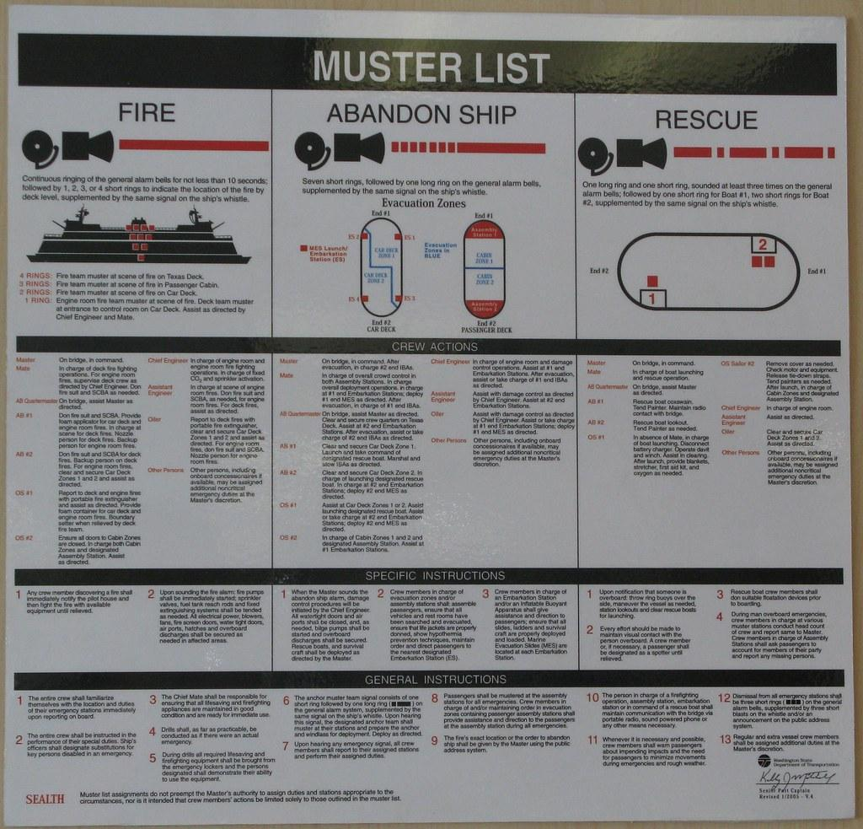
Figure # 2 - Crew muster list and crew emergency plan

- OPTIMIZE THE USE OF RESOURCES

2.1. Ability to optimize the use of resources, taking into account:

During an emergency, people react differently. Two common psychological modes are:
- Flight: Desire to run away.
- Fight: Desire to tackle the problem head-on.
On a ship, "flight" is a secondary option; the "fight" mode is developed through practice. Incident managers must consider factors when dealing with people in emergencies:
- Uncertainty, Ambiguity, or Conflicting Information: Information must be gathered, assessed, and clarified in early stages before decision-making.
- Shifting and Competing Goals: Priorities during incident escalation must be:
  - Passenger and personnel safety.
  - Vessel safety.
  - Environmental safety.
  - Operational safety.
  - The CCT should take "time out" to ensure priorities are covered.
- Time Stress: Time seems to slow down during emergencies. The CCT must avoid demanding information when none is available and trust the ERT to deliver timely reports.
- Potential Serious Consequences: The focus should be on containing the incident and ensuring safety to lessen consequences.
- Multiple Players (Team Factors): Language, culture, and communication are vital. Panicked or stressed people may revert to their mother tongue. A closed-loop communication style is essential. Tasks should be assigned to competent team members, and all tasks/completions recorded with time annotations.
- Personal Factors: Unwanted behaviors (anger, sorrow, apathy, indecision, confusion, stress, panic) can break down teamwork. The incident manager must control their own emotions and observe others. Other factors to monitor include fatigue, workload, communications, and competency.
2.2. Full Use of Available Personnel and Equipment, and Improvisation
- Ability of Staff to Take Over:
  - Principles of Delegation: Passenger ship organizational structure facilitates task delegation (e.g., Master as Incident/Crisis Manager, Chief Officer for marine incidents, Chief Engineer for technical incidents, Navigational Officer for safety, another Officer for communications, and a dedicated incident recorder).
  - Effective delegation relies on training and competency; exercising the Command Control Team improves performance.
  - How to Delegate: Define the task, communicate requirements clearly, ensure understanding (closed loop), and follow up on progress.
- Short-Term Strategies for Unavailable/Malfunctioning Equipment:
  - Emergency Response Equipment and Personnel: LSA and emergency equipment are mandated by SOLAS. Maintenance and training ensure readiness.
  - Tips for Effective Utilization:
    - Regular Drills and Onboard Training: Familiarizes teams with equipment.
    - Ventilation and Watertight Integrity: Quick shutdown prevents smoke/gas spread; rapid closure of watertight doors contains flooding.
    - Speed: Fast ERT response limits escalation.
    - Communication: Quick, clear Muster Station/Head count reports; regular Situation Reports (SITREPS) reduce fear.
    - Use of Fixed Fire Fighting Systems: Early deployment can suppress fires or aid fire teams. Ensure compartments are evacuated first.
    - Safe Working Areas: Setting up close to the incident saves SCBA air, shortens hoses, and provides quick first aid.
    - Electrical/Mechanical Isolation: Early shutdown reduces load and ensures personnel/equipment safety.
    - Record-keeping: A dedicated log keeper (scribe) records time, decisions, instructions, and situation reports. Diagrams should be marked with incident details, ERT locations, equipment status, and atmosphere monitoring results. These records are vital for investigations.
    - Lifeboats and Liferafts: Abandonment is an executive order based on vessel habitability. Factors include trim (up to 10°), list (up to 20°), and speed of loading/launching.

- CONTROL RESPONSE TO EMERGENCIES
3.1. Ability to make initial assessment and effective response to emergency situations in accordance with established emergency procedures

3.1.1. Effectively assess and response to the emergency
  - Emergencies require strong leaders at all levels (on-scene commander, engine room control, first aid, zone commanders).
  - Initial information may be sparse, but personnel and resources must be mobilized under calm, decisive leadership.
  - Leadership style should be firm and decisive.
  - Stress levels will heighten; symptoms (rapid heart rate, sweating) must be identified to reallocate tasks and request support.
  - Raising the Alarm: Seafarers are taught to report location, nature of emergency, and casualties.
  - Situational Awareness: These reports, along with detectors (smoke/flame, gas, flooding), are vital for the crisis manager's initial assessment and action plan development.
  - Initial Assessment Questions: What's the problem? What's been done? How to contain it? What resources are needed? Anyone hurt? Who needs to be informed?
  - Practice Scenario (Engine Room Fire): A detailed step-by-step example of initial response, containment, resource deployment, casualty management, and communication for an engine room fire.
3.2. Leading and Directing Others in Emergency Situations
- Setting an Example: Leaders must demonstrate tolerance under pressure and consider team members' suggestions.
- Focusing Decision Making: Decisions must be firm and based on established contingency and emergency plans, given the need for quick action.
- Motivating, Encouraging, and Calming:
  - Effective Communications: Keep all crew and passengers informed with Situation Reports (SITREPS) every 15 minutes. Use the public address system.
  - Radios should be handled by the scribe. The crisis manager uses closed-loop communication with the radio operator (instruction, repeat-back, acknowledgment).
  - Communication should be short and clear (e.g., "pass to the fire team on air standby to enter XYZ compartment").
3.3. Identifying and Managing Personnel Stress
- Symptoms of Excessive Stress: Traumatic incidents can cause strong emotional reactions.
  - Physical Symptoms: Chest pain, difficulty breathing, fatigue, nausea/vomiting, dizziness, sweating, rapid heart rate, thirst, headaches, visual difficulties, jaw clenching, non-specific aches.
  - Cognitive Symptoms: Confusion, nightmares, disorientation, heightened/lowered alertness, poor concentration, memory problems, poor problem-solving, difficulty identifying familiar objects/people.
  - Emotional Symptoms: Anxiety, guilt, grief, denial, intense anger, fear/irritability, loss of emotional control, depression, feeling overwhelmed, blaming others/self, severe panic (rare).
  - Behavioral Symptoms: Withdrawal, emotional outbursts, temporary loss/increase of appetite, excessive alcohol consumption, inability to rest, pacing, changes in sexual functioning.
  - Note: Seek medical attention for severe physical symptoms.
- Managing Stress: Stress is normal but can be managed.
  - Adhere to safety policies and procedures.
  - Encourage and support co-workers.
  - Recognize that "not having enough to do" or "waiting" are normal.
  - Take "time outs" to decompress.
  - Practice relaxation techniques (deep breathing, meditation, stretching).

- CONTROL PASSENGERS AND OTHER PERSONNEL DURING EMERGENCY SITUATIONS

4.1 General reaction patterns of passengers and other personnel in normal and emergency situations

4.1.1 Generally it takes some time before people accept the fact that there is an emergency situation.

- Phase One – Warning:
  - People often show reluctance to accept an emergency, especially in early stages. Social inhibitions can lead to slow initial responses.
  - If warnings are prolonged or guidance is absent, uncertainty and anxiety rise, potentially leading to panic.
  - Sources of Information: Reactions are based on information received.
  - Effective Warnings/Instructions: Early and clear information from officers and crew is crucial.
- Factors Influencing Reaction:
  - Credibility of Sender: Authority, expertise, and experience lend credibility.
  - Conveyance and Content: How the message is delivered and by whom; avoid ambiguity.
  - Age Differences: Younger people may respond faster than the elderly.
  - Immediate Social Situation: Individuals or peer groups may respond slower than family groups.
  - Presence of Family or Friends: Families/friends take warnings more seriously and try to stay together.
  - Observations: People observe others' behavior to interpret the situation.
  - Place: In public places, it's harder to interpret danger.
  - Time of Warning: Harder to rouse people at night; alarms need to be louder than background noise.
  - Experience: Prior emergency experience or knowledge increases adaptive response.
- Aids to Decision Making (Cues):
  - How other people behave (especially crew).
  - What other people say (processing information in small groups).
  - Presence of specialized staff (senior officers, fire parties).
  - Changes in the environment (e.g., engines slowing down).
  - Physical products/evidence of a problem (heat, noise, smoke).
  - Instructions by staff (physical presence prompts seriousness).
- Maximizing Effectiveness of Warnings/Instructions:
  - Given by appropriate, trustworthy people.
  - Specific, correct content.
  - Clearly define expectations and timing.
  - Neither underestimate nor overestimate danger.
  - Suggest appropriate actions.
  - As personal as possible.
  - Understandable language.
  - Repeated frequently.
  - Never refer to similar catastrophes.
  - No unrelated information in pauses.
4.2. Awareness of Passengers' and Personnel's Actions When Emergency is Confirmed
- Phase Two – Impact:
  - The threat is understood as real.
  - People detect environmental changes, collect information, interpret it, and decide on actions.
  - Understanding and responses will differ even with the same information.
  - Families and close friends want to stay together and rely on each other for advice. They should be kept together.
  - Roughly 25% of people act rationally; this group can be a valuable asset.
  - The bulk of passengers may accept the problem but take no action due to fear/uncertainty or confidence in the crew.
  - A small number (approx. 15%) may engage in inappropriate behaviors (collecting belongings, weeping, panic).
  - Communication must be clear and informative; officers' and crew's behavior must be exemplary and professional.
- Common Passenger Reactions:
  - Looking for relatives, friends, and/or belongings.
  - Seeking safety in cabins or other perceived safe places. Search parties are assigned to ensure all areas are evacuated.
  - Tendency to move to the upper side when the ship is listing. Explain that survival vessels may not be usable on the high side, and the danger of sliding to the lower side.
4.3. Appreciation of Panic Problem from Separated Families
- Phase Three – Evacuation:
  - Getting passengers to stop what they are doing and move.
  - Requires awareness of threat (warning phase) and acceptance (impact phase).
  - Unfamiliar and unexpected events can be alarming; people may try to normalize what they see/hear.
- Common Assumptions Hindering Evacuation:
  - Individuals move immediately upon alarm.
  - Motivation to escape drives all actions.
  - Evacuation time depends only on physical movement to exit.
  - People move to the nearest exit.
  - People move as individuals ("every man for himself").
  - Fire exit signs guarantee safe routes.
  - People won't use smoke-filled routes.
  - All people are equally capable of moving.
  - People's safety cannot be guaranteed due to panic.
- Categories of Human Behavioral Response During Evacuation:
  - Adaptive Behavior: Rational, assists survival.
  - Non-Adaptive Behavior: Irrational, hinders survival.
  - Category 1 – Inaction: Stunned, bewildered response ("freezing" or "negative panic").
  - Category 2 – Fear – Flight: Non-rational escape behavior, just short of panic. Automatic responses to danger (e.g., moving to the high side of a listing vessel, trying to retrieve belongings).
  - Category 3 – Panic: Highly emotional, intense, non-adaptive behavior characterized by self-preservation at all costs, breakdown of group ties. Can increase danger for self and others.
    - Individual Panic: Occurs if isolated or threat is overwhelming.
    - Group Panic: Occurs when others' actions confirm danger, or in a slowly evolving crisis with little information from authorities.
    - Non-Panic Behaviors (Adaptive): Acceptance, use of information, stress control, warning others, constructive action, self/other evacuation.
  - Category 5 – Altruism and Affiliation: Protective behaviors that assist survival. People often respond rationally and altruistically, especially towards primary groups (family, close friends). Threat strengthens these bonds; families try to stay together.
- Phase Four – Recoil (Stop Phase):
  - Non-Serious Event: Return to normal duties for crew, passengers resume activities.
  - Serious Event: Realization of full extent of what happened (loss of possessions/loved ones).
  - Post-Traumatic Stress Disorder (PTSD) Symptoms: Flashbacks, depression, anxiety, nightmares.
  - Anger and despair are common.
  - Helpful Responses During Recoil: Decisive, compassionate leadership; maintaining control; will to survive; actively assisting others; mental rehearsal; thinking of loved ones; prayer; mental/physical rest.
  - Children's Vulnerability:
    - Up to 8-9 years: Mirror parents' responses.
    - 9-14 years: Excitement, no fear/anxiety; may try to re-enter disaster area.
    - Over 14 years: More likely to show fear, behave like adults.
  - Officer and Crew Behavioral Responses:
    - Manage tension and urgency by: not being overwhelmed, grasping the overall picture, developing simple plans, breaking tasks down, setting clear objectives, avoiding doing too much, accepting limitations.
    - Roll Call: A powerful tool to establish authority, identify capable individuals, utilize skills, record injuries, assess mental state, reassure individuals, and provide relief. Repeat roll calls for reassurance. Accept volunteer help.

- ESTABLISH AND MAINTAIN EFFECTIVE COMMUNICATIONS

5.1. Ability to establish and maintain effective communications, including:
5.1.1 Clear and concise instructions and reports.
5.1.1.1. Use elementary language to give clear and concise instructions and reports when communicating basic instructions to passengers.
- Elementary Language: Use simple language for basic instructions to passengers.
  - Importance: Higher chance of understanding, English is widely spoken.
  - Audible Communication: Use appropriate tone (professional, friendly), pace (slowly), volume (loud but low pitch), and diction (clear words).
- Closed-Loop Communication: A technique to avoid misunderstandings.
  - Sender gives message, receiver repeats it back, sender confirms.
  - Importance for Safety: Ensures message is fully understood before execution, avoids misinterpretation.
  - Example: Illustrated instructions for life-saving appliances, using standard symbols for key facilities.
5.2. Relevant Information to Passengers and Other Personnel
- Language Appropriateness: Identify languages appropriate to the principal nationalities of passengers.
  - The MV Estonia tragedy highlighted the need for announcements in languages understood by passengers.
- Alternative Communication Means (when oral is impractical):
  - Demonstration, hand signals, pointing to instructions, muster stations, life-saving devices, or evacuation routes.
  - Information should be accessible (large print, audio/video, Braille, "easy-to-read"). Separate leaflets for different languages are better than multi-language ones.
  - For Hearing-Impaired or Non-English Speakers: Assign interpreters (crew/fellow passengers), use hand signals, point to posters/safety signs/symbols.
- Emergency Announcements:
  - Crew must demonstrate the ability to broadcast emergency announcements using elementary English.
  - Announcements should be simple, concise, accurate, and clear.
  - Examples of Announcements: Instructions for putting on lifejackets, guidance to lifeboat stations, maintaining single file.

6.Evaluation
Evaluation is a way of finding out if learning has taken place. It enables the assessor (instructor), to ascertain if the leaner has gained the required skills and knowledge needed at a given point towards a course or qualification.
The purpose of evaluation is to:
- Assist student leaning;
- Identify student’s strengths and weaknesses;
- Asses the effectiveness of a particular instructional strategy;
- Asses and improve the effectiveness of curriculum programs;
- Asses and improve teaching effectiveness.
Upon successful completion of the examination which is carried out during and at the end of the course, the trainee will be awarded relevant course completion certificate issued by the training center.

