* Connected to the development server



* Backend configuration steps are mentioned in README.md file under /home/ec2-user/GL-IIIT-TechDocs/backend directory.
* Connection to MySql RDS instance was tested.



* update the def_Tables.py with changes in database (e.g., checkout_flag in Documents table)

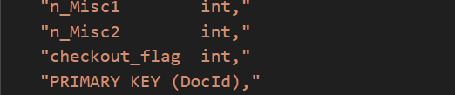

* update the orm_Tables with changes in database (e.g., checkout_flag in Documents table)
  + orm_Common.py

* + orm_Tables.py

* Schema created using following steps:
  + cd Schema
  + python3 def_Tables.py.
  + Opened another terminal for checking the RDS database from EC2 instance.



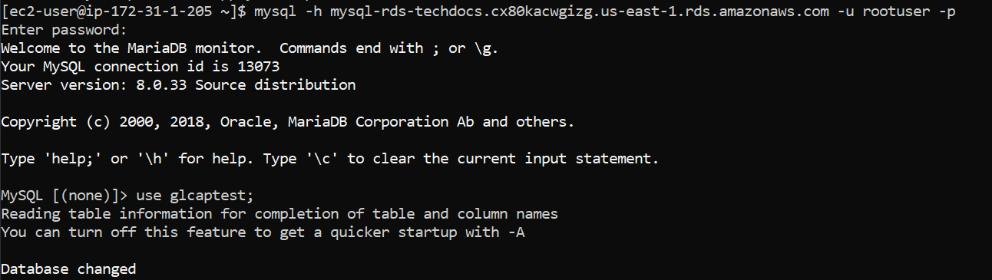

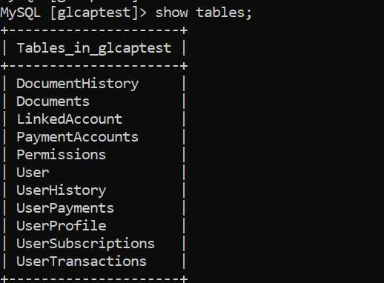

* Template folder setup for backend in the flask app (app.py)



* Flask app was run either by running the Docker or by using flask command.



* Opened another terminal for testing while the flask app is running.



* User registration



* User login. Authtoken generated at runtime is being used in further API calls.



* If user forgets password.



* User password reset.



* User profile updated and reviewed.

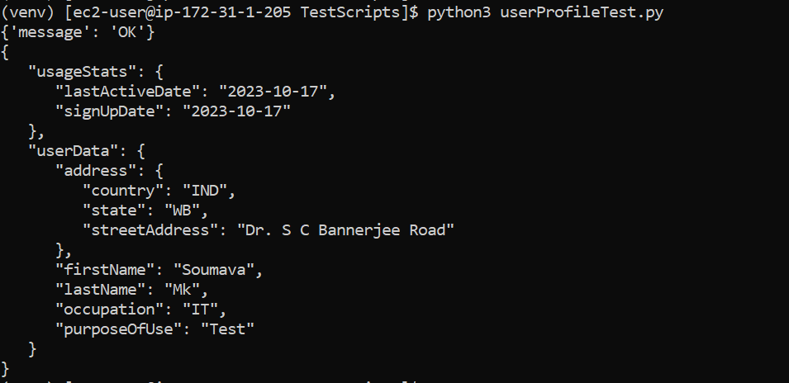

* Open another terminal and map server localhost with client localhost



* File upload to user specific directory.



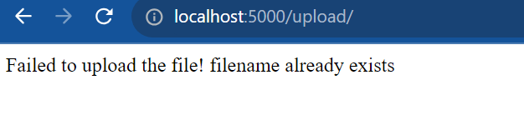

* Changing file permissions and reviewing the same.







* Version management



* Payment using RazorPay

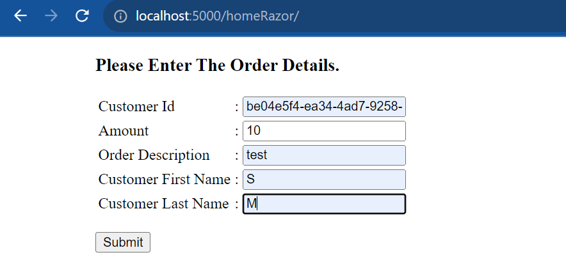

* File upload

* Multi-user editing documents using ckeckout flag.



* + While one is updating a document the checkout flag is set (**Document.checkout_flag=1**) restricting others to modify the same document.

* + Once the update is done the checkout flag is reset (**Document.checkout_flag=0**) making the document editable by others.

* Latex to PDF. User specific files are converted into PDF in the user repository for download.



* File download. On clicking download, file gets downloaded in the local computer.

