SOFTWARE REQUIREMENTS SPECIFICATION
SIM — Security Incident Mapping System
A Web-Based Platform for Reporting Campus Security Incidents
Course: SEN202 — Weekly Dev, Weekend 1
Prepared by: [Your Full Name]
Matric Number: [Your Matric Number]
Supervisor: Dr. O. O. Ajayi
Date: July 10, 2026

1. Introduction

1.1 Purpose
This document specifies the software requirements for SIM (Security Incident Mapping), a web-based platform that allows students, staff, and landlords within a campus community to report security incidents such as theft, stabbing, assault, and other crimes. The purpose of this SRS is to describe the functional and non-functional requirements of the system, based on findings from a community survey and an Ishikawa (root-cause) analysis of the underlying problem.

1.2 Scope
SIM will allow community members to submit incident reports (with an option for anonymity), view the status of their submitted reports, and receive notifications. Administrators/security personnel will be able to view all submitted reports, verify them, and update their status. The initial version of the system is a lightweight web prototype, intentionally scoped to avoid unnecessary complexity given the project's development timeline.

1.3 Definitions and Abbreviations
- SIM — Security Incident Mapping
- SRS — Software Requirements Specification
- UML — Unified Modeling Language
- Respondent — A participant who completed the community survey

1.4 References
- Community Survey (Google Forms) — SIM Community Security Survey
- Ishikawa (Fishbone) Diagram — see project repository (ishikawa-diagram.png)
- Use-Case Diagram — see Section 6 of this document

2. Overall Description

2.1 Product Perspective
SIM is a new, standalone web-based system developed in response to rising community/campus crime and the observed reluctance of victims and witnesses to report incidents through existing (informal, word-of-mouth) channels. It is designed to be simple, fast, and accessible from any browser.

2.2 User Classes and Characteristics
User Class | Description
Student | Primary users; report incidents witnessed/experienced on or around campus.
Staff | Report incidents observed during the course of work on campus.
Landlord | Report incidents occurring at off-campus lodges/hostels under their management.
Admin / Security Personnel | Review, verify, and act on submitted reports; update report status.

2.3 Operating Environment
SIM is a web-based application accessible via any standard browser (Chrome, Firefox, Safari) on desktop or mobile devices. No installation is required by end users.

2.4 Design and Implementation Constraints
- The system must remain intentionally simple ("mini web interface") due to project submission timelines, as specified in the project brief.
- The prototype does not implement persistent server-side storage; this is noted as a limitation and a direction for future work.

3. Community Survey Findings
A community survey was administered via Google Forms to gather input on security incident experiences and expectations for a reporting platform. The survey received 25 responses. Key findings that directly inform the requirements in this document are summarized below.
Finding | Result
Respondents who witnessed/experienced an incident | 76.0% (19 of 25)
Most common incident type reported | Theft (68.4% of those who experienced an incident)
Incidents reported to any authority | Only 26.3% — 73.7% went unreported
Top reason for not reporting | Didn't know who to contact (42.9%)
Other reasons for not reporting | Feared retaliation (28.6%); slow process (28.6%); doubted it would help (28.6%)
Willingness to use a web app to report incidents | 92.0% Yes, 8.0% Maybe — no respondent said No
Most important data a report should capture | Type of incident (84.0%), Location (72.0%), Time (72.0%)
Preference for anonymous reporting | 52.0% No / 48.0% Yes — nearly evenly split

These findings, together with the Ishikawa root-cause analysis (see project repository), directly justify the functional requirements defined in Section 4 — particularly the emphasis on clear reporting channels, optional anonymity, and status visibility.

4. Functional Requirements
ID | Requirement | Justification
FR1 | The system shall allow a user to submit an incident report including type, location, time, and description. | 84.0% of respondents said the report should capture the type of incident; 72.0% cited location and time.
FR2 | The system shall allow a user to submit a report anonymously. | 48.0% of respondents preferred anonymous reporting; fear of retaliation was cited by 28.6% of non-reporters.
FR3 | The system shall clearly display who receives a report and how it will be handled. | 42.9% of respondents did not report an incident because they didn't know who to contact — the single largest barrier identified.
FR4 | The system shall allow a user to view the status of their submitted report. | Addresses distrust in authorities and the perception that reporting "wouldn't help" (cited by 28.6%).
FR5 | The system shall allow an Admin/Security user to view all submitted reports. | Required for the platform to function as a central reporting hub.
FR6 | The system shall allow an Admin to verify and update the status of a report. | Provides accountability and closes the feedback loop identified as missing by respondents.
FR7 | The system shall send notifications to users regarding updates on their report. | Improves trust and follow-through, addressing the "no follow-up" root cause identified in the Ishikawa analysis.

5. Non-Functional Requirements
Category | Requirement
Usability | The interface shall be simple and require no training to use, given that 92.0% of respondents were willing to use a web-based reporting tool (with a further 8.0% saying "Maybe").
Security & Privacy | Anonymous reports shall not store or expose any identifying information about the reporter.
Performance | Report submission shall complete and confirm within 2 seconds under normal network conditions.
Availability | The system shall be accessible via web browser at all times, given the time-sensitive nature of security incidents.
Scalability | The system architecture shall allow for future extension to persistent storage and real-time alerts as usage grows.

6. Use-Case Diagram
The diagram below illustrates the actors who interact with SIM and the primary use cases each actor performs.
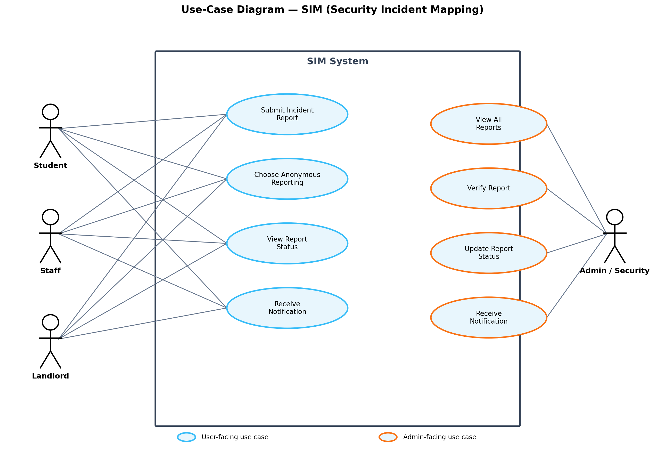

6.1 Use-Case Descriptions
Use Case | Actor(s) | Description
Submit Incident Report | Student, Staff, Landlord | User fills in and submits details of a security incident.
Choose Anonymous Reporting | Student, Staff, Landlord | User opts to submit a report without revealing their identity.
View Report Status | Student, Staff, Landlord | User checks the current status of a report they submitted.
Receive Notification | All actors | User/Admin is notified of updates relevant to a report.
View All Reports | Admin/Security | Admin views the full list of submitted incident reports.
Verify Report | Admin/Security | Admin reviews a report to confirm its validity.
Update Report Status | Admin/Security | Admin changes a report's status (e.g., Under Review, Resolved).

7. Appendix

7.1 Related Project Artifacts
- Ishikawa (Fishbone) Diagram — ishikawa-diagram.png (project repository)
- Community Survey Instrument — Google Forms link (project repository / README)
- Mini Web Interface Prototype — sim-app.html (project repository)
- Use-Case Diagram Source — usecase-diagram.png (project repository)

