Building Surface Image Classification
  - Midterm Project Report
I compared four classical image classifiers on the BD3 dataset, evaluated them with five-fold cross-validation, and tuned the strongest model. The tuned random forest achieved 76.4% accuracy on 584 test images. In separate experiments, I trained a small convolutional neural network (CNN) and a vision transformer (ViT) from random weights. Their test accuracies were 81.2% and 71.1%. All fitted models used the supplied BD3 data without pretrained weights.

Project objective
My goal was to compare image classifiers for seven surface categories and demonstrate the saved models through a small upload website. I followed Tasks 5, 6, and 7 by comparing four classifiers, using five-fold cross-validation, and tuning the model with the best cross-validation macro F1 score. I used standard library functions so that the workflow stays easy to follow.

Dataset and cleaning
I used the supplied BD3_original_dataset folder. It contained 3,965 readable RGB JPEG images, each 512 by 512 pixels. The seven folders inside train provided the labels. There was no separate validation or test folder in the supplied dataset.
Category | Original images | Used images
Algae | 620 | 618
Major Crack | 580 | 576
Minor Crack | 624 | 577
Peeling | 520 | 515
Plain | 600 | 589
Spalling | 500 | 500
Stain | 521 | 518
Total | 3,965 | 3,893

Before splitting, I checked exact image content. I excluded all 11 files in three duplicate groups with conflicting major crack and minor crack labels. I also removed 61 extra copies from same-label duplicate groups. This left 3,893 images and prevented an exact duplicate from appearing in different subsets. I kept the cleaning decisions and fixed image assignments in the project files.

Evaluation sets
I retained the fixed stratified split made with seed 42: 2,725 training, 584 validation, and 584 test images. For the classical comparison, I combined training and validation into 3,309 development images and used five-fold cross-validation within that set. The CNN and ViT kept the original training and validation subsets separate for checkpoint selection.

Task 5 Model comparison

Image preparation and features
For the classical models, I converted images to RGB and calculated 646 fixed measurements of colour, texture, and edge direction. Most measurements used a 128 by 128 image; HOG used a 64 by 64 grayscale image. These feature calculations do not learn weights from data. I used the same features for all four classifiers.
Feature group | Numbers | Purpose
RGB and HSV histograms | 96 | 16 bins for each of six colour channels
Local binary patterns | 28 | Texture at two neighbourhood sizes
HOG | 324 | Patterns of local edge directions
Local RGB averages | 192 | Mean colour in an 8 by 8 grid
RGB mean and spread | 6 | Overall colour and variation

The four classifiers
I trained logistic regression, a decision tree, a random forest, and K-nearest neighbours. Logistic regression learns a weighted rule for each class. A decision tree splits the data through a sequence of decisions. A random forest combines many trees. K-nearest neighbours predicts from the closest training examples in feature space.
The starting settings were C equal to 1 for logistic regression, at least 2 samples per decision-tree leaf, 200 trees for the random forest, and 5 distance-weighted neighbours for KNN. After cross-validation, I fitted each model on all 3,309 development images and evaluated it on the same 584 test images. The table below shows these starting models before tuning.
Model | Accuracy | Precision  macro | Recall  macro | F1  macro | Balanced  accuracy
Logistic Regression | 0.625 | 0.621 | 0.621 | 0.620 | 0.621
Decision Tree | 0.553 | 0.555 | 0.549 | 0.552 | 0.549
Random Forest | 0.753 | 0.754 | 0.750 | 0.750 | 0.750
KNN | 0.651 | 0.661 | 0.643 | 0.638 | 0.643

All values are scores from 0 to 1 on the same 584 test images. Accuracy is the fraction of correct predictions. Precision measures how often a predicted class is correct, recall measures how many true examples are found, and F1 balances precision and recall. Macro averaging gives each class equal weight. Balanced accuracy equals average class recall, so it matches macro recall here.
Random Forest had the highest test accuracy among the four starting models (75.3%); Decision Tree had the lowest (55.3%). I used the cross-validation results in Task 6 to choose which model to tune, rather than selecting from this test table.

Task 5 Confusion matrices
I used a confusion matrix for each classifier to see the types of mistakes. Rows show the true class and columns show the predicted class. Counts on the main diagonal are correct predictions; the other cells are errors. Each matrix contains the same 584 test images.
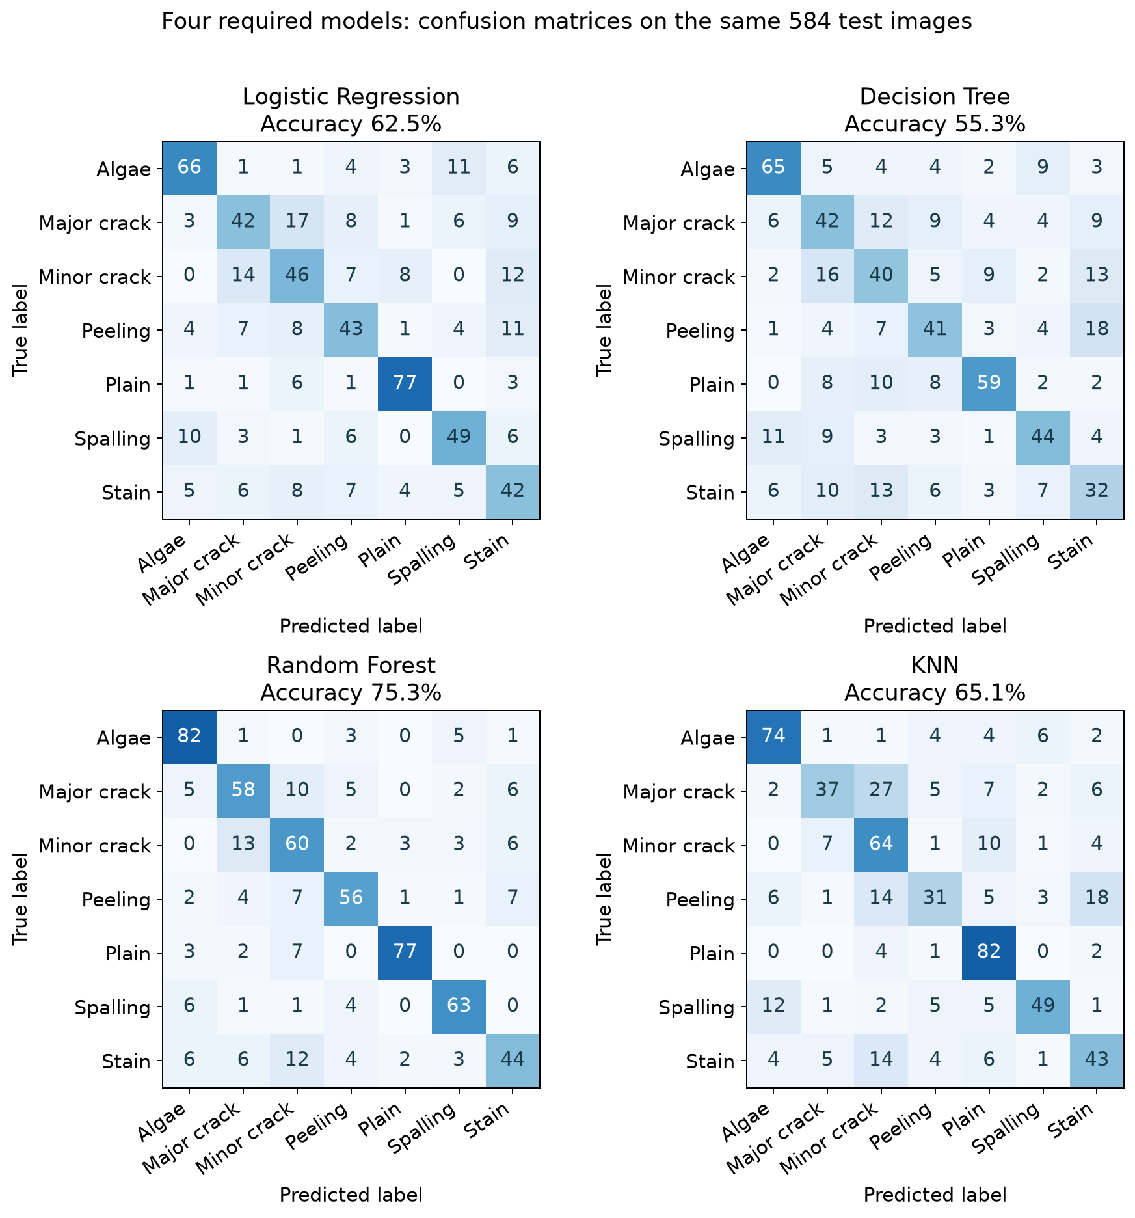
Figure 1 Test confusion matrices for the four classical classifiers before tuning.
For random forest, the largest individual confusion was 13 minor crack images predicted as major crack. The other models showed different error patterns, which is why I considered per-class performance as well as overall accuracy.

Task 6 Five fold cross validation
I used StratifiedKFold with five folds, shuffling enabled, and random seed 42 on the 3,309 development images. In each round, I fitted a fresh model on four folds and evaluated it on the remaining fold. Stratification kept class proportions similar. Each development image served in a validation fold once, while the 584 final test images stayed outside this process.
Model | Accuracy | Precision  macro | Recall  macro | F1  macro | Balanced  accuracy
Logistic Regression | 0.629 (0.013) | 0.624 (0.016) | 0.623 (0.014) | 0.623 (0.015) | 0.623 (0.014)
Decision Tree | 0.559 (0.009) | 0.556 (0.007) | 0.553 (0.009) | 0.553 (0.007) | 0.553 (0.009)
Random Forest | 0.745 (0.021) | 0.748 (0.023) | 0.739 (0.021) | 0.738 (0.022) | 0.739 (0.021)
KNN | 0.611 (0.008) | 0.630 (0.005) | 0.602 (0.007) | 0.598 (0.007) | 0.602 (0.007)

Each cell shows the mean score across five folds, followed by the sample standard deviation in brackets. The mean summarises average performance. A smaller standard deviation means the score changed less across these folds; it does not prove the model will work equally well on new buildings.

Macro F1 in each fold
Model | Fold 1 | Fold 2 | Fold 3 | Fold 4 | Fold 5
Logistic Regression | 0.641 | 0.601 | 0.616 | 0.627 | 0.628
Decision Tree | 0.542 | 0.562 | 0.555 | 0.555 | 0.551
Random Forest | 0.755 | 0.746 | 0.743 | 0.701 | 0.747
KNN | 0.608 | 0.601 | 0.594 | 0.591 | 0.595

Random Forest had the highest mean cross-validation macro F1 (0.738, sample standard deviation 0.022). This made it my choice for tuning. Its mean training accuracy across the folds was 100.0%, compared with 74.5% on the validation folds. This gap shows why training accuracy alone would overstate performance.

Keeping the comparison fair
I kept StandardScaler inside the logistic-regression and KNN pipelines, so each fold learned its scaling from that fold's training data only. The tree models used the original feature values. The image measurements were calculated separately for each image and used no labels or fitted dataset statistics.
I chose the model for tuning using its mean cross-validation macro F1. I did not use the test accuracy to rank the classical models for this choice. I kept the same folds and evaluation measures when testing the tuning candidates.

Task 7 Hyperparameter tuning
I applied GridSearchCV to random forest because it had the highest development cross-validation macro F1. I searched the parameter values below using the same five folds and selected by mean macro F1. This produced 8 parameter combinations and 40 cross-validation fits, followed by fitting the selected model on all 3,309 development images.
Parameter | Values tested
Maximum tree depth | 20 or Unlimited
Minimum samples per leaf | 1 or 2
Features considered per split | Square root of the feature count or 30% of the features

Before tuning, the forest used unlimited depth, at least 1 sample per leaf, and the square root of the feature count at each split. The selected settings were maximum tree depth: 20; features considered per split: 30% of the features; minimum samples per leaf: 1. Both versions used 200 trees. I froze the selection before calculating test metrics.
Version | CV mean  macro F1 | Test  accuracy | Test precision  macro | Test recall  macro | Test F1  macro | Balanced  accuracy
Before tuning | 0.738 | 0.753 | 0.754 | 0.750 | 0.750 | 0.750
After tuning | 0.740 | 0.764 | 0.763 | 0.761 | 0.761 | 0.761

The selected model correctly classified 446 of 584 test images. Test accuracy rose by 1.03 percentage points. The best grid score uses the same folds that selected the settings, so it is not an unbiased nested cross-validation estimate.

Grid search results
Depth | Features  per split | Minimum  leaf samples | CV mean  macro F1 | CV mean  accuracy
20 | 30% | 1 | 0.740 | 0.747
20 | Square root | 1 | 0.740 | 0.747
Unlimited | Square root | 1 | 0.738 | 0.745
Unlimited | 30% | 1 | 0.738 | 0.745
Unlimited | Square root | 2 | 0.736 | 0.743
20 | Square root | 2 | 0.735 | 0.743
20 | 30% | 2 | 0.735 | 0.743
Unlimited | 30% | 2 | 0.734 | 0.742

The rows are ordered by cross-validation macro F1. The first row is the selected setting. Full search results and the tuned model's confusion matrix are included with the project results.

Convolutional network trained from scratch
As an additional experiment, I built a small CNN and trained all its weights from random initial values using BD3 images. This experiment is separate from Tasks 5–7: I did not include it in the classical model cross-validation ranking or the grid search.
Part | Setting
Input | 96 by 96 RGB pixels, scaled to 0 to 1
Convolution blocks | Four 3 by 3 blocks with 16, 32, 64, and 128 channels; batch normalisation, ReLU, and max pooling
Output layers | 4 by 4 average pooling, a 128-unit hidden layer, dropout 0.3, and seven class outputs
Training | Adam at 0.0005; cosine decay to 0.00001; cross-entropy loss; batch size 64; 40 epochs
Model size | 361,095 parameters, all randomly initialised

I trained on 2,725 images, applying random horizontal flips and rotations up to 10 degrees only during training. I selected epoch 38 using the highest macro F1 on the 584 validation images (0.777; accuracy 78.4%). I then evaluated that saved checkpoint on the 584 test images.
Accuracy | Precision macro | Recall macro | F1 macro | Balanced accuracy
0.812 | 0.812 | 0.808 | 0.809 | 0.808

The CNN correctly classified 474 of 584 test images. It used a separate validation checkpoint and fewer fitting images than the final classical models. Its result is therefore an additional experiment rather than a like-for-like five-fold comparison.
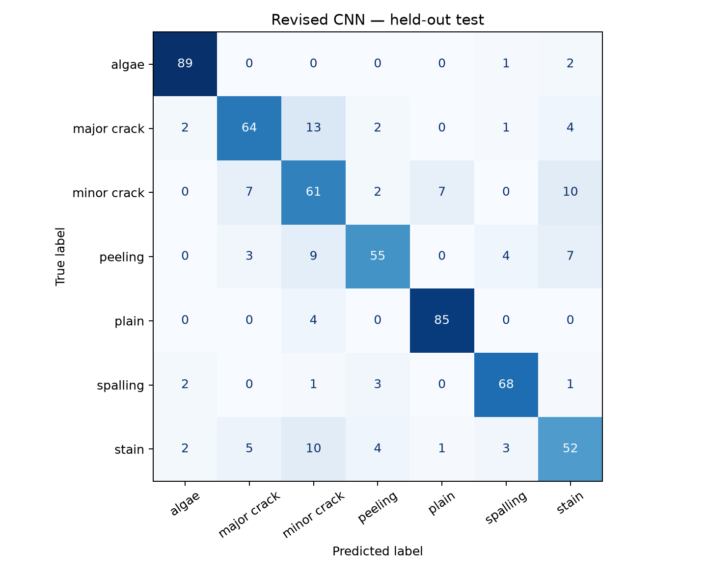
Figure 2 Test confusion matrix for the additional CNN trained from random initial weights.

CNN validation stability
My original CNN validation scores changed sharply between some epochs. I retrained the same architecture with the settings below, keeping the image split, seed 42, preprocessing, and training augmentation unchanged.
Setting | Original run | Revised run
Starting learning rate | 0.001 | 0.0005
Batch size | 32 | 64
Learning rate schedule | Constant | Cosine decay to 0.00001
Epoch budget | 30 | 40

I plotted raw validation accuracy and loss without smoothing. For each ten-epoch window, I averaged its nine absolute changes in accuracy. A smaller change in percentage points (pp) means less movement between neighbouring epochs.
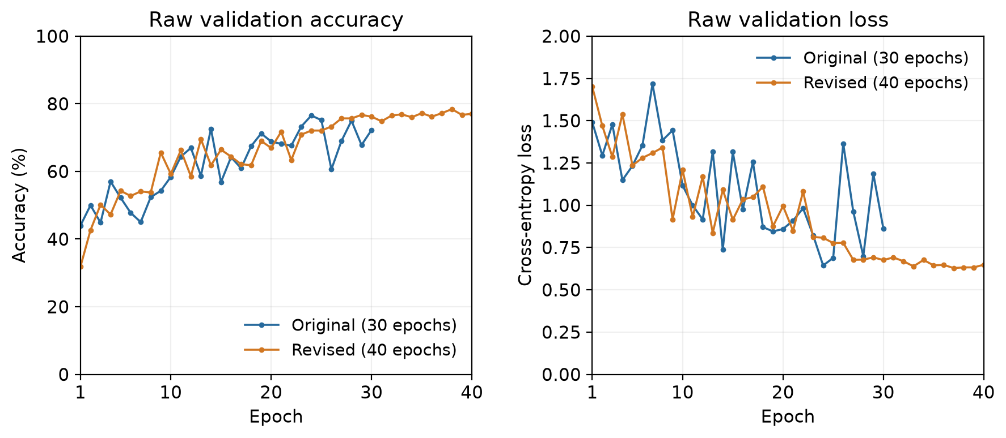
Figure 3 Raw validation results from the original and revised CNN runs without smoothing.

Changes between neighbouring epochs
Epoch window | Original run  Mean change in pp | Revised run  Mean change in pp
Matched epochs 21 to 30 | 5.708 | 2.473
Final ten epochs  Original 21 to 30; revised 31 to 40 | 5.708 | 1.046

Mean accuracy changes fell by 56.7% in the matched window and 81.7% in the final windows. Best validation macro F1 rose from 0.759 to 0.777. I chose the revised run using validation results before calculating its test metrics.
Training settings and the epoch budget changed together, so I cannot isolate one cause. Larger batches also changed the update count. These are single runs, and the fluctuation measure includes learning trends. A smoother curve alone does not establish better predictions.

Vision transformer trained from scratch
I also built a small vision transformer using the image-patch idea from Dosovitskiy et al. [6]. It divides an image into patches and uses attention to combine information between them. I used PyTorch TransformerEncoder [7] for a compact adaptation and trained every weight from scratch.
Part | Setting
Input and patches | 96 by 96 RGB; 64 patches of 12 by 12 pixels plus a class token
Transformer | 96-number embeddings; 3 blocks; 4 attention heads; 192-unit feedforward layers; dropout 0.1
Output and size | Layer normalisation and 7 class outputs; 273,127 trainable parameters
Training | AdamW at 0.001; weight decay 0.01; cosine decay; 50 epochs; batch size 32

I used the same 2,725 training and 584 validation images as the CNN. I normalised RGB values to minus 1 to 1 and used horizontal flips and rotations up to 10 degrees only during training. I selected epoch 40 by validation macro F1 (0.687; accuracy 69.3%) before evaluating the fixed 584 test images.
Model | Accuracy | Precision  macro | Recall  macro | F1  macro | Balanced  accuracy
CNN | 0.812 | 0.812 | 0.808 | 0.809 | 0.808
Small ViT | 0.711 | 0.707 | 0.706 | 0.705 | 0.706

The ViT classified 415 of 584 test images correctly, 10.10 percentage points below the CNN. Both neural models used one validation split; their training settings and epoch budgets differed. This is an additional comparison for this dataset, not a general claim that one architecture is better.
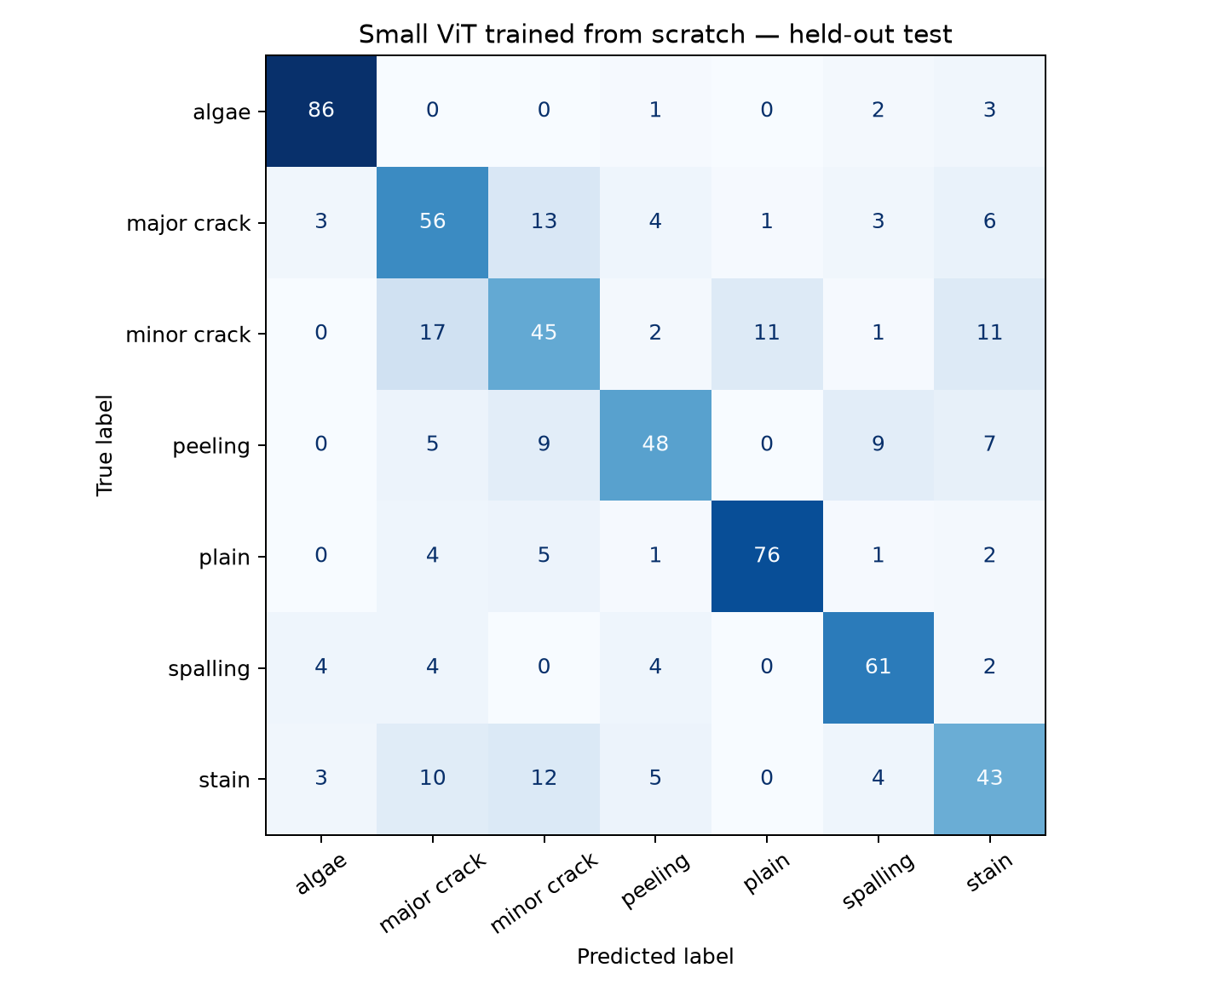
Figure 4 Test confusion matrix for the small vision transformer trained from scratch.

Website demonstration and conclusions
I made a local Streamlit website that lets a user select a saved model, upload an image, and view its predicted class. The app shows the selected model's measured test accuracy and a comparison table. That accuracy summarises the test set; it is not a confidence score for the individual upload. Images are processed by the Python app on the same machine and are not saved.

Running the demonstration
- Follow START_HERE.txt to install requirements.txt, then run python -m streamlit run app.py from the project folder.
- Open the local browser address, choose a model, and upload a JPG, PNG, or WebP image.
- Click Classify to see the label. Open Compare model results to inspect the measured scores.

Reproducing my workflow
The main notebook records feature preparation, the four-model comparison, five-fold results, and grid search. The CNN and ViT notebooks record the additional experiments. To rerun them, keep the models and results folders, point the dataset path to BD3_original_dataset, and run the cells in order. Saved models allow the website to run without training again.

Limitations
The test images were excluded from fitting and from the cross-validation searches, but the same split had been evaluated in earlier project versions. This is an internal comparison, not a new independent external test. Building and capture-session identifiers were unavailable, so similar scenes may remain across the subsets even after exact duplicates were removed.
Each image has one label, even if several conditions appear together. The classifiers always choose one of the known categories and can make mistakes on unrelated images. The demo classifies surface appearance; it does not measure damage or assess building safety.

Conclusion
I completed the model comparison, cross-validation, tuning, and upload demonstration. Test accuracy was 76.4% for the tuned random forest, 81.2% for the revised CNN, and 71.1% for the small ViT. Some surface conditions remained difficult to separate. I would next test these models on new photographs from different buildings.

References
1. BD3_original_dataset. Supplied local image dataset. Dataset counts, training outputs, and evaluation results come from my project run.
2. scikit-learn documentation — cross_validate
3. scikit-learn documentation — GridSearchCV
4. scikit-image documentation — HOG and local binary patterns
5. PyTorch tutorial — Training a Classifier
6. Dosovitskiy et al. — An Image is Worth 16x16 Words (2021)
7. PyTorch documentation — TransformerEncoder

