**Usecase: DHL**

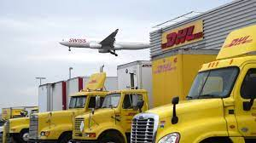

**The trend of Big Data Analytics refers to the analysis of large quantities of data to reveal patterns of the past, highlight real-time changes in the status quo, and create predictions and forecasts for the future. This trend involves various processing techniques of structured data, which consists of specific numbers and values that are searchable and stored in a predefined format, as well as unstructured data, which may come in various native formats like video and audio files from sensors and social media posts.**

The importance of data has generally been well understood for decades by those in the logistics industry. Without data and analytics, one cannot optimize or even have foresight to prepare for things to come. It is for these and other visibility reasons that logistics leaders have embraced sensors, dashboards, and other technologies to collect and display streams of information. As the use of data collecting devices increases, compounded with exponentially growing raw data found on social media and the internet overall, the rate of data coming in is far outstripping the rate of processing, with 463 quintillion (1018) bytes (or 463 billion GB) of data to be produced daily in 2025. To differentiate these massive accumulations of both structured and unstructured data from more traditional data that can be easily manipulated on a spreadsheet, experts have labelled the former as ‘big data.’

The processing and analysis of big data in real time using artificial intelligence (AI) algorithms and other technologies is itself an entire field of study, but we here at DHL see 4 main types of big data analytics that could be applied in use cases along and across entire supply chains: descriptive, diagnostic, predictive, and prescriptive analytics.

Descriptive analytics seeks to understand the existing situation and answer the question of what happened, while diagnostic analytics tries to investigate why something happened. Meanwhile, predictive analytics, as the name suggests, generates predictions and forecasts of what might happen in the future, and prescriptive analytics utilizes historical and situational data to recommend changes in what should be done.

The trend of Big Data Analytics has moderately high impact on logistics. While not directly transforming the look and feel of the supply chain physically, the greater visibility and optimized decision making that result from this trend can lead to strategic optimization along supply chain segments, substantially improving levels of service, from more efficient pallet storage in a facility to better customer case handling. In terms of realization, big data analytics is very much closer in the logistics industry than in other industries. Many, if not all, logistics leaders have harnessed big data in recent years to drive strategic decisions, and soon this trend will simply become the standard way of doing business and incorporated into logistics services.

#### Business leaders who work with big data say that ‘analysis,’ ‘processing,’ and ‘implementation of findings’ are the 3 most intimidating aspects of working with big data.

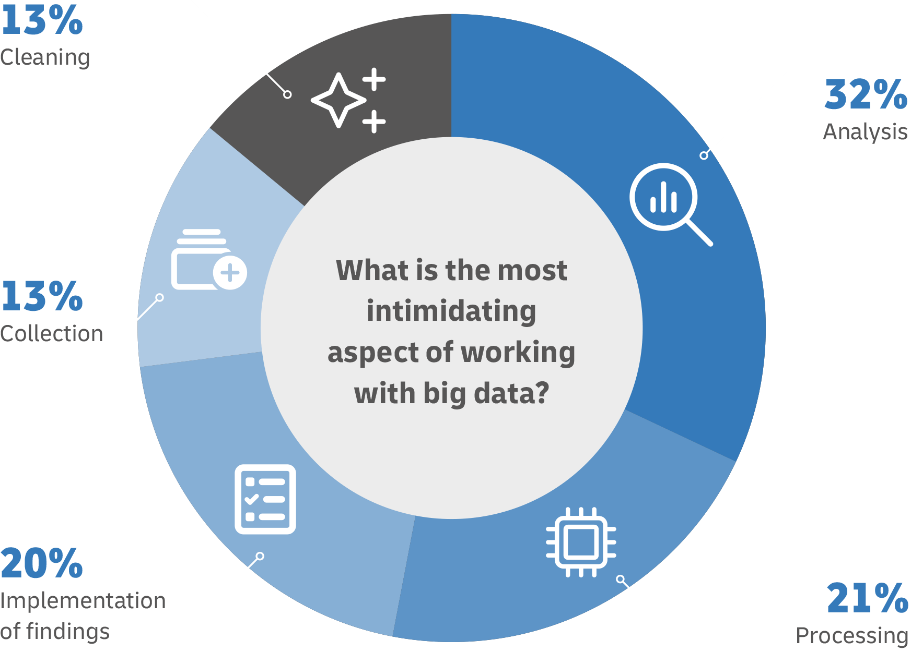

**Relevance to the Future of Logistics**

**1. Inventory & Asset Optimization**

One of the main opportunities of analyzing big data is providing logistics players with organized, filtered, and digestible real-time visibility of the current situation on the ground in facilities like warehouses and hubs.

On the descriptive end, the processing of big data from sensors can reveal where assets such as roller cages are located and what their current status is – for example, if they are currently being used or they are broken. Analysis of inventory data from sensors can help determine if stocks are running low or if any vacancies exist on pallet shelves. For diagnostic purposes, analyses may reveal how certain shipments cause a particular conveyor to frequently break down or can identify world or local events that have a dramatic effect on the inventory level of specific products.

Meanwhile, when it comes to prediction, the analysis of sensor data on assets like machinery and vehicles can support predictive maintenance procedures, flagging damaged assets that should be inspected and repaired before they break down. For inventory, forecasts can be made to project an expected pattern of incoming orders and deliveries during upcoming peak and low seasons. Finally, prescriptive analyses can compare inventory plans with actual adoption to better allocate inventory space to various stock keeping units (SKUs). DHL’s Applied Analytics team, for instance, performs studies for customers that can recommend changes based on identified patterns in the data, where inventory may have exceeded original demand forecasts, for example, or in which safety stock may have depleted below critical thresholds. For assets, historical data can be processed to suggest the best place to store tools and other equipment to limit the distance workers must travel to retrieve them.

In general, big data analytics can give logistics organizations the necessary visibility to optimize shipment storage and movement through facilities, as well as to improve the utility and lifetime of assets.

**2. Transport & Delivery Optimization**

The trend of Big Data Analytics offers various solutions to overcome challenges that logistics organizations often face in the transportation and delivery segments of the supply chain.

For descriptive analysis, big data processing can help monitor service levels on a particular route or lane, identifying disruptions like truck breakdowns in real time when they occur. Additionally, data from dozens to thousands of sensors gives visibility to supply chain organizations on whether products are being delivered in a high-quality state or are damaged along the way. With diagnostic analysis, companies can see why certain shipments are chronically late – this may be because the route schedule coincides with rush hour traffic or the shipment passes through understaffed ports of entry, for example.

For predictive purposes, various sources of data can help calculate the risk of lane disruption along segments of the supply chain. For instance, Everstream Analytics utilizes global news feeds and other propriety data to make predictions for its supply chain customers across 30 risk categories, including natural disasters and political violence. In doing so, it claims to reduce disruption-caused revenue losses by 30%, achieving 100 million USD in savings from transport-mode optimization. For prescriptive information, logistics leaders can look at past data and adjust scheduling and fleet sizes accordingly, ensuring vehicles are maximally utilized and products are delivered on time. Such analyses may show supply chain managers the wisdom of modifying routes and lanes where historical theft has occurred in a particular segment of the supply chain.

Overall, big data analytics can improve the performance of delivery, ensuring shipments are delivered in good condition and on time, in a cost-efficient manner.

**3. Supplier Risk & Due Diligence Assessment**

Auditing existing and potential partners, whether a robotics provider or a packaging supplier, as part of a risk-and-resilience due diligence evaluation can be tedious work. Leveraging big data analytics to drive decisions and even automate some evaluation processes can help logistics organizations save time, money, and risk.

On the descriptive end, data from sensors and other sources can be used to evaluate the timely delivery and quality of offerings by suppliers in real time. This, paired with diagnostic analysis, can help logistics leaders find patterns and understand the factors that make certain suppliers superior to others, informing organizations of variables and attributes to look for when evaluating partners in the future. For example, if the results of a diagnostic study finds suppliers from certain regions are chronically late with their shipments due to customs checks, this signals to inventory planners where the problem may lie.

Predictive information can help with vendor selection. Processing the various attributes and the supply chains of potential vendors can achieve automated forecasting of each vendor’s likelihood of meeting the logistics organization’s needs in certain emergency scenarios like natural disasters in a particular region. Finally, with prescriptive analysis of vendor past performance, the logistics company can receive a recommendation on contract renewal. Results from this type of analysis also help the organization to grade and classify existing and potential partners, facilitating strategic business decisions like pursuing a contract or purchase order.

In general, big data analytics can be a useful tool for logistics organizations when evaluating existing or potential partnerships with suppliers and vendors.

**4. Customer Management**

While big data analytics is often used to optimize core operations within a supply chain, it can also be used to improve the customer-facing functions of a logistics organization to improve the customer experience.

With descriptive analyses, B2B and B2C customers can be grouped by various categories with their associated attributes like industry, age, geographic region, order sizes, and needs. These categories can then be displayed in a visual manner like in a dashboard so logistics organizations can better understand the customer base and who may be affected by supply chain changes. Meanwhile, diagnostic analyses can help demystify the loss of customers or the preference for a particular offering, whether it is because price modifications, convenience factors, or other variables.

Prediction is also valuable for customer-facing use cases. Demand forecasting helps logistics organizations that frequently experience bottlenecks in the supply chain or underutilization of facilities and vehicle fleets. For instance, DHL’s Applied Analytics team uses machine learning models to help customers optimize capacity and transport planning based on historical data, reducing costs associated with booking resources at the last minute. Lastly, prescriptive analyses can take on several forms. Processing historical data can help logistics leaders calculate and determine price elasticity for their offerings, ensuring a better price point that lies within customer expectations. Supply chain organizations can also study past orders and throughput patterns through peak and low seasons to optimize current workforce size while guaranteeing high-quality service levels. Furthermore, processing consumer data from websites can enable more personalized customer journeys, increasing the chance of purchases and customer retention.

Overall, big data analytics can help logistics organizations improve the customer experience and the customer journey, strengthening brand loyalty.

แหล่งที่มา: [**https://www.dhl.com/global-en/home/insights-and-innovation/thought-leadership/trend-reports/big-data-analytics.html**](https://www.dhl.com/global-en/home/insights-and-innovation/thought-leadership/trend-reports/big-data-analytics.html)