**Продажи магазина напитков**

-- BEGINNER QUESTIONS --

**1) Наиболее покупаемые продукты (топ 10)**

SELECT

Product,

COUNT(*) AS Num_by_products

FROM beverage

GROUP BY Product

ORDER BY num_by_products DESC

LIMIT 10;

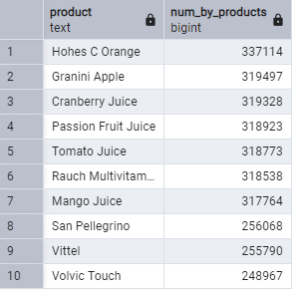

**2) Количество покупок по категориям**

SELECT

Category,

COUNT(*) AS Num_by_categories

FROM beverage

GROUP BY Category

ORDER BY num_by_categories DESC;

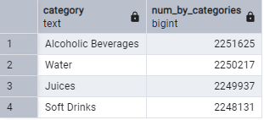

**3) Наибольшее количество заказов по регионам (топ 5)**

SELECT

Region,

COUNT(DISTINCT Order_ID) AS Num_by_regions

FROM beverage

GROUP BY Region

ORDER BY num_by_regions DESC

LIMIT 5;

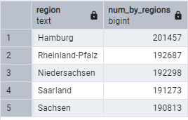

**4) Количество заказов по типам клиентов**

SELECT

Customer_Type,

COUNT(DISTINCT Order_ID) AS Num_of_customer_type

FROM beverage

GROUP BY Customer_Type;

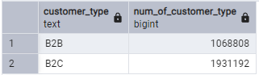

-- INTERMEDIATE QUESTIONS --

**1) Затраты и количество купленных товаров по регионам**

SELECT

Region,

COUNT(Quantity) AS Quantity,

ROUND(SUM(Total_Price::numeric), 2) AS Total_Price

FROM beverage

GROUP BY Region

ORDER BY Total_Price DESC;

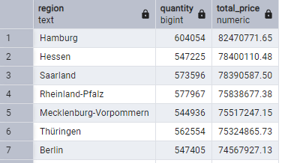

**2) Затраты и количество купленных товаров по категориям**

SELECT

Category,

COUNT(Quantity) AS Quantity,

ROUND(SUM(Total_Price::numeric), 2) AS Total_Price

FROM beverage

GROUP BY Category

ORDER BY Total_Price DESC;

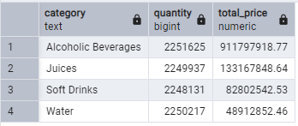

**3) Продажи по дате (по дням)**

SELECT

Order_Date,

ROUND(SUM(Total_Price::numeric), 2) AS Sales

FROM beverage

GROUP BY Order_Date

ORDER BY Order_Date;

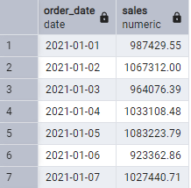

**4) Продажи по дате (по месяцам)**

SELECT DATE_PART('year', Order_Date) AS date_year,

DATE_PART('month', Order_Date) AS date_month,

ROUND(SUM(Total_Price::numeric), 2) AS Sales

FROM beverage

GROUP BY date_month, date_year

ORDER BY date_year, date_month;

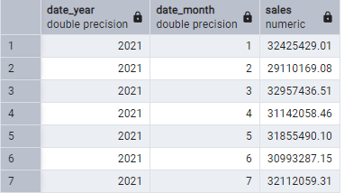

**5) Прибыль по дате (по годам)**

SELECT

DATE_PART('year', Order_Date) AS Sales_by_Year,

ROUND(SUM(Total_Price::numeric), 2) AS Sales

FROM beverage

GROUP BY Sales_by_Year

ORDER BY Sales_by_Year

LIMIT 10;

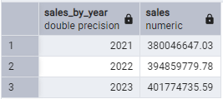

-- МЕТРИЧЕСКИЕ ПОКАЗАТЕЛИ --

**1) DAU: число покупателей в день (за последние полгода)**

WITH d AS(

SELECT

Order_Date,

COUNT(DISTINCT Customer_ID) AS cust_day

FROM beverage

WHERE Order_Date >= '2023-07-01'

GROUP BY Order_Date

)

SELECT

ROUND(AVG(cust_day)::numeric, 2) AS DAU

FROM d;

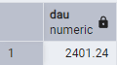

**2) WAU: число покупателей в неделю (за последние полгода)**

WITH w AS(

SELECT

DATE_PART('year', Order_Date) AS year_num,

DATE_PART('week', Order_Date) AS week_num,

COUNT(DISTINCT Customer_ID) AS cust_week

FROM beverage

WHERE Order_Date >= '2023-07-01'

GROUP BY year_num, week_num

)

SELECT

ROUND(AVG(cust_week)::numeric, 2) AS WAU

FROM w;

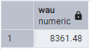

**3) MAU: число покупателей в месяц (за последние полгода)**

WITH m AS(

SELECT

DATE_PART('year', Order_Date) AS year_num,

DATE_PART('month', Order_Date) AS month_num,

COUNT(DISTINCT Customer_ID) AS cust_month

FROM beverage

WHERE Order_Date >= '2023-07-01'

GROUP BY year_num, month_num

)

SELECT

ROUND(AVG(cust_month)::numeric, 2) AS MAU

FROM m;

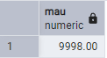

**4) Sticky_factor: степень лояльности и частота взаимодействия клиентов (за последние полгода)**

WITH d AS(

SELECT

Order_Date,

COUNT(DISTINCT Customer_ID) AS cust_day

FROM beverage

WHERE Order_Date >= '2023-07-01'

GROUP BY Order_Date

),

m AS(

SELECT

DATE_PART('year', Order_Date) AS year_num,

DATE_PART('month', Order_Date) AS month_num,

COUNT(DISTINCT Customer_ID) AS cust_month

FROM beverage

WHERE Order_Date >= '2023-07-01'

GROUP BY year_num, month_num

)

SELECT

ROUND(AVG(cust_day) / AVG(cust_month) * 100, 2) AS sticky_factor

FROM d, m;

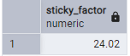

**5) Lifetime**

WITH f as( -- День первой покупки

SELECT DISTINCT Customer_ID,

Order_Date,

FIRST_VALUE(Order_Date) OVER (PARTITION BY Customer_ID ORDER BY Order_Date) AS First_Order

FROM beverage

WHERE Order_Date >= '2023-07-01'

ORDER BY Order_Date

),

df as ( -- Разница между датой текущей покупки и датой первой покупки

SELECT

Order_Date - First_Order AS diff,

COUNT(DISTINCT Customer_ID) AS count_cust

FROM f

GROUP BY diff

),

ret as( -- Доля оставшихся клиентов

SELECT

diff,

ROUND(count_cust * 1.0 / FIRST_VALUE(count_cust) OVER (ORDER BY diff), 4) AS retention

FROM df

)

SELECT

SUM(retention) AS lifetime

FROM ret;

