**Client Requirement Details**

Hi,

We need the contact details of all US boat dealers.

Here is the Job description:

Important:

* you have to search in ALL states in the USA: <http://state.1keydata.com/state-abbreviations.php>
* Extract all required data fields
* Search on URL for more email addresses (we need them for Ad Words and Social Media Targeting not for E-Mailing)
* Clean duplicates and merge data. Identify duplicates by phone number or website...
* Data to be scrapped from URL: http://www.yellowpages.com/search?search_terms=Boat+Dealers&geo_location_terms

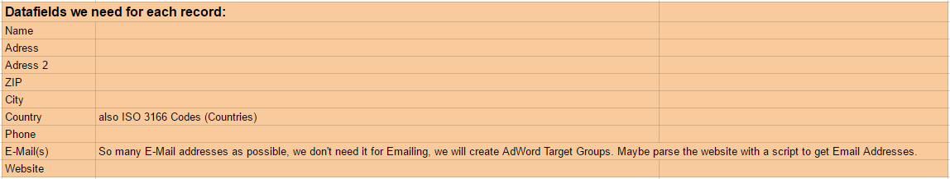

**Work flow followed for Scrapping the Data**

* URL: http://www.yellowpages.com/search?search_terms=Boat+Dealers&geo_location_terms
* Client required name, address, city, pin code, ph.no, website, email address of all 50 states in US.
* Packages Installed Selenium, Pandas
* Installed Chrome driver to open browser and to run the script
* Listed all States in list[] and using for loop appended it to URL
* Page numbers (page numbers are calculated by taking results of the page and by reviewing the page, I have come to know that each page consists of 30 records so did some mathematical calculation to bring the page number count) are also appended to URL.
* Listed the result in List (and where I used DICT inside it for representing the name and variable name as key and value respectively) and used pandas.
* Since Pandas beauty is it converts the keys as a title of respective column and values as its elements/values.

**Output**

