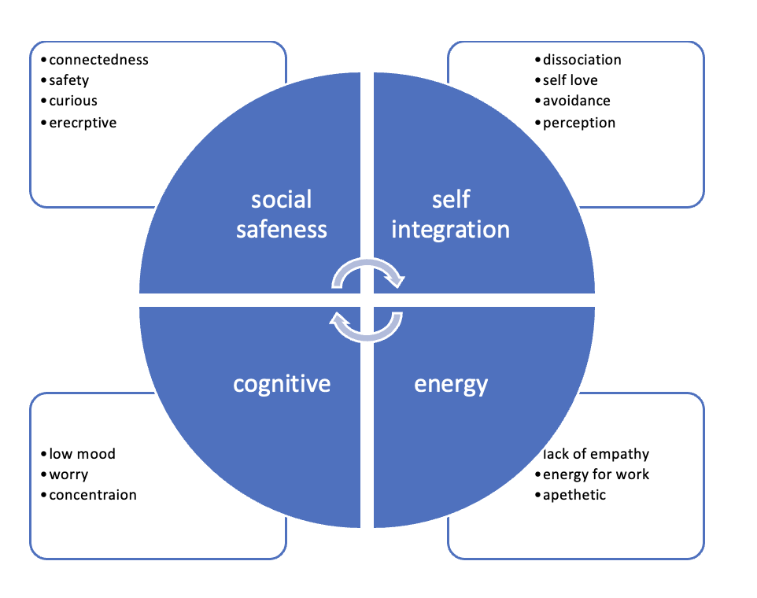
S2 Fig. The four overarching areas characterizing ‘wellbeing’.

