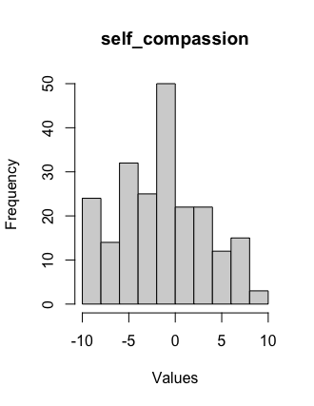
S1 Fig. Distribution of the values of the ‘self_compassion’ item.

