P_APP_183 : Secured WebShop

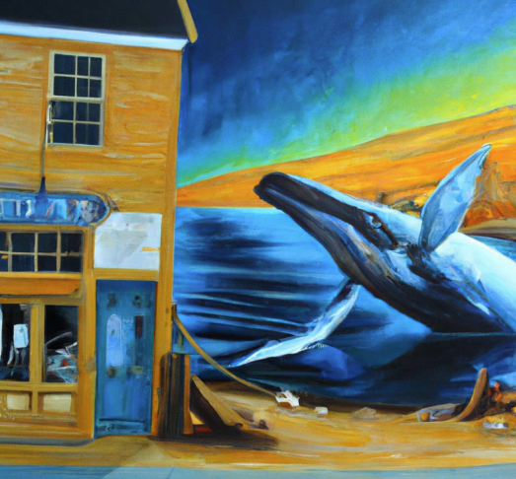

Créateur : Dario Chasi

Vennes

32 périodes

M.Sonney

Table

Analyse

MCD

MDP PrivateKey : etml

Sources :

[OpenSSL - CrypTool](https://www.cryptool.org/en/cto/openssl/)

[Form Data Validation in Node.js with express-validator (stackabuse.com)](https://stackabuse.com/form-data-validation-in-nodejs-with-express-validator/)

[Using express-validator for data validation in NodeJS | by Chau Nguyen | Medium](https://medium.com/@hcach90/using-express-validator-for-data-validation-in-nodejs-6946afd9d67e)

<https://www.cockroachlabs.com/docs/stable/create-security-certificates-openssl>