**4. Tensor decomposition with the STRIKE program**

**4.1 Overview of code development**

**2002 :** STRIKE code obtained from Alan Jones as a Fortran program. Application to multiple sites and handling implemented in Linux with shell scripts developed by Wolfgang Soyer. Results viewed in MATLAB with early version of **mj_pcolor.m**

Lack of convenient way to compare measured impedance tensor with the decomposed 2-D tensor.

**2006 : Decompview.m** developed by Ted Bertrand to allow the measured impedance tensor and the decomposed 2-D tensor to be compared. Old notes archived in previous versions of the documentation showed that this was quite complicated!

**2012 :** Decided to move all codes to run under Windows, with control and file handling using MATLAB. Initial version developed in MATLAB by Yaotian Yin (**EasyTensor2D.m**). This worked well but was written in high level MATLAB that was difficult to develop / modify.

**2013 :** Simpler MATLAB/Windows scripts developed by Dennis Rippe and called **run_strike.m** and based on the scripts originally run under Linux. Results plotted in much improved version of **mj_pcolor_v11.m** that was developed by Greg Nieuwenhuis.

Key issues included problems when all frequencies were not defined at each site. Also, when STRIKE fails, the strike angle is written as 0.0º and this needs to recognized and these values excluded from following data analysis (NaN).

Multi-site tensor decomposition implemented external to **STRIKE.exe** through the following approach. Implement multiple decompositions with the strike angle fixed at a range of angles [35º,40º,45º,50º,55º,60º,65º] . This can be done within **run_strike.m** or by running it multiple times. The overall r.m.s. misfit is calculated with **mj_pcolor.m**. A plot of r.m.s. misfit as a function of strike angle can be plotted e.g. Rippe at al., JGR, (2013).

**4.2 Background**

1. A number of early techniques were proposed to find the strike direction of the impedance tensor. These include the Swift angle and looking for the direction in which there is the largest difference between Φxy and Φyx
2. Tensor decomposition is a better way of doing this because it allows for the fact that the measured impedance tensor is often distorted by a frequency independent matrix. Tensor decomposition allows the strike angle to be computed statistically e.g. if multiple periods/stations are included in the calculation, then the best-fitting strike is found.
3. The tensor decomposition algorithm solves an inversion problem, finding the **distortion parameters** and **2-D impedance tensor** (Z2D) that give the best fit to the measured impedance tensor (Zmeas).

The tensor decomposition algorithm assumes that (1) the distortion is galvanic (i.e. it is only in the electric field) and (2) that the regional geoelectric structure is 2-D. If these assumptions are valid then the tensor decomposition will give a stable solution and a low r.m.s. misfit between the predicted impedance and the measured impedance tensor (Zmeas).

If these assumptions are not valid then a larger misfit can result. Often, tensor decomposition will show that the assumptions are valid in a subset of the measured data (i.e. only at certain sites and in selected period ranges).

1. Read the papers that describe the physical basis for tensor decomposition. The most popular implementation is that of Groom and Bailey (1989). This was extended to handle multiple sites and multiple periods by McNeice and Jones (2001) and this forms the basis of the STRIKE code.

An alternative parameterization was developed by Chave and Smith (1994).

1. The Fortran source code for STRIKE is available upon request from Alan Jones. You will need to sign a form that covers the conditions of use. Information can be found at: <http://homepages.dias.ie/~ajones/progs/strike/strike.html>
2. STRIKE is now run under Windows, using the MATLAB script **run_strike.m** that automates the processing of multiple files. These scripts were developed by Dennis Rippe, based on an earlier implementation in Linux developed by Wolfgang. **run_strike.m** and the Windows executable (strike.exe) are kept in the MT group MATLAB archive folder on Google Drive.
3. Compiling the STRIKE code under Fortran requires certain NAG libraries that are not always freely available. We have found that executables are quite portable between different computers and different versions of Linux / Windows. Note : Maybe some issues with Windows 8 in March 2015 - stay tuned for updates.
4. The input files for STRIKE are EDI files containing **impedance** data [Zxx(ω), Zyy (ω), Zxy,(ω) and Zyx(ω)]. STRIKE will not run if the EDI file contains spectra. STRIKE is quite tolerant of minor format variations. Importing EDI files into Winglink and then exporting should resolve format issues. Each EDI file should contain data from a single MT station. If you have multi-site EDI files, then split them up using the “Tools” in Winglink.
5. Certain codes used below require that the original EDI files have an **11 character** name e.g. ABC360RR365.edi
6. Results of STRIKE can be viewed with MATLAB codes, primarily **mj_pcolor_v11.m**, which are kept in the MT group MATLAB archive folder on Google Drive.

**4.3 Running strike under Windows - Setting up folders**

1. Input data (EDI files) in data folder

In the test example, this is *I:/......../4-MJ-decomp/example-field-data/ABC-S*

This is a set of test files from the ABC-S profile in the Canadian Cordillera

1. Control parameters defined in **strike_settings.m** which is in the data folder

If this file does not exist it will be created in the data folder

1. MATLAB scripts in *C:/....../matlab/run_strike*

Set MATLAB path to this folder.

Main code **run_strike.m** (latest version 29/08/2013)

Dependencies **set_strike_settings.m**, **dcmp2edi.m**

1. FORTRAN executables in folder *C:/....../matlab/run_strike/bin*

This location is a subfolder of the MT group MATLAB codes and is hard-wired. Containsstrike.exe which was compiled a few years ago.

Need to verify that it runs under Windows 8

**4.4. To run the tensor decomposition**

* + Navigate to folder above the data folder

In this case, this is *I:/......../4-MJ-decomp/example-field-data*

* + Run **run_strike.m**
  + You need to select the folder containing the EDI files
  + Control parameters are contained in **strike_settings.m**, which is generated by the function **set_strike_settings.m** if **strike_settings.m** does not exist.
  + **run_strike.m** generates the input file for strike.exe and executes bin/strike.exe

**strike_settings.m**

% Set level of screen output

verbose = 'n'; % Verbose (y/n)

% Set strike parameters

% Note: Multiple values are allowed for the variables errfloor, bwidth,

% minstrike and maxstrike, as the program will loop over these values.

errfloor = [3]; % Impedance relative error floor (in %)

minper = '0.01'; % Minimum period

maxper = '1000'; % Maximum period

bwidth = [5]; % Bandwith (no. of period decades)

ssite = 'y'; % Single site (y/n)

bounds = 'n'; % Change bounds from standard bounds? (y/n)

minstrike = [-360]; % Minimum strike

maxstrike = [360]; % Maximum strike

minshear = '-45'; % Minimum shear

maxshear = '45'; % Maximum shear

mintwist = '-60'; % Minimum twist

maxtwist = '60'; % Maximum twist

% For debugging purposes only

dispcfg = 'n'; % Display configuration files (y/n)

**run_strike.m** also then converts *.dcmp files to *dcmp.edi format with call to **dcmp2edi.m**

Typically need to run multiple decompositions, as summarized in the flow chart below.

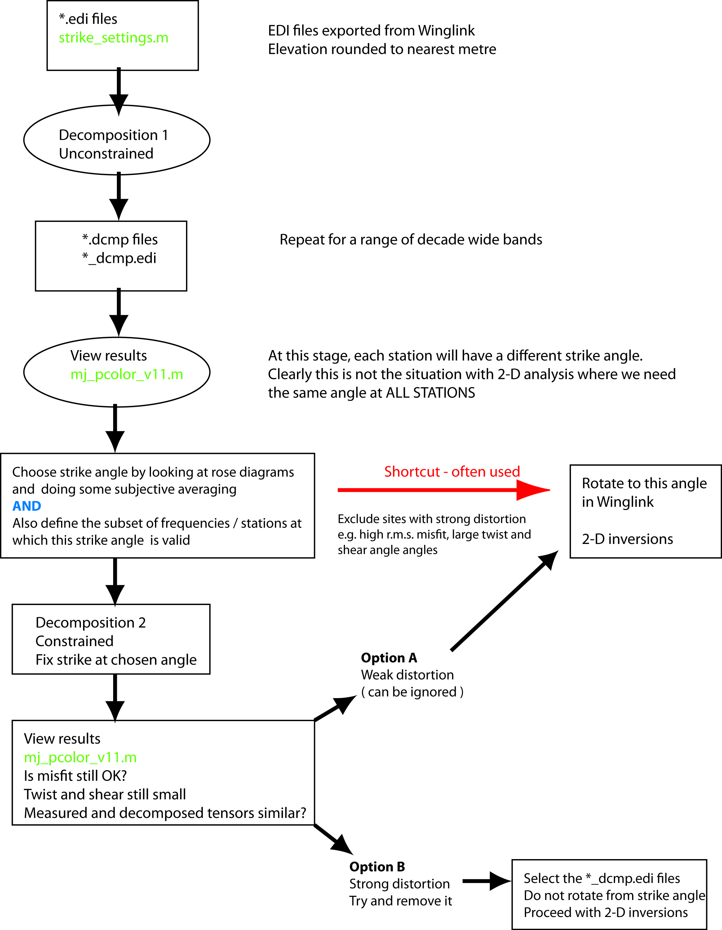

**Decomposition 1 – strike angle is free (unconstrained)**

In this decomposition, the strike, twist and shear angles are all free to vary. With the strategy used here, we calculate a single strike angle for each station that is constant for an entire decade of period.

You could do this for a single period, but by averaging over a decade, the result is more stable.

The strike angle sometimes (often) varies with signal period (depth in the Earth). Thus using an interval larger than a decade can include impedance data with a range of strikes.

Edit the values in **strike_settings.m** and run **run_strike.m** each time.

Output folders with the results will be automatically generated.

Suggested values to run are as follows.

**minper maxper pers folder name**

0.01 0.1 1 ATF-E-V5-EDIfiles-edit-0.01-0.1s_1_3ef

0.1 1 1 ATF-E-V5-EDIfiles-edit-0.1-1s_1_3ef

1 10 1 ATF-E-V5-EDIfiles-edit-1-10s_1_3ef

10 100 1 ATF-E-V5-EDIfiles-edit-10-100s_1_3ef

100 1000 1 ATF-E-V5-EDIfiles-edit-100-1000s_1_3ef

0.01 1000 5 ATF-E-V5-EDIfiles-edit-0.01-1000s_5_3ef

* + First 5 are for single decades, final one is for all data at once.
  + Can vary the error floor (ef) but the default value of 3% generally seems to work well.
  + All EDI files present in the input folder will be processed.
  + If a particular EDI file causes STRIKE to crash or pause then move this EDI file to a subfolder and repeat. Usually, the cause is noisy (low quality) data points.

**Look in the output folders**

For each station there should be

* A copy of the original EDI file (*.edi)
* DCMP file (*.dcmp). This contains the value of twist, shear and strike angle computed by the tensor decomposition. Also look at the r.m.s. misfit which is important because it tells you how well the decomposition is fitting the measured impedance data.
* J-format file (*.dat) that contains the regional 2-D impedance tensor (Z2D**) (NOT USED)**
* *_dcmp.edi file that is the estimate of the regional 2-D impedance tensor (Z2D**).** Note that this file has Zxx=Zyy=0 so be careful when rotating!

**View results of decomposition in MATLAB with mjpcolor_v11.m**

* + **Navigate in MATLAB to the folder containing the output files**
  + Run **mj_pcolor.m** (latest version is v11)
  + On first run, the sites plotted will be all of those with a *.dcmp file in the folder.
  + A text file with a station list is then output
  + On subsequent runs, this file can be used to define stations (after editing as needed)
  + On the first run, enter latitude and longitude limits for maps. This information is saved in a defaults file (*defaults.mjp*)
  + Also need to define **preferred strike direction** in the defaults file. This will control plots that require the horizontal distance along the MT profile (options = *pcolor* and *profile*). It will also over-ride the 90º ambiguity in strike (but not, of course, resolve it).
  + **mj_pcolor.m** will ask which periods to use. If you select all periods, then the angle will be averaged over all values.
  + It will also ask which sites to use. Select accordingly.

Many plotting options, but important ones to check are:

**rose > strike** : Will clearly show if there is a dominant strike direction, but can mask systematic variations in strike direction along the profile. Note that strike direction has an inherent 90° ambiguity, so the **red** and **blue** lines show both alternatives.

Note : red and blue **do not imply** xy and yx as described below.

**map > strike** : Shows strike in map view. Note that strike direction has an inherent 90° ambiguity, so the **red** and **blue** lines show both alternatives. Look for a consistent strike from station to station.

**pcolor > r.m.s. error** : Shows a pseudosection with period on vertical axis and distance on horizontal axis. This plot is useful for deciding which stations and period range are consistent with the assumptions made by tensor decomposition.

**profile > twist** : Shows values of the twist angle. Large values indicate strong distortion of the electric fields.

**profile > shear** : Shows values of the shear angle. Large values indicate strong distortion of the electric fields.

Recommended to make these figures for each period band and save a JPEG file.

Depending on extent of map, may need to change variable *strike_scale* which controls the length of red-blue lines on strike maps.

In more advanced option .... line color = r.m.s.; length = phase split (measure of how 2-D the data can be considered)

**Choose the strike angle (see this as a working hypothesis)**

Now it is time **to think** and decide what strike direction is consistent with your MT data.

The 90° ambiguity can usually be resolved by comparison with surface geology, or other geophysical data. Induction vectors can also be useful at this point.

Sometimes a single strike direction can be found for all stations and all period bands.

On other occasions it will be seen that a given strike direction is only valid for certain stations (sections of profile) or for certain period bands.

The STRIKE program can also be used to carry out a multi-station decomposition. This attempts to find a strike direction that is applicable to multiple stations and periods. This can be a good way to average the strike directions computed at individual stations.

You now have determined (1) a strike direction **and** have an idea (2) which stations / period bands are consistent with a 2-D regional structure at 90° to this strike direction.

However, in the unconstrained decomposition, each site has a different strike direction. This is clearly not supportive of a 2-D analysis, which would require a common angle for all stations.

**Decomposition 2 (strike angle is fixed)**

In decomposition 1, each site had a different strike direction. Looking at these strike directions (as rose diagrams) can give an impression of whether there is a strike direction that is valid for ALL sites.

A second decomposition is needed because a 2-D MT data analysis requires the same strike direction at every site and period.

The decomposition should be run for the entire period range that you wish to use for further analysis (i.e. the period range that you believe to be 2-D).

However, to do this quantitatively requires that we apply a **constrained decomposition**.

The **strike_settings.m** should now be edited in the regions highlighted.

% Set level of screen output

verbose = 'n'; % Verbose (y/n)

% Set strike parameters

% Note: Multiple values are allowed for the variables errfloor, bwidth,

% minstrike and maxstrike, as the program will loop over these values.

errfloor = [3]; % Impedance relative error floor (in %)

minper = '0.01'; % Minimum period

maxper = '1000'; % Maximum period

bwidth = [5]; % Bandwith (no. of period decades)

ssite = 'y'; % Single site (y/n)

bounds = 'y'; % Change bounds from standard bounds? (y/n)

minstrike = [55]; % Minimum strike

maxstrike = [55]; % Maximum strike

minshear = '-45'; % Minimum shear

maxshear = '45'; % Maximum shear

mintwist = '-60'; % Minimum twist

maxtwist = '60'; % Maximum twist

% For debugging purposes only

dispcfg = 'n'; % Display configuration files (y/n)

This fixes the strike direction at the specified value (55º in this example)

**Run decomposition**

Run the STRIKE program with **run_strike.m**. This will also generate the EDI files contain the undistorted regional impedance tensor (Z2D).

Compare before and after in mj_pcolor_v11.m (previously this used a cumbersome procedure - notes move to the Appendix at the end of this file.

**View results of decomposition 2**

Use **mj_pcolor.m** to view results. All stations have the same strike direction. Look at :

**pcolor > r.m.s. error** : Shows a pseudosection with period on vertical axis and distance on horizontal axis. May need to change the colour scale. Ideally the r.m.s. misfit is in the range 1-1.5 but this is not always the case.

**profile > twist/shear** : Shows values of the twist / shear angle. These may be different from those derived from the free decomposition.

**Decomp compare** : Shows apparent resistivity and phase of original data and after decomposition. Very useful option to see how much the impedance has been modified by the distortion. Note that the original data is rotated to the strike direction to make figures.

Two options are now available

(A) - distortion is weak and can be ignored

(B) - distortion is strong needs to be removed from the data

**Option A - distortion is weak and can be ignored**

* This option views tensor decomposition as **a test** of whether a 2-D analysis can be applied to the MT data.
* Stations with high r.m.s. misfit / large values of twist and shear angle should be excluded from further analysis.
* It also gives the best estimate of the strike direction. Can also consider that it allows you to identify which subset of your data can be considered 2-D.
* To proceed, select the MT data that is consistent with the calculated strike direction. Rotate the data in Winglink so that x is parallel to strike direction. This will allow you to choose **TE** **= xy** and **TM** **= yx**
* You can draw a profile at 90° to the strike direction in Winglink and project stations onto the profile. Note that your actual profile and the profile at 90° to strike may not be the same.

**Example** : In the figure below, an MT profile was deployed based on geological evidence that the strike was N70°E as shown in (a).

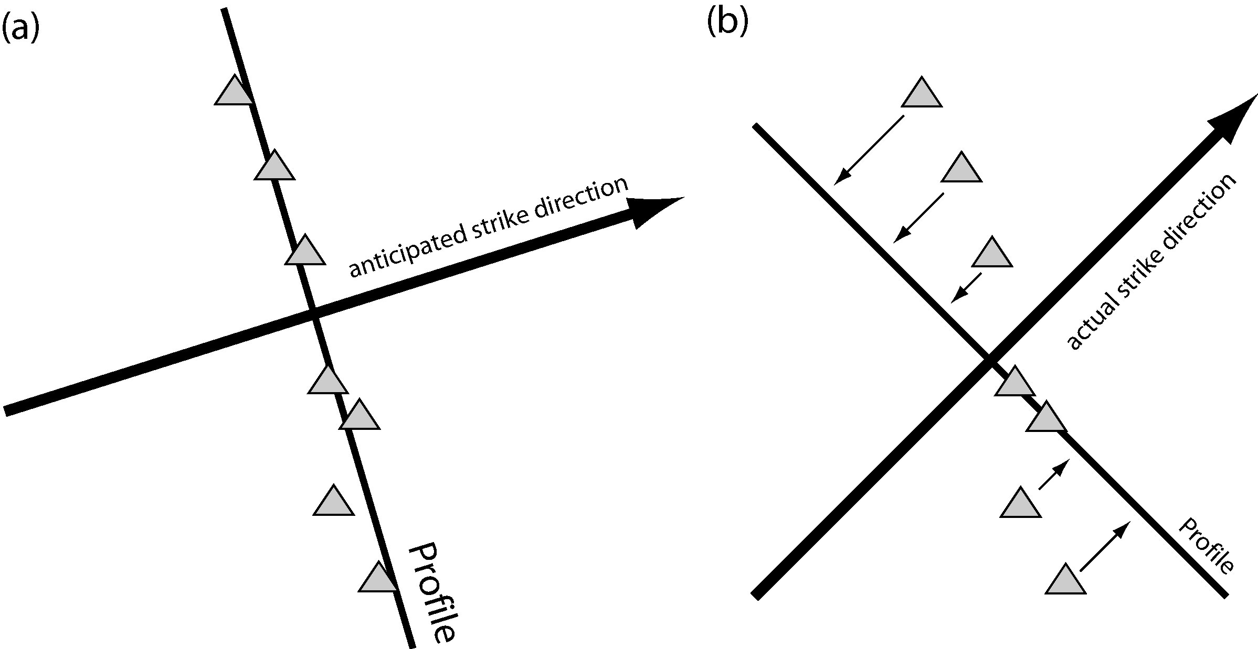

However careful tensor decomposition showed that the strike direction was actually N45°E. Thus a 2-D analysis requires that the stations are projected onto a profile that is orthogonal to the actual strike direction (b). The MT stations are then projected onto this profile. Note that this reduces the spacing between stations. The data should be rotated 45° so that the x-axis is parallel to the strike direction.

The apparent resistivity and phase data can now be used in a 2-D inversion.

**Option B - distortion needs to be removed from the data**

* This option takes things a stage further. It seeks to recover the undistorted regional impedance tensor (Z2D).
* Work with the *_dcmp.edi files
* Do not rotate these files
* The errors are not preserved so error floor will likely need to be used
* Vertical magnetic field transfer functions are not transferred to the *_dcmp.edi files. Need code to do this.

**NOTE**

(1) If the distortion is strong, it is not guaranteed that the original tensor can be reconstructed, especially in the presence of noise. e.g. in a narrow valley, there can be a thin strip of low resistivity material. This can polarize the electric field in one direction. Not possible to reconstruct two orthogonal electric fields.

Synthetic study of this will be very interesting. Stay tuned (or volunteer!)

(2) If the regional response is 3-D then the tensor decomposition method is not going to work. This includes both regional 3-D effects, and local effects such as current channelling that cause phase to go out of quadrant.

**4.5 Multi-site tensor decomposition**

Look for a single strike angle that fits all sites and all frequencies. Can be implemented within STRIKE, but calculation is slow and code often hangs up or crashes.

BETTER OPTION

Alternative approach implemented external to **STRIKE.exe** as follows.

Implement **multiple** **constrained** decompositions with the strike angle fixed at a range of values [35º,40º,45º,50º,55º,60º,65º] .

This can be done automatically within **run_strike.m** by defining variables min_strike and max_strike as vectors. Alternatively this can be done by executing **run_strike.m** multiple times.

For each angle, the overall r.m.s. misfit is calculated with **mj_pcolor.m**. To see the r.m.s. misfit value select pcolor > misfit and the r.m.s. misfit is plotted in the title.

A plot of r.m.s. misfit as a function of strike angle can be plotted. With good data a clear minimum can be seen e.g. Rippe at al., JGR, (2013). Noisy data does not often yield a clear minima.



**4.6 Common problems (please send more!)**

1. EDI files should have elevation rounded to nearest meter, or STRIKE will not run. Solutions :
   * + Manually edit the EDI file,
     + MATLAB script **edi_elev_fix.m** automatically fixes multiple EDI files.
     + Code from **edi_elev_fix.m** is pasted into **run_strike.m** (but currently commented out)
2. EDI files exported from Winglink must have the same rotation angle at all frequencies. Avoid the option to “*Rotate to Principal direction*” when importing or exporting EDI files with Winglink.
3. EDI files do not reuqire a rotation angle of 0 ° at a
4. Running the C-shell script. Check first line and compare with query “which csh” to check location of csh.
5. Convert EDI files to UNIX format with “dos2unix *”
6. Remove the output folder before running STRIKE again after a crash.
7. J2edi requires that the input file is 11 characters long.

**4.7 Synthetic test of STRIKE**

MATLAB script available to generate a single frequency EDI file.

Can then distort with specified twist and shear.

Folder = *699-A6-impedance-tensor\synthetic-distortion-DR-2008-Ass4-v1*

Could develop with a multi-frequency EDI file for a 2-D structure in Winglink.

Could also use a 3-D forward modelling to generate data.

WE WILL DEVELOP THIS FURTHER IN PHYS699

**4.8 LINUX notes - now redundant since 2013 with move to MATLAB-Windows**

* Can be found in *old-notes\4-Tensor-decomp-Strike-v2-2011.docx*