Q1.

I got everyone of these at ease!!!

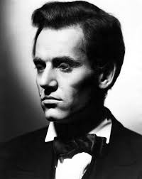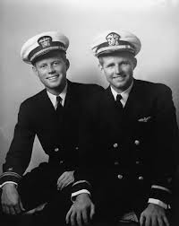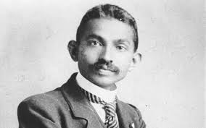

But the truth resides where the modern makers of mine reunite.

Ans: Montreuil, France

Q2.

This



Is my life and this is my death. My name is the game.

Ans. Paul William Walker IV

Level 1

Q3.

Dar ke aaghe jeet hai !!

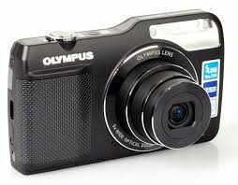 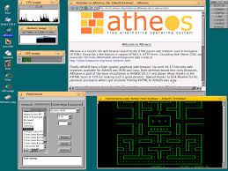

I lie in between and yield powers to the sea.

Ans: Trident, Poseidon’s Trident.

Level 6

Q 4.What, where did you say??

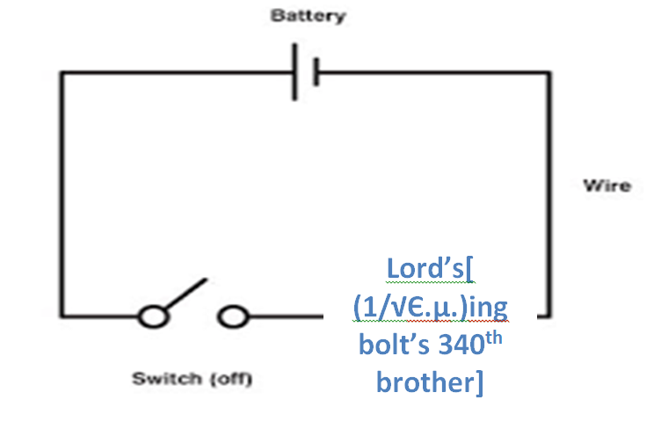

Ans: Coomera QLD, Australia.

# Q5.

So that they may witness all the benefits in store for them, and offer during the known, appointed days the sacrificial cattle that He has provided for them by pronouncing God's Name over them. Eat and feed the distressed.

Praise the LORD! with all my heart I will thank the LORD in the assembly of his people

And

All living bodies subsist on food grains, which are produced from rains. Rains are produced by performance of yagna , and yagna is born of prescribed duties.

The one who understands GOD gets the gold !!!

Ans: Goods of Desire.

Q.6.

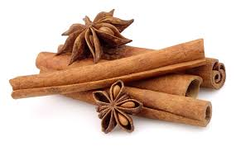 I love my lappy.

Ans: Linux Mint.

Q.7.