1. bhara and raghav an ips officer met at iit patna. they wanted to become enterprenours so they started company of electrical appliances. (change)

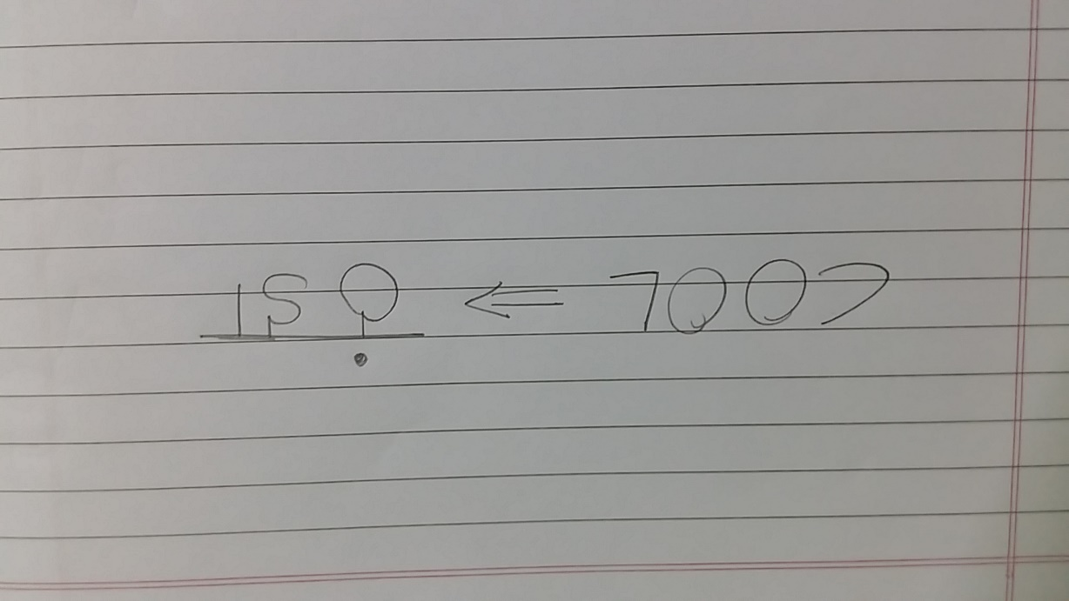

they put up their first factory in india in which city???

ans==>kolkata

2.what red bull says, i was working on that and found that it was litrally false. but i tried to make it true and done it few years back. my name will be written in history as well as in the answer space. (wrong) 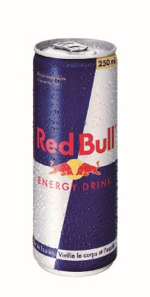

ans🡺 yves rossy

3. i m an



and i have won 13 times world championship by kicking of my opponents on my back, even we don't have that no of icc world cups in our history. (lvl 2, lvl3)

Ans🡺 angel nieto

4. 37 % of worlds population die heartdly love football, on the other hand there is one game of which the whole tournament was seen by only one person. and then the game lost from international sports. but u should recall the game or u will not get any points for reading this story.

Ans🡺croquet (lvl4)

5.

 

name the hidden



Ans🡺 astriod (wrong)

6. IMEI question lvl 4.