**Coding Academy by Orange**

**Sewing House website**

**By**

**Dareen Alhiasat**

**Table of Contents**

|  |  |
| --- | --- |
| Title | Page |
| acknowledgement | **I** |
| Abstract | **II** |
| Chapter ONE: INTRODUCTION and Background | **1** |
| 1.1 Background | 2 |
| 1.2 Objective | 3 |
| 1.3 Research Methodology | 7 |
| Chapter Two: Requirements and Analysis | **13** |
| 2. Requirements and Analysis | 14 |
| 2.1. Functional Requirements | 14 |
| 2.1.1 User | 17 |
| 2.1.2 Admin | 17 |
| 2.2 Non-Functional Requirements | 17 |
| 2.2.1 Security |  |
| 2.3 Test Case |  |
| Chapter three: System Design and Methodology | **25** |
| 3. Methodology | 26 |
| 3.1 Technologies and tools | 26 |
| 3.2 Methodology Process | 27 |
| 3.3 Some Website pages |  |
| Chapter four: Conclusion & Future work | **25** |
| 4. Conclusion & Future work | 26 |
| 4.1 Conclusion | 26 |
| 4.2 Future work | 27 |

**Acknowledgement**

‏ First and foremost , we thank Allah who enabled us and gave us the courage to achieve this work. After that, we would like to thank our supervisors, MR. Mohammed Frehat, coach Hala Obiedat, coach Rawan and coach Esraa for their assistance, support, guidance and wide knowledge throughout our project. I would like to express our profound gratitude to the members of the Committee for spending their valuable time reading draft.

**Abstract**

This web application is considered important to the people who will use it as it will save time and effort for both who wants to find a good trusted Taylor for their fabric.

**Chapter One**

**Introduction and Background**

* 1. **Background**

Nowadays, the internet has become one of the main requirements every person needs and that is why online platforms or communication sites have become so important to present a person, his accomplishments, works and even interests.

The idea of my project to combines Taylors with users based on the data provided by the user. In addition, it offers suggestions for Taylor stores and their locations.

* 1. **Objective**

The main objectives of the project are:

* Reduce search time.
* Improve commination between client, Taylors and store owners.
* Enable clients to obtain the service at any time.
* to translate the client's ideas and the professional holistic vision in a space combining aesthetics, comfort and practicality.
  1. **Research Methodology**

The data has been collected and analyzed, then attempted the design for the system after that the implementation and evaluation has been done.

**Chapter Two**

**Requirements and Analysis**

**2.1 FUNCTIONAL Requirements**

**2.1.1 User**

* Home page.
* Register and Login.
* User can view Taylors profile.
* User can view Taylors places and recommendation location.
* User can make appointment to take a service.

**2.1.2 Admin**

* Dashboard.
* Login.
* Admin can view, add and delete Taylors.
* Admin can view, add and delete users.
* Admin can view, confirm and reject the appointments.
* Admin can view and delete comments.

**2.1.3 Taylors**

* Home page.
* Register ang login.
* View their works.
* Take appointment.

**2.2 Non-Functional Requirements**

* Ease of use: The website is user-friendly, simple, and responsive.

**2.2.1 security**

* SQL injection attacks

* User login authentication system

**Chapter Three**

**System Design and Methodology**

* 1. **Technologies and tools**
* **Front-end (HTML, CSS, Bootstrap, Java Script):**

front end development is that the tools and techniques used to create the front end of a website change constantly and so the developer needs to constantly be aware of how the field is developing.



* **Back-end**

* **PHP (Laravel framework):**

Laravel is primarily used for building custom web apps using PHP. It’s a web framework that handles many things that are annoying to build yourself, such as routing, templating HTML, and authentication. Laravel is entirely server-side, due to running on PHP, and focuses heavily on data manipulation and sticking to a Model-View-Controller design.



* **PHP my admin (MySQL):**

MySQL is an open-source SQL relational database management system that’s developed and supported by Oracle. MySQL is just one popular system that can store and manage that data for you.



* **Tools:**
* **VS code:**

Visual Studio Code is a code editor in layman’s terms. Visual Studio Code is “a free-editor that helps the programmer write code, helps in debugging and corrects the code using the intel sense method”. In normal terms, it facilitates users to write the code in an easy manner.



* **XAMPP control panel**:
* is simply a local host or server.
* This local server runs on your personal computer, whether it’s a desktop or a laptop.
* It is used to test clients or websites before publishing them to a remote web server.
* **Figma:**

To draw the wireframe and mockup.



* **Trello:**

a collaboration tool that organizes your projects into boards.



**3.2 Methodology Process**

Sewing house Website has been developed based on the Scrum framework. It has been generated based on 4 sprints, where a sprint is the basic unit of work for a Scrum team. This is the main feature that marks the difference between Scrum and other models for agile development

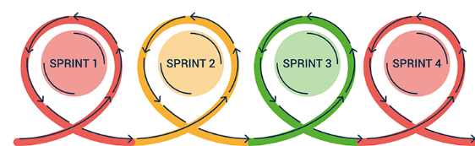

* Sprint 1: Front End for Website and dashboard
* Sprint 2: Back End for website
* Sprint 3: Back End for dashboard
* Sprint 4: Documentation and presentation
  1. **Some website pages**

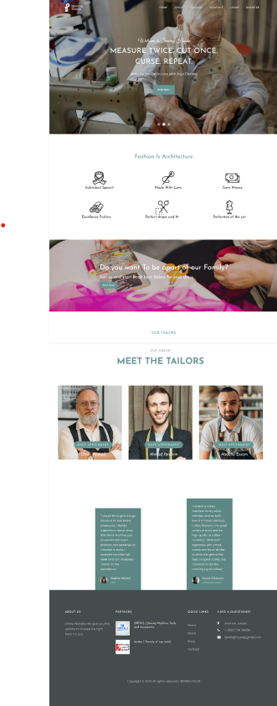

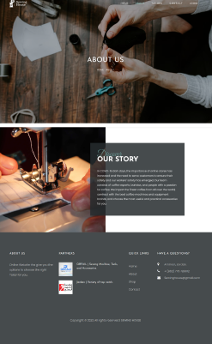

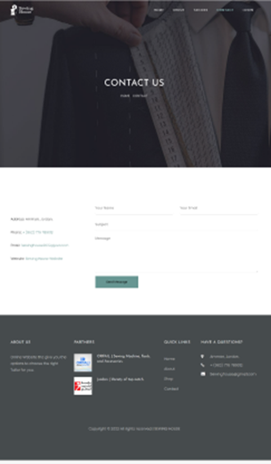

**Chapter four**

**Conclusion & Future work**

**4.1 Conclusion**

We are Taylors who help you to sewing design your style and we recommend TAYLOR stores near you.

**4.2 Future Work**

* The possibility of choosing the language of the site.
* Tafseel service.
* City category.
* Online Payment.
* User can Rate.