Snakeboard Engine — Project Update
Base Model, Stability & Analysis — Technical Summary for Supervisor Review

1. Executive Summary
This update covers the core snakeboard dynamics and control engine. The project simulates a two-wheeled, nonholonomic snakeboard with an actuated rotor, supporting two mechanism variants (JINT and RAS) and eleven feedback controllers. Beyond any single feature, the engine provides rollout simulation, behavior metrics, parameter sweeps, Poincare section analysis, finite-time Lyapunov exponent computation, and trajectory/phase-portrait visualization. This document summarizes the implemented capabilities, current results, and the gap between what is built and the planned non-smooth stability / bifurcation roadmap.
Scope: engine/ package only. The suite/ directory (backend + web) is excluded.

2. Engine Architecture
Package | Key Files | Role
cli | base.py, sweep.py, jint.py, ras.py | Command-line entry points: single rollout, sweeps, model-specific runners
control | base.py, pd.py, advanced.py, factory.py, optimizer.py | 11 controllers + GaitOptimizer (Nelder-Mead)
core | constants.py, params.py | Physical constants and Params dataclass (jint_params, ras_params)
dynamics | constraints.py, jacobian.py, lyapunov.py, poincare.py | Constraint handling, Lyapunov exponents, Poincare sections
models | base.py, jint.py, ras.py | 32-state KKT snakeboard core; JRobot and RRobot plant wrappers
sim | metrics.py, plant.py, sweep.py | Rollout integration, 34-metric characterization, cartesian sweeps
viz | plots.py, sweep.py | Overview/phase-portrait plots and sweep heatmap/trajectory figures

3. Base Snakeboard Model
The core is a 32-state KKT (Karush-Kuhn-Tucker) snakeboard formulation implemented in packages/models/base.py, with concrete variants JRobot (packages/models/jint.py) and RRobot (packages/models/ras.py). Plant wrapping and integration live in packages/sim/plant.py via model_plant().
- Two mechanism variants: JINT (higher mass/inertia, torque-limited) and RAS (lighter, stiff contact springs, no torque limiter).
- Shared physical parameters: board mass ~4 kg (JINT) / 3.2 kg (RAS), rotor inertia, wheelbase, gear ratios, damping, stopper limits, spring stiffness.
- State dimension: 32 states covering board pose (x, y, yaw), wheel angles, rotor angle, and associated velocities plus constraint/support states.
- Integration: rollouts simulate the full nonlinear dynamics with a selected controller over a duration at a chosen simulation frequency (default 500 Hz).
Model defaults (JINT vs RAS):
Parameter | JINT | RAS
Mass (Mtot) | 4.0 kg | 3.2 kg
Board yaw inertia (I0) | 0.08 | 0.02
Rotor inertia (I3) | 0.05 | 0.015
Wheelbase (L1, L2) | 0.10 m | 0.15 m
Gear ratio (g1, g2) | 1.0, -1.0 | 2.0, -2.0
Stopper limit (O0_lim) | pi/4 | pi/12
Spring stiffness (Ks) | 5.0 | 500.0
Torque limit (Tlim_max) | 0.10 | none

4. Controllers
Eleven feedback controllers are registered in packages/control/factory.py and selectable via the --controller CLI flag.
Controller | Key | Type
Proportional-Derivative | pd | Baseline feedback
Proportional-Integral-Derivative | pid | Baseline feedback
Feedback Linearization | fl | Model-based
Sliding Mode Control | smc / sliding_mode | Robust (smoothed tanh)
Linear Quadratic Regulator | lqr | Optimal
Linear Quadratic Gaussian | lqg | Optimal + observer
Model Reference Adaptive Control | mrac | Adaptive
Energy Shaping | energy | Passivity-based
Flatness-based Control | flatness | Differentially flat

5. Rollout Metrics & Characterization
Every rollout is post-processed by characterize_rows() in packages/sim/metrics.py over a steady-state window (default: second half of the trajectory). It produces a 34-column metric set:
Metric Group | Metrics
Motion | distance, x_displacement, y_displacement, path_length, straightness, speed, mean_speed
Orientation | turn, final_yaw
Effort | energy, mean_abs_tau, max_abs_tau
Contact | sat_frac (fraction of time at stopper limit)
Tracking | tracking_rmse, tracking_max_error
Validity | finite, behavior (translating / turning / stationary / mixed / unstable)

6. Generated Figures
The engine saves overview plots (trajectory, rotor tracking, phase portrait) and Lyapunov spectra as PNGs at 200 dpi. Representative figures from executed runs are shown below.
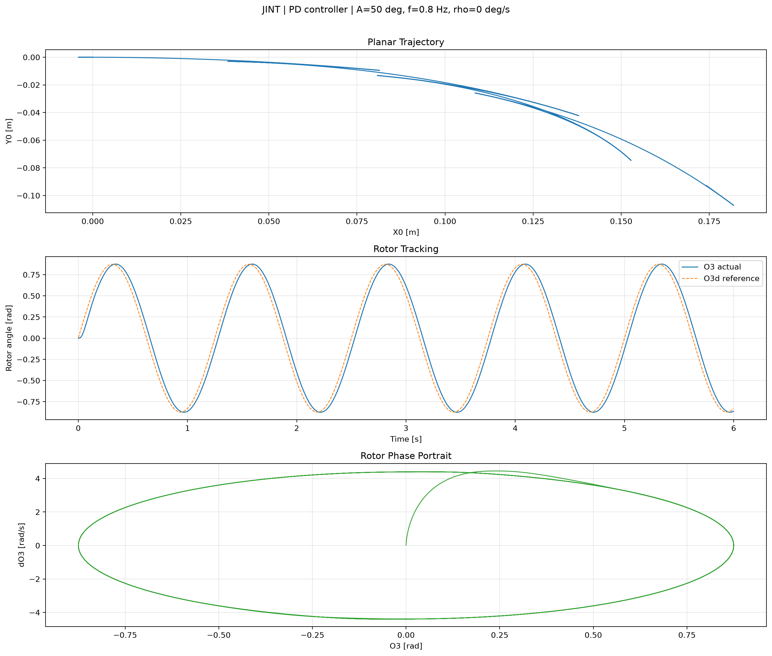
Figure 1. JINT overview plot: planar trajectory (top), rotor tracking vs. reference (middle), rotor phase portrait (bottom). Default gait A=50 deg, f=0.8 Hz, rho=0, PD controller, 6 s rollout.
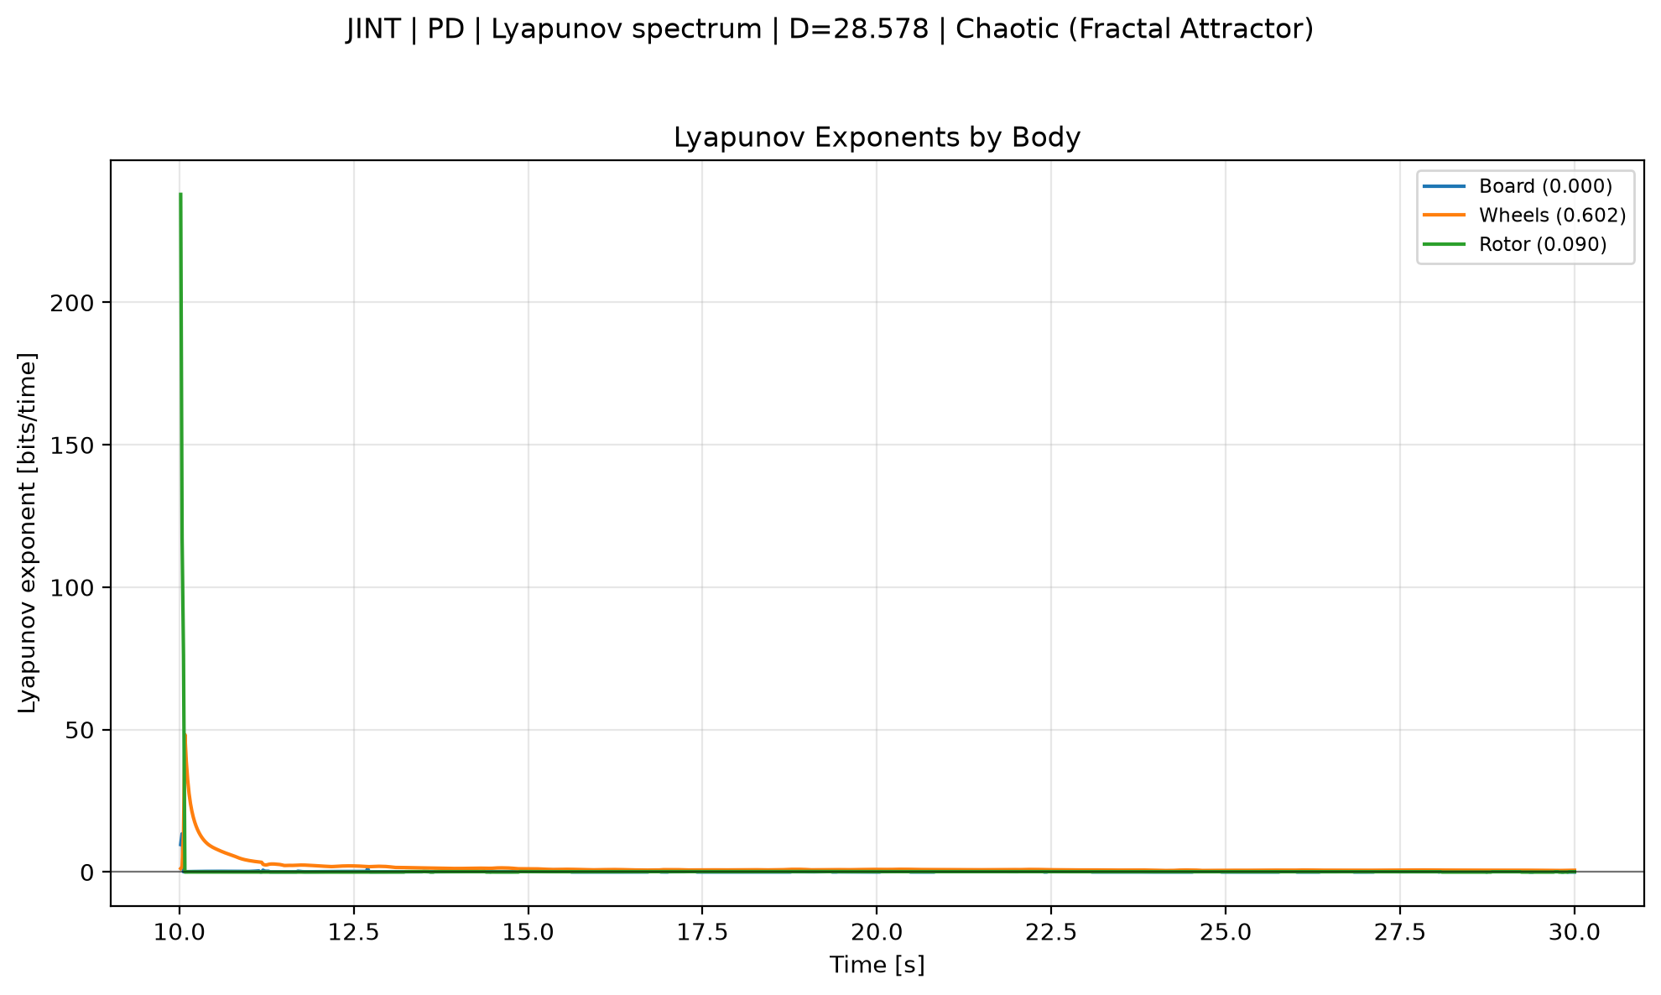
Figure 2. JINT Lyapunov exponent spectrum with dimension and classification. Same default rollout as Figure 1.
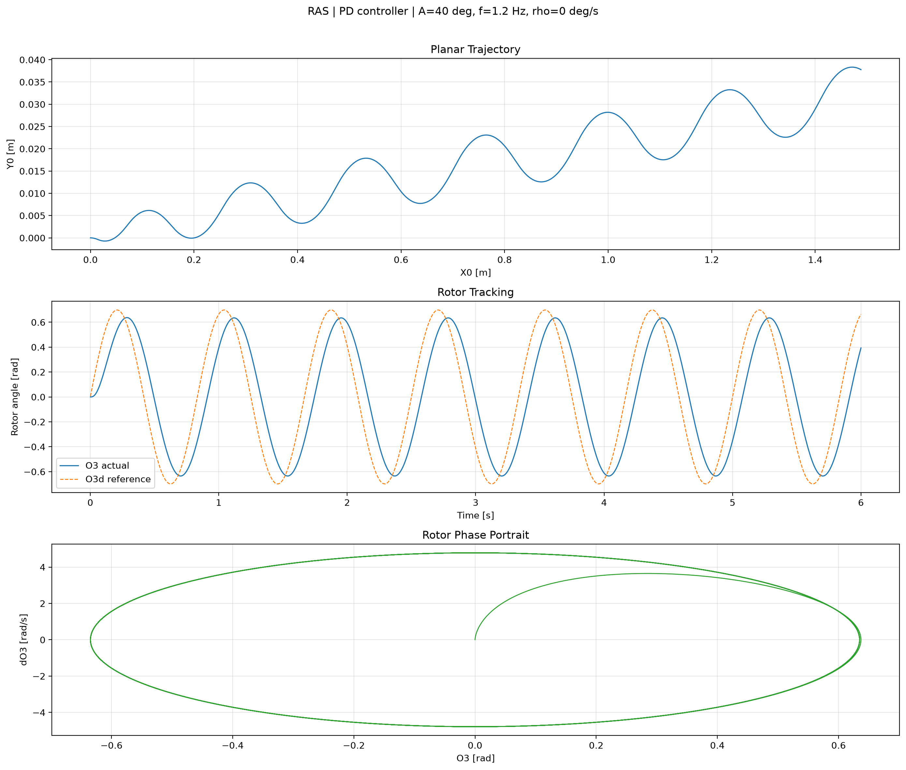
Figure 3. RAS overview plot. Default RAS gait A=40 deg, f=1.2 Hz, rho=0, PD controller, 6 s rollout. RAS uses stiff contact springs (Ks=500) and no torque limiter.
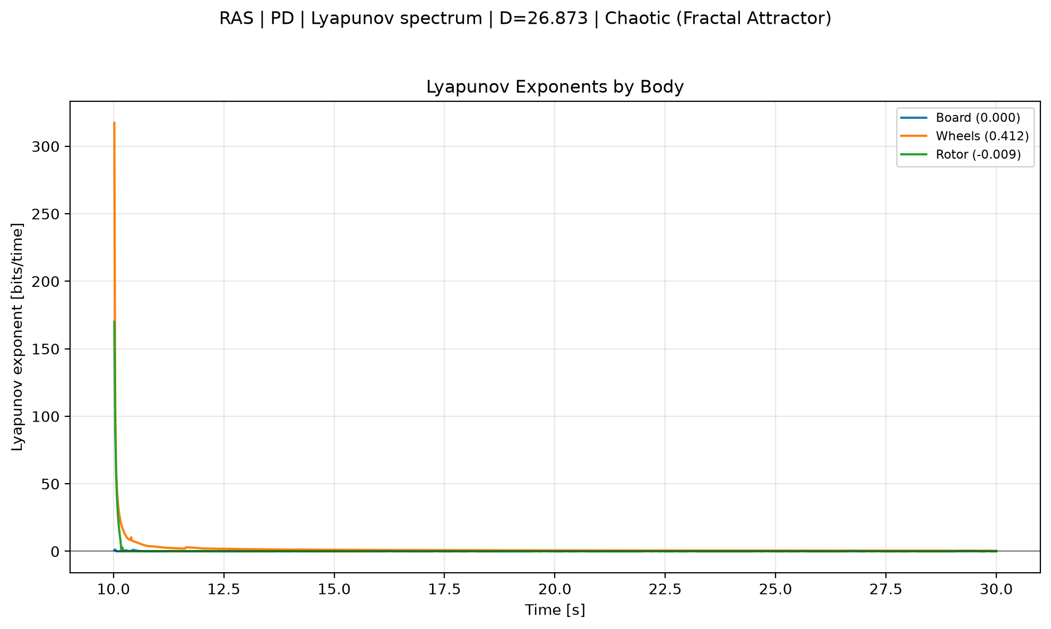
Figure 4. RAS Lyapunov exponent spectrum. Same default RAS rollout as Figure 3.
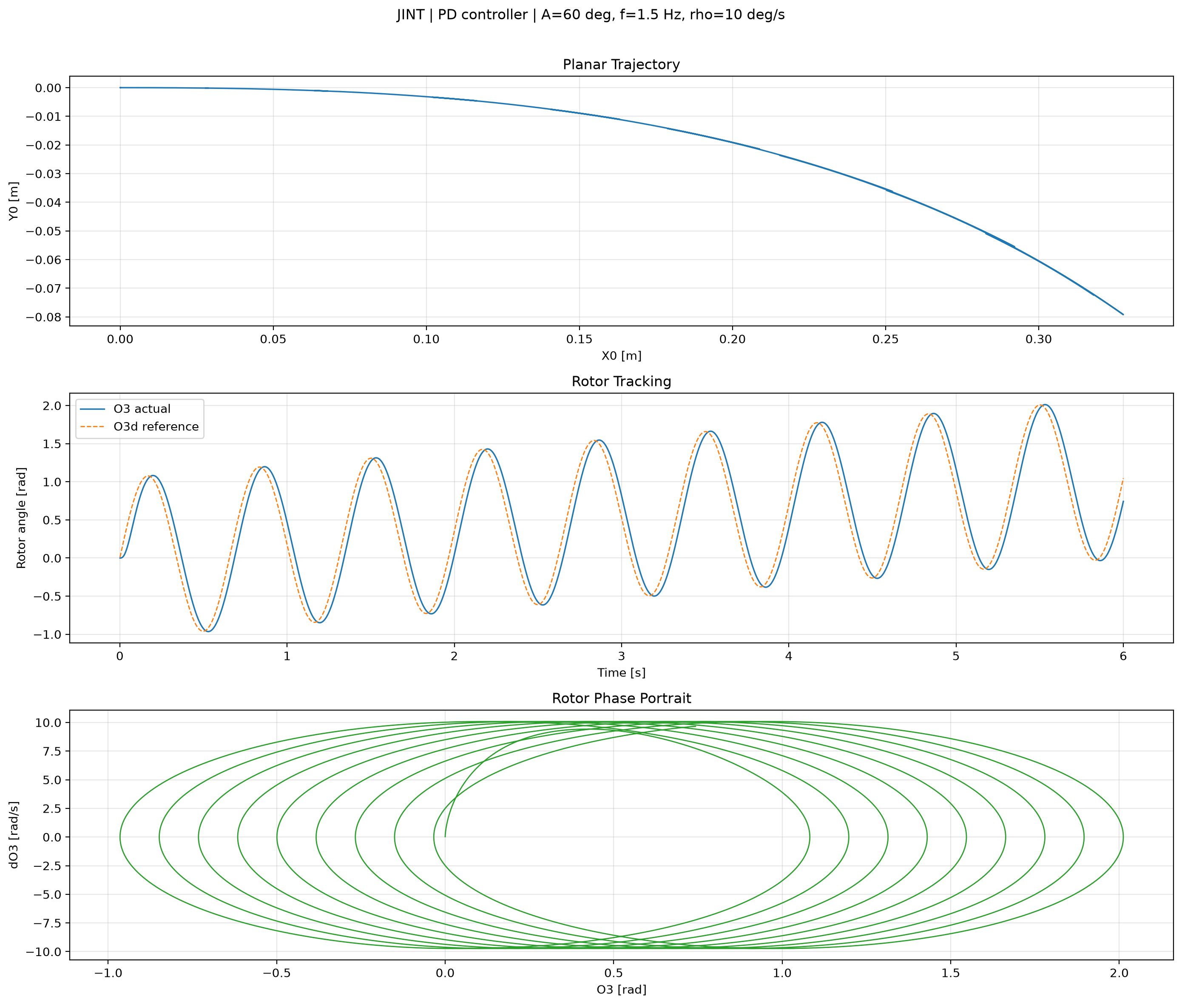
Figure 5. JINT overview plot with an overridden gait (A=60 deg, f=1.5 Hz, rho=10 deg/s). Demonstrates that custom gait parameters propagate into cache keys, titles, and figures.

7. Poincare Section Analysis
Implemented in packages/dynamics/poincare.py and exposed via the --poincare CLI flag. The analysis builds a robot from the current parameters, integrates from the zero state, and finds crossings of a defined section in state space.
- Scalar radius return map: extracts a 1D return map from Poincare crossings for periodic-orbit characterization.
- Fixed point detection: reports the Poincare fixed point value and crossing count.
- Configurable section angle (--poincare-theta), duration, and transient discard.
- Plots saved alongside rollout figures (e.g., *_poincare.png).
Status: implemented and functional for the scalar return map. Full-state Poincare map (P: Sigma -> Sigma) and Floquet multipliers are planned but not yet built.

8. Lyapunov Exponent Analysis
Implemented in packages/dynamics/lyapunov.py and exposed via the --lyapunov CLI flag. Computes the finite-time Lyapunov exponent spectrum from the variational equations along a trajectory.
- Spectrum output: one exponent per body/component, reported in bits/time.
- Derived diagnostics: Lyapunov dimension and classification (periodic / quasi-periodic / chaotic / unstable).
- Configurable integration step (--lyapunov-dt), duration, transient, and finite-difference epsilon.
- Plots saved as *_lyapunov.png (see Figures 2 and 4).
Status: implemented as a smooth finite-time algorithm. The planned rewrite calls for event-aware tangent integration with saltation matrices at switching events, which is not yet built.

9. Bifurcation & Non-Smooth Stability (Roadmap)
docs/NONSMOOTH_STABILITY_TODO.md outlines a roadmap for non-smooth analytical modeling and bifurcation characterization. These items are planned and not yet implemented.
Planned Item | Status
Event/saltation-aware tangent integration (hybrid_flow, hybrid_simulate) | Not implemented
Full-state Poincare map P: Sigma -> Sigma and Floquet multipliers | Not implemented
Bifurcation continuation (pseudo-arclength) and discontinuity-induced bifurcation detection | Not implemented
Controller state augmentation for PID / LQG / MRAC | Not implemented
Saltation matrix computation at switching events | Not implemented
Region-aware Jacobian linearization (implicit / central / complex-step) | Not implemented
Event-aware Lyapunov rewrite (segmented integration, saltation at events) | Not implemented
CLI stability module (--mode lyapunov|floquet|bifurcation) | Not implemented
Bifurcation diagrams and codimension-1 boundaries in parameter space | Not implemented
Acceptance / regression tests for event detection and Floquet verification | Not implemented
Key constraints from the roadmap: do not smooth switchings (smoothing destroys grazing/sliding bifurcation structure); do not propagate expm(J*dt) across a switching event; do not analyze drifting gaits in raw rotor coordinates without removing the drift; do not silently use frozen-controller Jacobians for stateful controllers.

10. Current Results Summary
Results below come from executed CLI runs against the live environment. They illustrate the analysis capabilities already available.
10.1 Default JINT rollout (A=50 deg, f=0.8 Hz, rho=0, PD, 6 s)
- Simulated and cached: 3000 samples at 500 Hz.
- Overview, phase portrait, rotor tracking, and Lyapunov plots generated (Figures 1 and 2).
10.2 Custom-gait JINT rollout (A=60 deg, f=1.5 Hz, rho=10 deg/s, PD, 6 s)
- Simulated and cached; cache filename encodes overridden gait parameters. Overview plot generated (Figure 5).
10.3 RAS rollout (A=40 deg, f=1.2 Hz, rho=0, PD, 6 s)
- Loaded from cache; overview and Lyapunov plots generated (Figures 3 and 4).

11. Artifacts Produced
- Rollout caches: outputs/simulations/ (.npz files with rows, model, controller, parameters, duration, f_sim).
- Overview plots: outputs/plots/ (*_overview.png, 200 dpi).
- Poincare plots: *_poincare.png when --poincare is enabled.
- Lyapunov plots: *_lyapunov.png when --lyapunov is enabled.
- Sweep outputs: outputs/sweeps/<model>_<controller>_<axes>/ (metrics.csv, metrics PNG, trajectories PNG).

12. Next Steps
- Restore tests/test_reproducibility_fixes.py (referenced by pytest cache but missing from tree).
- Implement event/saltation-aware tangent integration (dynamics/events.py, integrator.py).
- Build full-state Poincare map + Floquet multipliers.
- Add bifurcation continuation and border-collision detection.
- Rewrite Lyapunov internals with event-aware segmented integration and saltation.
- Add dedicated stability CLI module.

13. Scope Note
The suite/ directory (backend + web) was deliberately excluded from this work package. All results, figures, and capabilities described above come from the engine/ package only. This update focuses on the base model, stability, and analysis layers rather than gait parameterization.

