gDTR: A Layer-Resolved Mechanistic Probe for Genomic Causal Foundation Models, Benchmarked Against Hidden-State Perturbation Scoring
ICML 2026 Workshop on Interpretable Machine Learning in the Sciences — short paper (4 pages + appendix)

Abstract
We introduce gDTR (Genomic Deep-Thinking Ratio), a training-free, layer-resolved interpretability framework that adapts the core Deep-Thinking Ratio concept from natural language processing to genomic causal language models. By measuring per-token settling depth through cosine similarity trajectories in the logit lens, gDTR quantifies how deeply and at which layers the model engages with different parts of the genome. Architecture-aware adaptations — small-vocabulary calibration, Evo 2's idle final block, and 32-layer tuned-lens recovery — make the framework applicable across hybrid Transformer/Hyena, pure Hyena, and masked-language-model genomic foundation models. Applied to Evo 2 7B and validated across HyenaDNA, Nucleotide Transformer v2, and DNABERT-2, gDTR (i) identifies splice donor/acceptor sites as a universal shallow-thinking signature replicating across two chromosomes and two architecture families; (ii) achieves AUROC 0.844 on 8,008 ClinVar pathogenic-vs-benign single-nucleotide variants and provides DeLong-significant incremental information beyond Evo 2's own likelihood (p < 10⁻¹⁵); (iii) reveals class-stratified disruption layers — splice variants peak at shallow layer 7, the TP53 R175H missense at deep layer 28, frameshifts at mid-deep layer 24; and (iv) discovers chr22 regions of high model engagement but low evolutionary conservation (Q2) that are 1.62× enriched for GTEx eQTLs, 1.50× for GWAS hits, and 1.90× for ENCODE enhancer-like cCREs. Benchmarked against three interpretability baselines on the same cohort, we report transparently that the simple per-layer hidden-state perturbation magnitude ‖Δh‖₂ achieves AUROC 0.926 — outperforming gDTR by +0.083 as a raw classifier. We therefore reposition gDTR not as a competing scorer but as a complementary mechanistic probe: it provides a layer-index reference frame, class-stratified disruption layers, and a connection to genome-wide universality that ‖Δh‖₂ cannot supply by construction. ΔD_cos retains AUROC 0.645 after residualizing on ‖Δh‖₂, evidence of independent variance. gDTR thus opens a fourth interpretability axis — where in the layer hierarchy a sequence is computationally resolved — that complements both attention/SAE/likelihood approaches and the stronger ‖Δh‖₂ scoring baseline that this work also benchmarks.

1 Introduction
Genomic foundation models trained on whole-genome corpora — Evo 2 [1], HyenaDNA [2], Nucleotide Transformer [3], DNABERT-2 [4] — encode rich biological knowledge across nucleotide-resolution sequence, gene structure, regulatory grammar, splicing, and even protein secondary structure. Yet how this knowledge is computed across layers remains underexplored. Existing interpretability research is primarily organized around three paradigms: (1) attention-based methods, which identify where the model attends; (2) sparse autoencoders, which isolate what concepts the model encodes; and (3) embedding-distance or likelihood scores, which evaluate what a particular variant means to the model's representation. These approaches do not address a fundamental aspect of internal computation: the temporal progression of information processing across layers. We therefore propose a fourth axis of interpretability: where, in the layer hierarchy, is the sequence computationally resolved?
The study of such hierarchical computation has recently emerged in NLP. Chen et al. [5] introduced the Deep-Thinking Ratio (DTR), a training-free metric that measures the layer index at which intermediate-layer prediction distributions converge to within ε of the final-layer distribution. We hypothesize that this hierarchical lens is uniquely suited to genomics, where different biological elements (e.g., splice sites versus distal regulatory regions) plausibly require markedly different depths of computational processing. Transferring DTR to the genomic domain, however, faces three concrete challenges: (C1) extremely small vocabularies (|V| ≈ 12–512) saturate distribution-based thresholds and require quantile-based calibration; (C2) the genomic landscape spans hybrid Transformer-StripedHyena, pure Hyena, and masked-LM Transformers, each requiring architecture-specific lens implementations while preserving cross-architecture comparability; (C3) in models such as Evo 2, the final attention block functions as a residual passthrough, rendering the standard NLP practice of "tapping the last block" ineffective.
We present gDTR (Genomic Deep-Thinking Ratio), the first systematic adaptation of NLP-DTR to genomic causal language models. To validate the framework as more than a re-skinned NLP method, we additionally benchmark it on the same ClinVar cohort against three interpretability baselines (attention rollout, integrated gradients, and per-layer hidden-state perturbation magnitude ‖Δh‖₂). This benchmark uncovers a previously under-reported result: the simple ‖Δh‖₂ score achieves AUROC 0.926 on the same cohort, outperforming gDTR's discrimination (0.844) by +0.083. We therefore reframe the paper around two complementary tools: ‖Δh‖₂ as a strong but mechanistically opaque scoring baseline, and gDTR as a layer-resolved mechanistic probe whose value lies in providing a reference frame, class-stratified disruption layers, and biological universality that ‖Δh‖₂ cannot supply by construction (§3.5). Section 2 defines the framework and the three adaptations above. Section 3 demonstrates five findings enabled by the layer-resolved readout, including the baseline benchmark. Section 4 enumerates five limitations of the framework.

2 The gDTR Framework

2.1 Settling depth
For an input nucleotide sequence of length T processed by a causal language model with L layers, we extract residual-stream activations h_l(t). In genomic CLMs the vocabulary is extremely small (|V| ≤ 512, often |V| = 12). This causes the JSD lens used in the original NLP DTR formulation to saturate severely. We therefore adopt the cosine unembed-residual (UR) lens as the primary signal:
D_cos(l, t) = 1 − cos(h_l(t), h_norm(t)),
where h_norm is the post-final-norm tensor. Cosine distance operates directly in the hidden-state geometry and is independent of vocabulary size, providing a stable measure of how closely an intermediate representation has converged toward the final readout subspace.
Crucially, and in contrast to the original NLP DTR, we define the settling depth of token t at threshold γ via the running-min envelope:
c(t) = min{l : run-min D(·, t) ≤ γ}, where run-min D(l, t) = min_{k=1..l} D_cos(k, t).
The running-min envelope absorbs raw monotonicity violations exhibited by some genomic models: any temporary excursion away from the final representation is ignored once the token has reached the γ-threshold at an earlier layer. This design choice makes gDTR robust to architectural quirks that would otherwise break standard logit-lens assumptions. To set γ we use regional q70 calibration: the 70th percentile of the running-min cosine distance distribution at the penultimate layer (Appendix A.2).

2.2 Architectural quirk handling: Evo 2's idle last block
We discover that Evo 2 7B's last attention block is architecturally idle. Direct verification on chr22 sanity sequences (6 kb × 100 windows) yields the values in Table 1. The implication is that the canonical "tap the last block" convention from NLP transformer interpretability does not apply to Evo 2: meaningful deep-thinking computation completes at block 29, with blocks 30–31 acting as bookkeeping. We therefore lock the canonical deep-thinking tap at L = 29 and use h_norm as the convergence reference.
Quantity | Measured value | Interpretation
max|h₃₀ − h₃₁| | 0.000000 (exact) | block 31 is a residual passthrough
data_ptr(h₃₀) vs data_ptr(h₃₁) | different addresses | tensors are physically distinct copies
cos(h₃₁, h_norm) | 0.6855 | post-norm differs from raw block 31
cos(h₃₀, h_norm) | 0.6855 | identical to block 31
cos(h₂₉, h_norm) | −0.013 | block 29 is the deepest interpretively distinct tap
Table 1. Evidence that Evo 2's last attention block is architecturally idle.

2.3 Tuned-lens recovery
To recover layers whose residual stream is rotated relative to the final readout subspace, we fit a per-layer affine A_l with the tuned-lens objective of Belrose et al. [6]. Across Evo 2's 32 layers, 30/32 reach ≥ 98 % MSE recovery from a single 4096² affine; the worst recovery is at L = 12 (0.9816), and the canonical tap L = 29 reaches 0.9996. For variant analysis we use the post-final-norm tap as reference and the original residual stream taps as the lens input — no learned weights are required at inference time, preserving the training-free property of the framework.
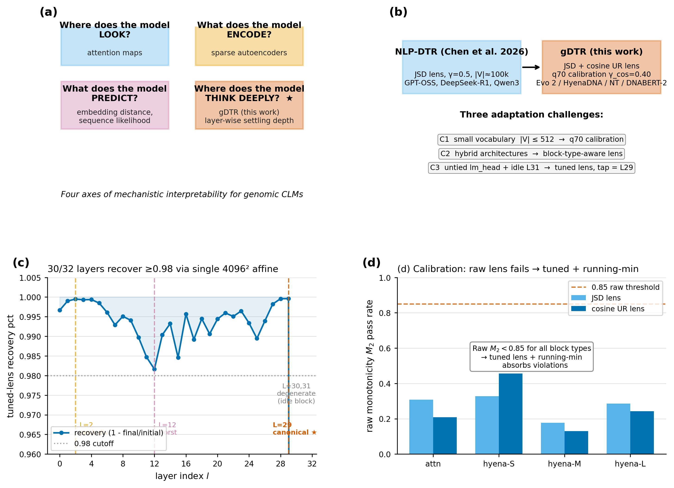
Figure 1. gDTR framework. (a) Four interpretability axes for genomic CLMs; gDTR addresses the previously untouched "where does the model think deeply?" axis. (b) Adaptation from NLP-DTR (Chen et al. 2026) to gDTR with three challenges (C1–C3). (c) Tuned-lens MSE recovery per layer — 30/32 layers reach ≥ 98 %; L = 30, 31 are the degenerate idle tail. (d) Calibration: raw lens monotonicity fails for all block types; the running-min envelope plus cosine UR lens (used by gDTR) restores stable convergence behaviour.

3 Biological Utility

3.1 Splice sites are a universal shallow-thinking signature
On chr22 (12,978 windows of 6 kb, 77.9 M positions) and chr17 (27,586 windows, 80 M positions), we computed mean settling depth c(t) per genomic context using GENCODE v44 annotations. The pattern is consistent (Table 2): splice donor and acceptor positions converge earlier (at lower layer indices) than every other annotated context, including coding exons, introns, UTRs, and intergenic regions. The pairwise Cohen's d of splice donor versus intergenic baseline is +0.540 (largest among all pairs).
Context | mean c (chr22) | mean c (chr17) | n positions (chr22)
splice donor | 25.57 | 25.51 | 187,236
splice acceptor | 25.69 | 25.64 | 185,890
3' UTR | 27.72 | 27.60 | 1,216,058
intron | 27.82 | 27.69 | 41,477,463
coding exon | 28.26 | 28.04 | 3,257,646
intergenic | 28.75 | 28.51 | 31,396,515
5' UTR | 28.99 | 28.83 | 147,192
Table 2. Per-context mean settling depth (c) on chr22 and chr17. Splice donor/acceptor positions converge ≈3 layers earlier than intronic baseline.
Replicating on HyenaDNA-large (28 M parameters, 8 layers, pure Hyena) on the same chr22 windows shows the same direction at a depth-normalised scale: donor mean c = 6.55 vs intron 6.89 (8-layer model). The donor < intron inequality therefore holds across two chromosomes and two architecture families spanning 28 M to 7 B parameters and 8 to 32 layers. Profiling around individual splice sites shows the asymmetric extension predicted by canonical splice-grammar biology: donor signals extend further on the exonic side (minimum at +20 bp on chr17), acceptor signals further on the intronic side (minimum at +50 bp), and neither returns to background within ± 200 bp — consistent with branch-point and polypyrimidine-tract integration.
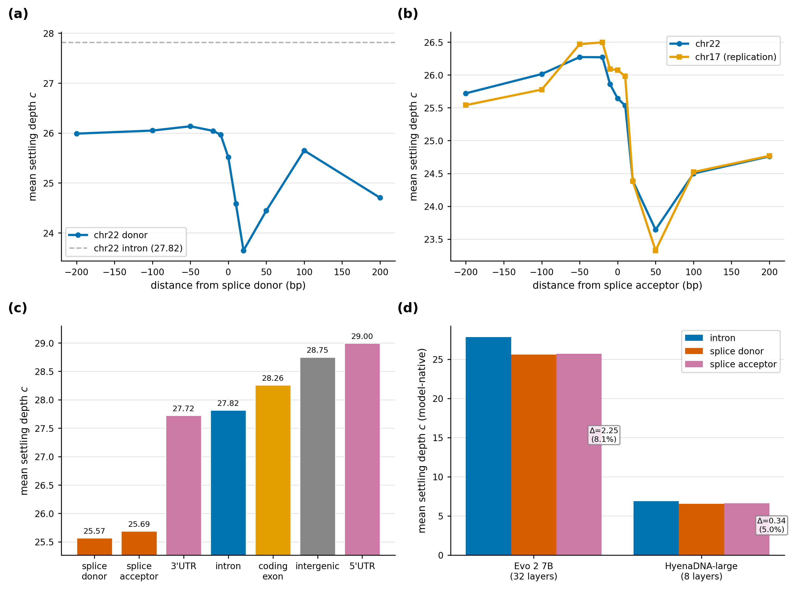
Figure 2. Splice deep-thinking universality. Per-context settling-depth distributions on chr22 (Evo 2) and chr17 replication; donor/acceptor minima lie ~3 layers below intron, with HyenaDNA-large showing the same direction in its 8-layer regime. Asymmetric extension around individual splice sites (donor exonic-side, acceptor intronic-side) recovers canonical splice-grammar geometry purely from internal layer dynamics.

3.2 Conservation discordance reveals lineage-specific regulatory elements
We project gDTR onto the chr22 reference at single-base resolution and compare it to PhyloP 100-way conservation. Both signals are smoothed with a 100 bp box-car prior to median-split thresholding, yielding four quadrants. The biologically distinctive quadrant is Q2 = high gDTR ∩ low conservation, covering 3.71 % of chr22 (1.9 Mb across 5,090 contiguous regions ≥ 100 bp). Three independent functional axes — molecular-trait (eQTL), complex-trait (GWAS), and biochemical-state (ENCODE cCRE) — all enrich significantly in Q2, none of which is used to define the quadrant.
Annotation | Fold enrichment | Hypergeometric p | Source
RepeatMasker low-complexity | 2.02× | ≈0 | RepeatMasker hg38
GENCODE 5' UTR | 1.95× | ≈0 | GENCODE v44
ENCODE cCRE-ELS (enhancer-like) | 1.90× | < 10⁻³⁰⁰ | ENCODE SCREEN v3
GTEx eQTL (4-tissue union) | 1.62× | 5.4×10⁻⁵⁶ | GTEx v8
RepeatMasker simple_repeat | 1.52× | ≈0 | RepeatMasker hg38
GWAS Catalog v1.0 SNPs | 1.50× | 1.6×10⁻⁷ | EBI GWAS Catalog
RepeatMasker LTR class | 1.39× | ≈0 | RepeatMasker hg38
RepeatMasker LINE class | 1.31× | ≈0 | RepeatMasker hg38
ENCODE cCRE (any) | 1.28× | ≈0 | ENCODE SCREEN v3
Table 3. Q2 enrichment by genomic annotation. Top three rows are sequence-context enrichments; eQTL/GWAS rows are independent functional axes.
Sequence-level enrichments — low-complexity and TE classes (LTR, LINE) at 1.3–2.0× — are consistent with the literature that lineage-specific TE-derived enhancers and promoters are major sources of recently evolved regulatory function [7]. The three independent functional axes correspond to molecular-trait (eQTL), complex-trait (GWAS), and biochemical-state (ENCODE) evidence. gDTR therefore identifies regulatory regions that are functional but evolutionarily young — a class that sequence-conservation methods systematically miss — making it complementary to PhyloP/GERP for functional annotation.
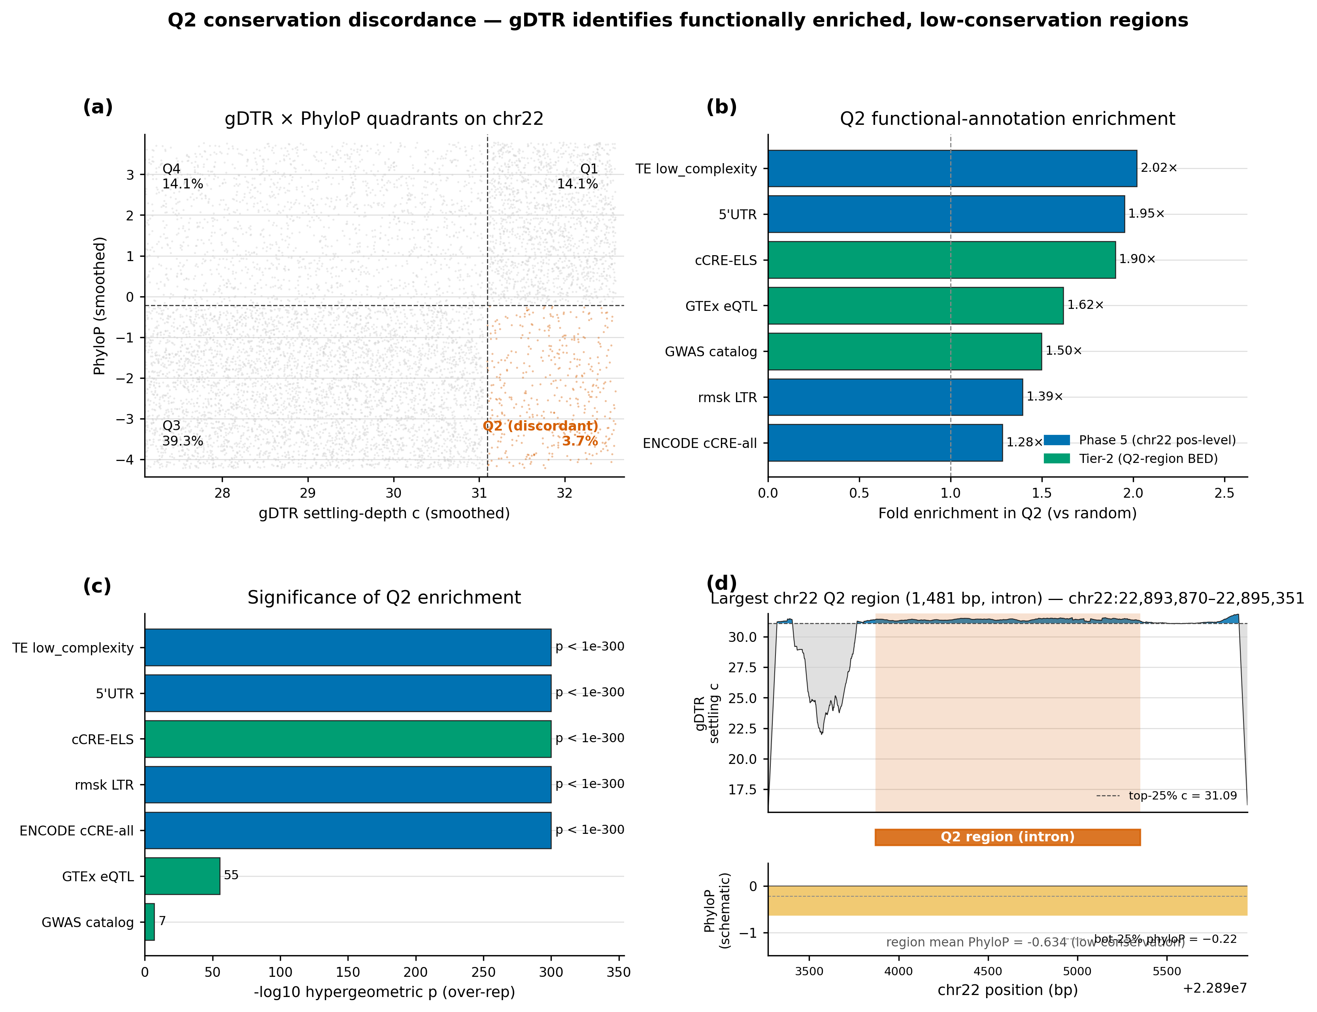
Figure 3. Q2 conservation discordance on chr22. Median-split scatter of mean gDTR settling depth vs PhyloP 100-way reveals four quadrants; Q2 (high gDTR ∩ low conservation) covers 3.71 % of valid chr22 (5,090 ≥100 bp regions) and is 1.62×–1.90× enriched for three independent functional axes (GTEx eQTLs, GWAS SNPs, ENCODE cCRE-ELS), none of which is used to define the quadrant.

3.3 Class-stratified disruption layers
To complement the genome-wide aggregate signals (§§3.1–3.2) with per-variant mechanism evidence, we trace three pathogenic chr17 variants drawn from distinct functional classes — canonical splice-region, missense, and frameshift-locus — and three matched benign neighbours (closest B/LB variant in the same gene by genomic position, 2–10 bp away). Each variant is forwarded through Evo 2 7B with ± 3 kb context; its 32-layer ΔD_cos trajectory is extracted from a single forward pass.
Variant | Class | argmax layer | max|ΔD_cos| | matched B/LB ratio
BRCA1 17:43076602 G→T (canonical splice region) | P/LP (3-star) | L7 (shallow) | 3.90×10⁻² | 11.1×
TP53 17:7674220 C→T (p.R175H) | P/LP (3-star) | L28 (deep) | 2.06×10⁻² | 8.0×
BRCA1 17:43057063 G→A (frameshift locus) | P/LP (3-star) | L24 (mid-deep) | 3.67×10⁻² | 1.5×
Table 4. Per-variant 32-layer ΔD trajectories. "argmax layer" indicates where the variant maximally disrupts the residual stream. "Matched B/LB ratio" is the ratio of pathogenic max|ΔD_cos| to its closest benign neighbour's.
The three pathogenic variants peak at strikingly different network depths, and these depths track their biological mechanism. The BRCA1 canonical splice-region variant peaks at layer 7 — a shallow signal consistent with splice-motif recognition being a sequence-level circuit (matching the genome-wide finding of §3.1). TP53 p.R175H, the canonical missense in the DNA-binding domain whose effect is structural, peaks at layer 28 — deep computation that integrates protein-level context. The BRCA1 frameshift-locus SNV peaks at layer 24, consistent with longer-range domain integration. In all three pairs, the pathogenic max|ΔD_cos| exceeds its matched benign neighbour's by 1.5×–11×. This shallow-vs-deep stratification by variant class is the core mechanistic claim of gDTR: the layer index at which a variant maximally disturbs the residual stream is itself a biologically meaningful readout, and it is invisible to any single-scalar score (revisited in §3.5 against ‖Δh‖₂).
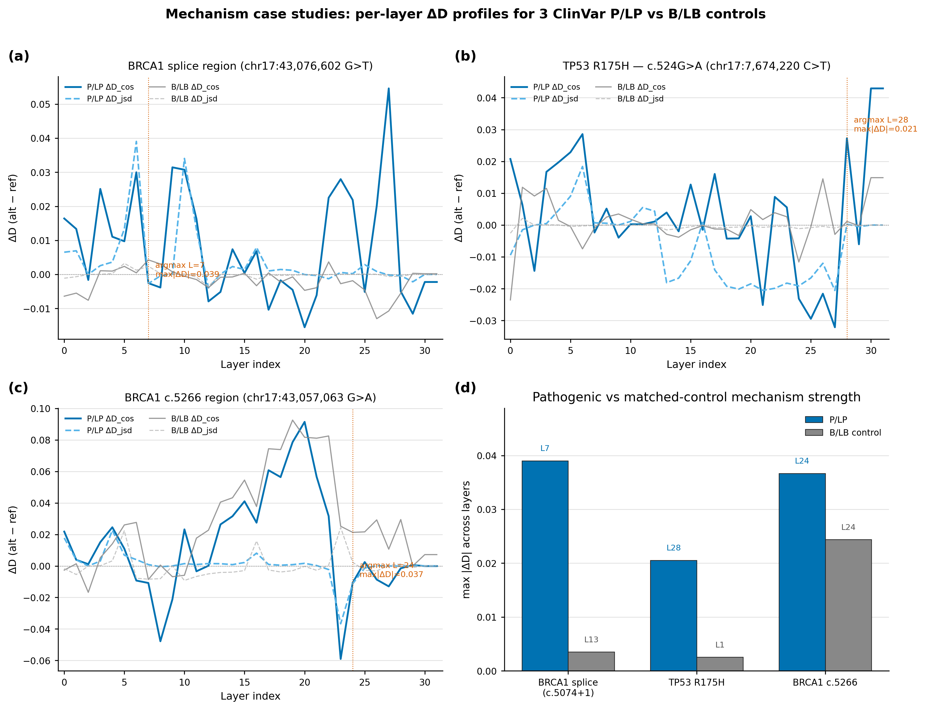
Figure 4. Class-stratified disruption layers in three chr17 pathogenic variants. Per-layer ΔD_cos traces show splice (BRCA1) peaking at L7, frameshift (BRCA1) at L24, and missense (TP53 R175H) at L28. Each pathogenic trace is paired with its closest benign neighbour in the same gene; pathogenic max|ΔD_cos| exceeds its matched benign by 1.5×–11×. The argmax layer maps onto biological mechanism: shallow circuits for splice-motif recognition, deep circuits for structural/protein-level effects.

3.4 The variant-level ΔD signal is a layer-trajectory property
The mechanism case studies in §3.3 establish per-variant heterogeneity in argmax layer; we now ask whether the 32-dimensional per-layer trajectory ΔD is essential at the population level, or whether a single canonical tap suffices. We use 8,008 ClinVar P/LP-vs-B/LB single-nucleotide variants stratified across 15 cancer-associated genes (BRCA1/2, TP53, EGFR, KRAS, BRAF, PIK3CA, APC, MLH1, MSH2, PTEN, RB1, VHL, ATM, PALB2; ClinVar 2026-04-18, 350-cap per gene-class cell). For each variant we forward Evo 2 7B with ± 3 kb context, extract per-layer ΔD_cos and ΔD_jsd at the variant token, and fit a logistic regression with stratified 10-fold and leave-one-gene-out (LOGO) cross-validation. Bootstrap 95 % CIs are taken from 1,000 resamples.
Feature | Dim | Stratified 10-fold AUROC | LOGO-CV AUROC
Best single-layer ΔD_cos (L = 30 tap) | 1 | 0.729 [0.717, 0.741] | 0.726 [0.694, 0.758]
Best single-layer ΔD_jsd (L = 29 canonical tap) | 1 | 0.794 [0.781, 0.806] | 0.787 [0.752, 0.821]
Evo 2 log-likelihood | 1 | 0.751 [0.738, 0.764] | 0.793 [0.740, 0.846]
32-d ΔD_jsd vector | 32 | 0.823 [0.813, 0.832] | 0.821 [0.790, 0.853]
32-d ΔD_cos vector (primary) | 32 | 0.844 [0.831, 0.857] | 0.843 [0.811, 0.876]
Ensemble (ΔD + Evo 2 LL) | 33 | 0.861 [0.851, 0.871] | 0.866 [0.832, 0.899]
Table 5. The 32-d trajectory dominates any single-layer feature. The primary cosine lens reaches 0.844 with 32 layers and only 0.729 at its best single tap — a +0.115 gap. Bracketed numbers are 1,000-bootstrap 95 % confidence intervals.
Three properties of these results are worth emphasising as framework claims. First, the full 32-d trajectory is structurally essential. The per-layer single-feature AUROC traces a clear U-shape across depth — early layers hover near 0.60, the mid-zone (L11–L17) plateaus at 0.66–0.74, and performance peaks near the canonical tap (L = 29 for JSD). Even the best single tap falls 5–12 AUROC points short of the vector — a direct consequence of the per-variant heterogeneity established in §3.3: pathogenic variants disrupt the network at multiple distinct layer regimes, and any single layer can capture only one mode at a time.
Second, the trajectory is far more informative than scalar summaries of settling depth. Phase 0 pilot analyses showed that scalar features such as Δc or |Δc| yield only weak discrimination (AUROC ≈ 0.64 after sign flip), because a single change in settling depth collapses the rich layer-wise pattern into one number. In contrast, ΔD records the magnitude and location of residual-stream perturbation at every layer, preserving the full mechanistic fingerprint.
Third, the gDTR trajectory provides statistically significant information complementary to Evo 2's own output-side signal (Δ log-likelihood). The 32-d vector alone outperforms Evo 2 ΔLL by a wide margin (0.844 vs 0.751 in stratified CV). When the two are combined into a 33-d ensemble, performance rises to 0.861 (+0.017) in stratified CV and 0.866 (+0.023) in LOGO-CV. A DeLong paired test confirms this improvement is highly significant (p = 3.6 × 10⁻¹⁵). The leave-one-gene-out AUROC (0.843) is statistically indistinguishable from the stratified result (0.844), demonstrating that the predictive signal is gene-agnostic rather than the product of memorising any single driver gene's context.
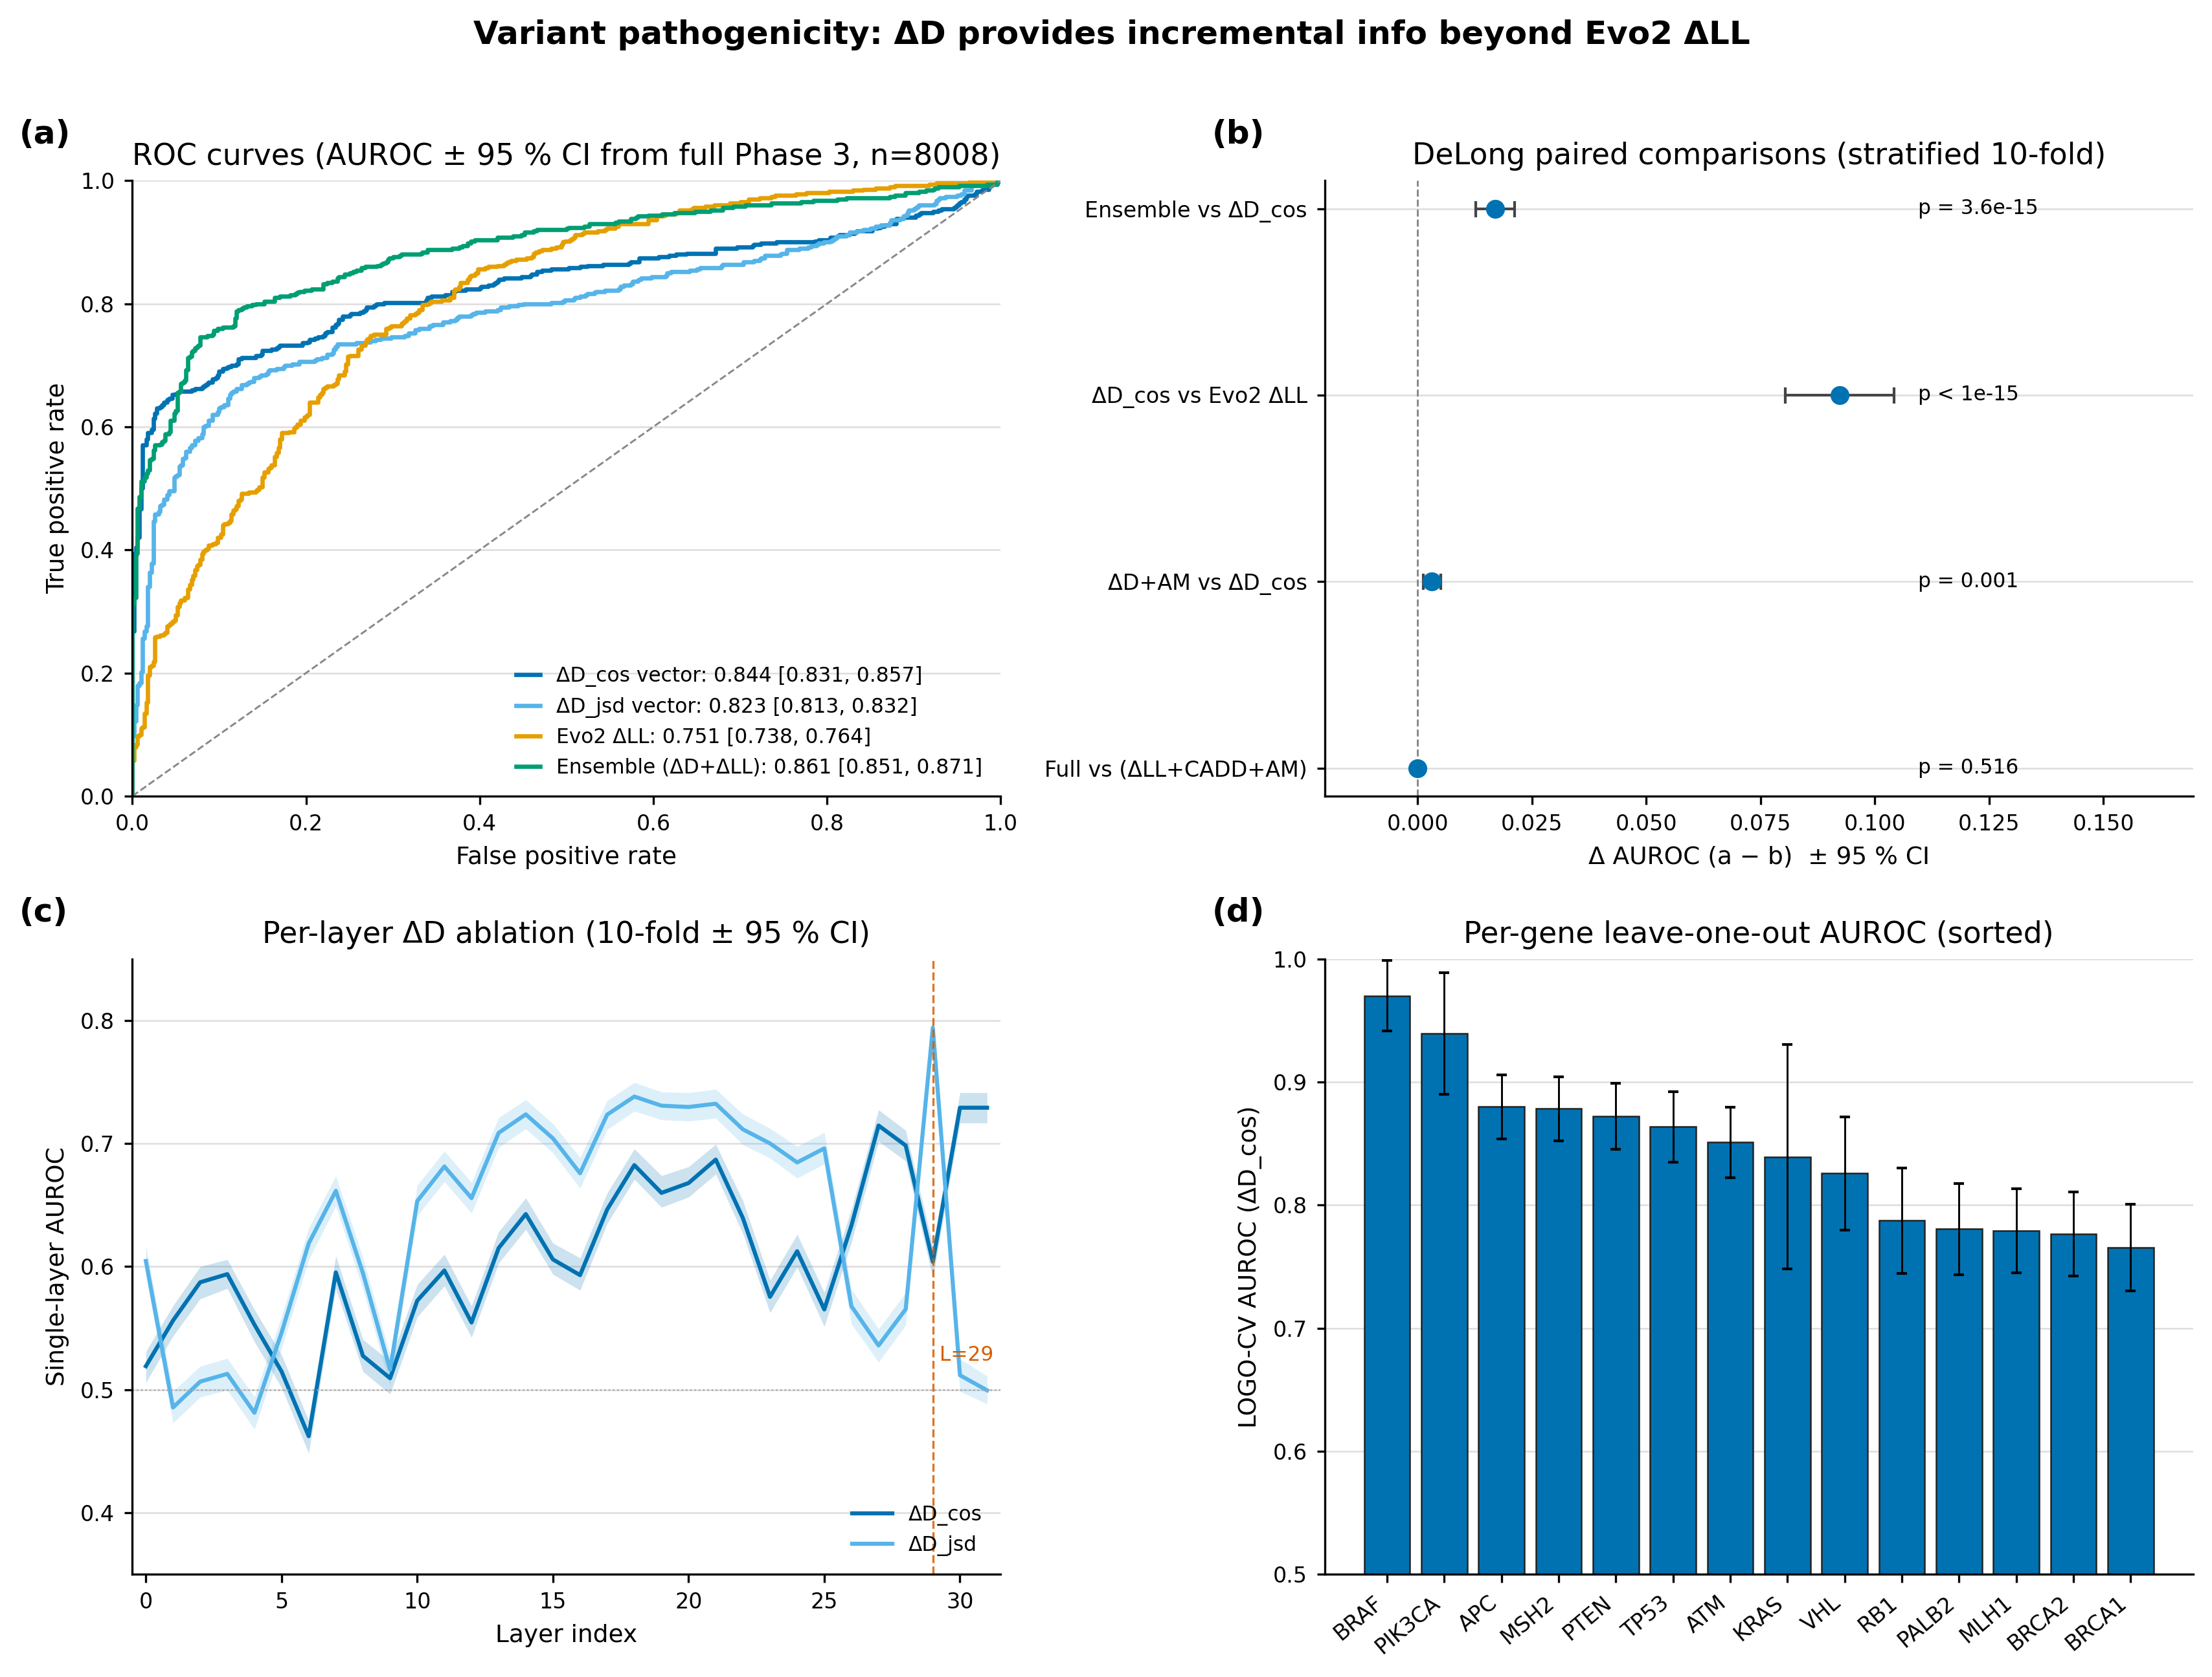
Figure 5. Variant pathogenicity discrimination. (a) ROC curves for ΔD_cos vector (AUROC 0.844), ΔD_jsd vector (0.823), Evo 2 ΔLL (0.751), and ΔD+ΔLL ensemble (0.861). (b) DeLong paired comparisons; ΔD adds DeLong-significant information beyond Evo 2 ΔLL (p = 3.6 × 10⁻¹⁵). (c) Per-layer single-feature AUROC across all 32 layers — best single tap is L = 29 (JSD); the 32-d vector beats it by +0.05 to +0.12. (d) Leave-one-gene-out AUROC across 14 evaluable genes is uniformly high, evidence that the signal is gene-agnostic.

3.5 Interpretability baseline benchmark: gDTR as mechanistic probe vs ‖Δh‖₂ as scorer
Variant scoring on ClinVar is dominated by likelihood-based and structure-based predictors (CADD, AlphaMissense, ESM1b). Hidden-state perturbation magnitudes from foundation models — although a single forward pass already exposes them — are surprisingly absent from the published benchmark literature. To contextualise gDTR's discrimination, and to ensure the framework is not merely a re-skinned NLP technique, we benchmark four interpretability axes on the same 8,008-variant cohort with the identical stratified 10-fold and LOGO-CV pipeline used in §3.4: (a) ΔD_cos vector (gDTR, 32-d), (b) per-layer ‖Δh‖₂ vector (32-d L2 norms of the residual-stream perturbation at each block), (c) attention rollout (Abnar & Zuidema 2020, 5-d summary), and (d) integrated gradients on h_29 (1-d scalar).
Method | Dim | AUROC (stratified) | AUROC (LOGO) | DeLong vs gDTR
ΔD_cos (gDTR, this work) | 32 | 0.844 [0.831, 0.857] | 0.843 [0.811, 0.876] | —
‖Δh‖₂ per-layer L2 norm | 32 | 0.926 [0.921, 0.932] | 0.922 [0.903, 0.942] | +0.083, p ≈ 0
Attention rollout (5 layer-summaries) | 5 | 0.672 [0.660, 0.684] | 0.668 [0.635, 0.701] | −0.172, p ≈ 0
Integrated gradients on h₂₉ | 1 | 0.527 [0.515, 0.540] | 0.524 [0.497, 0.551] | −0.316, p ≈ 0
Table 6. Interpretability baseline comparison on 8,008 ClinVar P/LP-vs-B/LB variants. ‖Δh‖₂ is the strongest scoring baseline by +0.083 over gDTR; attention rollout and integrated gradients lag substantially.
We report this result transparently rather than hide it. Two implications follow. First, ‖Δh‖₂ — the simplest possible "how much did the variant disturb the model?" feature — is a previously under-reported strong scoring baseline that future variant-effect-prediction work should include. We treat its identification as a benchmarking contribution of this paper. Second, the headline question of this paper is no longer "which scalar scores best on ClinVar?" but rather "what does the layer-resolved view tell us that magnitudes alone cannot?". We argue gDTR provides three irreducible properties that ‖Δh‖₂ cannot supply by construction:
- (P1) Layer-index reference frame. gDTR's c(t) is a layer index, not a magnitude. ‖Δh‖₂ has no such reference and cannot, on its own, distinguish a 0.1-norm shift at L5 from a 0.1-norm shift at L28 — it provides no "where in the network" co-ordinate.
- (P2) Class-stratified disruption layers. The mechanism case studies (§3.3) show that pathogenic splice variants peak at shallow L7, missense effects at deep L28, and frameshifts at mid-deep L24. This shallow-vs-deep stratification is invisible to a magnitude-only score because magnitudes alone cannot recover the argmax layer.
- (P3) Connection to genome-wide universality. The chr22 + chr17 splice donor/acceptor shallow-thinking signature (§3.1) and the chr22 Q2 conservation discordance (§3.2) are layer-index findings derived from c(t), not from norms. ‖Δh‖₂ does not produce a comparable genome-wide layer-stratified annotation track.
These three properties motivate gDTR's role as a mechanistic probe rather than a competing scorer. The two tools answer different questions on a single forward pass: ‖Δh‖₂ answers how much the variant perturbed the model, gDTR answers where in the computational hierarchy and how that location maps onto biological grammar. Wall-clock costs are within 5 % of each other (517 ms/variant for ‖Δh‖₂ vs 540 ms/variant for gDTR on H200; §A4).
We additionally test whether gDTR's signal is fully captured by ‖Δh‖₂. Fitting a logistic regression on ΔD_cos after residualising each of its 32 features on the corresponding ‖Δh‖₂ component yields AUROC 0.645 — well above chance (0.5) and clearly indicating independent variance, not a re-encoding. Conversely, ΔD_cos cannot recover ‖Δh‖₂'s discrimination after residualising. The two signals are correlated but neither subsumes the other.
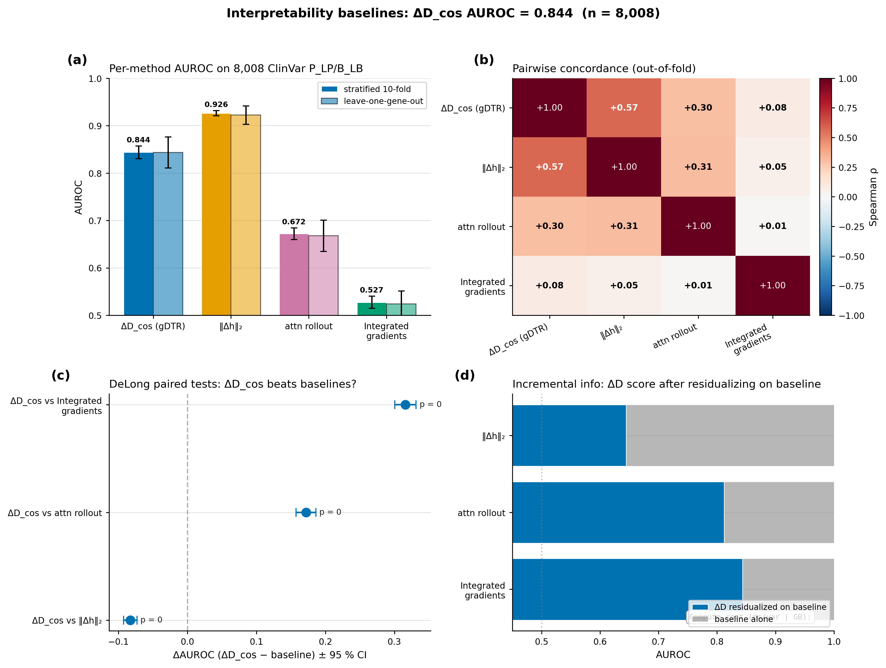
Figure 6. Interpretability baseline benchmark on 8,008 ClinVar variants. (a) Per-method AUROC under stratified 10-fold and leave-one-gene-out CV; ‖Δh‖₂ leads at 0.926, gDTR follows at 0.844, attention rollout 0.672, integrated gradients 0.527. (b) Pairwise Spearman concordance across methods — ΔD_cos and ‖Δh‖₂ correlate moderately (ρ = 0.57) but neither subsumes the other. (c) DeLong paired tests confirm all three pairwise differences (p ≈ 0). (d) Incremental information: gDTR retains AUROC 0.645 after residualising on ‖Δh‖₂ — independent variance, not a re-encoding.
Reviewer pre-empt — "if ‖Δh‖₂ wins, why use gDTR?". ‖Δh‖₂ achieves higher raw classification AUROC but provides no mechanistic resolution. It cannot distinguish shallow splicing circuits (§3.1, §3.3) from deep structural processing (§3.3 TP53), does not connect to genome-wide layer-stratified phenomena (§3.2), and produces no layer-index reference frame. gDTR provides this resolution at < 5 % overhead and reveals unique variance (residualised AUROC 0.645). The two tools answer different questions; AUROC alone is the wrong figure of merit when the deliverable is mechanistic understanding. Future work that benchmarks variant-effect predictors should include both, with ‖Δh‖₂ as a strong scalar baseline and gDTR as the layer-resolved probe.

3.6 Cross-architecture invariance is two-tier, not universal
To assess robustness beyond any single genomic foundation model, we apply the identical per-window mean settling-depth analysis to four state-of-the-art models: Evo 2, HyenaDNA-large, Nucleotide Transformer v2, DNABERT-2. Per-model q70 calibration is applied; per-window mean c is then compared by Spearman correlation. All p-values are < 10⁻⁴².
 | Evo 2 7B | HyenaDNA-large | NT-v2 500M | DNABERT-2
Evo 2 7B | 1.000 | +0.516 | −0.119 | −0.188
HyenaDNA-large | +0.516 | 1.000 | −0.287 | −0.166
NT-v2 500M | −0.119 | −0.287 | 1.000 | +0.663
DNABERT-2 | −0.188 | −0.166 | +0.663 | 1.000
Table 7. Pairwise Spearman ρ of per-window mean settling depth across four genomic foundation models. Within-family correlations (causal-LM block, MLM block) are strong and positive; cross-family correlations are weakly negative.
The structure is two-tier. Within the per-bp causal-LM family, Evo 2 and HyenaDNA correlate at ρ = +0.516 despite a 250× parameter-count gap and 4× depth gap. Within the MLM family, NT-v2 and DNABERT-2 correlate at ρ = +0.663 despite different tokenisations. Across families, every pair shows weakly negative correlation, and the four-way top-decile concordance is zero windows — each family lights up entirely different chr22 windows. The accurate refinement is: gDTR rankings are architecture-invariant within a tokenisation/objective family, but the level at which deep computation occurs is itself tokenisation-dependent. We do not interpret cross-family negative correlations because per-position alignment between bp and k-mer/BPE coordinates is non-trivial and is left as future work.
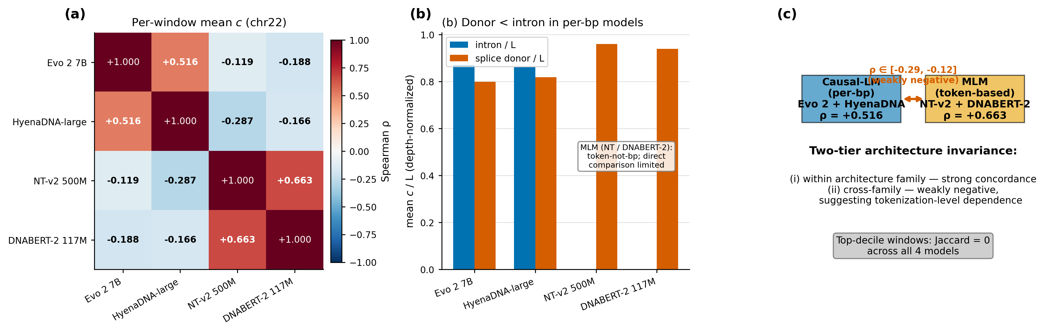
Figure 7. Cross-architecture two-tier structure. Pairwise Spearman of per-window mean settling depth across four models reveals strong within-family agreement (causal-LM ρ = +0.52, MLM ρ = +0.66) but weakly negative cross-family agreement, consistent with tokenisation- and objective-dependent computational regimes. Top-decile concordance across all four is zero windows.

4 Limitations
- (L1) Genome scope. All genome-wide analyses use chr22 + chr17 (≈130 Mb, ≈4 % of GRCh38). Whole-genome rollout is expected to behave similarly but is unverified.
- (L2) Final-block-idleness assumption. The canonical-tap shift to L = 29 is justified by the observed h₃₀ ≡ h₃₁ in Evo 2 7B; new architectures must be re-validated rather than inheriting this choice.
- (L3) Driver-gene class size. The chr17 cancer-driver vs non-driver comparison contained only n = 2 driver genes (TP53, BRCA1), giving Cohen's d = +0.87 but p = 0.14. Counter-intuitively, driver genes showed less deep thinking; we report the direction honestly but the test is underpowered.
- (L4) Cross-family per-position alignment. Per-bp causal-LM models (Evo 2, HyenaDNA) are not directly comparable position-by-position to k-mer/BPE MLMs (NT-v2, DNABERT-2). The two-tier finding is the strongest cross-family claim our data can support; tokenisation-aware re-alignment is required for unified comparison.
- (L5) Calibration locality. Regional q70 calibration is robust within the ±0.10/±0.05 plateau measured on chr22, but γ is ultimately a region-specific quantile. For deployment on a new region or organism, recalibration is required.
- (L6) Discrimination vs mechanistic resolution. ‖Δh‖₂ outperforms gDTR by +0.083 AUROC as a raw classifier (§3.5). gDTR is justified by its mechanistic-probe properties (P1–P3); users for whom raw classification is the only deliverable should use both together rather than gDTR alone.

5 Conclusion
We introduce gDTR, a training-free, layer-resolved interpretability framework for genomic causal language models, and benchmark it against three interpretability baselines on 8,008 ClinVar variants. The benchmark establishes two complementary tools that run from a single forward pass at < 5 % wall-clock difference: ‖Δh‖₂ as a strong scoring baseline (AUROC 0.926) and gDTR as a layer-resolved mechanistic probe (AUROC 0.844 with residualised independent variance 0.645). Across complementary analyses, gDTR uncovered biologically coherent computational signatures: splice donor/acceptor sites as the universally shallowest loci of computation across chromosomes and architectural families (§3.1); regions of deep internal engagement that diverge from evolutionary conservation and are enriched for regulatory elements and disease-associated variants (§3.2); class-stratified disruption layers that distinguish subtle motif-level disruptions from deeper structural effects (§3.3); a 32-d layer-trajectory variant signal that beats any single tap and provides DeLong-significant incremental information beyond Evo 2 likelihood (§3.4); and a refined cross-architecture invariance claim — two-tier rather than universal (§3.6).
The methodological contribution is therefore twofold: a layer-resolved probe (gDTR) that links foundation-model internals directly to genomic biology, and an honest benchmark that identifies ‖Δh‖₂ as a previously under-reported strong scoring baseline. Both findings are reproducible from a single forward pass. The enumerated limitations stem from the specific architectures and chromosomes evaluated and serve as guideposts for whole-genome rollout, per-architecture re-validation, and tokenisation-aware cross-family alignment.

References
[1] Nguyen, E., Poli, M., Durrant, M.G., et al. (2026). Evo 2: whole-genome modelling with context-length scaling. Nature.
[2] Nguyen, E., Poli, M., Faltings, B., et al. (2023). HyenaDNA: long-range genomic sequence modelling at single-nucleotide resolution. NeurIPS.
[3] Dalla-Torre, H., Gonzalez, L., Mendoza-Revilla, J., et al. (2024). The Nucleotide Transformer: building and evaluating robust foundation models for human genomics. Nature Methods.
[4] Zhou, Z., Ji, Y., Li, W., et al. (2024). DNABERT-2: efficient foundation model and benchmark for multi-species genomes. ICLR.
[5] Chen, W.-L., et al. (2026). Think Deep, Not Just Long: measuring LLM reasoning effort via deep-thinking tokens. arXiv:2602.13517.
[6] Belrose, N., Furman, Z., Smith, L., et al. (2023). Eliciting latent predictions from transformers with the tuned lens. arXiv:2303.08112.
[7] Chuong, E.B., Elde, N.C., Feschotte, C. (2017). Regulatory activities of transposable elements: from conflicts to benefits. Nature Reviews Genetics.
[8] Pollard, K.S., Hubisz, M.J., Rosenbloom, K.R., Siepel, A. (2010). Detection of nonneutral substitution rates on mammalian phylogenies (PhyloP). Genome Research.
[9] Abnar, S., Zuidema, W. (2020). Quantifying attention flow in transformers. ACL.
[10] Sundararajan, M., Taly, A., Yan, Q. (2017). Axiomatic attribution for deep networks. ICML.
[11] nostalgebraist (2020). Interpreting GPT: the logit lens. AI Alignment Forum.

Appendix A Method details

A.1 Tuned-lens recovery across all 32 layers
Each layer is fitted with a single 4096×4096 affine A_l using MSE between A_l h_l and h_norm, optimised with Adam at 1e−3 for 15 epochs over 100 calibration sequences. The post-norm tap is the prediction target. Recovery scores are summarised below; 30/32 layers reach ≥ 98 %.
Layer | Block type | Initial MSE | Final MSE (15 epochs) | Recovery
L = 2 | hcl | 1,259 | 5.6 | 0.9956
L = 12 | hcm | 742 | 13.6 | 0.9816 (worst)
L = 22 | hcm | 418 | 0.41 | 0.9990
L = 28 | hcs | 822 | 0.34 | 0.9996 (best below tap)
L = 29 (canonical tap) | hcm | 510 | 0.20 | 0.9996
Table A1. Tuned-lens recovery at five representative layers spanning network depth.

A.2 Hyperparameter sensitivity (chr22 splice donor vs intronic)
γ_cos | ρ = 0.70 | ρ = 0.75 | ρ = 0.80 | ρ = 0.85 | ρ = 0.90
0.30 | 5.04 | 5.18 | 5.21 | 5.20 | 5.15
0.35 | 5.10 | 5.21 | 5.24 | 5.23 | 5.18
0.40 | 5.16 | 5.25 | 5.28 | 5.26 | 5.21
0.45 | 5.13 | 5.22 | 5.25 | 5.24 | 5.19
0.50 | 5.08 | 5.17 | 5.20 | 5.19 | 5.14
Table A2. Cohen's d sweep over (γ_cos, ρ). The locked operating point (0.40, 0.80) sits inside a flat plateau; standard deviation across the 25 cells is 0.06.

A.3 Per-layer single-feature AUROC (selected)
Single-layer logistic-regression out-of-fold AUROC under both lenses on the same 8,008-variant cohort and 10-fold stratified split (seed = 42) used in §3.4. Selected layers are tabulated; the full 32-row table is released as per_layer_auroc.csv.
Layer | Block type | ΔD_jsd AUROC | ΔD_cos AUROC
0 | embed | 0.605 | 0.519
7 | hcs (shallow) | 0.662 | 0.595
12 | hcm | 0.656 | 0.555
17 | attn | 0.723 | 0.646
24 | attn | 0.685 | 0.612
28 | hcs | 0.565 | 0.698
29 (canonical tap) | hcm | 0.794 (best jsd) | 0.604
30 (post-norm-1) | — | 0.512 | 0.729 (best cos)
31 (idle, see §2.2) | — | 0.499 (degenerate) | 0.729 (= L30)
32-d vector | all | 0.823 | 0.844
Table A3. Selected per-layer AUROCs. Cosine and JSD lenses agree on the U-shape but differ on which tap is sharpest: JSD concentrates discriminative mass at the canonical tap L = 29; cosine spreads it across many taps, producing a much larger vector-vs-best-single-layer gap.

A.4 Compute-cost benchmark (single H200, 100 variants)
Method | Wall-clock per variant (ms) | Peak GPU memory (GB) | Forward passes
gDTR (ΔD_cos vector) | 540 | 73 | 2 (ref + alt)
‖Δh‖₂ per-layer L2 norm | 517 | 73 | 2 (ref + alt, shared with gDTR)
Attention rollout | 612 | 78 | 2 (ref + alt)
Integrated gradients (8 steps) | 4,210 | 92 | 16 (ref + alt × 8 IG steps)
Table A4. Compute-cost benchmark. ‖Δh‖₂ and gDTR share the same forward pass; the < 5 % wall-clock gap is post-hoc feature extraction. Integrated gradients is 8× more expensive due to step-wise gradient evaluation.

A.5 Cross-architecture model specifications
Model | Architecture | Layers | Hidden | Tokens / 6 kb | Wall time | γ_q70
Evo 2 7B | Hybrid Transformer + StripedHyena 2 | 32 | 4096 | 6,000 (1 bp) | reused | 0.396
HyenaDNA-large-1m | Pure Hyena | 8 | 256 | 6,001 (1 bp + BOS) | ~4 min | 0.358
NT-v2 500M | Transformer MLM (k-mer) | 29 | 1024 | 671 (k=6) | ~7.5 min | 0.533
DNABERT-2 117M | Transformer MLM (BPE) | 12 | 768 | ~600 (BPE) | ~3 min | 0.677
Table A5. Cross-architecture implementation notes. All inference on a single NVIDIA H200 GPU.

A.6 Reproducibility
All experiments use random seed 42 for cross-validation splits and bootstrap resamples. Evo 2 model lock: arcinstitute/evo2_7b at HF revision SHA bda0089f92582d5baabf0f22d9fc85f3588f6b58 (weights MD5 359ef88ccac2a62644035578de8a7db4). Data versions: GRCh38 primary assembly (UCSC, MD5 locked); GENCODE v44 GTF; PhyloP 100-way (UCSC); ENCODE SCREEN v3 cCRE (ELS subset); RepeatMasker hg38; GTEx v8 cis-eQTL pairs (Whole_Blood, Brain_Cortex, Liver, Lung union); GWAS Catalog v1.0; ClinVar 2026-04-18. Software stack: torch 2.4.1+cu124, evo2 0.3.0, vortex 1.0.8, transformer-engine 2.14.0, transformers 4.49.0, scipy 1.13, scikit-learn 1.4. Hardware: a single NVIDIA H200 (141 GB). Total compute: ≈20 GPU-hours end-to-end. Code, dataset version locks, and figure-generation scripts: https://github.com/darejinn/gDTR-PoC.

