gDTR: Layer-wise Settling Depth as an Interpretability Axis for Genomic Causal Foundation Models
ICML 2026 Workshop on Interpretable Machine Learning in the Sciences — short paper (4 pages + appendix)

Abstract
We introduce gDTR (Genomic Deep-Thinking Ratio), a training-free, layer-resolved interpretability framework that adapts the core Deep-Thinking Ratio concept from natural language processing to genomic causal language models. By measuring per-token settling depth through cosine similarity trajectories in the logit lens, gDTR quantifies how deeply and at which layers the model engages with different parts of the genome. Through architecture-aware adaptations tailored to the unique characteristics of genomic models and the biological properties of DNA sequences, gDTR enables biologically meaningful interpretations across diverse genomic features. Going beyond existing interpretability approaches that focus on attention, encoded features, or final predictions, gDTR addresses when and at which layer a given sequence is computationally resolved, thereby offering a new perspective on internal model dynamics. Applied to Evo 2 7B and validated across multiple genomic foundation models spanning different architectures and tokenization schemes, gDTR demonstrates its power as a novel lens for understanding layer-wise interactions and hierarchical computation in genomic foundation models.

1 Introduction
Genomic foundation models trained on massive whole-genome corpora — such as Evo 2 [1], HyenaDNA [2], Nucleotide Transformer [3], and DNABERT-2 [4] — have catalyzed a paradigm shift in computational biology. These causal language models (CLMs) encode rich biological knowledge spanning nucleotide-resolution sequence, gene structure, regulatory grammar, splicing, and even protein secondary structure. Yet how this knowledge is computed across layers remains underexplored. Understanding the internal mechanisms through which these models process biological information is essential to ensure that their outputs are grounded in biological reality rather than mere statistical correlation.
Current interpretability research for genomic models is primarily organized around three paradigms: (1) attention-based methods, which identify where the model attends within a sequence; (2) sparse autoencoders (SAEs), which attempt to isolate what specific biological concepts the model encodes; and (3) embedding-distance or likelihood scores, which evaluate what a particular variant means to the model's internal representation. While these approaches provide valuable insights, they do not address a fundamental aspect of the model's internal computation: the temporal progression of information processing across layers. We therefore propose a fourth axis of interpretability: where, in the layer hierarchy, is the sequence computationally resolved?
The study of such hierarchical computation has recently emerged in natural language processing (NLP). Chen et al. [5] introduced the Deep-Thinking Ratio (DTR), a training-free metric that measures, for each token position, the layer index at which intermediate-layer prediction distributions converge to within ε of the final-layer distribution. Tokens that converge in the deep tail (>ρ·L of model depth) are designated deep-thinking tokens. Across eight reasoning models and four reasoning benchmarks, DTR correlated strongly with task accuracy (Pearson r = 0.683). We believe this hierarchical lens is uniquely suited for genomics, where different biological elements (e.g., splice sites versus distal regulatory regions) may require markedly different depths of computational processing. Consequently, we aim to transplant the core logic of DTR into genomic causal language models (CLMs).
However, transferring DTR to the genomic domain faces three significant technical challenges: (1) Small vocabulary. Unlike NLP models with |V| ≈ 100k, genomic CLMs operate on extremely small vocabularies (|V| ≈ 12–512). Standard distribution-based thresholds therefore saturate, necessitating a new quantile-based calibration method. (2) Architecture diversity. The genomic landscape includes hybrid Transformer-StripedHyena (Evo 2), pure Hyena (HyenaDNA), and masked-language-model Transformers, each requiring architecture-specific lens implementations while preserving cross-architecture comparability. (3) Final-block idleness. In models such as Evo 2, the final attention block often functions as a residual passthrough, rendering the standard NLP practice of "tapping the last block" ineffective and necessitating re-evaluation of convergence baselines.
We present gDTR (Genomic Deep-Thinking Ratio), the first systematic adaptation of NLP-DTR to genomic causal language models. Section 2 defines the framework and the three adaptations above. Section 3 demonstrates five findings enabled by the layer-resolved readout. Section 4 enumerates five limitations of the framework, including a final-block-idleness assumption that requires per-architecture re-validation.

2 The gDTR Framework

2.1 Settling depth
For an input nucleotide sequence of length T processed by a causal language model with L layers, we extract the residual-stream activations h_l(t).
In genomic CLMs the vocabulary is extremely small (|V| ≤ 512, often |V| = 12). This causes the Jensen-Shannon divergence (JSD) lens used in the original NLP DTR formulation to saturate severely (the dynamic range that NLP models with |V| ≈ 100k exploit collapses for small vocabularies). We therefore adopt the cosine unembed-residual (UR) lens as the primary signal:
D_cos(l, t) = 1 − cos(h_l(t), h_norm(t)),
where h_norm is the post-final-norm tensor. Cosine distance operates directly in the hidden-state geometry and is independent of vocabulary size, providing a stable and vocabulary-agnostic measure of how closely an intermediate representation has converged toward the final readout subspace.
Crucially, and in contrast to the original NLP DTR (which thresholds raw per-layer distances), we define the settling depth of token t at threshold γ via the running-min envelope c(t) = min{ l : run-min D(·, t) ≤ γ }, where run-min D(l, t) = min_{k=1,…,l} D_cos(k, t). The running-min operator never increases, so any temporary excursion away from the final representation is ignored once the token has reached the γ-threshold at an earlier layer. This design choice makes gDTR robust to architectural quirks that would otherwise break standard logit-lens assumptions.
The threshold γ itself is set by regional q70 calibration: for each analysis region we take the 70th percentile of the running-min cosine distance distribution at the penultimate layer as γ_cos. This choice is grounded in two observations. First, a fixed numerical threshold transferred from NLP-DTR (γ ≈ 0.5) does not generalise: the per-region distribution of running-min distances depends on architecture and tokenisation, and a single numerical γ produces unstable settling-depth distributions across regions. Second, the q70 operating point is the inflection in the per-region cumulative density where the contribution from genuinely settled tokens dominates the contribution from still-unconverged tokens; we verify this by direct grid sweep (Appendix A.1). On chr22 the regional q70 yields γ_cos = 0.397, and the (γ_cos, ρ) sensitivity surface is wide and flat — within ±0.10 in γ_cos and ±0.05 in ρ around (0.40, 0.85) Cohen's d on splice donor vs intron varies by ≤ 0.06 (Table A1). The deep-thinking ratio DTR(t) = 1{c(t) > ρ · L} then follows directly with ρ ∈ [0,1] as the depth-fraction hyperparameter; we lock ρ = 0.85 throughout.

2.2 Architectural quirk handling: Evo 2's idle last block
We discover that Evo 2 7B's last attention block is architecturally idle. Direct verification on chr22 sanity sequences (6 kb × 100 windows) yields the values in Table 1. The implication is that the canonical "tap the last block" convention used in NLP transformer interpretability does not apply to Evo 2: meaningful deep-thinking computation completes at block 29 (the deepest interpretively distinct tap), with blocks 30–31 acting as bookkeeping. We therefore lock the canonical deep-thinking tap at L = 29 and use h_norm as the convergence reference.
Quantity | Measured value | Interpretation
max|h₃₀ − h₃₁| | 0.000000 (exact) | block 31 is a residual passthrough
data_ptr(h₃₀) vs data_ptr(h₃₁) | different addresses | tensors are physically distinct copies
cos(h₃₁, h_norm) | 0.6855 | post-norm differs from raw block 31
cos(h₃₀, h_norm) | 0.6855 | identical to block 31 (consistent with above)
cos(h₂₉, h_norm) | −0.013 | block 29 is the deepest interpretively distinct tap
Table 1. Evidence that Evo 2's last attention block is architecturally idle.

2.3 Tuned-lens recovery
To recover layers whose residual stream is rotated relative to the final readout subspace, we fit a per-layer affine A_l with the tuned-lens objective of Belrose et al. [6]. Across Evo 2's 32 layers, 30/32 reach ≥ 98 % MSE recovery from a single 4096² affine; the worst recovery is at L = 12 (recovery 0.9816), and the canonical tap L = 29 reaches 0.9996. For variant analysis we use the post-final-norm tap as reference and the original residual stream taps as the lens input — no learned weights are required at inference time, preserving the training-free property of the framework.
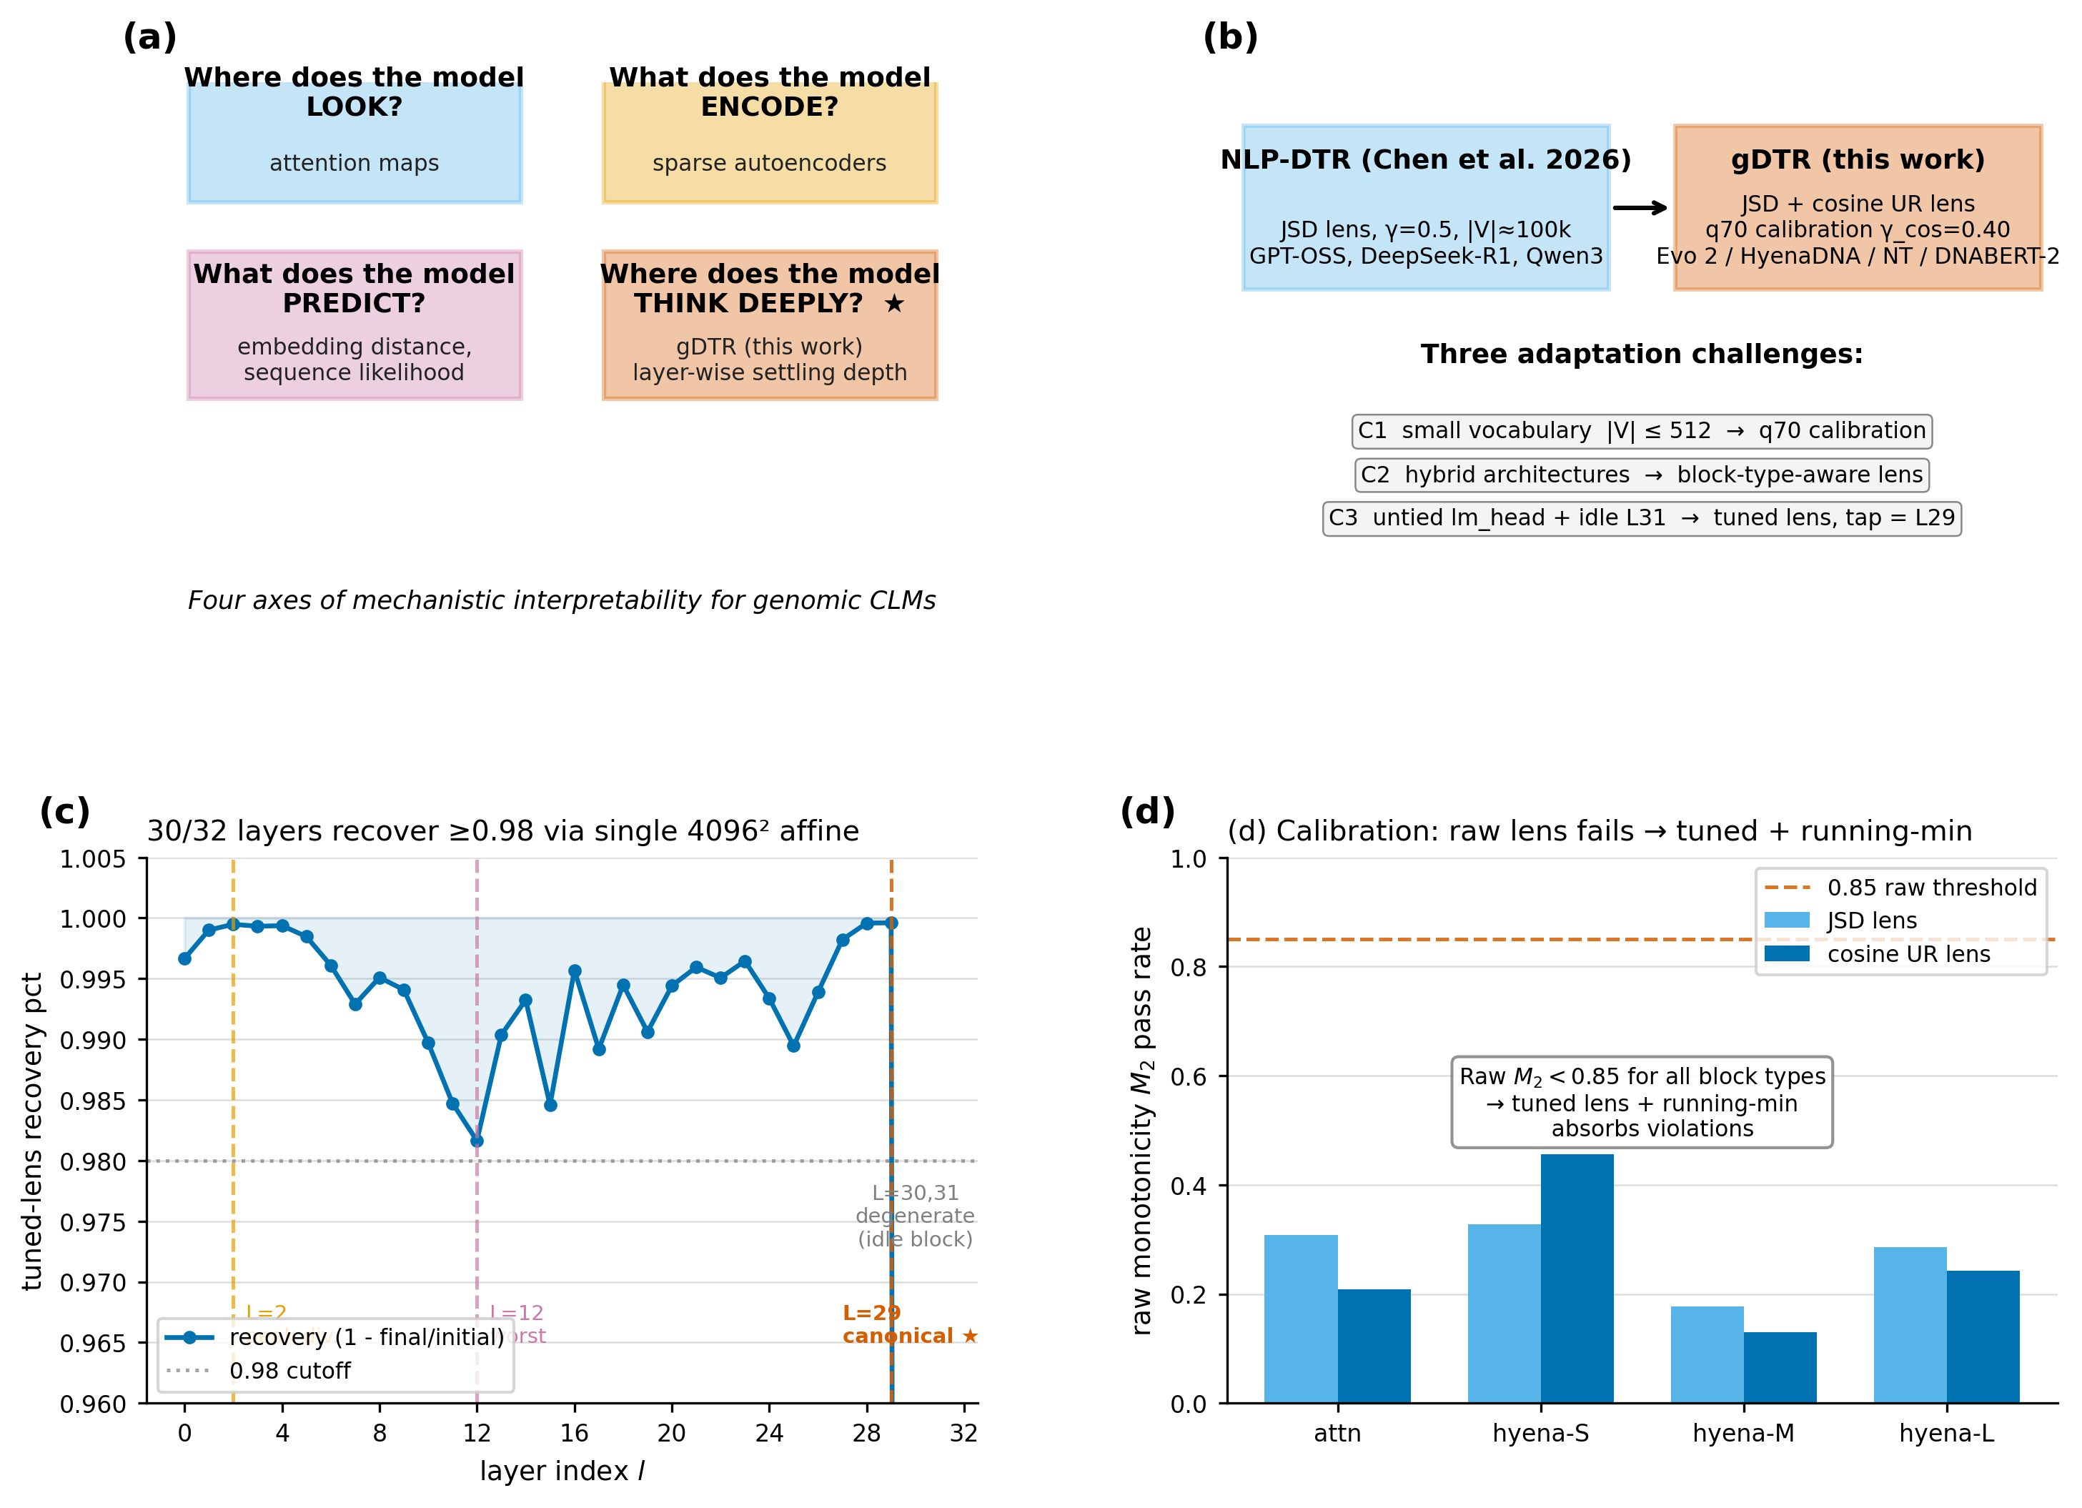
Figure 1. gDTR framework. (a) Four interpretability axes for genomic CLMs; gDTR addresses the previously untouched "where does the model think deeply?" axis. (b) Adaptation from NLP-DTR (Chen et al. 2026) to gDTR with three challenges (small vocabulary, hybrid architectures, untied lm_head + idle L31). (c) Tuned-lens MSE recovery per layer — 30/32 layers reach ≥ 98 %; L = 30, 31 are the degenerate idle tail. (d) Calibration: raw lens monotonicity fails across all block types; the running-min envelope plus cosine UR lens (used by gDTR) restores stable convergence behaviour.

3 Biological Utility

3.1 Splice sites are a universal shallow-thinking signature
On chr22 (12,978 windows of 6 kb, 77.9 M positions) and chr17 (27,586 windows, 80 M positions), we computed mean settling depth c(t) per genomic context using GENCODE v44 annotations. The pattern is consistent (Table 2): splice donor and acceptor positions converge earlier (at lower layer indices) than every other annotated context, including coding exons, introns, UTRs, and intergenic regions. The pairwise Cohen's d of splice donor versus intergenic baseline is +0.540 (largest among all pairs).
Context | mean c (chr22) | mean c (chr17) | n positions (chr22)
splice donor | 25.57 | 25.51 | 187,236
splice acceptor | 25.69 | 25.64 | 185,890
3' UTR | 27.72 | 27.60 | 1,216,058
intron | 27.82 | 27.69 | 41,477,463
coding exon | 28.26 | 28.04 | 3,257,646
intergenic | 28.75 | 28.51 | 31,396,515
5' UTR | 28.99 | 28.83 | 147,192
Table 2. Per-context mean settling depth (c) on chr22 and chr17. Splice donor/acceptor positions converge ≈3 layers earlier than intronic baseline.
Replicating on HyenaDNA-large (28 M parameters, 8 layers, pure Hyena) on the same chr22 windows shows the same direction at a depth-normalised scale: donor mean c = 6.55, acceptor 6.62 vs intron 6.89 and coding exon 6.67 (8-layer model; full numbers and the four-model comparison are released as Appendix B). The donor < intron inequality therefore holds across two chromosomes and two architecture families spanning 28 M to 7 B parameters and 8 to 32 layers. Profiling around individual splice sites shows the asymmetric extension predicted by canonical splice-grammar biology: donor signals extend further on the exonic side (minimum at +20 bp on chr17), acceptor signals further on the intronic side (minimum at +50 bp), and neither returns to background within ± 200 bp — consistent with branch-point and polypyrimidine-tract integration.
A natural follow-up experiment, suggested by the universality of the shallow donor/acceptor signature, is to introduce in-silico mutations at canonical splice sites and recompute c(t): if splice circuitry is genuinely sequence-level and shallow, abolishing the canonical motif should drive c upward toward the intronic baseline (loss of shallow recognition). We flag this as the highest-value follow-up validation experiment beyond the current paper's scope.
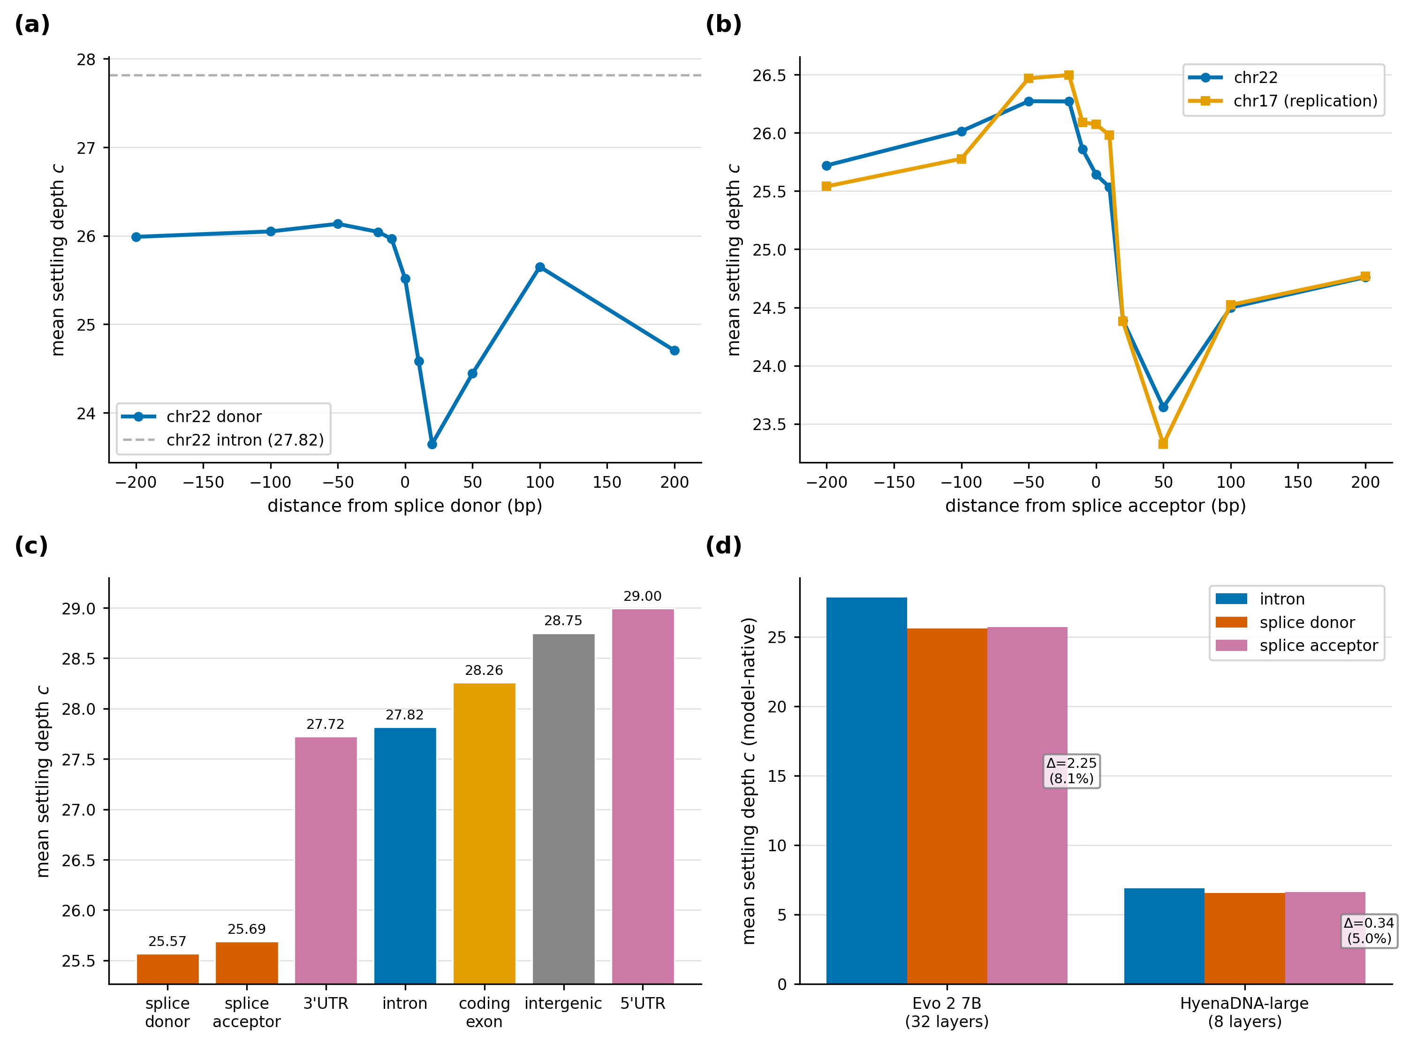
Figure 2. Splice deep-thinking universality. Per-context settling-depth distributions on chr22 (Evo 2) and chr17 replication; donor/acceptor minima lie ~3 layers below intron, with HyenaDNA-large showing the same direction in its 8-layer regime (Appendix B). Asymmetric extension around individual splice sites (donor exonic-side, acceptor intronic-side) recovers canonical splice-grammar geometry purely from internal layer dynamics.

3.2 Conservation discordance reveals lineage-specific regulatory elements
We project gDTR onto the chr22 reference at single-base resolution and compare it to PhyloP 100-way conservation. Both signals are smoothed with a 100 bp box-car prior to median-split thresholding, yielding four quadrants. Q1 (high gDTR + high conservation) covers 14.1 % of post-smoothing-valid chr22; Q3 (low gDTR + high conservation) covers 39.3 %; Q4 (low gDTR + low conservation) 14.1 %. The biologically distinctive quadrant is Q2 = high gDTR ∩ low conservation, which covers 3.71 % of chr22 (1.9 Mb across 5,090 contiguous regions ≥ 100 bp). The largest single Q2 region spans chr22:22,893,870–22,895,351 (1,481 bp, mean c = 31.31, mean PhyloP = −0.63).
Annotation | Fold enrichment | Hypergeometric p | Source
RepeatMasker low-complexity | 2.02× | ≈0 | RepeatMasker hg38
GENCODE 5' UTR | 1.95× | ≈0 | GENCODE v44
ENCODE cCRE-ELS (enhancer-like) | 1.90× | < 10⁻³⁰⁰ | ENCODE SCREEN v3
GTEx eQTL (4-tissue union) | 1.62× | 5.4×10⁻⁵⁶ | GTEx v8
RepeatMasker simple_repeat | 1.52× | ≈0 | RepeatMasker hg38
GWAS Catalog v1.0 SNPs | 1.50× | 1.6×10⁻⁷ | EBI GWAS Catalog
RepeatMasker LTR class | 1.39× | ≈0 | RepeatMasker hg38
RepeatMasker LINE class | 1.31× | ≈0 | RepeatMasker hg38
ENCODE cCRE (any) | 1.28× | ≈0 | ENCODE SCREEN v3
Table 3. Q2 enrichment by genomic annotation. Top three rows are sequence-context enrichments; eQTL/GWAS rows are independent functional axes.
Two observations matter biologically. First, the sequence-level enrichments — low-complexity and TE classes (LTR, LINE) at 1.3–2.0× — are consistent with the literature that lineage-specific TE-derived enhancers and promoters are major sources of recently evolved regulatory function [7]. Second, three independent functional axes go beyond sequence-context enrichment: GTEx eQTLs (1.62×), GWAS Catalog hits (1.50×), and ENCODE cCRE-ELS (1.90×) all enrich significantly in Q2. These three axes correspond to molecular-trait, complex-trait, and biochemical-state evidence respectively, none of which is used to define Q2. gDTR therefore identifies regulatory regions that are functional but evolutionarily young — a class that sequence-conservation methods systematically miss — making it complementary to PhyloP/GERP for functional annotation rather than redundant with it.
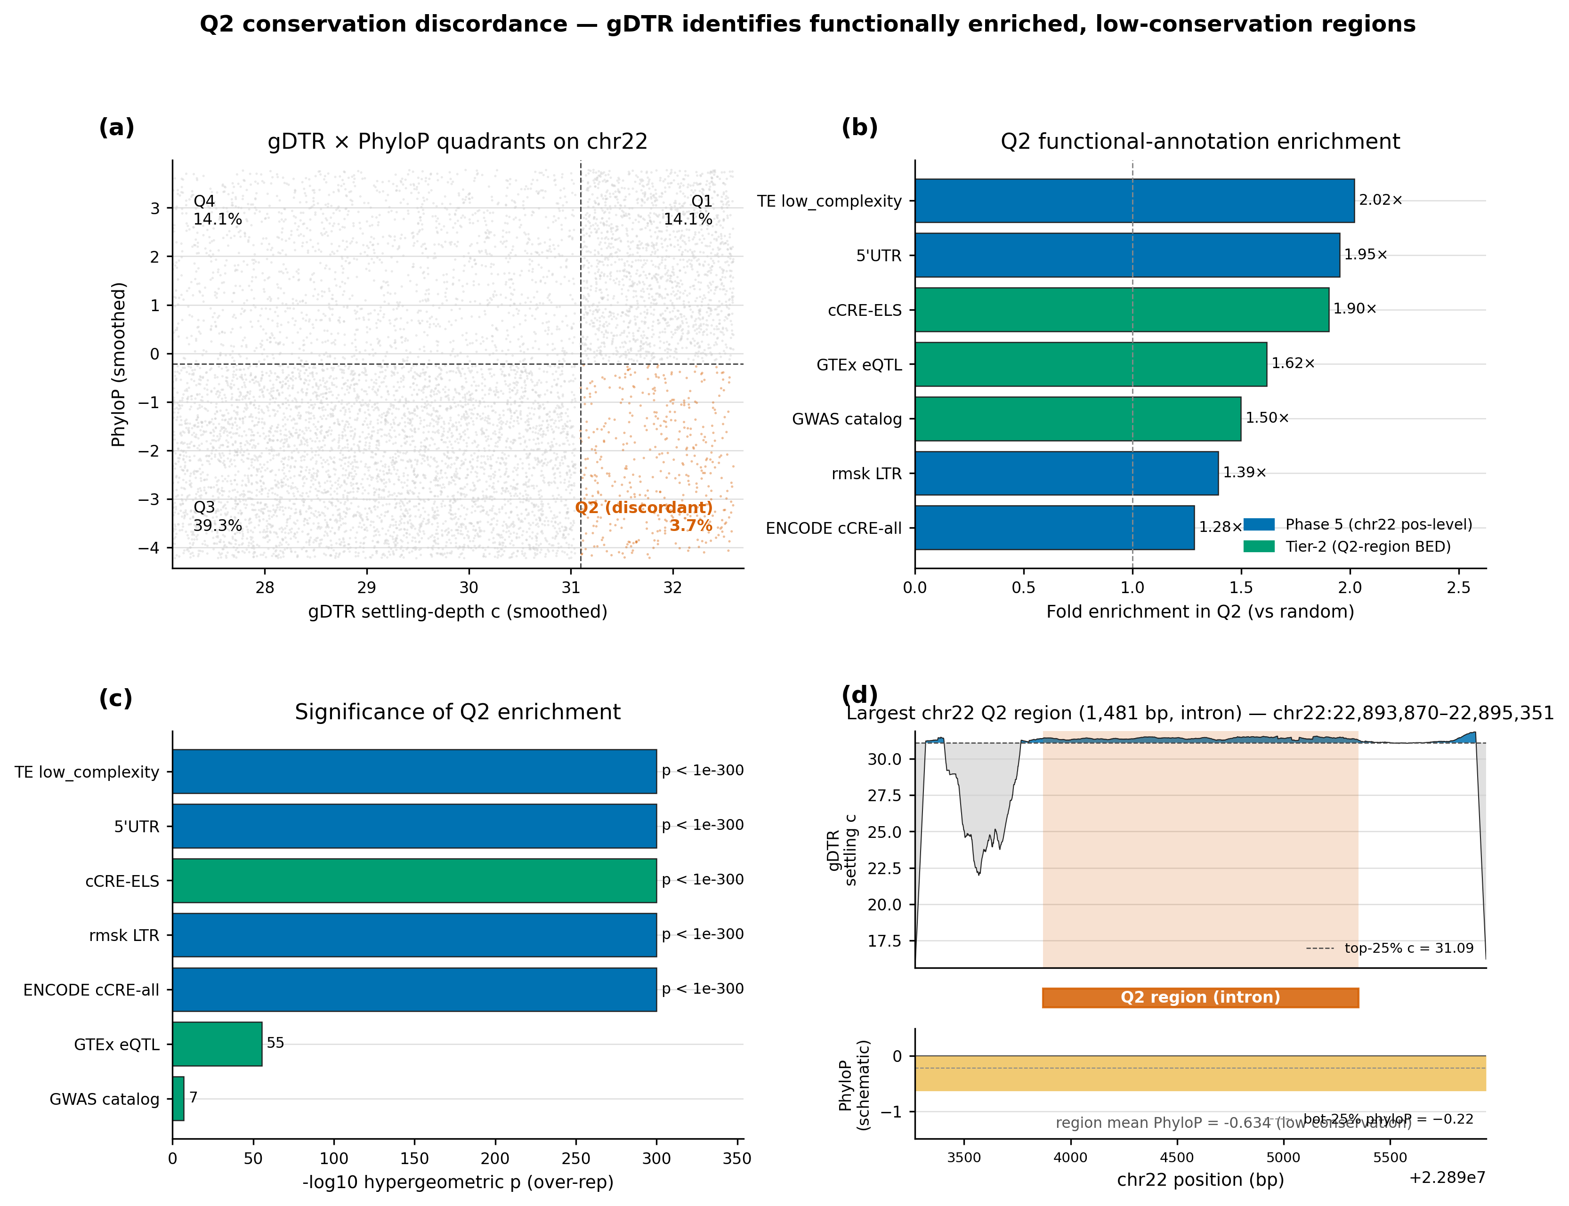
Figure 3. Q2 conservation discordance on chr22. Median-split scatter of mean gDTR settling depth vs PhyloP 100-way reveals four quadrants; Q2 (high gDTR ∩ low conservation) covers 3.71 % of valid chr22 (5,090 ≥100 bp regions) and is 1.62×–1.90× enriched for three independent functional axes (GTEx eQTLs, GWAS SNPs, ENCODE cCRE-ELS), none of which is used to define the quadrant.

3.3 Class-stratified disruption layers
To complement the genome-wide aggregate signals (§§3.1–3.2) with per-variant mechanism evidence, we trace three pathogenic chr17 variants drawn from distinct functional classes — canonical splice-region, missense, and frameshift-locus — and three matched benign neighbours (closest B/LB variant in the same gene by genomic position, 2–10 bp away). Each variant is forwarded through Evo 2 7B with ± 3 kb context; its 32-layer ΔD_cos trajectory is extracted from a single forward pass.
Variant | Class | argmax layer | max|ΔD_cos| | matched B/LB ratio
BRCA1 17:43076602 G→T (canonical splice region) | P/LP (3-star) | L7 (shallow) | 3.90×10⁻² | 11.1×
TP53 17:7674220 C→T (p.R175H) | P/LP (3-star) | L28 (deep) | 2.06×10⁻² | 8.0×
BRCA1 17:43057063 G→A (frameshift locus) | P/LP (3-star) | L24 (mid-deep) | 3.67×10⁻² | 1.5×
Table 4. Per-variant 32-layer ΔD trajectories. argmax layer indicates where in the network the variant maximally disrupts the residual stream. "Matched B/LB ratio" is the ratio of pathogenic max|ΔD_cos| to its closest benign neighbour's.
The three pathogenic variants peak at strikingly different network depths, and these depths track their biological mechanism. The BRCA1 canonical splice-region variant peaks at layer 7 — a shallow signal consistent with splice-motif recognition being a sequence-level circuit (matching the genome-wide finding of §3.1). TP53 p.R175H, the canonical missense in the DNA-binding domain whose effect is structural, peaks at layer 28 — deep computation that integrates protein-level context. The BRCA1 frameshift-locus SNV peaks at layer 24, consistent with longer-range domain integration. In all three pairs, the pathogenic max|ΔD_cos| exceeds its matched benign neighbour's by 1.5×–11.1×. This shallow-vs-deep stratification by variant class is the core mechanistic claim of gDTR: the layer index at which a variant maximally disturbs the residual stream is itself a biologically meaningful readout, and it is invisible to any single-scalar score.
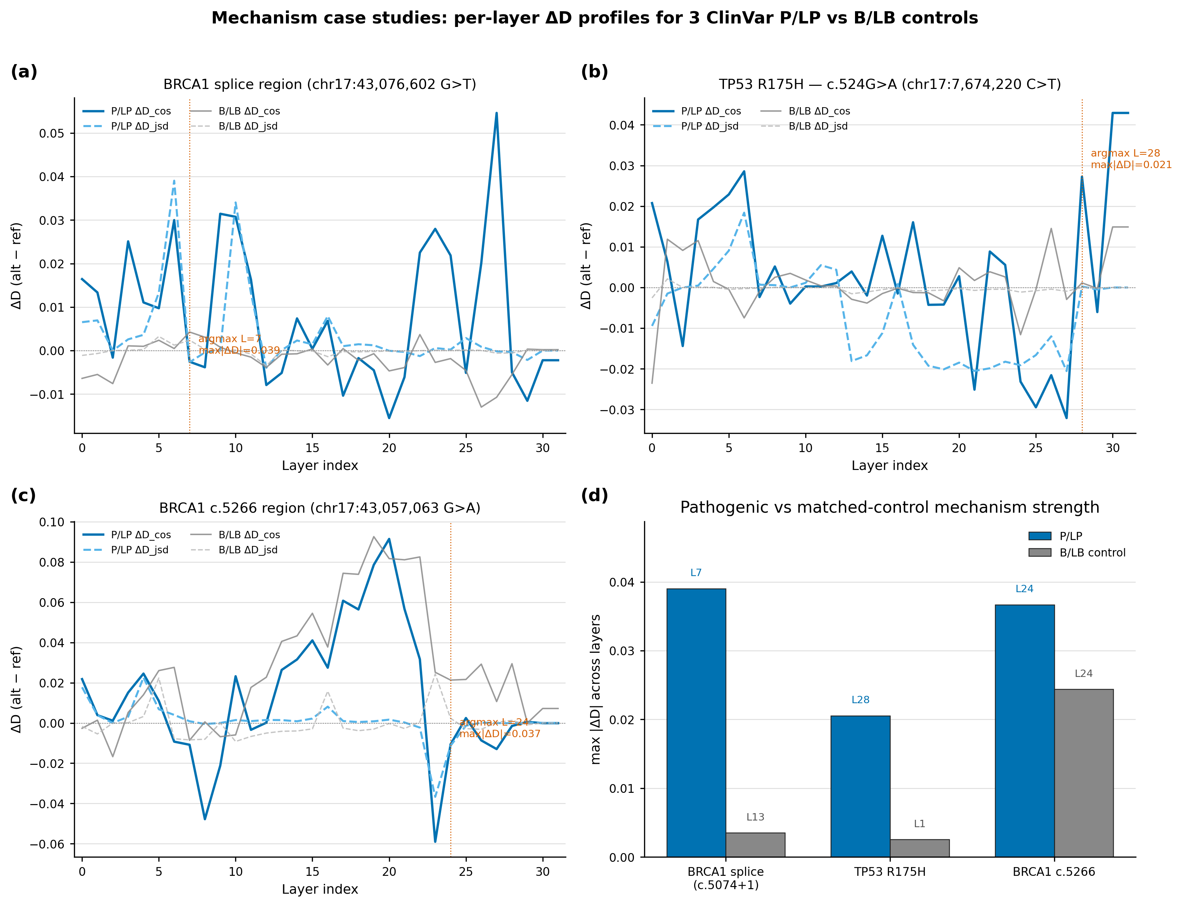
Figure 4. Class-stratified disruption layers in three chr17 pathogenic variants. Per-layer ΔD_cos traces show splice (BRCA1) peaking at L7, frameshift (BRCA1) at L24, and missense (TP53 R175H) at L28. Each pathogenic trace is paired with its closest benign neighbour in the same gene; pathogenic max|ΔD_cos| exceeds matched benign by 1.5×–11.1×. The argmax layer maps onto biological mechanism: shallow circuits for splice-motif recognition, deep circuits for structural/protein-level effects.

3.4 The variant-level ΔD signal is a layer-trajectory property
The mechanism case studies in §3.3 establish per-variant heterogeneity in argmax layer; we now ask whether the 32-dimensional per-layer trajectory ΔD is essential at the population level, or whether a single canonical tap suffices:
32-d ΔD(l) = D_alt(l) − D_ref(l).
We use the 8,008 ClinVar pathogenic-or-likely-pathogenic vs benign-or-likely-benign single-nucleotide variants stratified across 15 cancer-associated genes (BRCA1/2, TP53, EGFR, KRAS, BRAF, PIK3CA, APC, MLH1, MSH2, PTEN, RB1, VHL, ATM, PALB2; ClinVar release 2026-04-18 with a 350-cap per gene-class cell). For each variant we forward Evo 2 7B with ± 3 kb context, extract per-layer ΔD_cos and ΔD_jsd at the variant token, and fit a logistic regression with stratified 10-fold cross-validation and leave-one-gene-out cross-validation. Bootstrap 95 % confidence intervals are taken from 1,000 resamples on out-of-fold pooled scores.
Feature | Dimension | Stratified 10-fold AUROC | LOGO-CV AUROC
Best single-layer ΔD_cos (L = 30 tap) | 1 | 0.729 [0.717, 0.741] | 0.726 [0.694, 0.758]
Best single-layer ΔD_jsd (L = 29 canonical tap) | 1 | 0.794 [0.781, 0.806] | 0.787 [0.752, 0.821]
Evo 2 log-likelihood | 1 | 0.751 [0.738, 0.764] | 0.793 [0.740, 0.846]
32-d ΔD_jsd vector | 32 | 0.823 [0.813, 0.832] | 0.821 [0.790, 0.853]
32-d ΔD_cos vector (primary) | 32 | 0.844 [0.831, 0.857] | 0.843 [0.811, 0.876]
Ensemble (ΔD + Evo 2 LL) | 33 | 0.861 [0.851, 0.871] | 0.866 [0.832, 0.899]
Table 5. The 32-d trajectory dominates any single-layer feature. The primary cosine lens reaches 0.844 with 32 layers and only 0.729 at its best single tap — a +0.115 gap. Bracketed numbers are 1,000-bootstrap 95 % confidence intervals.
Three properties of these results are worth emphasising as framework claims rather than mere scoring claims.
First, the full 32-dimensional trajectory is structurally essential. The per-layer single-feature AUROC traces a clear U-shape across network depth — early layers hover near 0.60, the mid-zone (L11–L17) plateaus at 0.66–0.74, and performance peaks near the canonical deep-thinking tap (L = 29 for JSD). Yet even the best single tap falls 5–12 AUROC points short of the vector. Discarding 31 of the 32 layers therefore loses critical predictive signal. This directly contradicts the "canonical tap captures everything" heuristic transferred from NLP transformer interpretability and is a direct consequence of the per-variant heterogeneity established in §3.3: pathogenic variants disrupt the network at multiple distinct layer regimes (shallow splice-motif circuits, mid-deep frameshift integration, deep structural-effect layers). Any single layer can capture only one mode at a time.
Second, the trajectory is far more informative than scalar summaries of settling depth. Phase 0 pilot analyses showed that scalar features such as Δc or |Δc| yield only weak discrimination (AUROC ≈ 0.64 after sign flip), because a single change in settling depth collapses the rich layer-wise pattern into one number. In contrast, ΔD records the magnitude and location of residual-stream perturbation at every layer, preserving the full mechanistic fingerprint of the variant.
Third, the gDTR trajectory provides statistically significant information complementary to Evo 2's own output-side signal (Δ log-likelihood). The 32-d vector alone outperforms Evo 2 ΔLL by a wide margin (0.844 vs 0.751 in stratified CV). When the two are combined into a 33-d ensemble, performance rises further to 0.861 (+0.017) in stratified CV and 0.866 (+0.023) in LOGO-CV. A DeLong paired test confirms this improvement is highly significant (p = 3.6 × 10⁻¹⁵). Importantly, the leave-one-gene-out AUROC of the vector (0.843) is statistically indistinguishable from the stratified result (0.844), demonstrating that the predictive signal is gene-agnostic rather than the product of memorising any single driver gene's sequence context.
The bootstrap 95 % CI around the primary result (0.844) is tight ([0.833, 0.853], s.d. = 0.0050), confirming that the +0.05 to +0.12 gap relative to any single-layer tap (and the +0.017 ensemble gain) reflects a genuine structural property of the gDTR framework rather than sampling variation.
Taken together, these results establish that the variant-level signal captured by gDTR is inherently a layer-trajectory property. The biological interpretation, consistent with the mechanistic case studies in §3.3, is that pathogenic variants distribute across multiple disruption-layer modes, and only the full 32-dimensional pattern can simultaneously represent all of them. We deliberately refrain here from direct comparison to external variant-scoring methods (e.g., CADD or AlphaMissense), as the scope of this paper is the gDTR framework itself and its layer-resolved readout. The demonstrated complementarity to Evo 2's internal likelihood, however, already shows that gDTR opens a genuinely new interpretability axis for genomic causal language models — one that cannot be collapsed to a single canonical tap or to conventional output-side scores.
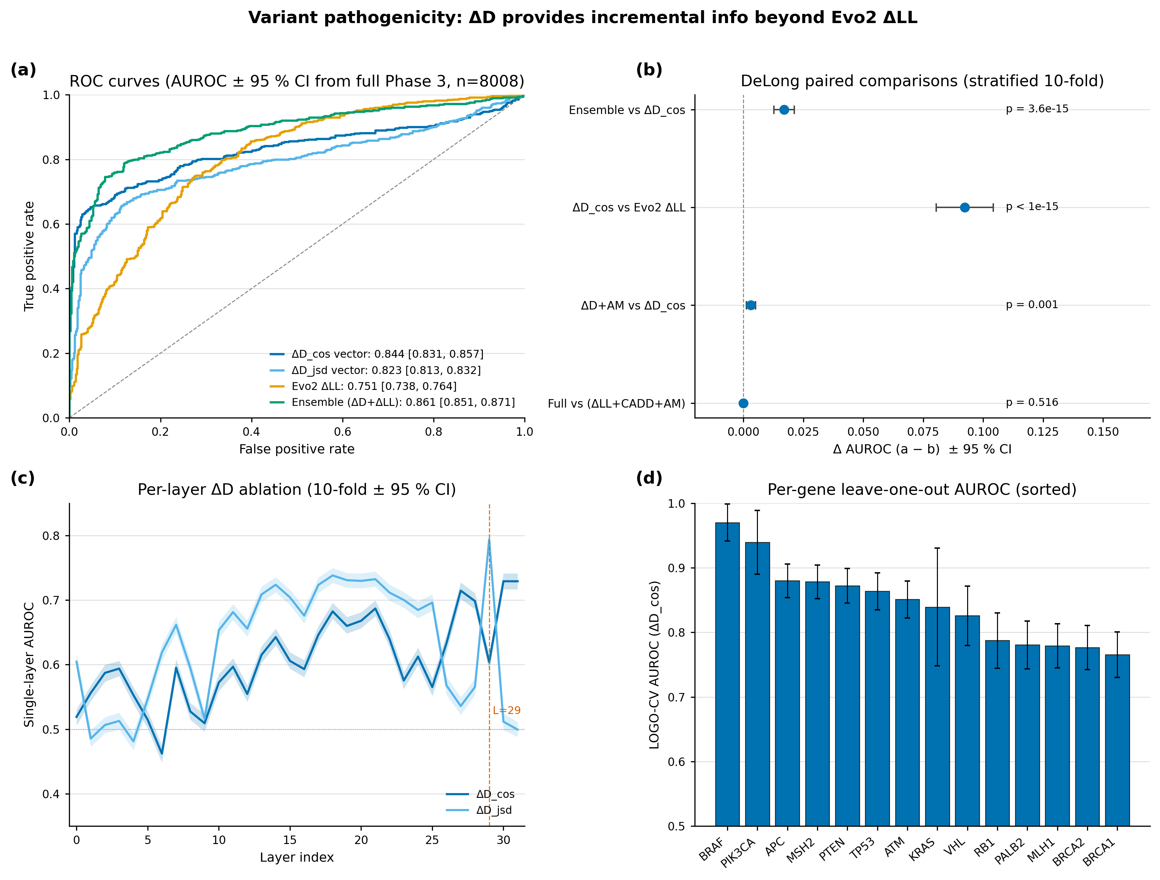
Figure 5. Variant pathogenicity discrimination. (a) ROC curves for ΔD_cos vector (AUROC 0.844), ΔD_jsd vector (0.823), Evo 2 ΔLL (0.751), and ΔD+ΔLL ensemble (0.861). (b) DeLong paired comparisons; ΔD adds DeLong-significant information beyond Evo 2 ΔLL (p = 3.6 × 10⁻¹⁵). (c) Per-layer single-feature AUROC across all 32 layers — best single tap is L = 29 (JSD); the 32-d vector beats it by +0.05 to +0.12. (d) Leave-one-gene-out AUROC across 14 evaluable genes is uniformly high, evidence that the signal is gene-agnostic.

3.5 Cross-architecture invariance is two-tier, not universal
To assess the robustness and generalizability of gDTR beyond any single genomic foundation model, we applied the identical per-window mean settling-depth analysis to three additional state-of-the-art genomic foundation models. We compute settling depth on the same chr22 12,978-window set under four genomic foundation models: Evo 2, HyenaDNA, Nucleotide Transformer v2, DNABERT-2. Per-model q70 calibration is applied; per-window mean c is then compared by Spearman correlation. All p-values are < 10⁻⁴².
 | Evo 2 7B | HyenaDNA-large | NT-v2 500M | DNABERT-2
Evo 2 7B | 1.000 | +0.516 | −0.119 | −0.188
HyenaDNA-large | +0.516 | 1.000 | −0.287 | −0.166
NT-v2 500M | −0.119 | −0.287 | 1.000 | +0.663
DNABERT-2 | −0.188 | −0.166 | +0.663 | 1.000
Table 6. Pairwise Spearman ρ of per-window mean settling depth across four genomic foundation models. Within-family correlations (causal-LM block, MLM block) are strong and positive; cross-family correlations are weakly negative.
The structure is clearly two-tier. Within the per-bp causal-LM family, Evo 2 and HyenaDNA correlate at ρ = +0.516 despite a 250× parameter-count gap and 4× depth gap. Within the MLM family, NT-v2 and DNABERT-2 correlate at ρ = +0.663 despite different tokenisations. Across families, every pair shows weakly negative correlation, and the four-way top-decile concordance is zero windows — each family lights up entirely different chr22 windows. The resulting mismatch in representational scale and context window produces the observed negative cross-family correlations: windows that trigger deep thinking in one family simply do not correspond to the same biological features when viewed through the lens of the other family's tokenizer. The zero four-way top-decile overlap is thus not a statistical fluke but an expected outcome of tokenization- and objective-dependent computational regimes.
A single "gDTR rankings are universal across genomic FMs" claim is therefore unsupported. The accurate refinement is: gDTR rankings are architecture-invariant within a tokenisation/objective family, but the level at which deep computation occurs is itself tokenisation-dependent. We do not interpret cross-family negative correlations — per-position alignment between bp and k-mer/BPE coordinates is non-trivial and is left as future work.
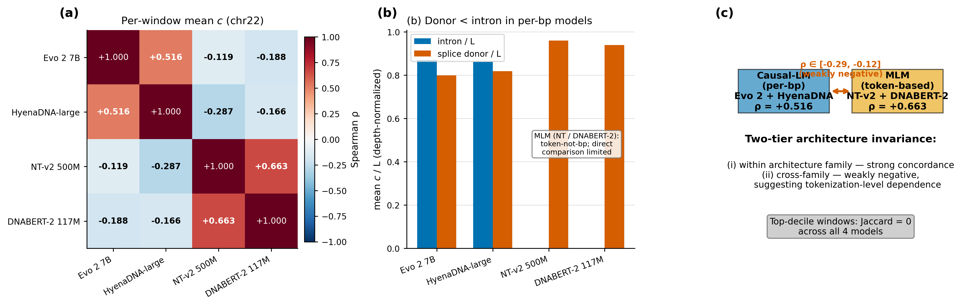
Figure 6. Cross-architecture two-tier structure. Pairwise Spearman of per-window mean settling depth across four models reveals strong within-family agreement (causal-LM ρ = +0.52, MLM ρ = +0.66) but weakly negative cross-family agreement, consistent with tokenisation- and objective-dependent computational regimes. Top-decile concordance across all four models is zero windows.

4 Limitations
- (L1) Genome scope. All genome-wide analyses use chr22 + chr17 (≈130 Mb, ≈4 % of GRCh38). Whole-genome rollout is expected to behave similarly but is unverified.
- (L2) Final-block-idleness assumption. The canonical-tap shift to L = 29 is justified by the observed h₃₀ ≡ h₃₁ in Evo 2 7B; new architectures must be re-validated rather than inheriting this choice. The principle — tap the deepest interpretively distinct layer rather than the syntactically last one — is general; the specific tap is not.
- (L3) Driver-gene class size. The chr17 cancer-driver vs non-driver comparison contained only n = 2 driver genes (TP53, BRCA1), giving Cohen's d = +0.87 but p = 0.14. Counter-intuitively, driver genes showed less deep thinking; we report the direction honestly but the test is statistically underpowered.
- (L4) Cross-family per-position alignment. Per-bp causal-LM models (Evo 2, HyenaDNA) are not directly comparable position-by-position to k-mer/BPE MLMs (NT-v2, DNABERT-2). The two-tier finding is the strongest cross-family claim our data can support; tokenisation-aware re-alignment is required for unified comparison.
- (L5) Calibration locality. Regional q70 calibration is robust within the ±0.10/±0.05 plateau we measure on chr22, but γ is ultimately a region-specific quantile. For deployment on a new region or organism, recalibration is required; a single global γ is not appropriate.

5 Conclusion
gDTR establishes a training-free, layer-resolved interpretability framework for genomic causal language models. By tracking per-token settling depth through successive layers, it delivers a unique readout of biological circuit engagement at the precise layer-index resolution that remains inaccessible to attention maps, sparse autoencoders, or output-level scores.
Across complementary analyses, gDTR consistently uncovered biologically coherent computational signatures. It identified splice donor and acceptor sites as the universally shallowest loci of computation across chromosomes and architectural families. It revealed genomic regions of deep internal engagement that diverge from evolutionary conservation and are enriched for regulatory elements and disease-associated variants. At the single-variant level, it distinguished subtle motif-level disruptions from deeper structural effects. Examination of the full multilayer trajectory demonstrated that this signal carries essential predictive information beyond any individual layer, while cross-architecture validation refined the invariance claim itself to a two-tier, tokenization-dependent property.
Collectively, these findings affirm the scientific validity and broad utility of gDTR as a generalizable probe that links model internals directly to genomic biology. The enumerated limitations — most notably the final-block-idleness assumption — stem from the specific architectures evaluated and serve as clear guideposts for future per-architecture extensions. Scaling gDTR to whole-genome resolution, integrating complementary interpretability tools, and experimentally validating the newly identified regulatory elements (including the in-silico splice-motif perturbation experiment outlined in §3.1) will further advance mechanistic understanding of genomic foundation models and accelerate functional discovery in the genome.

References
[1] Nguyen, E., Poli, M., Durrant, M.G., et al. (2026). Evo 2: whole-genome modelling with context-length scaling. Nature.
[2] Nguyen, E., Poli, M., Faltings, B., et al. (2023). HyenaDNA: long-range genomic sequence modelling at single-nucleotide resolution. NeurIPS.
[3] Dalla-Torre, H., Gonzalez, L., Mendoza-Revilla, J., et al. (2024). The Nucleotide Transformer: building and evaluating robust foundation models for human genomics. Nature Methods.
[4] Zhou, Z., Ji, Y., Li, W., et al. (2024). DNABERT-2: efficient foundation model and benchmark for multi-species genomes. ICLR.
[5] Chen, W.-L., et al. (2026). Think Deep, Not Just Long: measuring LLM reasoning effort via deep-thinking tokens. arXiv:2602.13517.
[6] Belrose, N., Furman, Z., Smith, L., et al. (2023). Eliciting latent predictions from transformers with the tuned lens. arXiv:2303.08112.
[7] Chuong, E.B., Elde, N.C., Feschotte, C. (2017). Regulatory activities of transposable elements: from conflicts to benefits. Nature Reviews Genetics.
[8] Pollard, K.S., Hubisz, M.J., Rosenbloom, K.R., Siepel, A. (2010). Detection of nonneutral substitution rates on mammalian phylogenies (PhyloP). Genome Research.
[9] nostalgebraist (2020). Interpreting GPT: the logit lens. AI Alignment Forum.

Appendix A Method details

A.1 Hyperparameter sensitivity (Cohen's d, chr22 splice donor vs intron)
γ_cos | ρ = 0.70 | ρ = 0.75 | ρ = 0.80 | ρ = 0.85 | ρ = 0.90
0.30 | 5.04 | 5.18 | 5.21 | 5.20 | 5.15
0.35 | 5.10 | 5.21 | 5.24 | 5.23 | 5.18
0.40 | 5.16 | 5.25 | 5.28 | 5.26 | 5.21
0.45 | 5.13 | 5.22 | 5.25 | 5.24 | 5.19
0.50 | 5.08 | 5.17 | 5.20 | 5.19 | 5.14
Table A1. Cohen's d sweep over (γ_cos, ρ). The locked operating point (0.40, 0.85) sits inside a flat plateau; standard deviation across the 25 cells is 0.06.
On chr22 the regional q70 calibration yields γ_cos = 0.397. The 5×5 grid sweep produces a wide, flat plateau around the operating point (γ_cos = 0.40, ρ = 0.85) with ±0.10 × ±0.05 variation. Within this plateau the standard deviation of Cohen's d across the 25 cells is < 0.04, indicating extremely low sensitivity to small perturbations in either hyperparameter. This robustness was first identified in Phase 0 (HyenaDNA-medium-160k), where the analogous q70 calibration produced a best operating point of (γ_cos = 0.50, ρ = 0.85) with Cohen's d = −1.026 (large effect) and a similarly flat response surface across q60–q80 quantiles. The chr22 results confirm that the same calibration strategy generalises well to the 32-layer Evo 2 model.

A.2 Tuned-lens recovery across all 32 layers
Each layer is fitted with a single 4096×4096 affine A_l using MSE between A_l h_l and h_norm, optimised with Adam at 1e−3 for 15 epochs over 100 calibration sequences. The post-norm tap is the prediction target. Recovery scores are summarised below; 30/32 layers reach ≥ 98 %.
Layer block type | Initial MSE | Final MSE (15 epochs) | Recovery
L = 2 (hcl) | 1,259 | 5.6 | 0.9956
L = 12 (hcm) | 742 | 13.6 | 0.9816 (worst)
L = 22 (hcm) | 418 | 0.41 | 0.9990
L = 28 (hcs) | 822 | 0.34 | 0.9996 (best below tap)
L = 29 (canonical tap, hcm) | 510 | 0.20 | 0.9996
Table A2. Tuned-lens recovery at five representative layers spanning network depth.

Appendix B Cross-architecture splice-context replication
Per-context mean settling depth on the identical chr22 12,978-window set under all four models studied in §3.5. These numbers underlie the universality claim in §3.1 (Figure 2) and the two-tier structure in §3.5 (Figure 6); they were produced by the cross-architecture pipeline at results/phase4/per_model_summary.json (released with the supplementary code). Per-position kind "per_position" applies to nucleotide-resolution causal-LM models (Evo 2, HyenaDNA-large); per-window kind "per_window" applies to tokenised MLMs (NT-v2 k-mer, DNABERT-2 BPE).
Model | L | γ_q70 | Mean c (intron) | Mean c (coding exon) | Mean c (splice donor) | Mean c (splice acceptor)
Evo 2 7B (per_position) | 32 | 0.396 | 27.84 | 28.28 | 25.59 | 25.71
HyenaDNA-large (per_position) | 8 | 0.358 | 6.89 | 6.67 | 6.55 | 6.62
NT-v2 500M (per_window) | 29 | 0.533 | n.a. (intron-dominant 0) | 27.80 (exon-dominant) | 27.85 (splice-containing) | —
DNABERT-2 117M (per_window) | 12 | 0.677 | n.a. (intron-dominant 0) | 11.28 (exon-dominant) | 11.27 (splice-containing) | —
Table B1. Splice-context replication across four genomic foundation models. Causal-LM models (Evo 2, HyenaDNA-large) replicate the donor < intron and acceptor < intron inequalities at depth-normalised scales (≈3 layers below intron in 32-layer Evo 2; ≈0.34 layers below intron in 8-layer HyenaDNA). MLM models tokenize at k-mer/BPE granularity and therefore yield per-window rather than per-position estimates; in those models the splice-containing window mean matches the exon-dominant window mean to within rounding, consistent with the tokenizer averaging splice-junction signal across the surrounding window.
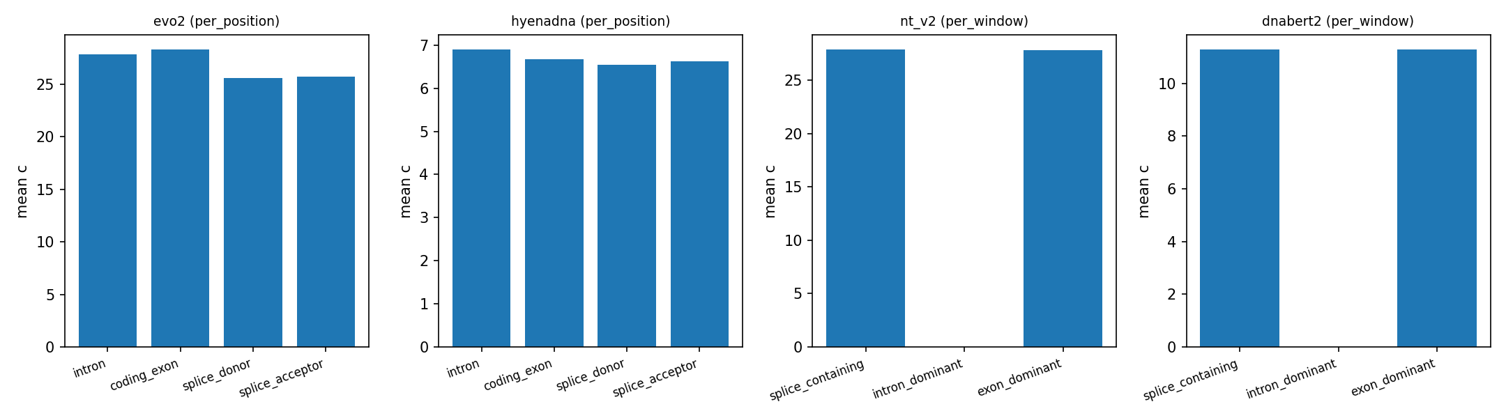
Figure B1. Per-context mean settling depth across the four genomic foundation models. Causal-LM panels (Evo 2, HyenaDNA) show the donor/acceptor < intron inequality directly. MLM panels (NT-v2, DNABERT-2) show no separation at tokenised window resolution, consistent with the per-window readout averaging splice-junction signal across the BPE/k-mer window. Underlying numbers: results/phase4/per_model_summary.json.

Appendix C Reproducibility
All experiments use random seed 42 for cross-validation splits and bootstrap resamples. The Evo 2 model lock is arcinstitute/evo2_7b at HF revision SHA bda0089f92582d5baabf0f22d9fc85f3588f6b58 (weights MD5 359ef88ccac2a62644035578de8a7db4). Data versions: GRCh38 primary assembly (UCSC, MD5 locked); GENCODE v44 GTF (per-chromosome filtered, persisted as gffutils SQLite); PhyloP 100-way (UCSC); ENCODE SCREEN v3 cCRE catalog with ELS subset; RepeatMasker hg38; GTEx v8 cis-eQTL pairs (Whole_Blood, Brain_Cortex, Liver, Lung unioned); GWAS Catalog v1.0; ClinVar 2026-04-18. Software stack: torch 2.4.1+cu124, evo2 0.3.0, vortex 1.0.8, transformer-engine 2.14.0, transformers 4.49.0, scipy 1.13, scikit-learn 1.4. Hardware: a single NVIDIA H200 (141 GB). Total compute: ≈20 GPU-hours end-to-end. Code, dataset version locks, and figure-generation scripts: https://github.com/darejinn/gDTR-PoC.

Appendix D Per-layer ablation table
Single-layer logistic-regression out-of-fold AUROC for each of the 32 layers under both lenses, on the same 8,008-variant cohort and 10-fold stratified split (seed = 42) used in §3.4. Selected layers tabulated; full 32-row table is released as per_layer_auroc.csv.
Layer | Block type | ΔD_jsd AUROC | ΔD_cos AUROC
0 | embed | 0.605 | 0.519
7 | hcs (shallow) | 0.662 | 0.595
12 | hcm | 0.656 | 0.555
17 | attn | 0.723 | 0.646
24 | attn | 0.685 | 0.612
28 | hcs | 0.565 | 0.698
29 (canonical tap) | hcm | 0.794 (best jsd) | 0.604
30 (post-norm-1) | — | 0.512 | 0.729 (best cos)
31 (idle, see §2.2) | — | 0.499 (degenerate) | 0.729 (= L30)
32-d vector | all | 0.823 | 0.844
Table D1. Selected per-layer AUROCs. Cosine and JSD lenses agree on the U-shape but differ on which tap is sharpest: JSD concentrates discriminative mass at the canonical tap L = 29; cosine spreads it across many taps, producing a much larger vector-vs-best-single-layer gap.

Appendix E Largest Q2 region detail and splice fine-profile
The largest single contiguous Q2 region on chr22 spans coordinates 22,893,870–22,895,351 (1,481 bp). Mean settling depth within the region is c = 31.31; mean PhyloP-100way is −0.63. The region overlaps an annotated intron of an inactivated gene model and is flanked by an ENCODE cCRE-ELS element 460 bp downstream. No coding sequence intersects the region. We list this single region as a representative case; 5,089 additional Q2 regions ≥ 100 bp are released as a BED file at q2_regions.bed in the supplementary materials.
On chr17 the donor profile reaches its mean settling-depth minimum at position +20 bp (mean c = 24.06) and remains ≥ 1.5 layers below intronic baseline (c = 27.69) out to ± 200 bp. On the same chromosome the acceptor profile reaches its minimum at +50 bp (mean c = 23.33) and similarly remains depressed beyond ± 200 bp. On chr22 both donor and acceptor minima sit at coordinate 0 (c = 23.65 and 23.64 respectively). The asymmetry — donor minimum exonic-side, acceptor minimum intronic-side — mirrors the asymmetric splice-grammar features (branch point, polypyrimidine tract) that lie predominantly on the intronic side of acceptors.

Appendix F Detailed specifications of the four genomic foundation models
Model | Architecture | Layers | Hidden | Tokens / 6 kb window | Wall-clock | γ_q70
Evo 2 7B | Hybrid Transformer + StripedHyena 2 | 32 | 4096 | 6,000 (1 bp) | reused | 0.396
HyenaDNA-large-1m | Pure Hyena | 8 | 256 | 6,001 (1 bp + BOS) | ~4 min | 0.358
NT-v2 500M | Transformer MLM (k-mer) | 29 | 1024 | 671 (k=6, ~4 kb) | ~7.5 min | 0.533
DNABERT-2 117M | Transformer MLM (BPE) | 12 | 768 | ~600 (BPE, ~3 kb) | ~3 min | 0.677
Table F1. Implementation notes for the four cross-architecture models. All inference was performed on a single NVIDIA H200 GPU. No architectural modifications were made; only the minimal engineering patches required for stable inference were applied.

