Department of Information Technology
“IoT Based Smart Agriculture Monitoring System”
Submitted in partial fulfillment of the requirements
of the degree of
Bachelor of Engineering
By
07 Harshal Bhosale
13 Rakesh Chaudhary
15 Pranit Chiman
73 Om Darekar
Supervisor:
(Prof. Janhavi Baikerikar)

The Bombay Salesian Society’s
Don Bosco Institute of Technology, Mumbai
(An Autonomous Institute Affiliated to the University of Mumbai)
A.Y. 2026-2027

The Bombay Salesian Society’s
Don Bosco Institute of Technology, Mumbai
(An Autonomous Institute Affiliated to the University of Mumbai)
Department of Information Technology
CERTIFICATE
This is to certify that the project entitled “IoT Based Smart Agriculture Monitoring System” is a bonafide work of
07 Harshal Bhosale
13 Rakesh Chaudhary
15 Pranit Chiman
73 Om Darekar

submitted to the University of Mumbai in partial fulfillment of the requirements for the award of the degree of Bachelor of Engineering in Information Technology.
Date: /11/2026
(Prof. Janhavi Baikerikar)
Supervisor

(Dr. Sunantha G.)  HOD, IT Department | (Dr. Sudhakar Mande)  Principal

The Bombay Salesian Society’s
Don Bosco Institute of Technology, Mumbai
(An Autonomous Institute Affiliated to the University of Mumbai)
Department of Information Technology
Project Report Approval for B.E.
This project report entitled “IoT Based Smart Agriculture Monitoring System” by Harshal Bhosale, Rakesh Chaudhary, Pranit Chiman and Om Darekar is approved for the degree of Bachelor of Engineering in Information Technology.
1. ___________________________________
2. ___________________________________
(Examiner’s Name and Signature)
____________________________
(Prof. Janhavi Baikerikar)
Supervisor
Date: /11/2026
Place: Kurla (West)

The Bombay Salesian Society’s
Don Bosco Institute of Technology, Mumbai
(An Autonomous Institute Affiliated to the University of Mumbai)
Department of Information Technology
Declaration
I declare that this written submission represents my ideas in my own words and where others’ ideas or words have been included, I have adequately cited and referenced the original sources. I also declare that I have adhered to all principles of academic honesty and integrity and have not misrepresented or fabricated or falsified any idea, data, fact or source in my submission. I understand that any violation of the above will be cause for disciplinary action by the Institute and can also evoke penal action from the sources which have thus not been properly cited or from whom proper permission has not been taken when needed.
Name of the Student | Roll No. | Signature
Harshal Bhosale | 07
Rakesh Chaudhary | 13
Pranit Chiman | 15
Om Darekar | 73

Date: /11/2026

Abstract
Agriculture relies on timely knowledge of soil and environmental conditions. Manual field inspection can delay recognition of dry soil, excessive moisture, high temperature, unfavorable humidity and changes in local gas-sensor readings. A low-cost monitoring interface can help farmers assess conditions and plan timely actions.
This report describes an Internet of Everything (IOE) based Smart Agriculture Monitoring System built around an ESP32 development board. A DHT11 measures ambient temperature and humidity; a resistive soil probe provides an analog wetness reading; and an MQ7 module contributes a raw gas-sensor signal. The ESP32 samples these sensors and makes measurements available through its built-in Wi-Fi connection.
An ESP32 HTTP web server responds with JSON at /data. A standalone browser dashboard implemented in HTML, CSS and JavaScript polls this endpoint, displays live readings, status indicators and short trend graphs, and evaluates configurable alert thresholds. The browser independently retrieves the next 12 hours of forecast information from OpenWeatherMap using a user-entered key.
The decision process converts calibrated raw soil input into an indicative moisture percentage, distinguishes dry soil from possible waterlogging, and issues heat, humidity and raw-gas alerts. If rain is likely, the dashboard may recommend delaying irrigation despite dry soil. The MQ7 readings are not calibrated CO concentrations and the prototype does not operate irrigation pumps or other actuators.
The supplied firmware, dashboard and working hardware demonstrate a local-network agricultural monitoring and advisory system linking Things, Data, Processes and People. Future improvements focus on validated sensing, secure connectivity, history retention and interface reliability, while preserving human control over agricultural actions.
Keywords: Internet of Everything, Smart Agriculture, ESP32, DHT11, MQ7, Soil Moisture, HTTP, OpenWeatherMap.

Contents
1 Introduction | 1
1.1 Problem Statement | 1
1.2 Scope of the Project | 1
1.3 Current Scenario | 2
1.4 Need for the Proposed System | 2
1.5 Summary of the Results and Tasks Completed | 3
2 Review of Literature | 4
2.1 Summary of the Investigation in Published Papers and Technical Sources | 4
2.2 Comparison Between Tools / Methods / Algorithms | 5
2.3 Algorithm(s) with Example | 6
3 Analysis and Design | 7
3.1 Methodology / Procedure Adopted | 7
3.2 Analysis | 7
3.2.1 Software / System Requirement Specification – IEEE Format | 8
3.3 System Architecture / Design | 8
3.3.1 Modules and Their Description | 9
4 Implementation | 13
4.1 Implementation Plan for Sem – 8 | 13
4.2 Coding Standard | 14
4.3 Testing | 14
4.3.1 Test Cases | 14
4.3.2 Results of Testing and System Performance | 15
5 Results and Discussion | 16
6 Conclusion & Future Work | 18
Appendix - I: Data Sheets and Installation Procedure | 19
Appendix - II: Software Requirement Specification | 21
Appendix - III: Source Code Listings | 23
References | 26
Acknowledgements | 27
Sustainable Development Goals | 28
Technical Paper in IEEE Format | 29

List of Figures
Figure 3.1: Block diagram of the IoE Smart Agriculture architecture | 8
Figure 3.2: Circuit diagram showing ESP32 and sensor wiring | 9
Figure 3.3: Flowchart of sensing and decision-support process | 11
Figure 3.4: Data Flow Diagram – Level 0 | 11
Figure 3.5: Data Flow Diagram – Level 1 | 12
Figure 4.1: Proposed Semester VIII implementation schedule | 13
Figure 5.1: Complete Smart Agriculture hardware setup | 16
Figure 5.2: ESP32 and sensor connection close-up | 16
Figure 5.3: Web dashboard with active warnings | 17
Figure 5.4: Web dashboard and calibration settings | 17

List of Tables
Table 1.1: Modules planned and achieved | 3
Table 2.1: Summary of reviewed project sources | 4
Table 2.2: Comparison of agricultural monitoring methods | 5
Table 2.3: Comparison of local vs cloud architecture | 5
Table 2.4: Time and space complexity of project algorithms | 6
Table 3.1: Requirements refined during development | 7
Table 3.2: Cost analysis of the sensor endpoint | 7
Table 3.3: The four pillars of IOE in the project | 8
Table 3.4: Technology stack | 8
Table 3.5: JSON schema of the ESP32 /data endpoint | 8
Table 3.6: Comparison with traditional field monitoring | 9
Table 3.7: GPIO pin mapping | 9
Table 4.1: Work Breakdown Structure for Sem – 8 | 13
Table 4.2: Individual contribution | 13
Table 4.3: Naming conventions used | 14
Table 4.4: Functional test cases | 14
Table 4.5: Results of functional testing | 15
Table 5.1: Comparison between proposed system and conventional practice | 17
Table A.1: ESP32 development board | 19
Table A.2: DHT11 sensor | 19
Table A.3: Soil moisture sensor | 19
Table A.4: MQ7 module | 19

1 Introduction

1.1 Problem Statement
Agricultural management depends on frequent assessment of soil moisture and ambient conditions. Manual checks can be infrequent, and their observations are not continuously available to the farmer. Soil may become too dry or overwatered while changes in temperature, humidity or gas-sensor readings go unnoticed.
Existing monitoring solutions may depend on a proprietary mobile application or a remote platform, restricting inspection of live readings without an account or external infrastructure. Irrigation decisions based only on current dryness may also waste water when rainfall is likely.
Aim of the project: to implement a low-cost Internet of Everything (IOE) based Smart Agriculture Monitoring System that links ESP32 sensor readings to a locally accessible custom browser dashboard, integrates an external weather forecast, and provides understandable, rule-based recommendations. All irrigation and ventilation actions remain the responsibility of the user.

1.2 Scope of the Project
The project scope and assumptions are as follows:
• Live environmental monitoring: temperature and relative humidity from DHT11, estimated moisture from a resistive soil probe, and a raw MQ7 analog signal.
• Local connectivity: ESP32 Wi-Fi station mode with HTTP data access at /data and browser polling, without Blynk or a project cloud database.
• Custom web application: responsive sensor cards, trend indicators, connectivity status, calibration controls and practical recommendations.
• Weather-aware advice: OpenWeatherMap forecast data considered together with local readings for irrigation decisions.
• User-controlled action: the dashboard informs farmers; it does not switch irrigation pumps, fans or other actuators.
Assumptions and limits: the ESP32 and browser can reach each other through the local network; the browser has internet access when forecast data is used; the user supplies the OpenWeatherMap API key. Soil moisture percentage is an indicative calibrated index, and the MQ7 signal is not reported as certified CO ppm.
• Requirements gathering phase: identify sensor parameters, local-network requirements and crop-related decision needs.
• Requirements analysis phase: select ESP32 and three existing sensors, determine the dashboard JSON contract, assess calibration and safety limitations.
• System design phase: develop local server architecture, dashboard panels, weather call and threshold rules.
• Validation phase: check hardware readings, browser access and working forecast integration on the actual prototype.

1.3 Current Scenario
Manual field inspection provides measurements only when a farmer visits the site. Readings may be recorded informally and may not be immediately comparable against practical thresholds. A stand-alone sensor display also cannot combine local field measurements with an upcoming rain forecast.
• Soil irrigation can be mistimed because the soil is inspected too rarely.
• Changes in local temperature and humidity may not be apparent until the next inspection.
• A raw gas-sensor response may be difficult to interpret without a clear indication that it is uncalibrated.
• A proprietary monitoring application may introduce unnecessary accounts or platform dependence.

1.4 Need for the Proposed System
An accessible local monitoring system is needed to present field conditions and prompt informed action without depending on automatic control. The selected architecture satisfies this need by:
• making live measurements available on an ordinary browser through the ESP32 IP address;
• transforming a resistive probe reading into an estimated percentage with adjustable wet/dry calibration;
• indicating dry soil, excess moisture, heat, high humidity and elevated raw gas-sensor levels using configurable limits;
• consulting near-term weather conditions to avoid recommending unnecessary irrigation before likely rainfall;
• retaining settings locally and displaying recent on-screen trends;
• connecting People, Process, Data and Things in one low-cost academic prototype.

1.5 Summary of the Results and Tasks Completed
Table 1.1: Modules planned and achieved
Module | Planned work | Status
Sensor node (ESP32) | Read DHT11 and average analog soil/MQ7 data | Working on hardware
Local HTTP service | Expose JSON measurements on /data | Working
Custom browser dashboard | Live values, status, trends and calibration | Working
Weather service | Fetch 12-hour forecast through OpenWeatherMap | Working
Decision-support rules | Dry soil, rain, heat, humidity and gas guidance | Implemented
Persistent logging and secure remote access | Potential later enhancement | Future scope

The hardware, dashboard and forecast display have been operated successfully on the real prototype as confirmed by the project team. No calibrated reference dataset, field water-savings result or independently measured end-to-end latency has been supplied; these results are not claimed.
In the embedded layer, the DHT11 provides two environmental quantities through one digital signal line, while GPIO34 and GPIO35 acquire the independent analog channels. The ESP32 caches these measurements and makes them available through a lightweight web service rather than pushing them to a separate database. This division keeps sensing and networking on the microcontroller, while interpretation remains in the browser.
In the interface, the farmer enters the ESP32 address and starts live polling. The dashboard displays the current readings with short in-session traces and evaluates advice using calibration and warning limits saved locally in the browser. Weather lookup is optional: the forecast is retrieved through OpenWeatherMap, and failure to configure the key does not prevent the ESP32 sensor display from working.

2 Review of Literature

2.1 Summary of the Investigation in Published Papers and Technical Sources
The source report surveys smart agriculture approaches and supplies primary technical references for the parts used in this prototype. The discussion below is restricted to those references rather than introducing unsupported claims about unpublished experiments or measured performance.

1. ESP32 Technical Reference Manual [1]
Describes the ESP32 processor, Wi-Fi and analog-to-digital interface. It supports the choice of the ESP32 for both sensor acquisition and local HTTP service.

2. DHT11 Technical Data Sheet [2]
Documents the sensor’s operating range, basic precision limits and single-wire digital data interface. These constraints limit the prototype to general ambient monitoring.

3. MQ7 Manufacturer Information [3]
Describes MQ7 gas-sensing characteristics and the need for appropriate heater operation and calibration. The project therefore displays raw ADC output, not a calibrated CO concentration.

4. Adafruit DHT Sensor Library [4] and Arduino Documentation [9]
Provide software support for reading DHT11 values and building an ESP32 embedded application with Arduino C/C++.

5. OpenWeather Forecast API [5]
Provides the 5-day / 3-hour forecast endpoint used by the browser to obtain the next four forecast samples and evaluate near-term rain probability.

6. Agriculture IoT Review [8]
The cited 2017 review introduces IoT sensing opportunities and challenges for agriculture; this project demonstrates a small monitoring and decision-support implementation rather than proving crop-yield changes.
Table 2.1: Summary of reviewed project sources
Ref. | Area | Project relevance
[1] | ESP32 hardware | Wi-Fi and ADC1-based acquisition
[2] | DHT11 | Temperature / humidity operating limits
[3] | MQ7 | Gas sensing and calibration caution
[4], [9] | Arduino libraries | Sensor acquisition and serial diagnostics
[5] | Forecast API | Rain-aware decision support
[8] | Agriculture IoT literature | Context for sensing and decision support

2.2 Comparison Between the Tools / Methods / Algorithms
The system was selected for local accessibility, low hardware complexity and direct user control. The comparisons reflect the design alternatives discussed in the original project report.
Compared with the earlier Blynk-based implementation described in the source report, the present interface is a self-contained browser page. It does not require the Blynk service to render sensor readings, although the viewing device must still reach the ESP32 over Wi-Fi. The sensor node and the forecast API serve different roles: the former reports conditions measured at the installed hardware, while the latter supplies broader predictions for the selected city.
The design deliberately limits the meaning of displayed results. A soil percentage is a relative index derived from two user-selected raw readings, not a laboratory measurement of water content. Likewise, the MQ7 card shows an ADC number that can be compared with configurable warning limits, not a calibrated carbon-monoxide concentration. These distinctions are central to interpreting the comparison tables.
Table 2.2: Comparison of agricultural monitoring methods
Parameter | Manual inspection | Blynk-based IoT | Proposed local dashboard
Readings | Occasional field checks | App-based remote values | Browser-based live values
Platform dependency | None | Blynk mobile service | No Blynk account
Forecast-aware advice | Manual judgement | Depends on app configuration | Built-in browser weather rules
Soil calibration | Observation-based | Depends on implementation | Editable dry/wet ADC values
Actuator control | Manual | May be configured | Not implemented; advisory only

Table 2.3: Comparison of local vs cloud architecture
Aspect | ESP32 local HTTP (adopted) | Cloud-dependent alternative
Connectivity | Browser reaches ESP32 on local Wi-Fi | Requires external data platform
Storage | No permanent sensor-history database | May support stored history
Software | Independent HTML/CSS/JavaScript file | Cloud dashboard or app
Remote reach | Not open to unrestricted internet | Requires authenticated architecture
Credentials | Wi-Fi in firmware; weather key in browser | Cloud credential management required

2.3 Algorithm(s) with Example

Algorithm 1: Averaged sensor acquisition on ESP32
Every ~2 seconds:
read DHT11 temperature and humidity
set dhtOk = true only if both readings are valid
for each analog sensor (soil and MQ7):
take 10 ADC readings with brief delay
return integer average
retain latest measurements
On GET /data: return JSON of cached measurements
Example: a soil input is read ten times and the firmware returns their arithmetic mean as the raw soil field. If the DHT11 read fails, dhtOk becomes false while previous temperature/humidity values remain cached.

Algorithm 2: Soil moisture conversion and rain-aware irrigation advice
soilPct = clamp(0, 100, (dryReading - rawSoil) /
(dryReading - wetReading) * 100)
if soilPct < soilLow:
if forecastRainProbability >= 0.60:
suggest postponing irrigation
else:
suggest irrigation
else if soilPct > soilHigh:
warn of possible waterlogging
Example using editable defaults: dry = 3200, wet = 1400 and raw = 2700 produces 27.8% estimated moisture. This is below the default 30% irrigation threshold. If the near-term maximum rain probability is at least 60%, the advice changes to wait rather than irrigate immediately.

Algorithm 3: Warning evaluation
The browser checks configured temperature limits (32°C warning; 38°C critical), raw MQ7 limits (1500 warning; 2500 critical), soil-waterlogging percentage (85%) and combined heat–humidity conditions. The overall banner summarizes the severity of the generated advisories. Thresholds are user adjustable and are not validated crop-specific standards.
Table 2.4: Time and space complexity of project algorithms
Algorithm | Time complexity | Space complexity
Analog averaging (10 samples) | O(10) = O(1) per sensor | O(1)
Soil calibration formula | O(1) | O(1)
Threshold-based recommendations | O(1) per refresh | O(1)
Forecast reduction (four 3h samples) | O(4) = O(1) | O(1)
Trend storage (30 readings per channel) | O(30) per redraw | O(30) per series

3 Analysis and Design

3.1 Methodology / Procedure Adopted
Development proceeded through connected stages: sensor and pin selection, ESP32 wiring, firmware data acquisition, local HTTP endpoint testing, browser interface implementation, OpenWeatherMap integration, calibration controls, decision rules and real-hardware demonstrations. The implementation replaces the previous semester’s Blynk application with a dedicated browser dashboard while retaining the essential sensor connections.
Validation used the ESP32 Serial Monitor and the locally opened dashboard to check that all four readings display properly. The weather panel was also confirmed to load successfully. No claimed statistical measurement dataset is available in the provided report and source files.

3.2 Analysis
Technical feasibility: the ESP32 includes 2.4 GHz Wi-Fi, digital GPIO and ADC1 analog inputs, so it can acquire the selected sensors and serve a small JSON response. HTML, CSS and JavaScript run in a standard browser; the OpenWeatherMap API adds forecast information separately.
Economic feasibility: the source report estimates ₹1,280 for the full hardware list, including a separately listed optional supply. Arduino IDE, the ESP32/DHT libraries and a locally opened HTML dashboard require no mandatory application license for this demonstration.
Operational feasibility: the user enters the ESP32 IP, presses Connect, and inspects the live readings and agricultural advisories. Data acquisition stays local and no pump or ventilation equipment is controlled.
Table 3.1: Requirements refined during development
Requirement | Earlier approach | Current approach | Reason
User interface | Blynk mobile app | Custom HTML/JS dashboard | Independent browser UI
Device data | Blynk transmission | Local HTTP /data JSON | Direct local access
Irrigation guidance | Soil observation | Soil + rain forecast | Context-aware advice
Sensor limits | Preselected values | Browser-editable thresholds | Adjustable demonstration
Actuators | Not part of this version | Recommendations only | Human retains control

Table 3.2: Cost analysis of the sensor endpoint
Sr. No. | Component | Qty | Approx. cost (INR) | Use
1 | ESP32 development board | 1 | 500 | Wi-Fi controller
2 | DHT11 | 1 | 100 | Ambient sensing
3 | Soil moisture probe | 1 | 80 | Analog soil sensing
4 | MQ7 gas sensor | 1 | 150 | Raw gas signal
5 | Breadboard | 1 | 120 | Prototyping
6 | Jumper wires | 1 set | 100 | Wiring
7 | USB cable | 1 | 80 | Power/programming
8 | External power supply (optional) | 1 | 150 | Standalone power
 | Total |  | 1,280 | Estimate from own report

3.2.1 Software / System Requirement Specification – IEEE Format
The Software Requirement Specification tailored to this ESP32 monitoring and advisory project appears as Appendix II. It describes the functional and interface requirements, operating assumptions, quality considerations and the exclusion of automatic control.

3.3 System Architecture / Design
The system combines physical sensing, local network exchange, independent weather information and browser-side decision support. The ESP32 acquires readings and publishes JSON; the dashboard performs display, calibration and recommendation logic.
Table 3.3: The four pillars of IOE in the project
Pillar | Components in the implemented project
Things | ESP32 with DHT11, resistive soil-moisture and MQ7 modules
Data | Digital temperature/humidity, analog averages, JSON and forecast values
Process | Polling, calibration conversion, alert thresholds and rain-conditioned advice
People | Farmer or operator who reads recommendations and acts manually

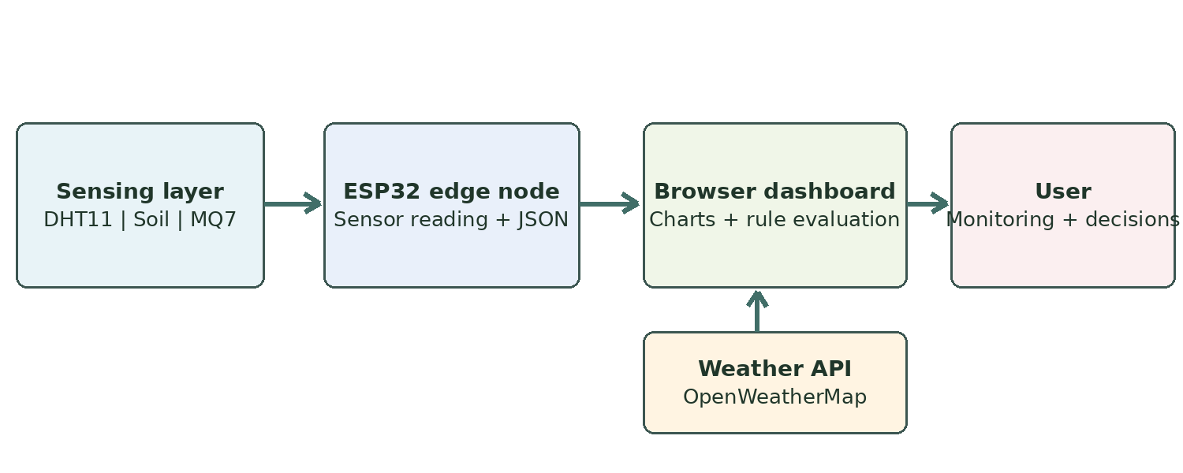
Figure 3.1: Block diagram of the IoE Smart Agriculture architecture
Table 3.4: Technology stack
Technology | Role
ESP32 Arduino C++ | Read sensors, manage Wi-Fi and serve JSON
WiFi.h / WebServer.h | Local HTTP networking at port 80
Adafruit DHT library | DHT11 acquisition
HTML, CSS and JavaScript | Interactive dashboard, visualizations and rules
Browser localStorage | Preserve settings and calibration limits
OpenWeatherMap 5-day / 3-hour API | Fetch near-term forecast in browser

Table 3.5: JSON schema of the ESP32 /data endpoint
Field | Type | Meaning
temperature | Number | Last valid DHT11 temperature in °C
humidity | Number | Last valid DHT11 relative humidity in %
soil | Integer | Average raw soil ADC reading
gas | Integer | Average raw MQ7 ADC reading
dhtOk | Boolean | Whether latest DHT11 read succeeded

Table 3.6: Comparison with traditional field monitoring
Feature | Conventional practice | Proposed IOE system
Data visibility | Field visit / manual notes | Periodic local dashboard refresh
Soil decisions | Observed wetness only | Calibration + rain-aware advice
Heat awareness | Occasional observation | Live temperature/humidity warnings
Gas sensing | Often absent | Raw MQ7 signal and caution
Control | Manual | Manual, informed by dashboard

3.3.1 Modules and Their Description

Module 1 – ESP32 sensor node
The ESP32 reads the DHT11 on GPIO4, soil sensor on GPIO34 and MQ7 on GPIO35. Analog inputs are on ADC1-capable pins, avoiding the known ESP32 ADC2/Wi-Fi conflict. All three attached sensors are operated at 3.3 V in the actual assembled prototype, as confirmed by the team.
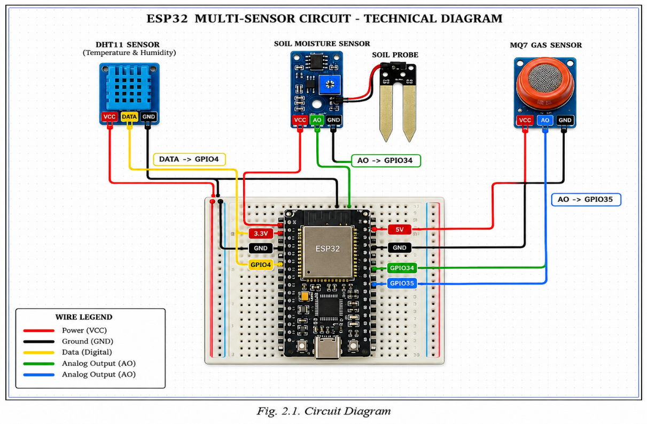
Figure 3.2: Circuit diagram showing ESP32 and sensor wiring
Table 3.7: GPIO pin mapping
Device | ESP32 pin | Function
DHT11 data | GPIO4 | Digital temperature/humidity
Soil moisture AO | GPIO34 | ADC1 analog input
MQ7 AO | GPIO35 | ADC1 analog input

Module 2 – Local HTTP service
The firmware uses WebServer(80), registers the /data endpoint and sends JSON on HTTP GET. An Access-Control-Allow-Origin header supports a separate locally opened browser page; Cache-Control: no-store prevents use of previously cached response data.

Module 3 – Custom dashboard
The browser displays temperature, humidity, estimated soil moisture and raw gas cards with animation and short trends. A connection indicator, global status banner, editable limits and an advice panel help the user interpret measurements. Polling defaults to every three seconds.

Module 4 – Forecast integration
The browser sends HTTPS requests to OpenWeatherMap for a selected city and the user-provided key. The application examines the next four three-hour forecast records and uses the greatest probability of precipitation when offering irrigation advice.

Module 5 – Decision-support rules
JavaScript evaluates dry soil, likely rain, waterlogging, heat, humidity and raw gas warnings against configurable thresholds. No relay, pump, fan or automatic switching mechanism is controlled by these rules.
The decision procedure first converts the resistive probe signal into a bounded percentage using the configured dry and wet readings. Soil below the lower threshold normally produces an irrigation recommendation; when the weather result shows a probability of precipitation of at least 60%, the advice may instead suggest waiting. Soil above the upper threshold produces a possible waterlogging message. These messages support manual decisions and do not command a water pump.
Temperature, humidity and gas conditions are assessed in the same JavaScript function. Heat warnings use two configurable temperature limits, while gas warnings compare the raw MQ7 ADC value against separate warning and critical levels. A combined hot-and-humid condition also provides an advisory message when its rule is reached. The browser assigns an overall status from the most severe recommendation, and each card retains its own visual threshold state.
The ESP32 and the weather service communicate independently with the browser. Thus, unavailable internet weather data need not prevent local sensing, and disconnected Wi-Fi prevents fresh sensor updates even when a previously retrieved forecast can still be displayed. The in-browser charts are short trend views that reset with the session; historical cloud storage is outside the present implementation.
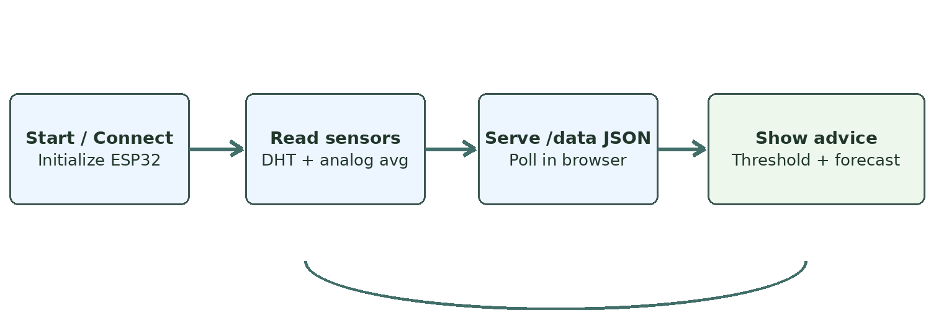
Figure 3.3: Flowchart of sensing and decision-support process
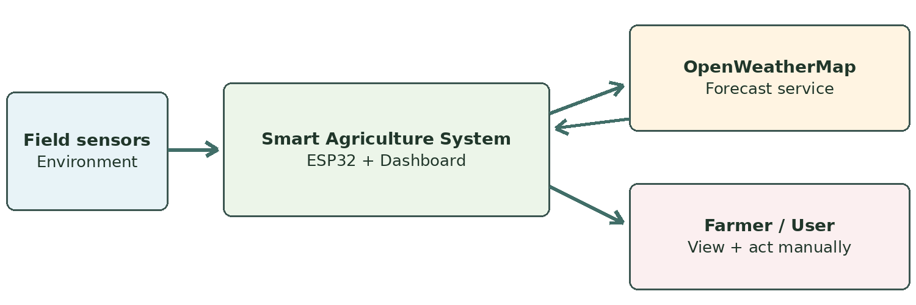
Figure 3.4: Data Flow Diagram – Level 0

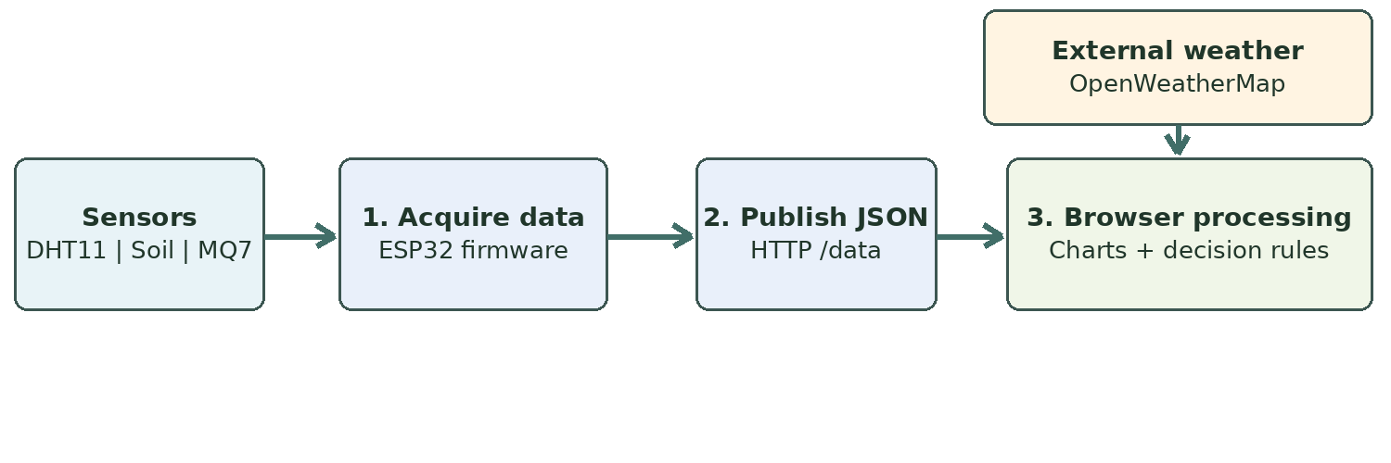
Figure 3.5: Data Flow Diagram – Level 1

4 Implementation

4.1 Implementation Plan for Sem – 8
The present Semester VII prototype is functional for live sensor monitoring and advisory recommendations. The proposed Semester VIII work below is adapted from the future-direction section of the existing Agriculture report. It focuses on measurement quality, reliability, records and safe access, rather than automatic actuation.
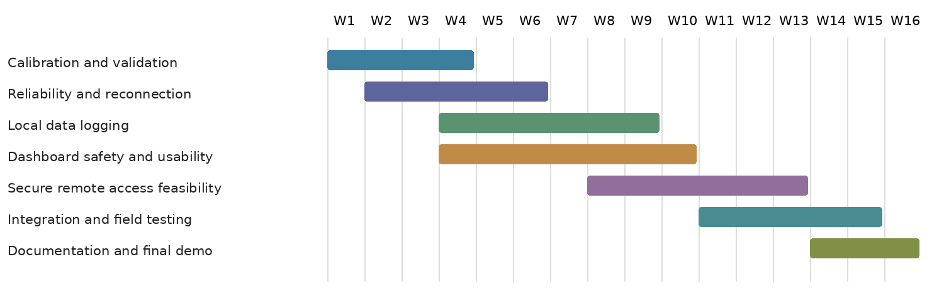
Figure 4.1: Proposed Semester VIII implementation schedule
Table 4.1: Work Breakdown Structure for Sem – 8
WBS | Task | Weeks | Deliverable
1.0 | Documented soil and sensor calibration | W1–W4 | Calibration procedure and test notes
2.0 | ESP32 reconnection and failure handling | W2–W6 | More reliable status reporting
3.0 | Historical logging and export | W4–W9 | Locally retained or secure stored readings
4.0 | Dashboard validation and usability | W4–W10 | Safer input handling, clear stale-data indication
5.0 | Secured access feasibility | W8–W13 | Secure design proposal / prototype
6.0 | Integration and environmental testing | W11–W15 | Functional evaluation record
7.0 | Documentation and final demonstration | W14–W16 | Final report and live demo

Table 4.2: Individual contribution
Roll No. | Name | Contribution (%)
07 | Harshal Bhosale | 25%
13 | Rakesh Chaudhary | 25%
15 | Pranit Chiman | 25%
73 | Om Darekar | 25%

4.2 Coding Standard
Naming conventions used in the supplied Arduino firmware and browser dashboard are summarized below. The full Arduino listing and representative dashboard code appear in Appendix III.
Table 4.3: Naming conventions used
Item | Convention | Examples
Arduino compile-time constants | Uppercase snake case / defines | WIFI_SSID, SOIL_PIN, MQ7_PIN
Arduino functions | lower camel case | readSensors, handleData
Arduino state | lower camel case | dhtOk, gasRaw, lastRead
Dashboard functions | lower camel case | soilPct, evaluate, fetchWeather
DOM element IDs | short or kebab-case | ip, t-temperature, v-soilPct
Settings fields | short camel case | soilLo, soilHi, tW, gC

The sketch separates Wi-Fi configuration, sensor sampling, HTTP headers/handlers, setup and the main loop. The dashboard separates styling, markup, storage, calibration, visualization, recommendation evaluation and network access. Error feedback is displayed in the interface, and the ESP32 prints its readings to the Serial Monitor.

4.3 Testing
The functioning prototype was tested by its project team on the real ESP32 and connected sensors. The team confirmed correct display of the four sensor outputs, local dashboard access and successful weather forecast loading. Code review additionally establishes the expected functions of the data endpoint and threshold rules. Formal numerical accuracy and latency measurements have not been supplied.

4.3.1 Test Cases
Table 4.4: Functional test cases
TC | Module | Test description | Expected result
1 | ESP32 | Power the sensor node | Firmware starts and joins Wi-Fi
2 | DHT11 | Read temperature and humidity | Numeric values in JSON
3 | Soil probe | Read analog moisture channel | Raw ADC data shown as estimated %
4 | MQ7 | Read gas channel | Raw gas value displayed
5 | HTTP | Request ESP32 /data | Valid JSON with five fields
6 | Dashboard | Connect using local IP | Connection status and values update
7 | Calibration | Edit dry/wet settings | Estimated soil percentage changes
8 | Rule engine | Simulate dry soil below limit | Irrigation recommendation appears
9 | Forecast | Supply city and valid API key | Near-term forecast loads
10 | Rain-aware rule | Dry soil and rain probability >= 60% | Advice may postpone irrigation
11 | Alerts | Raise temperature/gas input | Corresponding configured warning
12 | Fault display | DHT read fails | dhtOk=false available for warning

4.3.2 Results of Testing and System Performance
Table 4.5: Results of functional testing
Test area | Observed / supported outcome | Evidence
Sensor hardware | All four readings display normally | User-confirmed working hardware
Local dashboard | Locally opened dashboard connects successfully | User-confirmed operational demo
Weather forecast | OpenWeatherMap forecast loads | User-confirmed successful API use
JSON and rules | Fields and rule paths present in source | Source code review
Quantitative accuracy | No calibrated measurement dataset provided | Not assessed
Network latency | No benchmark measurements provided | Not assessed

Integration result: the actual demonstration confirms the useful end-to-end chain from three sensors to ESP32 and local browser and from the external forecast API to the dashboard. As with any prototype, uncalibrated gas output must not be interpreted as a certified gas-safety reading. No claim of automatic irrigation, water savings, crop-yield improvement or sub-second latency is made.
The confirmed operating setup consists of the ESP32 and three attached modules, each powered at 3.3 V according to the project team, together with a locally opened dashboard. Temperature, humidity, estimated soil moisture and raw MQ7 values were visible in the user interface. The weather panel also returned forecast information when configured with a valid city and API key. These observations support the working-prototype status reported here.
The listed test cases describe both demonstrated capabilities and logical paths that can be examined in the supplied source. They are not presented as a set of instrument-calibrated trials. In particular, the real hardware demonstration does not establish sensor precision, certified gas thresholds, long-term Wi-Fi reliability or quantified agricultural benefits. The future-work plan therefore reserves dedicated activities for calibration, failure handling, safe access and broader validation.

5 Results and Discussion
The Smart Agriculture Monitoring System was demonstrated as a local-network sensor-to-browser application, with external weather information shown in the same dashboard. The images below are taken from the user’s own project report.

Intermediate results
• ESP32 firmware reads digital DHT11 and analog soil/MQ7 channels and publishes cached values through /data.
• The dashboard processes the payload and displays live values, status and small trend graphs.
• OpenWeatherMap is configured separately in the browser and supplies the next 12 hours of forecast information.

Final results: hardware integration
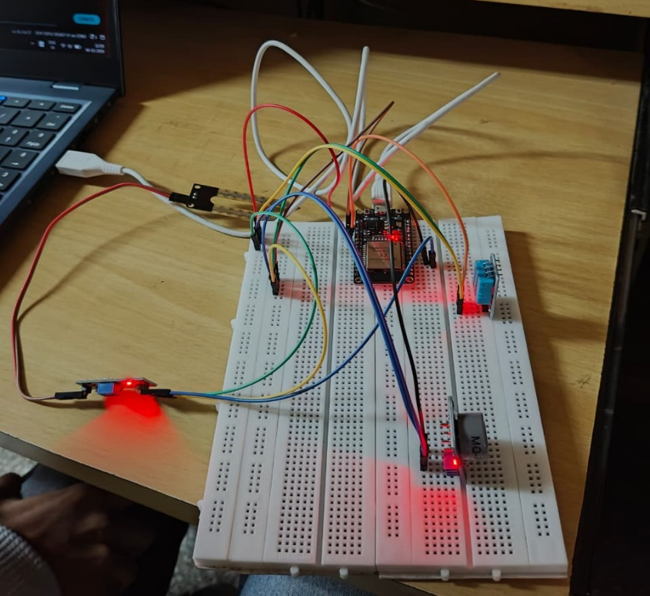
Figure 5.1: Complete Smart Agriculture hardware setup
The breadboard-based prototype connects the ESP32 to all three sensor modules. The project team confirmed correct hardware operation at 3.3 V and correct readings on the local dashboard.
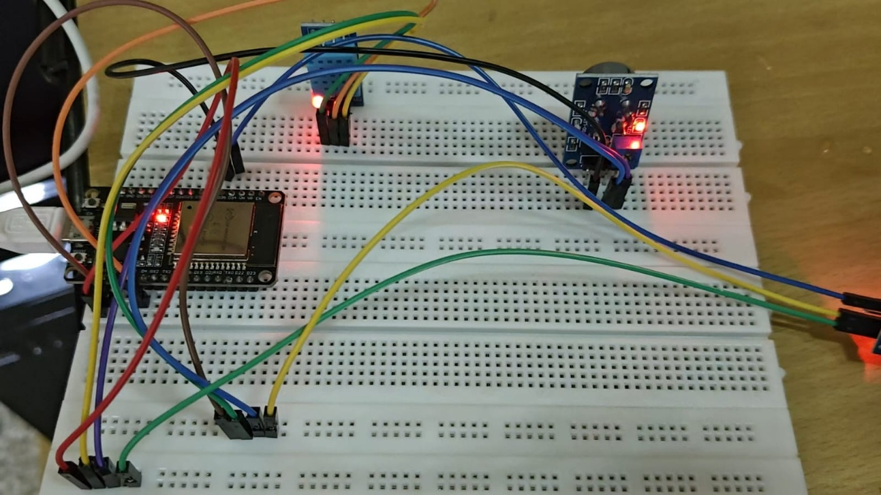
Figure 5.2: ESP32 and sensor connection close-up
The close-up demonstrates direct pin-level interfacing of the sensor modules and shared ground connections. The setup is for academic demonstration; environmental hardening remains an identified improvement.

Final results: monitoring and decision support
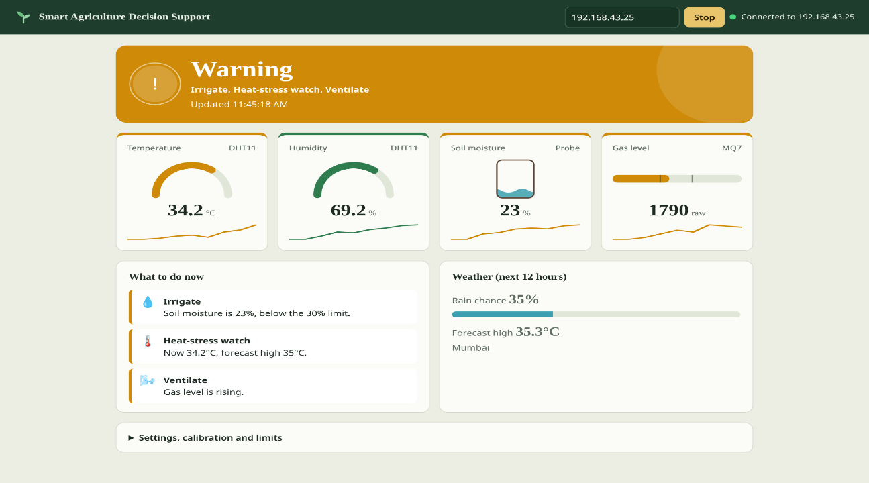
Figure 5.3: Web dashboard with active warnings
The dashboard presents temperature, humidity, moisture and raw gas indicators, plus rule-generated warnings and weather information. These views make the threshold logic visible to the user without operating hardware actuators.
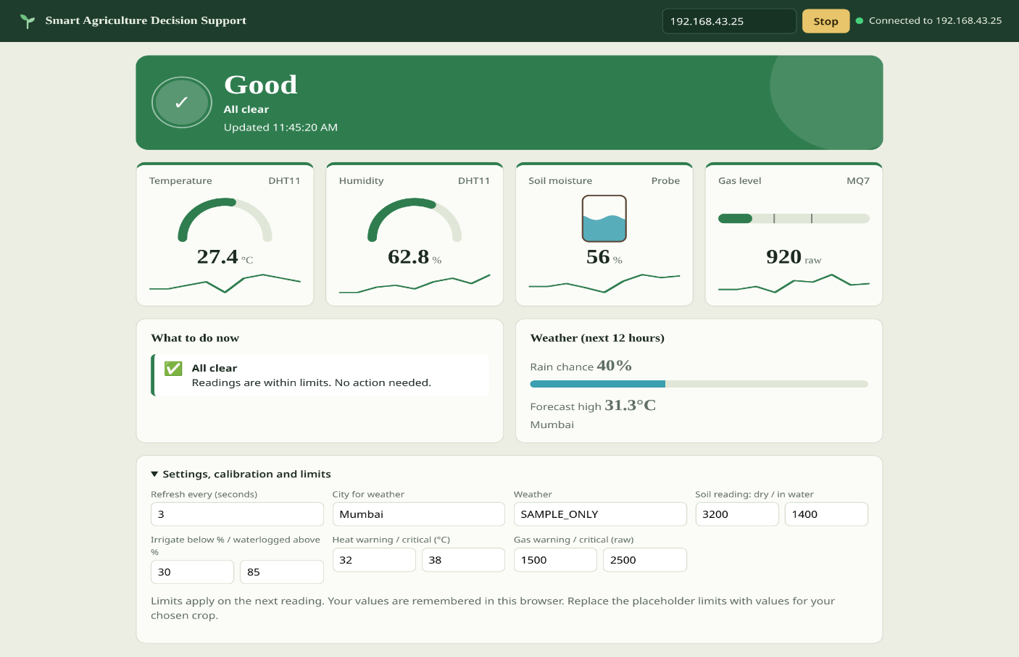
Figure 5.4: Web dashboard and calibration settings
The configuration panel allows changes to soil calibration, warning thresholds, city and weather key. Browser localStorage retains these settings; the mini-history graphs contain the last 30 readings in memory, not a persistent historical database.

Comparison with existing practice
Table 5.1: Comparison between proposed system and conventional practice
Criterion | Traditional inspection | Smart Agriculture system
Measurement access | Occasional manual checks | Live local browser readings
Soil advisory | Depends on field judgement | Moisture estimate and editable limits
Rain awareness | Manual consultation | Integrated 12-hour forecast
Heat / gas indicators | Not necessarily available | Visible warnings with caveats
Autonomous irrigation | No | No: user-directed actions
Stored history | Manual notes | Temporary 30-sample browser trends

Discussion: the project illustrates how locally measured information and external forecast data can be combined to support agricultural decisions. It does not replace agronomic judgement, laboratory calibration or certified environmental safety instrumentation.

6 Conclusion & Future Work

Conclusion
The IoT Based Smart Agriculture Monitoring System has been designed and demonstrated as a working ESP32 monitoring prototype. It collects temperature, humidity, soil and raw MQ7 sensor values, provides them through a lightweight local HTTP endpoint and displays them using a custom browser dashboard.
The dashboard combines live readings, sensor status, trends, editable limits and OpenWeatherMap forecast information to support decisions about irrigation, waterlogging and environmental conditions. In contrast with the previous semester’s Blynk-based approach, the current solution uses an independent HTML/CSS/JavaScript interface and a local ESP32 data service.
The work brings together IOE Things (sensor modules and ESP32), Data (JSON readings and forecast values), Process (calibration and rule evaluation), and People (the farmer interpreting recommendations). The final project is explicitly monitoring and recommendations only. It does not switch a pump, fan, relay or other actuator.

Future Work
1. Better sensor characterization: document soil wet/dry calibration; evaluate a capacitive soil probe and a more accurate ambient sensor; preserve the distinction between raw MQ7 output and calibrated concentrations.
2. Local history and analysis: store readings for longer-term trend views and enable export, instead of retaining only short in-browser trend arrays.
3. Connection and safety feedback: show stale-reading status, handle Wi-Fi interruption and DHT failures more robustly, and validate configuration fields.
4. Secure access and credentials: evaluate authenticated access, secure transmission and safer storage of OpenWeatherMap credentials before wider deployment.
5. Improved environmental readiness: protect the enclosure and wiring, test power stability and consider maintainability during extended operation.
6. Better decision support: evaluate crop-specific limits and the reliability of weather-informed recommendations using documented observations.

Learning from Project Management
• Keeping ESP32 acquisition and browser decision logic separate simplifies revisions and testing.
• Testing on the real hardware and checking the serial output is important even when dashboards render correctly.
• Actual measured outcomes should be distinguished from source-code capabilities and proposed enhancements.
• Future improvements should be planned with safety, sensor calibration and credential protection in mind.

Appendix - I

Data Sheet(s) - Electronic Component
Table A.1: ESP32 development board
Parameter | Specification
Role | Sensor acquisition and HTTP/Wi-Fi service
Processor | Dual-core Xtensa LX6, up to 240 MHz
Wi-Fi | Integrated 2.4 GHz 802.11 b/g/n
ADC | 12-bit analog inputs; raw range 0–4095
GPIO logic | 3.3 V
Connected analog inputs | GPIO34 and GPIO35 (ADC1)

Table A.2: DHT11 sensor
Parameter | Specification
Type | Digital ambient temperature and humidity sensor
Temperature | 0–50°C; typical accuracy ±2°C
Humidity | 20–90% RH; typical accuracy ±5%
Interface | Single-wire digital output
Power | 3.3 V on this prototype
ESP32 connection | GPIO4

Table A.3: Soil moisture sensor
Parameter | Specification
Type | Resistive analog soil probe
Readout | Raw ADC converted to indicative % in browser
Calibration | Editable defaults: dry 3200; wet 1400
Thresholds | Below 30% dry; above 85% possible waterlogging
Power | 3.3 V on this prototype
ESP32 connection | GPIO34

Table A.4: MQ7 module
Parameter | Specification
Function | Raw semiconductor gas response
Readout | Analog ADC value (not CO ppm)
Warning settings | 1500 raw warning; 2500 raw critical
Power | 3.3 V in user-tested prototype; module-specific heater requirements must be verified
ESP32 connection | GPIO35
Qualification | No documented heater cycling or certified CO calibration

Installation Procedure - Development Software
1. Arduino IDE: install Arduino IDE and the ESP32 board package from Espressif using Boards Manager; choose the connected ESP32 development board and port.
2. DHT library: install the Adafruit DHT sensor library and any required dependencies using the Arduino Library Manager.
3. Firmware: open esp32_web_server.ino; configure the local Wi-Fi SSID and password privately; check pin assignments and upload the sketch.
4. Serial diagnostics: open Serial Monitor at 115200 baud; verify sensor output and record the IP address assigned to the ESP32.
5. HTTP check: on a browser connected to the same reachable network, request http://ESP32-IP/data and verify the JSON response.
6. Dashboard: open smart_agri_dashboard_v2.html locally, enter the ESP32 IP in the top bar and select Connect.
7. Weather: enter the city and an OpenWeatherMap key in the settings panel; verify that the near-term forecast loads.
8. Calibration: replace the example wet/dry values and warning limits as appropriate to the actual sensors and growing conditions. No automatic actuator setup is required.

Appendix - II

Software Requirement Specification for the IoE Smart Agriculture Monitoring System

1 Introduction
1.1 Purpose. This SRS describes functional and nonfunctional requirements for the local ESP32 sensor-monitoring and browser-based advisory system.
1.2 Scope. The system acquires environmental measurements, publishes them to an HTTP/JSON service, displays live values, incorporates external weather forecasts and provides rule-based suggestions. It performs no automatic actuation.
1.3 Definitions. IOE – Internet of Everything; ADC – Analog-to-Digital Converter; HTTP – Hypertext Transfer Protocol; JSON – JavaScript Object Notation; RH – Relative Humidity; API – Application Programming Interface.
1.4 Reference documents. ESP32 technical manual, DHT11 data sheet, MQ7 manufacturer documentation, OpenWeatherMap API documentation and the supplied source code.

2 Overall Description
2.1 Product perspective. A local Wi-Fi sensing node and standalone browser interface, plus a browser-accessed internet weather service.
2.2 Product functions. Sensor readings, JSON data, live gauges and trends, editable calibration/limits, connection indicator, forecast-aware advice and status warnings.
2.3 User characteristics. Farmers and project evaluators with access to an ordinary web browser and basic familiarity with local-network connectivity.
2.4 Constraints. The browser must reach the ESP32 IP; the forecast requires internet access and a working API key; the resistive probe and MQ7 require appropriate calibration and interpretation.
2.5 Assumptions. The sensor node has stable power, all connected modules share a common ground, and the user has a local network available.

3 Specific Requirements
3.1 Functional requirements
FR-1. The ESP32 shall read temperature and humidity from the DHT11 on GPIO4.
FR-2. The ESP32 shall sample soil and gas analog inputs from GPIO34 and GPIO35 and publish averaged raw readings.
FR-3. The ESP32 shall expose the latest readings in JSON at /data, including dhtOk status.
FR-4. The dashboard shall display live values, connection status and short trend information.
FR-5. The dashboard shall compute indicative moisture percentage using editable dry/wet ADC values.
FR-6. The dashboard shall show advisory messages based on configurable soil, heat, humidity and raw gas limits.
FR-7. When weather is configured, the dashboard shall consider rain probability before recommending irrigation.
FR-8. The system shall not actuate irrigation pumps, fans or other field equipment.
3.2 External interfaces. DHT11 digital signal on GPIO4; analog sensors on GPIO34 and GPIO35; ESP32 Wi-Fi/HTTP service; HTML/CSS/JavaScript dashboard; HTTPS request to OpenWeatherMap.
3.3 Performance and quality requirements. The Arduino sketch refreshes cached sensor values about every two seconds; the browser polls every three seconds by default. The interface should accurately distinguish stale or unsuccessful sensor data from live reliable measurements. No guaranteed latency or calibrated accuracy has been established from the supplied materials.

Appendix - III

A. ESP32 Sensor Node Firmware (Arduino C++)
The following listing reproduces the project’s firmware logic, with Wi-Fi credentials and unused API credential values replaced by placeholders for safe circulation. The operational source is esp32_web_server.ino.
/*
Smart Agriculture DSS - ESP32 web server (no MQTT)
The ESP32 reads DHT11 + soil + MQ7 and serves them as JSON at:
http://<ESP32-IP>/data
The dashboard page fetches that address every few seconds.

Libraries (Library Manager): DHT sensor library (Adafruit), Adafruit Unified Sensor
(WiFi and WebServer come with the ESP32 board package)
*/

#include <WiFi.h>
#include <WebServer.h>
#include "DHT.h"

// ---------- EDIT THESE ----------
const char* WIFI_SSID = "YOUR_WIFI_SSID";
const char* WIFI_PASS = "YOUR_WIFI_PASSWORD";

const char* WEATHER_API_KEY = "YOUR_API_KEY";
const char* WEATHER_CITY = "Mumbai";
// --------------------------------

#define DHTPIN 4
#define DHTTYPE DHT11
#define SOIL_PIN 34 // ADC1, input only
#define MQ7_PIN 35 // ADC1, input only (use a voltage divider if the module runs at 5 V)

DHT dht(DHTPIN, DHTTYPE);
WebServer server(80);

float temperature = 0, humidity = 0;
int soilRaw = 0, gasRaw = 0;
bool dhtOk = false;
unsigned long lastRead = 0;

int readAnalogAvg(int pin) {
long sum = 0;
for (int i = 0; i < 10; i++) { sum += analogRead(pin); delay(5); }
return sum / 10;
}

void readSensors() {
float h = dht.readHumidity();
float t = dht.readTemperature();
dhtOk = !(isnan(h) || isnan(t));
if (dhtOk) { humidity = h; temperature = t; }
else Serial.println("DHT11 read failed - check wiring");
soilRaw = readAnalogAvg(SOIL_PIN); // higher = drier
gasRaw = readAnalogAvg(MQ7_PIN); // higher = more gas
}

void sendCORS() {
server.sendHeader("Access-Control-Allow-Origin", "*"); // lets the dashboard page read this data
server.sendHeader("Cache-Control", "no-store");
}

void handleData() {
sendCORS();
char json[160];
snprintf(json, sizeof(json),
"{\"temperature\":%.1f,\"humidity\":%.1f,\"soil\":%d,\"gas\":%d,\"dhtOk\":%s}",
temperature, humidity, soilRaw, gasRaw, dhtOk ? "true" : "false");
server.send(200, "application/json", json);
}

void handleRoot() {
sendCORS();
server.send(200, "text/plain", "ESP32 smart agriculture node is running. Data at /data");
}

void setup() {
Serial.begin(115200);
dht.begin();
pinMode(SOIL_PIN, INPUT);
pinMode(MQ7_PIN, INPUT);

WiFi.mode(WIFI_STA);
WiFi.begin(WIFI_SSID, WIFI_PASS);
Serial.print("Connecting to WiFi");
while (WiFi.status() != WL_CONNECTED) { delay(500); Serial.print("."); }
Serial.println();
Serial.print("Connected. Open this in the dashboard: ");
Serial.println(WiFi.localIP());

server.on("/", handleRoot);
server.on("/data", handleData);
server.begin();
readSensors();
}

void loop() {
if (WiFi.status() != WL_CONNECTED) { // simple auto-reconnect
WiFi.disconnect();
WiFi.begin(WIFI_SSID, WIFI_PASS);
delay(3000);
}
server.handleClient();

if (millis() - lastRead >= 2000) { // DHT11 needs at least 1 s between reads
lastRead = millis();
readSensors();
Serial.printf("T=%.1f C H=%.1f %% Soil=%d Gas=%d\n", temperature, humidity, soilRaw, gasRaw);
}
}

B. Browser Data Processing (JavaScript excerpts)
The complete dashboard is supplied as smart_agri_dashboard_v2.html. The representative code below illustrates calibration, decision rules, polling and weather access without duplicating all visual styles in the printed appendix.
Function soilPct()
function soilPct(raw){ // resistive probe: higher reading = drier
const dry = num('dry'), wet = num('wet');
return Math.max(0, Math.min(100, (dry - raw) / (dry - wet) * 100));
}
Function evaluate()
function evaluate(d){
const out = [], add = (level, ic, title, msg) => out.push({level, ic, title, msg});
const rainSoon = rain && rain.pop >= 0.6;
if (d.soilPct < num('soilLo')) {
if (rainSoon) add('good', '🌧️', 'Suppress irrigation', `Soil is dry (${d.soilPct.toFixed(0)}%) but rain is likely (${Math.round(rain.pop * 100)}% chance). Wait.`);
else add('warning', '💧', 'Irrigate', `Soil moisture is ${d.soilPct.toFixed(0)}%, below the ${num('soilLo')}% limit.`);
} else if (d.soilPct > num('soilHi')) add('warning', '🚫', 'Hold irrigation', `Soil moisture is ${d.soilPct.toFixed(0)}%. Waterlogging risk.`);

if (d.temperature >= num('tC')) add('critical', '🔥', 'Heat stress', `${d.temperature}°C is at or above the critical limit.`);
else if (d.temperature >= num('tW') || (rain && rain.tmax >= num('tC'))) add('warning', '🌡️', 'Heat-stress watch', `Now ${d.temperature}°C${rain ? `, forecast high ${rain.tmax.toFixed(0)}°C` : ''}.`);

if (d.gas >= num('gC')) add('critical', '☠️', 'Ventilate now', 'Gas level is critical. Open vents and keep people out of enclosed areas.');
else if (d.gas >= num('gW')) add('warning', '🌬️', 'Ventilate', 'Gas level is rising.');
else if (d.humidity > 85 && d.temperature > 30) add('warning', '🌬️', 'Ventilate', 'High heat and humidity. Disease risk.');

if (!out.length) add('good', '✅', 'All clear', 'Readings are within limits. No action needed.');
return out;
}
Function fetchWeather()
function fetchWeather(){
if (!$('key').value || !$('city').value) return;
try {
const r = await fetch(`https://api.openweathermap.org/data/2.5/forecast?q=${encodeURIComponent($('city').value)}&units=metric&cnt=4&appid=${$('key').value}`);
if (!r.ok) throw new Error(r.status);
const j = await r.json();
rain = {pop: Math.max(...j.list.map(x => x.pop || 0)), tmax: Math.max(...j.list.map(x => x.main.temp_max))};
$('wx').innerHTML = `<div>Rain chance <span class="num">${Math.round(rain.pop * 100)}%</span></div>
<div class="rainbar"><i id="rb"></i></div>
<div>Forecast high <span class="num">${rain.tmax.toFixed(1)}°C</span></div>
<div class="muted">${j.city ? j.city.name : ''}</div>`;
requestAnimationFrame(() => { const b = $('rb'); if (b) b.style.width = rain.pop * 100 + '%'; });
if (last) render(last);
} catch (e) { $('wx').textContent = 'Weather unavailable (' + e.message + '). Check the city name and API key.'; }
}

References
[1] Espressif Systems, “ESP32 Technical Reference Manual.” [Online]. Available: https://www.espressif.com/sites/default/files/documentation/esp32_technical_reference_manual_en.pdf
[2] DHT11 Temperature and Humidity Sensor, “Technical Data Sheet.” [Online]. Available: https://www.mouser.com/datasheet/2/758/DHT11-Technical-Data-Sheet-Translated-Version-1143054.pdf
[3] Winsen Electronics, “MQ-7 Carbon Monoxide Sensor Datasheet.” [Online]. Available: https://www.winsen-sensor.com/
[4] Adafruit Industries, “DHT Sensor Library for Arduino.” [Online]. Available: https://github.com/adafruit/DHT-sensor-library
[5] OpenWeather, “5 Day / 3 Hour Forecast API.” [Online]. Available: https://openweathermap.org/forecast5
[6] Espressif Systems, “Arduino ESP32 WiFi Library Documentation.” [Online]. Available: https://docs.espressif.com/projects/arduino-esp32/en/latest/api/wifi.html
[7] Espressif Systems, “Arduino ESP32 WebServer Library.” [Online]. Available: https://github.com/espressif/arduino-esp32/tree/master/libraries/WebServer
[8] A. Tzounis et al., “Internet of Things in Agriculture: Recent Advances and Future Challenges,” Biosystems Engineering, vol. 164, pp. 31–48, 2017.
[9] Arduino, “Arduino Documentation.” [Online]. Available: https://docs.arduino.cc/
[10] Espressif Systems, “Arduino Core for the ESP32.” [Online]. Available: https://github.com/espressif/arduino-esp32

Acknowledgements
We express our sincere gratitude to our project guide, Prof. Janhavi Baikerikar, for guidance and constructive feedback throughout the development of the IoT Based Smart Agriculture Monitoring System. Her support helped us refine the embedded-sensing work and its custom web dashboard.
We also thank the Department of Information Technology, Don Bosco Institute of Technology, Mumbai, for providing an environment in which the hardware and software aspects of this Semester VII project could be developed and demonstrated.
Finally, we are grateful to our families, classmates and peers for their encouragement during prototype development, testing and documentation.

(________________________)
(Harshal Bhosale - 07)
(________________________)
(Rakesh Chaudhary - 13)
(________________________)
(Pranit Chiman - 15)
(________________________)
(Om Darekar - 73)
Date:

SDG
SDG 2 – Zero Hunger: Monitoring supports timely crop-management choices.
SDG 6 – Clean Water and Sanitation: Rain-aware moisture advice can discourage unnecessary irrigation.
SDG 9 – Industry, Innovation and Infrastructure: Low-cost sensors, Wi-Fi and a custom interface demonstrate connected infrastructure.
SDG 12 – Responsible Consumption and Production: Condition-based suggestions support responsible water use.
SDG 13 – Climate Action: Forecast information aids responses to changing environmental conditions.
These alignments describe intended relevance. The present project does not claim experimentally measured crop-yield, water-saving or climate outcomes.

IoE-Based Smart Agriculture Monitoring with ESP32, Local Web Visualization and Weather-Aware Decision Support
Harshal Bhosale, Rakesh Chaudhary, Pranit Chiman and Om Darekar
Department of Information Technology, Don Bosco Institute of Technology, Mumbai, India
Abstract— This paper presents an Internet of Everything (IOE) based Smart Agriculture Monitoring System using an ESP32, DHT11, resistive soil moisture probe and MQ7 module. The ESP32 exposes readings through a local HTTP/JSON endpoint; a standalone HTML/CSS/JavaScript dashboard displays live values and short trends, computes estimated soil moisture, and offers configurable environmental advisories. OpenWeatherMap forecast information can modify irrigation suggestions when rainfall is likely. The project has been demonstrated on working hardware, and does not automatically control any actuator.
Index Terms— Internet of Everything, smart agriculture, ESP32, soil moisture, HTTP, decision support, OpenWeatherMap.

I. INTRODUCTION
Agricultural decisions require timely information about soil and microclimatic conditions. Manual inspection can miss rapid changes. An IOE-oriented approach combines sensing devices, data, rules and the person taking action. This prototype provides local readings and advisory recommendations without automatic irrigation.
II. RELATED WORK
The ESP32 technical reference [1] supports the selection of an integrated Wi-Fi and ADC platform. The DHT11 data sheet [2] establishes the sensor’s basic ambient-measurement limitations. MQ7 documentation [3] motivates the decision to treat its signal as a raw analog value rather than a calibrated CO result. The OpenWeather API [5] supplies near-term forecast information; the cited agriculture IoT review [8] provides broader context.
III. SYSTEM ARCHITECTURE
The sensing layer contains DHT11 (GPIO4), a resistive soil probe (GPIO34) and MQ7 (GPIO35). Arduino firmware averages ten analog samples per channel, refreshes values approximately every two seconds, and exposes JSON fields temperature, humidity, soil, gas and dhtOk at HTTP /data. A browser dashboard polls the ESP32 over accessible local Wi-Fi.
Independently, the browser requests four forecast samples from OpenWeatherMap. The browser preserves user configuration in localStorage and renders animated gauges, mini-trends, warnings and recommended actions. The architecture contains no Blynk-specific cloud service and no database that permanently stores measurements.
IV. METHODS
Soil moisture is estimated by M = clamp((D - R)/(D - W) × 100, 0, 100), where D and W are dry/wet calibration readings and R is the raw ADC result. With defaults D=3200 and W=1400, a raw value of 2700 gives M≈27.8%. Below the configured 30% low threshold, irrigation is suggested unless forecast rain probability is at least 60%. A value above 85% flags possible waterlogging.
Other rules compare ambient temperature against the configurable 32°C/38°C warning levels, and raw gas ADC against 1500/2500 values. These settings are demonstration parameters, not crop-specific agronomic limits or certified gas-concentration thresholds. The DHT failure flag allows error awareness.
V. IMPLEMENTATION AND RESULTS
The ESP32 was operated with the three attached sensors, and the project team confirmed that four displayed measurements are normal in the local dashboard. The OpenWeatherMap forecast also loaded successfully. The interface therefore demonstrates the integrated sensor-to-browser and forecast-to-advice flow. No field yield, water-saving, gas-calibration accuracy or response-time benchmark is reported.
VI. DISCUSSION
The local-first design reduces reliance on a proprietary dashboard account. However, it depends on reachable Wi-Fi, has limited in-memory trend history, and uses browser-stored weather credentials. The user remains responsible for the final irrigation or ventilation decision. More rigorous sensor calibration and failure-state handling would improve practical reliability.
VII. CONCLUSION
The completed prototype combines inexpensive sensing, ESP32 HTTP data access, independent browser visualization and forecast-aware advisory rules. It demonstrates the four pillars of IOE while keeping all actuation manual. Future work can improve secure access, historical retention, calibration and environmental robustness.
REFERENCES
[1] Espressif Systems, “ESP32 Technical Reference Manual.” [Online]. Available: https://www.espressif.com/sites/default/files/documentation/esp32_technical_reference_manual_en.pdf
[2] DHT11 Temperature and Humidity Sensor, “Technical Data Sheet.” [Online]. Available: https://www.mouser.com/datasheet/2/758/DHT11-Technical-Data-Sheet-Translated-Version-1143054.pdf
[3] Winsen Electronics, “MQ-7 Carbon Monoxide Sensor Datasheet.” [Online]. Available: https://www.winsen-sensor.com/
[4] Adafruit Industries, “DHT Sensor Library for Arduino.” [Online]. Available: https://github.com/adafruit/DHT-sensor-library
[5] OpenWeather, “5 Day / 3 Hour Forecast API.” [Online]. Available: https://openweathermap.org/forecast5
[6] Espressif Systems, “Arduino ESP32 WiFi Library Documentation.” [Online]. Available: https://docs.espressif.com/projects/arduino-esp32/en/latest/api/wifi.html
[7] Espressif Systems, “Arduino ESP32 WebServer Library.” [Online]. Available: https://github.com/espressif/arduino-esp32/tree/master/libraries/WebServer
[8] A. Tzounis et al., “Internet of Things in Agriculture: Recent Advances and Future Challenges,” Biosystems Engineering, vol. 164, pp. 31–48, 2017.

