# Build a Quiz Application using Angular

(please use bootstrap to the maximum extent and write their own CSS code only when it is absolutely unavoidable!)

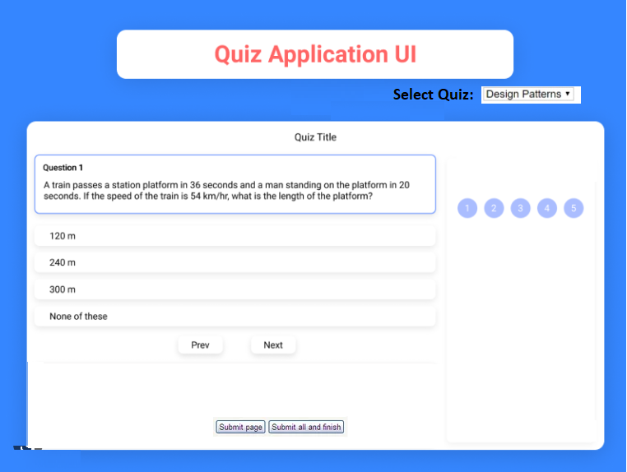

Screenshot 1.0

**Requirement**:

1. 3 Topics as “Select Quiz” options/dropdown. To move from one topic to another this dropdown should be used.
   1. Design Patterns
   2. Angular
   3. Java
2. Each Topic should contain 5 questions.
3. User should be able to navigate to any question via 5 badges (circles) at right side.
4. User should be able to navigate to any question via Prev/Next button.
5. Each question and answer should come from a JSON File and integrated as Service
   1. Build your own JSON FILE for each topic’s questions and answers.
6. Click on **Submit Page** button will store answer of the current selected topic [For example - Design Pattern] and move user to next quiz topic. Once the user press **Submit Page** button then that topic option in drop down must be disabled for user.
7. Click on **Submit all and finish** will complete the quiz and take user to result /completion page. Display result as per the Screenshot 2.0.
8. Store answers either via **In Memory** or write in **JSON File** to calculate correct answers. No DB required.
9. UI must be responsive for laptop, mobile & tab layouts

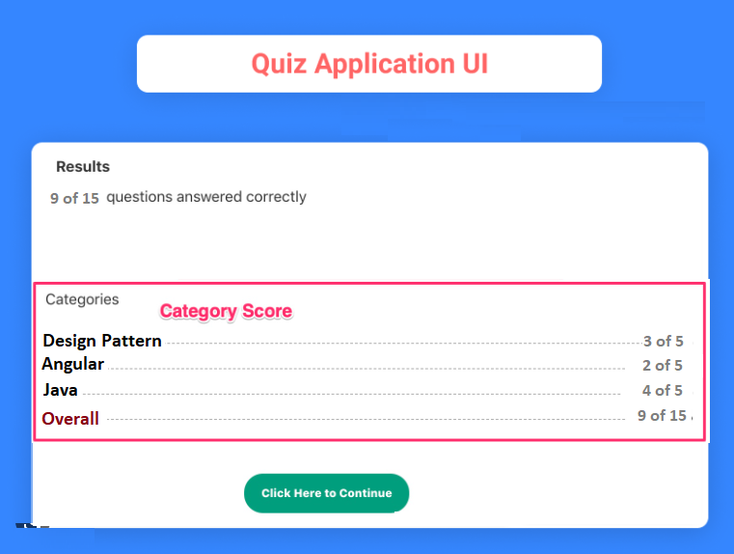

Screenshot: 2.0

Comments:

1. UI colors, fonts, etc., can be of your choice.
2. Please make sure to apply *best practices* in such a way that a change in one component does not severely impact other components.
3. All the best!