% Parameter

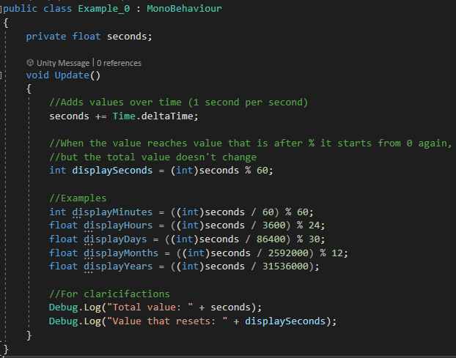

Code: [GitHub](https://github.com/darekpawlo/Examples-of-Functions/blob/main/Code%20Sandbox/Assets/Scripts/%25%20Operator/Example_0.cs)

Inspector Attributes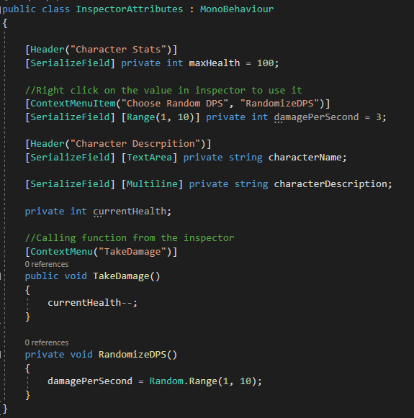

Code:[Github](https://github.com/darekpawlo/Examples-of-Functions/blob/main/Code%20Sandbox/Assets/Scripts/InspectorAttributes/InspectorAttributes.cs)

Inspector Attributes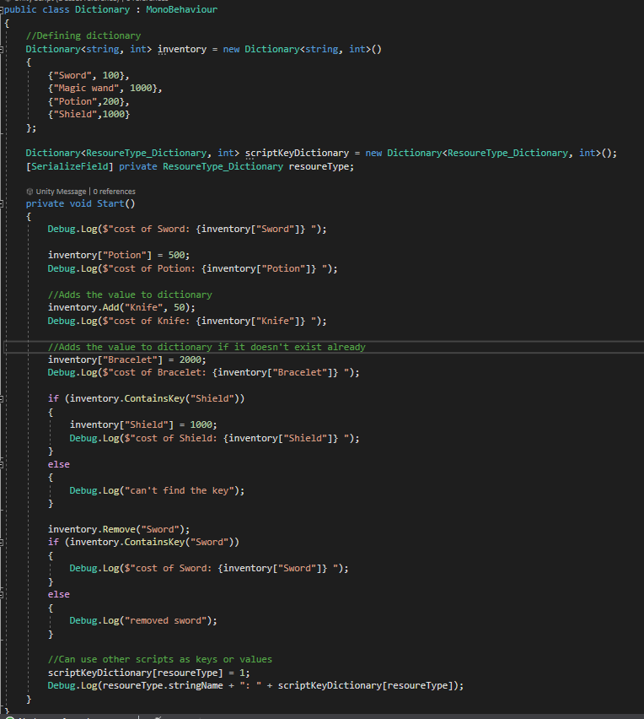

Code:[Github](https://github.com/darekpawlo/Examples-of-Functions/blob/main/Code%20Sandbox/Assets/Scripts/Dictionary/Dictionary.cs)