Frosmear Legacy Modernization — Stakeholders
Company: Schumann Hudson Acquisition & Technology (SHAT)
Project: Frosmear Legacy Modernization
Target Platform: Darfcloud (Docker containers and Django)

Stakeholder Names and Roles
# | Stakeholder | Role | Responsibilities / Interests
1 | Glenda Schumann | Chief Executive Officer (CEO) | Executive sponsor; high power and high interest; considers modernization essential to the company’s future.
2 | Zelda Hudson | Chief Technology Officer (CTO) | Technology executive and steering committee member; directs technical strategy and champions modernization.
3 | Theresa Hudson | Chief Financial Officer (CFO) | Financial oversight, budgets, investment decisions, and return on investment. Her appointment reflects SHAT’s nepotistic management culture.
4 | Gordie Roberts | Director of Operations | Oversees business operations and organizational transition; concerned about operational disruption.
5 | Jay Caufield | Legacy Systems Manager | Manages the existing Frosmear.com infrastructure and PHP codebase; initially resistant to modernization.
6 | Jim Paek | Lead Developer | Leads implementation of the new platform and drives technical decisions.
7 | Grant Jennings | Information Security Manager | Oversees security architecture, compliance, and risk controls.
8 | Phil Bourque | Amazon Web Services (AWS) Account Manager | External cloud provider representative; interested in the cloud deployment opportunity.
9 | Jamie Leach | Microsoft Azure Account Manager | External cloud provider representative; promotes Azure as an alternative cloud platform.
10 | Peter Taglianetti | Frosmear Power-User Representative | Represents long-term customers concerned with preserving familiar features, accounts, data, and user experience.
11 | Brad Aitken | Frosmear Casual-User Representative | Represents occasional website users concerned with availability, usability, performance, and continued access.
12 | Jeff Daniels | Institutional and Investment-Tool Customer Representative | Represents prospective Darfcloud customers interested in investment-analysis capabilities.
13 | Troy Loney | Shareholder Representative | Represents SHAT shareholders and investors; interested in financial performance, project risk, company value, and return on investment.
The names were generated by AI to be used as fictional characters for this academic exercise. Their assigned business roles and organizational relationships are fictional. None of my family members nor members of the 1991 Pittsburgh Penguins are involved with SHAT, Frosmear, or Darfcloud.

Stakeholder Engagement Assessment Matrix

Stakeholder | Role | Power / Influence | Current (C) | Desired (D) | Management Approach
Glenda Schumann | CEO | High | Supportive | Leading | Provide executive briefings and involve her in key decisions and project advocacy.
Zelda Hudson | CTO | High | Leading | Leading | Maintain executive coordination and provide timely information for technical decisions.
Theresa Hudson | CFO | High | Neutral | Supportive | Provide cost estimates, budget forecasts, risk assessments, and return-on-investment analysis.
Gordie Roberts | Director of Operations | Medium-high | Supportive | Leading | Involve him in transition planning, operational readiness reviews, and contingency planning.
Jay Caufield | Legacy Systems Manager | Medium | Resistant | Supportive | Investigate concerns, involve him in legacy analysis and migration planning, and address role and knowledge-transfer concerns.
Jim Paek | Lead Developer | Medium | Leading | Leading | Keep him empowered and informed; involve him in technical decisions.
Grant Jennings | Information Security Manager | Medium-high | Supportive | Leading | Include him in security architecture reviews, risk assessments, and production release approvals.
Phil Bourque | AWS Account Manager | Medium | Supportive | Supportive | Maintain vendor coordination and clarify cloud service expectations.
Jamie Leach | Azure Account Manager | Medium | Neutral | Neutral | Provide appropriate vendor communications without prioritizing deeper engagement.
Peter Taglianetti | Power-User Representative | Low formal power; high interest | Neutral | Supportive | Conduct user feedback sessions and communicate plans for preserving useful features and account data.
Brad Aitken | Casual-User Representative | Low | Unaware | Supportive | Explain what is changing, why it is changing, and how users will be affected; provide feedback channels.
Jeff Daniels | Investment-Tool Customer Representative | Low current power; moderate interest | Unaware | Supportive | Explain planned capabilities and gather prospective-customer requirements.
Troy Loney | Shareholder Representative | High | Neutral | Supportive | Provide periodic project progress, financial performance, risk, and long-term value updates.

Five Engagement-Level Use Cases
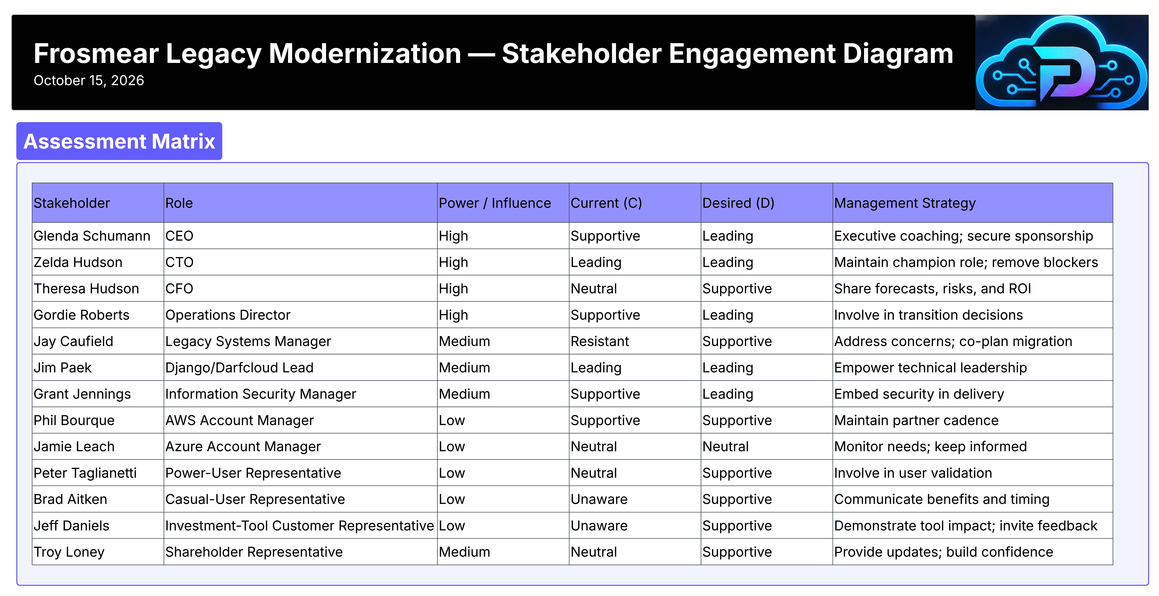
Diagram illustrating the five stakeholder engagement levels
Figure 2. Five stakeholder engagement levels: Unaware, Resistant, Neutral, Supportive, and Leading.

Unaware — Brad Aitken, Casual-User Representative
Casual users may not know that Frosmear.com is being modernized. The project team should communicate the purpose of modernization, expected changes, continuity of important features, and opportunities for user feedback.
Desired outcome: Move from unaware to supportive through timely communication and customer engagement.

Resistant — Jay Caufield, Legacy Systems Manager
Jay is concerned that replacing the PHP-based legacy system could diminish the value of his existing knowledge, change his responsibilities, or threaten his team’s future.
The project manager should investigate the reasons for his resistance, involve him in technical discussions and migration planning, and address legitimate concerns.
Desired outcome: Move from resistant to supportive by addressing concerns and involving him constructively.

Neutral — Theresa Hudson, CFO
Theresa is primarily concerned with financial performance and is not yet committed to supporting or opposing modernization.
The project manager should provide credible cost estimates, budget forecasts, risk assessments, and return-on-investment analysis.
Desired outcome: Move from neutral to supportive by demonstrating the project’s financial justification and establishing financial controls.

Supportive — Gordie Roberts, Director of Operations
Gordie believes modernization will benefit SHAT but is concerned about disruption to existing operations.
The project manager should involve him in transition planning, operational readiness reviews, and contingency planning.
Desired outcome: Move from supportive to leading by involving him actively in organizational change and implementation readiness.

Leading — Zelda Hudson, CTO
Zelda actively supports modernization, provides technical direction, removes organizational obstacles, and advocates for project success.
The project manager should maintain regular executive coordination, involve her in major technical decisions, and ensure she has the information needed to make timely decisions.
Desired outcome: Maintain her leading engagement throughout the project.

Project Context
Frosmear.com is a legacy PHP-based website focused primarily on online games. The modernization project will transform it into Darfcloud, a modern cloud-oriented application platform built using Docker containers and Django.
Darfcloud is intended to support artificial intelligence concepts, general-purpose applications, and tools for evaluating investment opportunities. The project will preserve relevant legacy functionality while establishing a maintainable and scalable foundation for future development.
Key project management concerns include requirements analysis, resource allocation, scheduling, risk management, data migration, security, stakeholder communication, and organizational change.

Stakeholder Engagement Management Objective
The project manager will evaluate each stakeholder’s current engagement level against the desired engagement level and select appropriate communication and management strategies.
Stakeholders already at their desired engagement level should remain informed and engaged. Stakeholders whose current and desired levels differ should receive targeted attention based on their power, influence, interest, urgency, and potential impact on project success.
The overall objective is to align current engagement with desired engagement, minimize resistance, encourage productive participation, and maintain stakeholder support throughout the Frosmear Legacy Modernization project.

Stakeholder Engagement Assessment Matrix
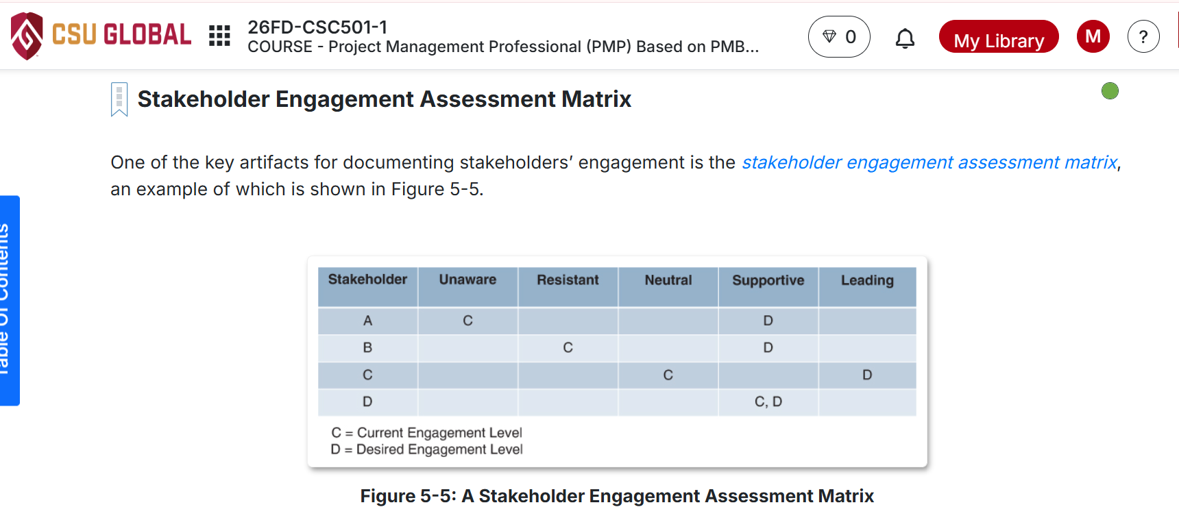
Stakeholder engagement assessment matrix from page 45 of the course textbook
Figure 1. Stakeholder engagement assessment matrix, adapted from page 45 of the course textbook.
The matrix uses the five engagement levels defined in the project-management course material:
- Unaware: The stakeholder does not know the project exists.
- Resistant: The stakeholder does not want the project to succeed and may actively work against it.
- Neutral: The stakeholder is indifferent to the project’s success or failure.
- Supportive: The stakeholder believes the project will provide benefits and wants it to succeed.
- Leading: The stakeholder actively participates in ensuring project success.
These levels were derived from page 45 of the textbook, as required by the assignment. Engagement levels assigned to individual characters were randomized using AI.

Stakeholder | Unaware | Resistant | Neutral | Supportive | Leading
A |  |  |  | C | D
B |  |  |  |  | C,D
C |  |  | C | D
D |  |  |  | C | D
E |  | C |  | D
F |  |  |  |  | C,D
G |  |  |  | C | D
H |  |  |  | C,D
I |  |  | C,D
J |  |  |  |  | C,D
K | C |  |  | D
L | C |  |  | D
M |  |  | C | D

Stakeholder Key
Letter | Stakeholder | Role
A | Glenda Schumann | CEO
B | Zelda Hudson | CTO
C | Theresa Hudson | CFO
D | Gordie Roberts | Director of Operations
E | Jay Caufield | Legacy Systems Manager
F | Jim Paek | Lead Django/Darfcloud Developer
G | Grant Jennings | Information Security Manager
H | Phil Bourque | AWS Account Manager
I | Jamie Leach | Azure Account Manager
J | Peter Taglianetti | Power-User Representative
K | Brad Aitken | Casual-User Representative
L | Jeff Daniels | Investment-Tool Customer Representative
M | Troy Loney | Shareholder Representative
Legend: C = Current engagement; D = Desired engagement.

