How to compile and run the program in terminal:

javac StoreManager.java

java -classpath ".:sqlite-jdbc-3.23.1.jar" StoreManager

**Main screen**

After starting to run the system, the main screen will show up. The database will be set up automatically. (I made a new store1.db for my system because there are some extra features of products)

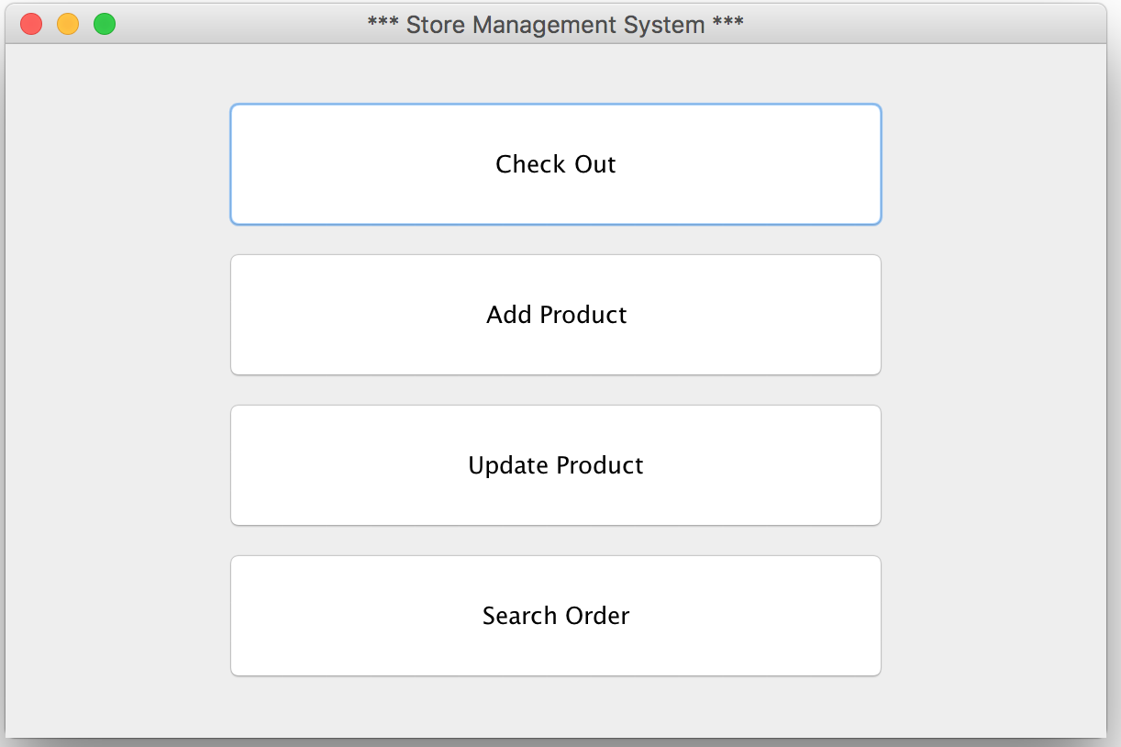

**Use case 1 – press “Add Product”:**

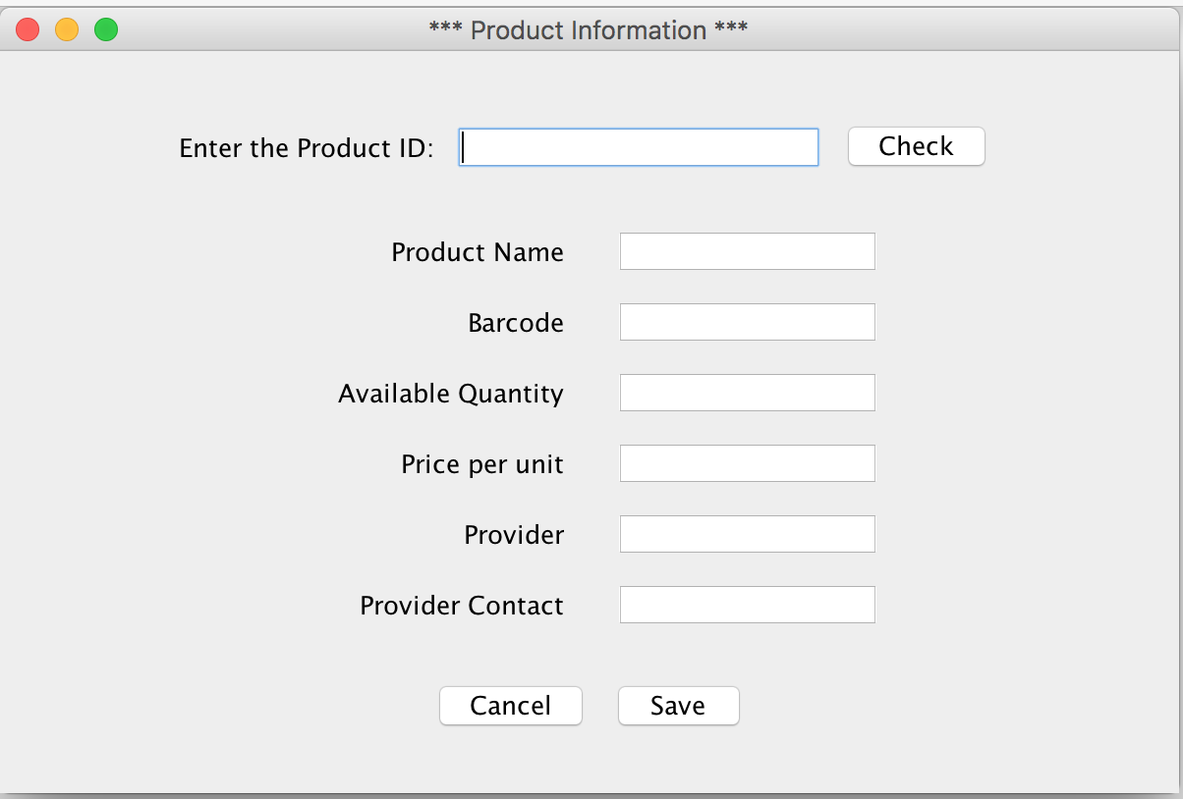

If you happen to enter an existing product id, the system will pop up the message and then display its info.

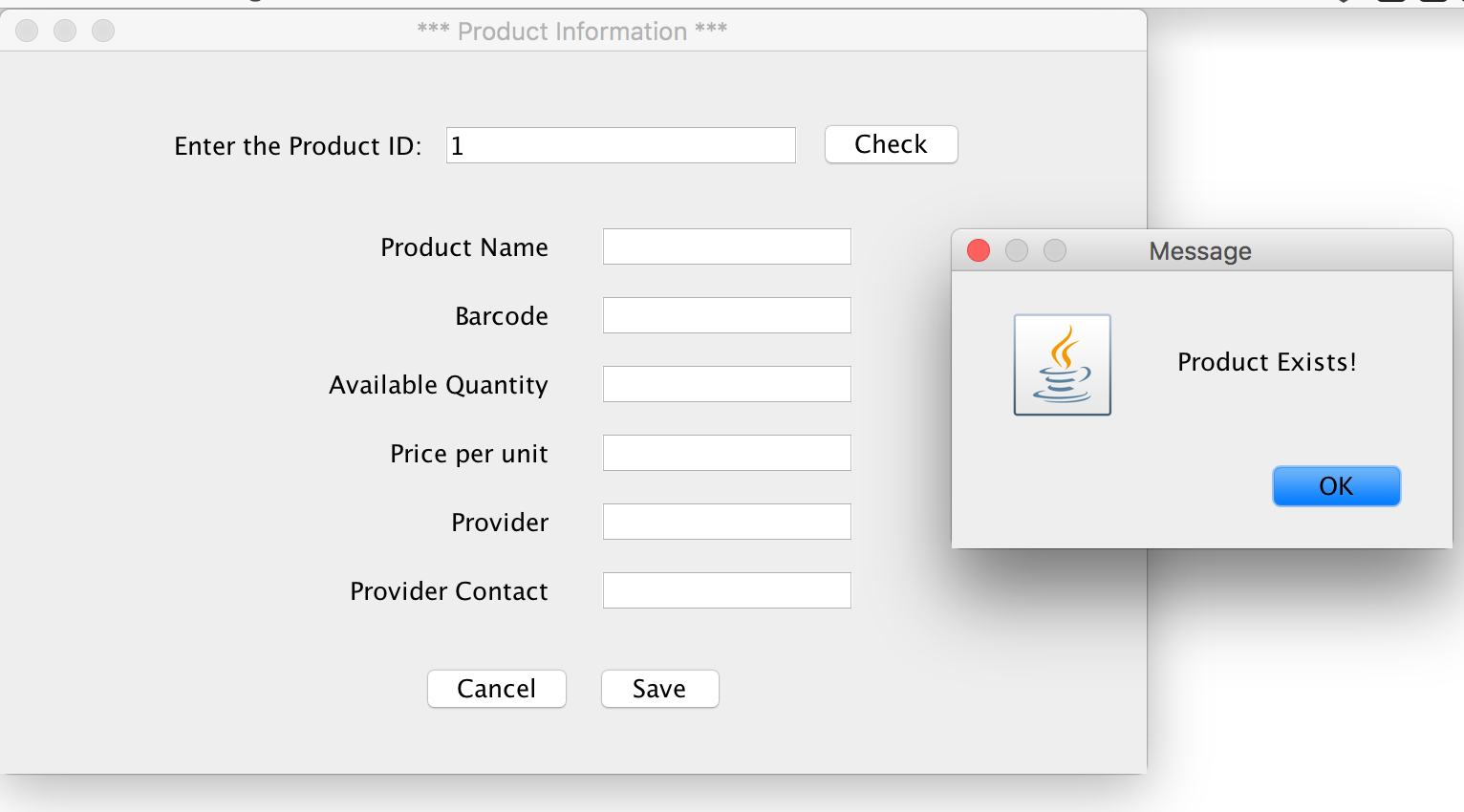

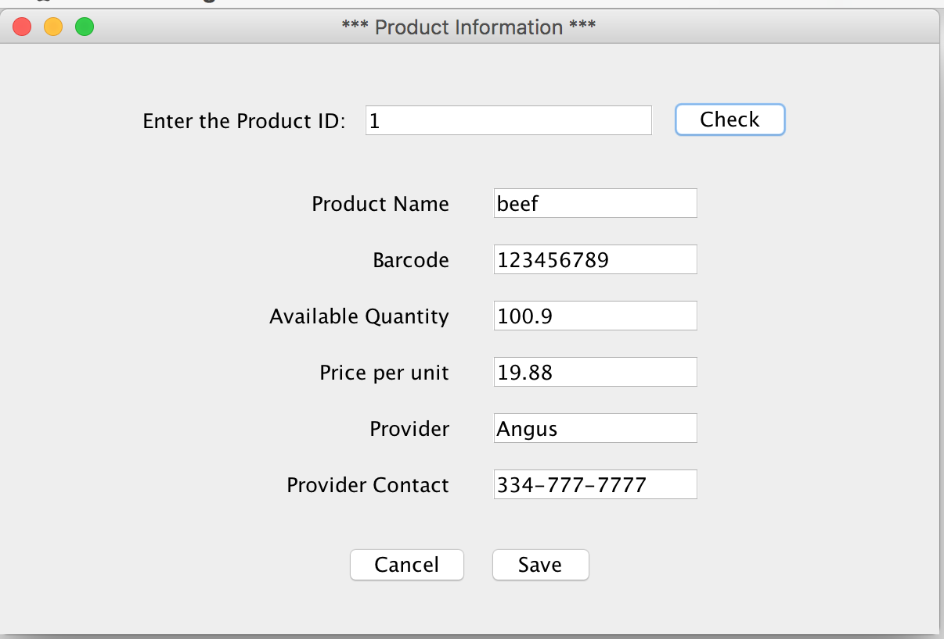

If the product id you entered is a new one, the system will pop up a message too, and then you can add a new product now.

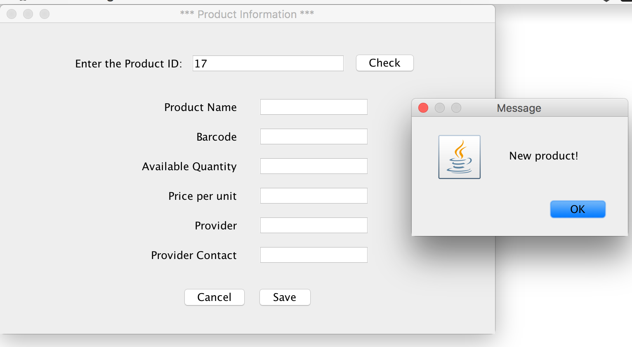

Press “Save” button to save the new product.

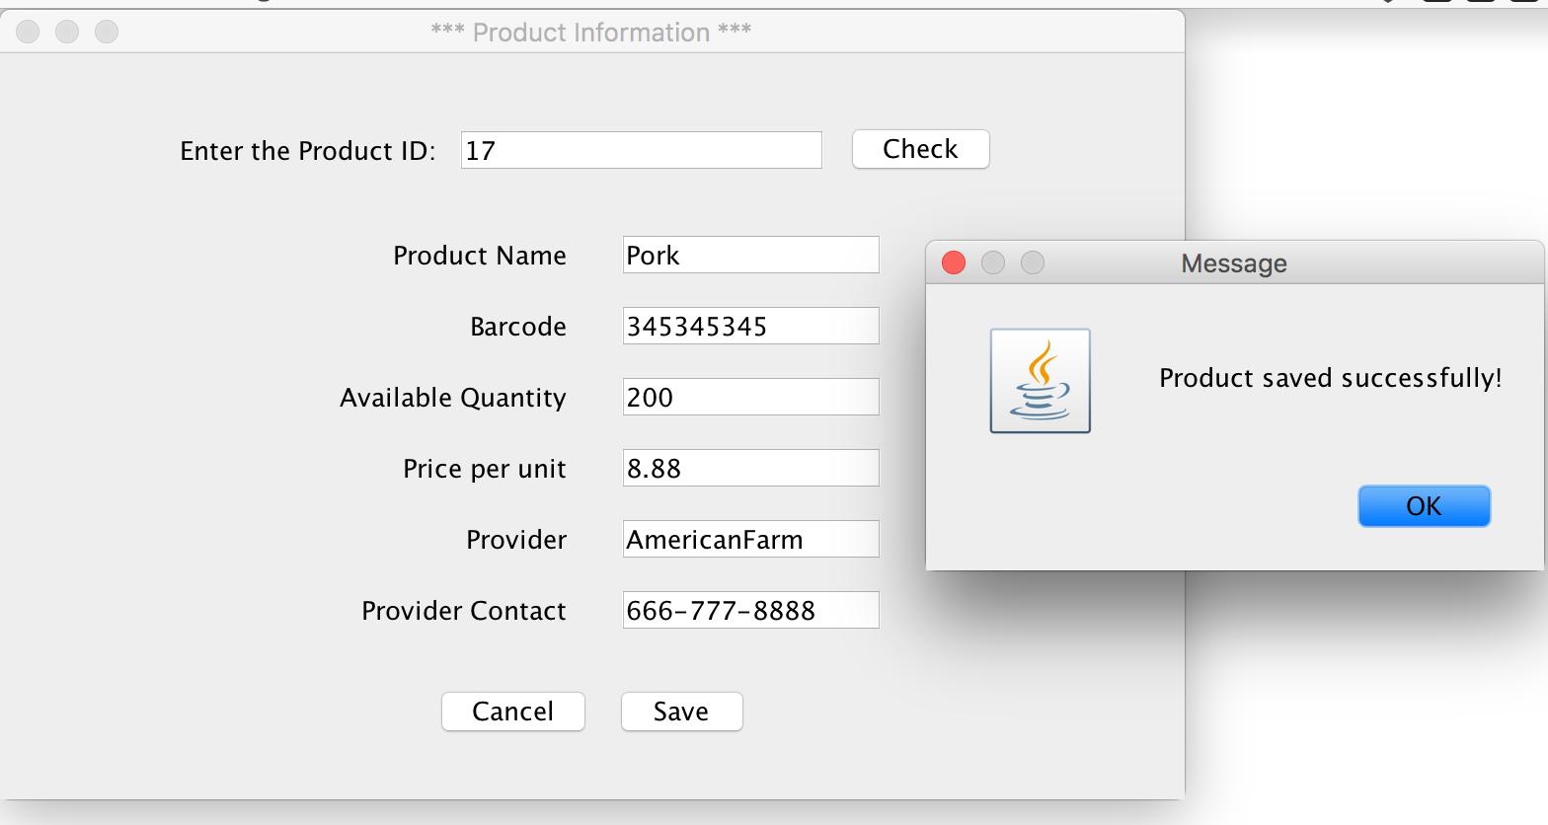

**Use case 2 – Press “Update Product”**

Actually this case is very similar to use case 1. You can edit any part of the product info and then press “Save” button to save it.

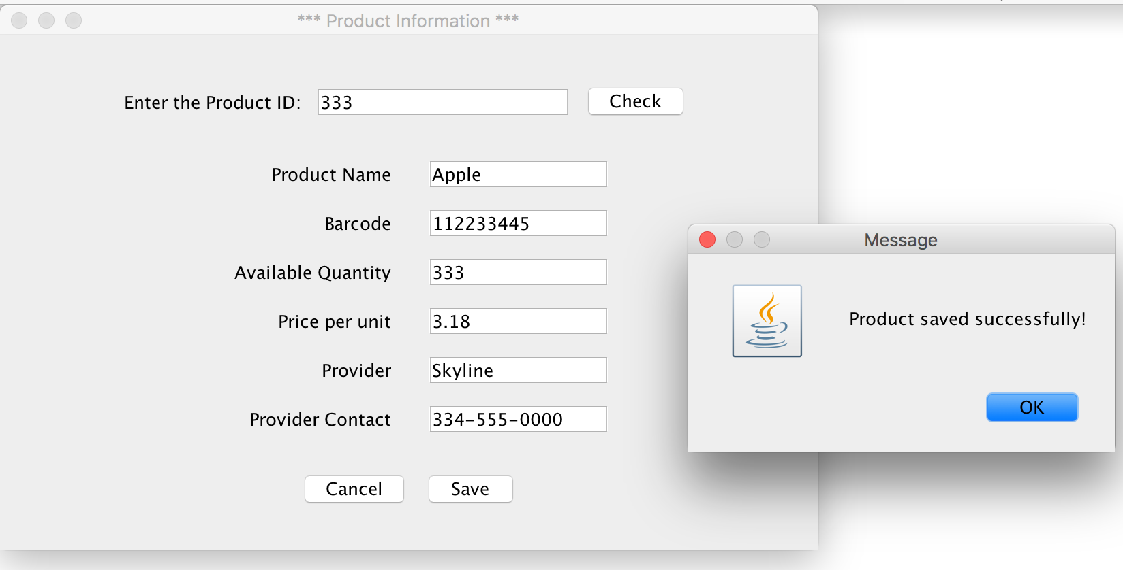

**Use case 3 – press “Check Out”**

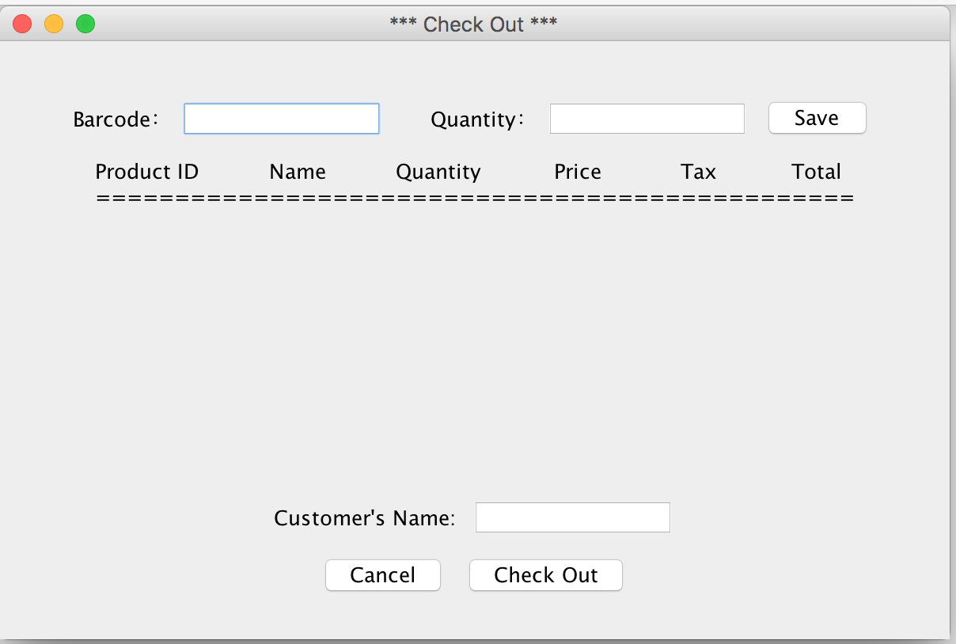

Theocratically, the barcode should be correct because it is scanned in. However, in case of a wrong one, it will pop up an error message:

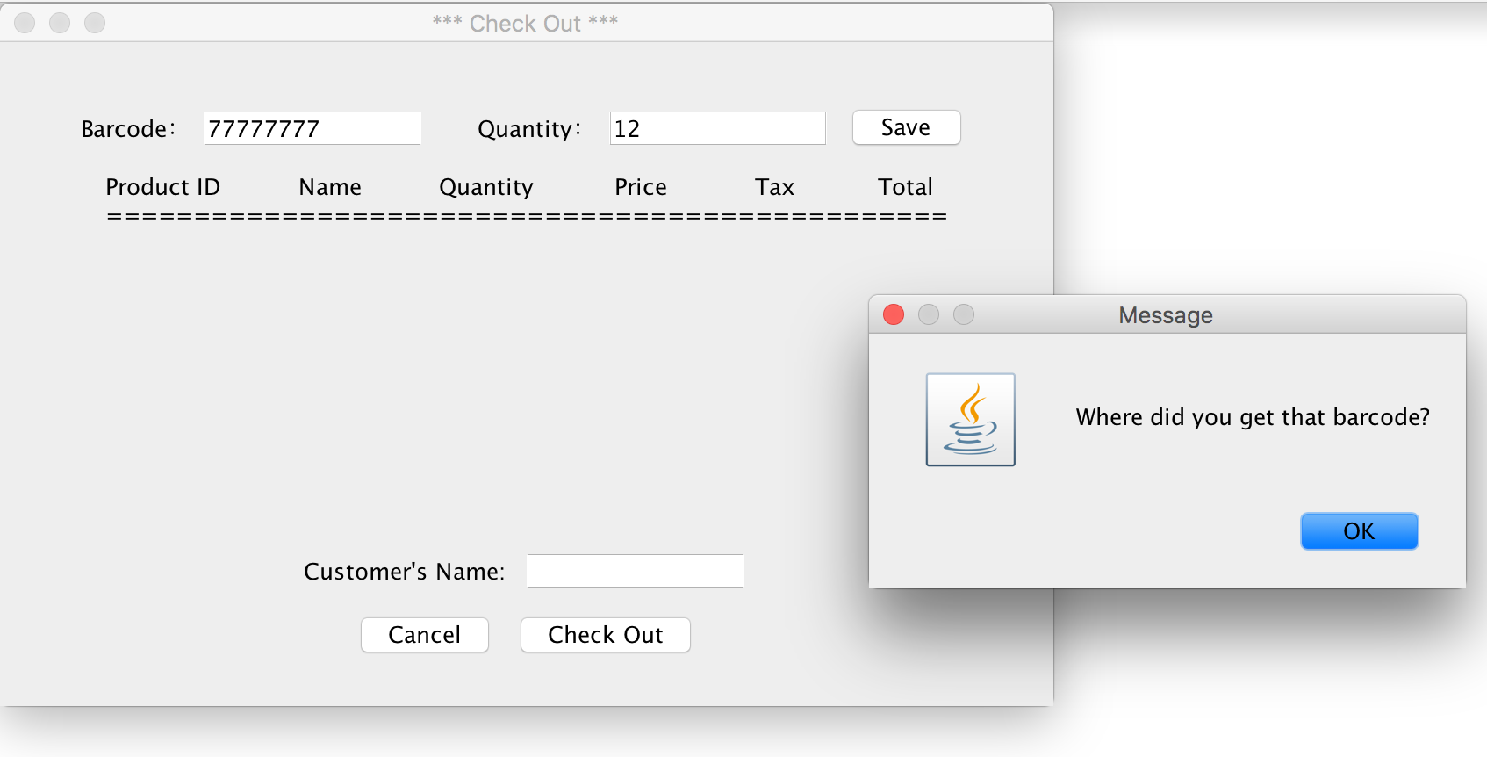

When scanned in a correct barcode, enter a quantity, and then press “Save”, the system will show off an order line. Keep doing this for all products that the customer wants to buy.

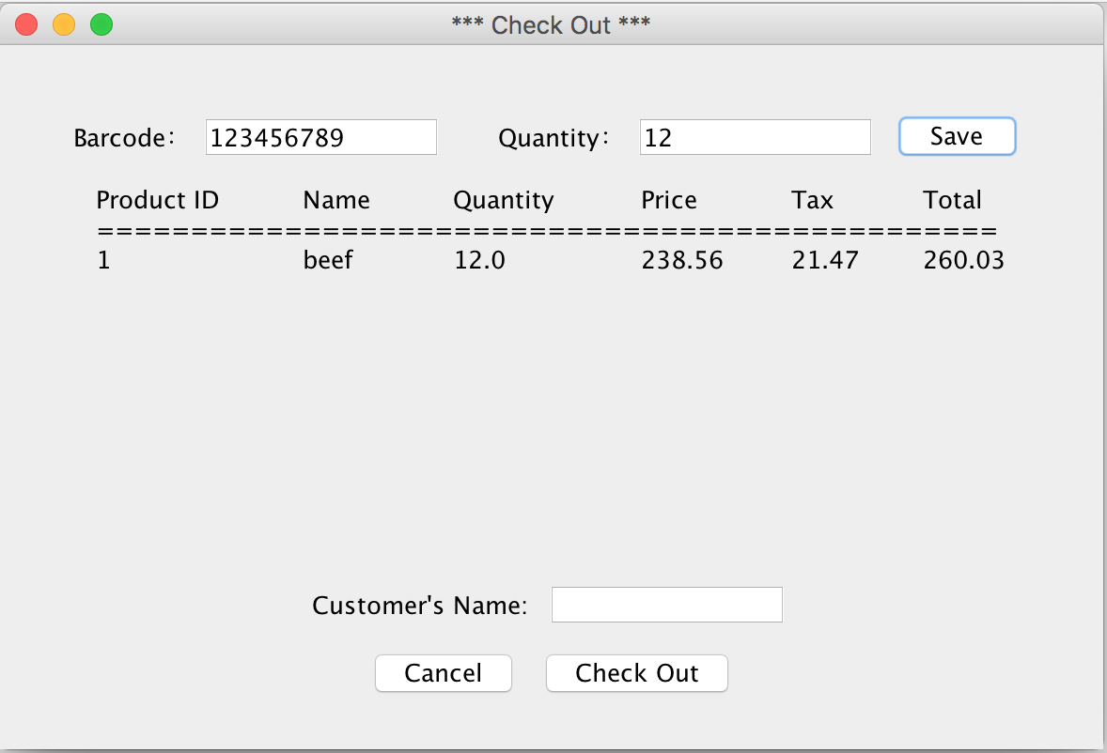

After “Save” all the products, enter the customer’s name and press “Check Out”.

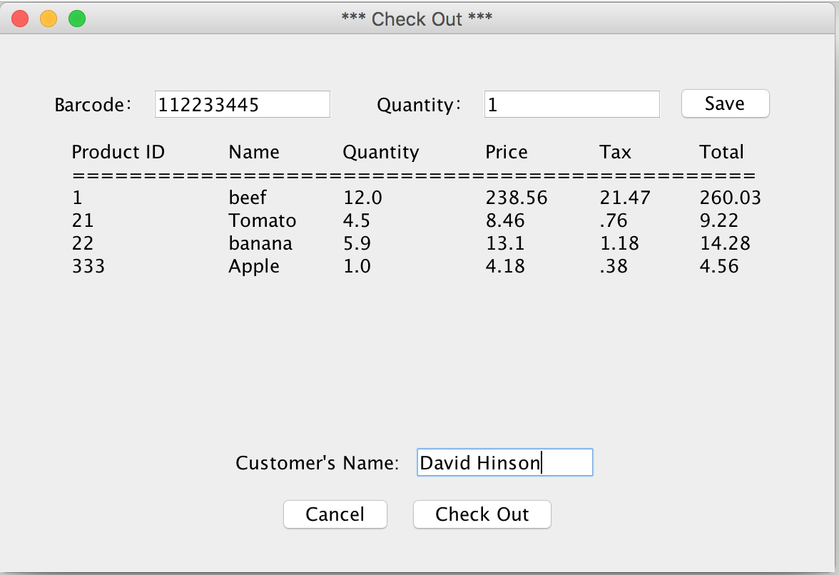

The system will pop out the message with the total due.

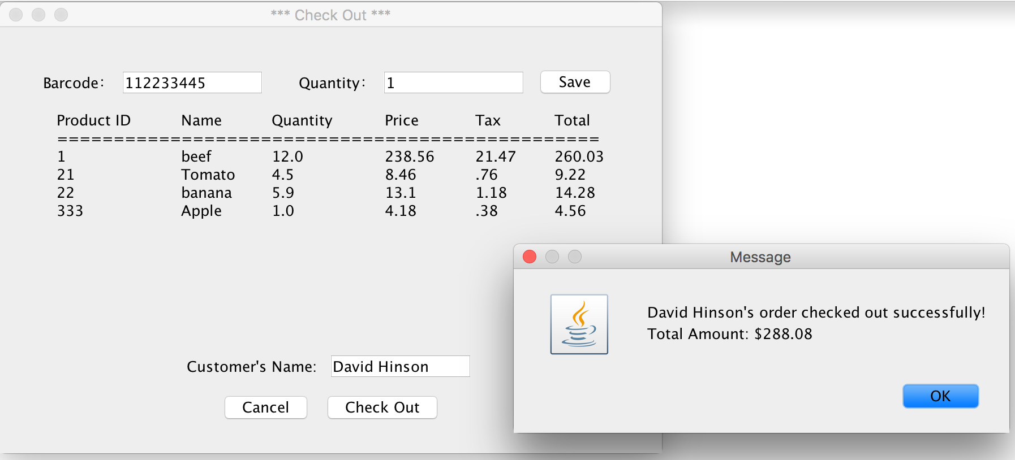

**Use case 4 – press “Search Order”**

You can either search by a customer’s name or by a date.

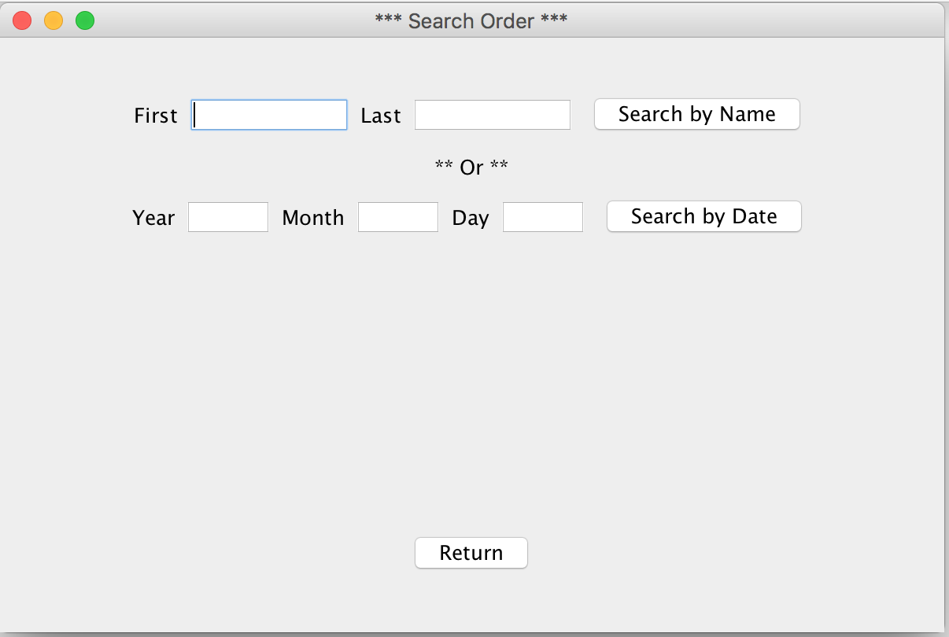

If you enter a name which never placed any order, the system will pop up an error message:

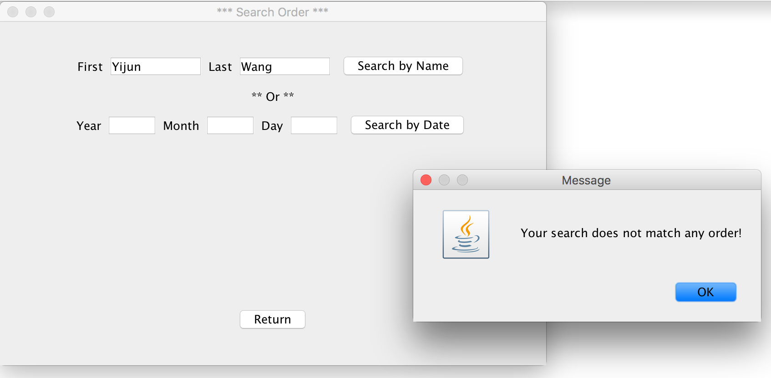

If the name shows up in the order list in the database, the system will display all of it.

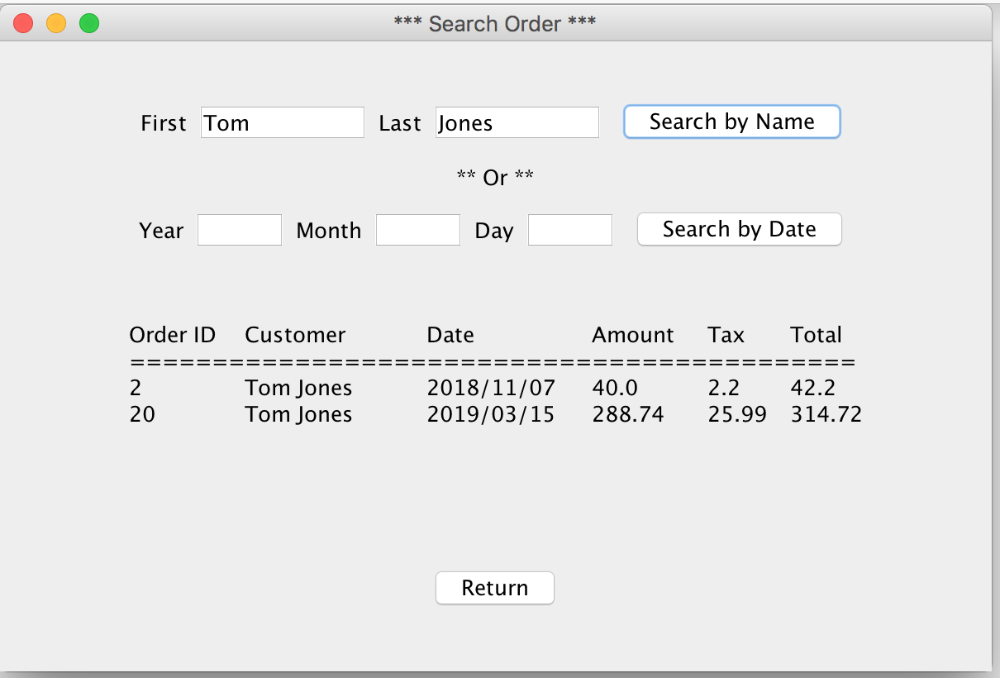

Same thing when search by date, if no order was placed at that date, the system will pop up the error message.

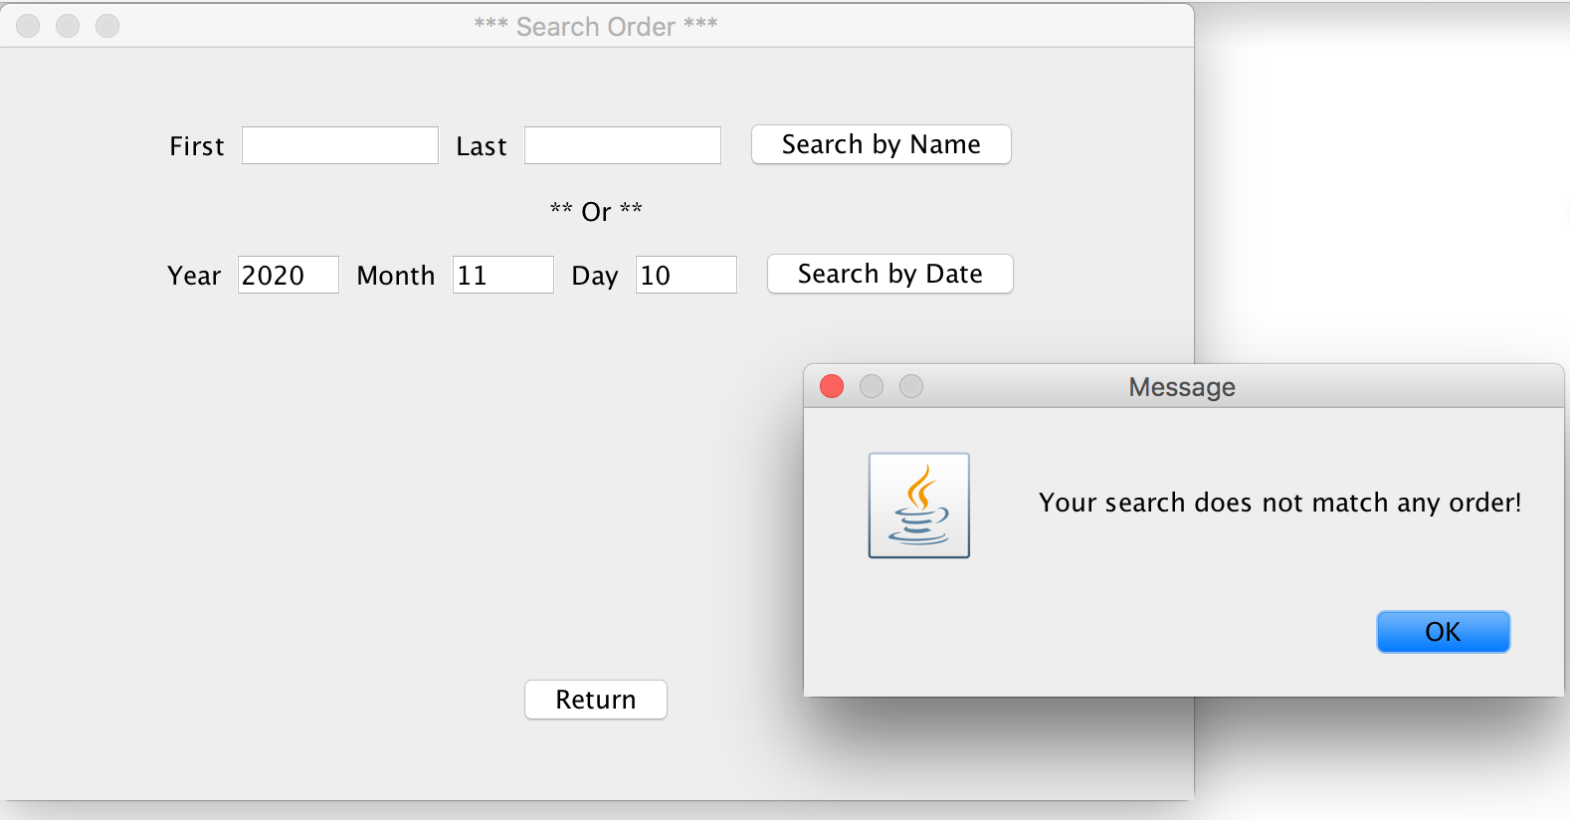

Otherwise, it will display all of the orders in that day.

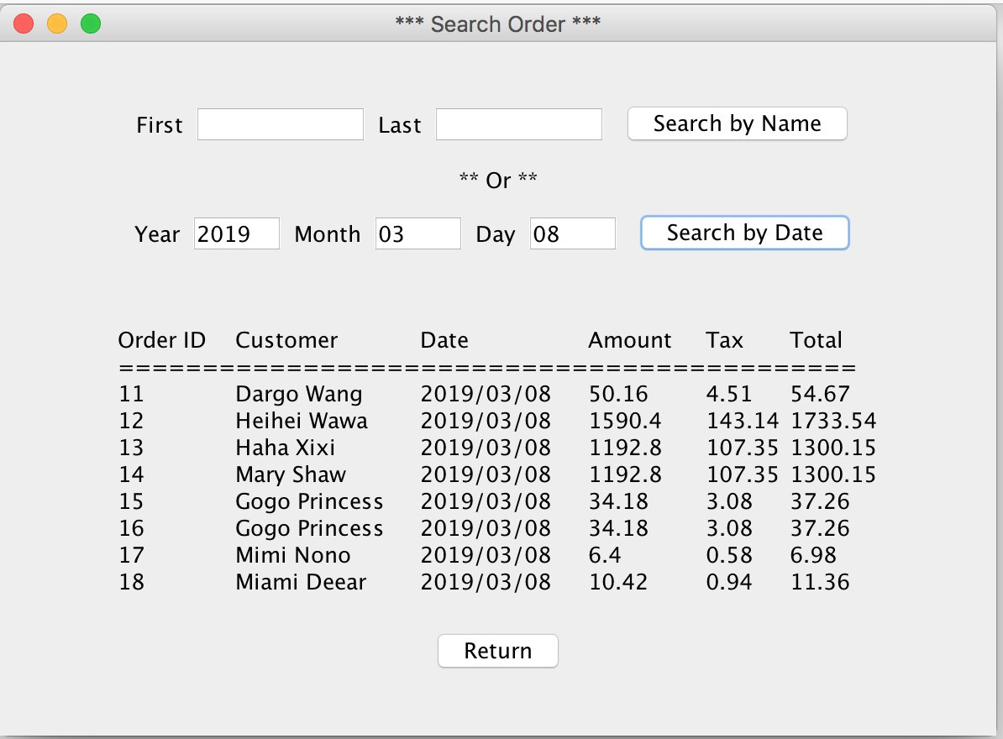

In all cases, press ”Cancel” or “Return” to cancel the operation or return to the main screen.