Assignment 2 - Factory Method and Abstract Factory
Institution: Astana IT University | School of Software Engineering
Course: ShP-2216 Software Design Patterns | Academic year 2026-2027
Programme: 6B06102 Software Engineering | Year 2, Trimester 4
Instructor: Yerassyl Bekenov
Format: Individual work | Java, JDK 17 | Report in English
Weight: 15% of the 1st Attestation grade
Submission deadline: 20.09.2026, 23:59
Student: Darkhan Tynyshtyk
Group: SE-2523
GitHub repository: https://github.com/darhanan/asik2
Submitted commit: tag submission-v1 (see README for the exact hash)

1. Introduction
The application is a console logistics program. In a single run it does two things: it plans a delivery using either a truck or a ship, and it renders a button and a checkbox belonging to either the Windows or the macOS UI family. The delivery mode and the UI platform are chosen independently at startup, so all four combinations run without any code change.
Why Factory Method fits the transport part. There is a single product hierarchy - a Transport - and one varying decision: which concrete transport a given logistics branch uses. The steps around that decision (obtain a transport, hand it the cargo and destination, report the result) are identical for road and sea. Factory Method is designed exactly for this shape: the shared steps live in the creator's planDelivery(...), and the single varying step is deferred to subclasses through createTransport(). A Simple Factory would place that decision in one conditional, which would have to be edited every time a transport is added; with Factory Method a new transport is a new subclass instead.
Why Abstract Factory fits the UI part. Here there is not one product hierarchy but two - Button and Checkbox - and the products must be consistent: a Windows button must never appear next to a macOS checkbox. Abstract Factory expresses precisely that constraint. Because one GUIFactory implementation supplies both creation methods, choosing WindowsFactory makes a mixed pair structurally impossible; the client cannot produce one even by mistake, because it never calls a component constructor at all.
The two patterns are complementary and not interchangeable: the transport side varies along one axis (one product, several implementations), while the UI side varies along two (several products that must belong to the same family).

2. UML class diagrams
Both diagrams below are drawn from the submitted code. Notation: a hollow triangle with a solid line is inheritance (extends), a hollow triangle with a dashed line is interface implementation (implements), and a dashed open arrow is a dependency such as <<creates>>.

2.1 Factory Method (Part A)
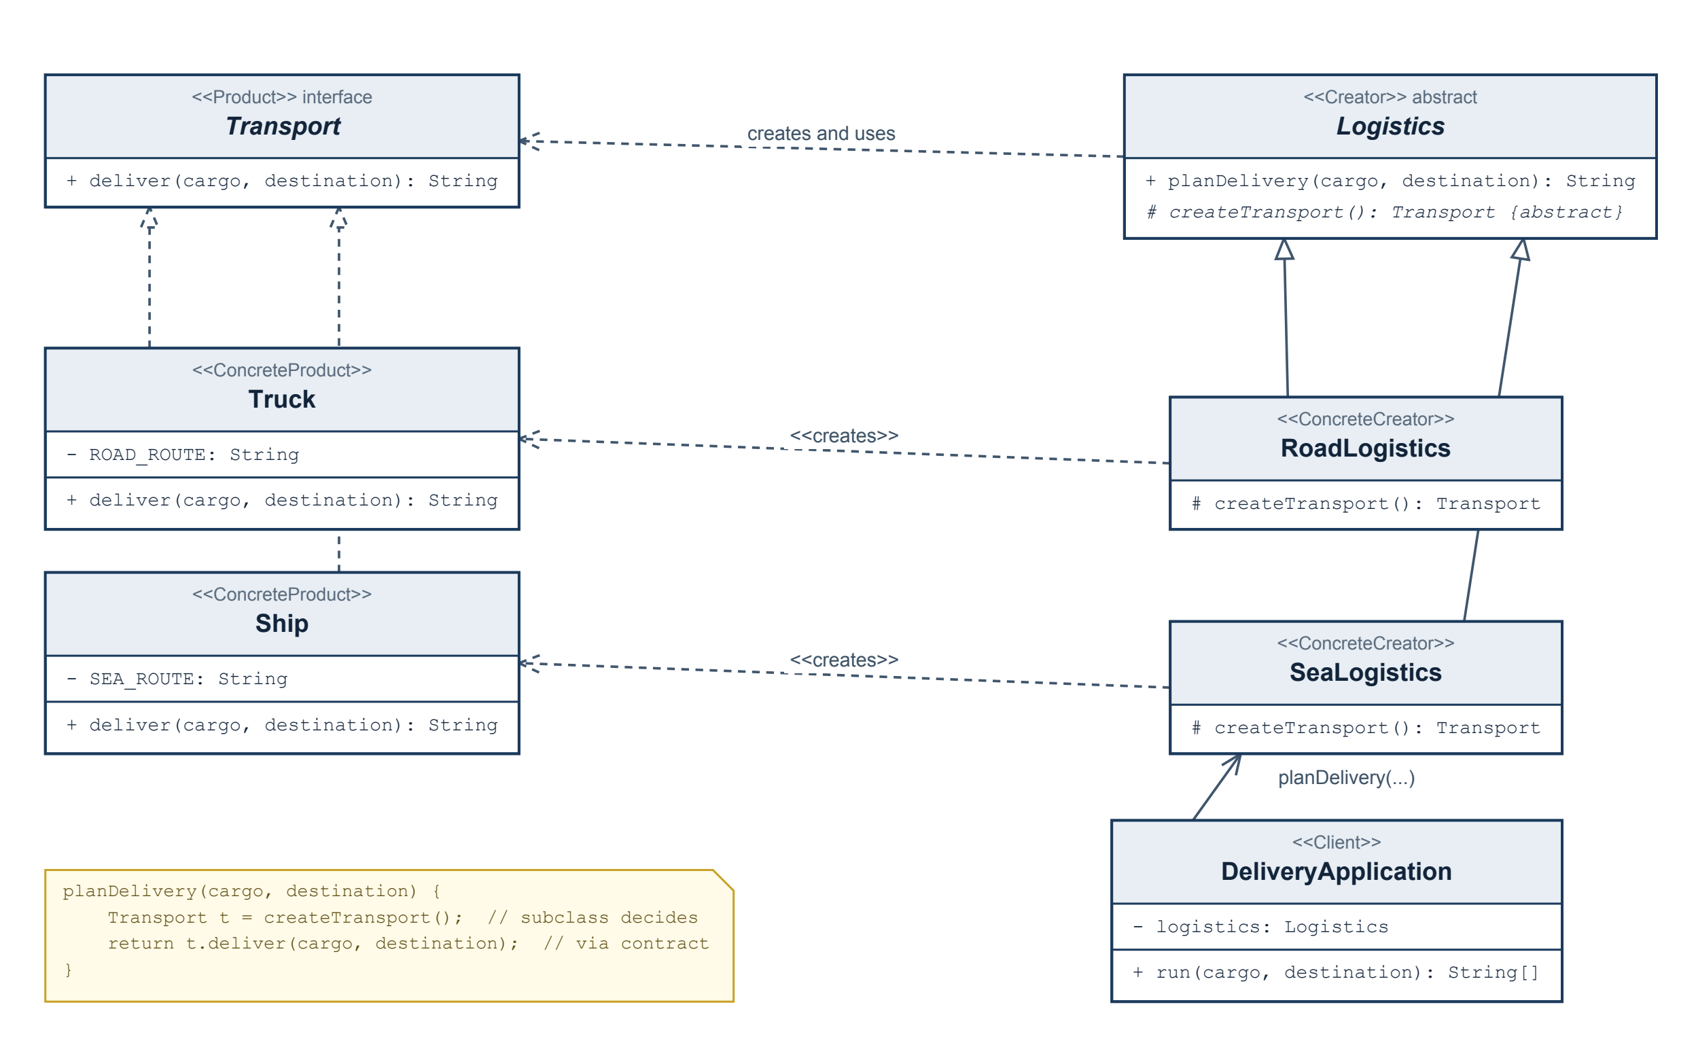
Roles shown in the diagram:
Pattern role | Class in the code
Product | Transport (interface)
Concrete products | Truck, Ship
Creator | Logistics (abstract)
Concrete creators | RoadLogistics, SeaLogistics
Client | DeliveryApplication

Relationships: Truck and Ship implement Transport; RoadLogistics and SeaLogistics extend Logistics; Logistics depends on Transport (it creates and uses one); each concrete creator has a <<creates>> dependency on its own transport; DeliveryApplication depends on the abstract Logistics type only.
Runtime path, matching the code exactly:
DeliveryApplication.run(cargo, destination)
-> Logistics.planDelivery(cargo, destination) shared workflow, no concrete type named
-> createTransport() overridden by RoadLogistics / SeaLogistics
-> new Truck() | new Ship()
-> Transport.deliver(cargo, destination) invoked through the contract

2.2 Abstract Factory (Part B)
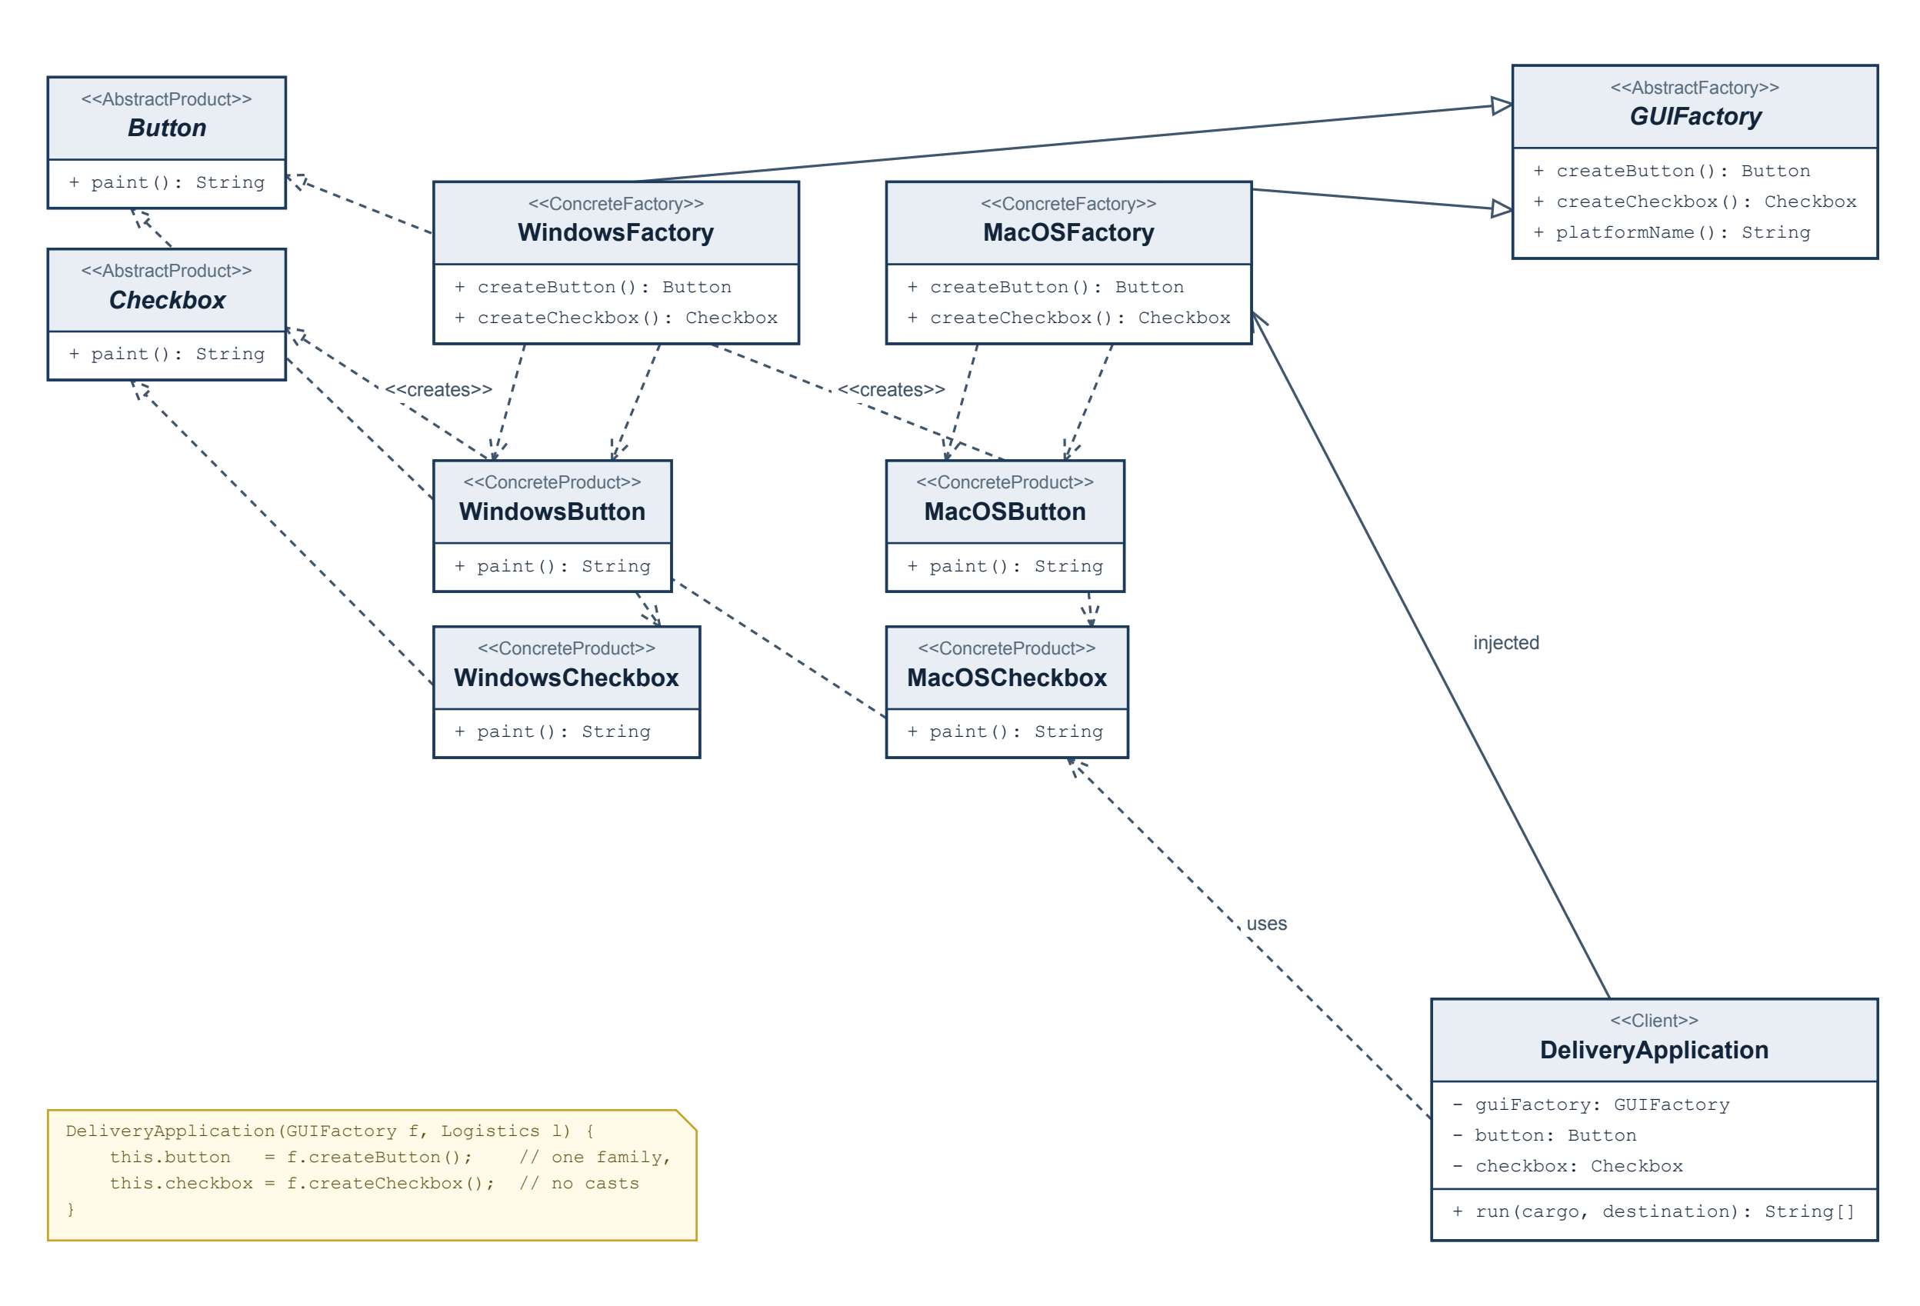
Pattern role | Class in the code
Abstract products | Button, Checkbox (interfaces, each with paint())
Concrete products | WindowsButton, WindowsCheckbox, MacOSButton, MacOSCheckbox
Abstract factory | GUIFactory with createButton() and createCheckbox()
Concrete factories | WindowsFactory, MacOSFactory
Client | DeliveryApplication (constructor injection of GUIFactory)

createButton() is declared as returning Button and createCheckbox() as returning Checkbox, so the client is never handed a concrete type. WindowsFactory creates the Windows pair, MacOSFactory the macOS pair; the family grouping is visible in the diagram as the two <<creates>> dependencies leaving each factory.

3. Clean Code evidence
Five Clean Code practices are demonstrated below, each with an excerpt from the submitted code and the specific benefit it provides. Practices 4 and 5 are the two explanations connected to Clean Code, Chapter 6 (Objects and Data Structures). Summary:
# | Practice | Where it is shown
1 | Meaningful names | Logistics, RoadLogistics, Transport, GUIFactory
2 | Small methods, one responsibility each | Main.main  readChoice  start
3 | No duplicated logic | Logistics.planDelivery(...) written once
4 | Data abstraction (Chapter 6) | DeliveryApplication fields typed as interfaces
5 | Objects and encapsulation (Chapter 6) | Truck.deliver(...), private ROAD_ROUTE

1. Meaningful names
Names identify both the domain and the pattern role, so a reader can tell what a class is in the pattern just from its name.
// src/main/java/aitu/sdp/assignment2/factory/logistics/Logistics.java
public abstract class Logistics {
protected abstract Transport createTransport();
public String planDelivery(String cargo, String destination) { ... }
}

// src/main/java/aitu/sdp/assignment2/factory/logistics/RoadLogistics.java
public final class RoadLogistics extends Logistics { ... }
Benefit. Logistics / RoadLogistics / SeaLogistics name the creator role, Transport / Truck / Ship name the product role, and GUIFactory / WindowsFactory name the factory role. The parameters cargo and destination say what the values mean rather than String a, String b. During the defense the class name alone answers "which pattern role is this?", and no comment is needed to explain the mapping.

2. Small methods with one responsibility
Input handling, selection, construction, rendering, and delivery are separate methods in separate classes instead of one long main.
// src/main/java/aitu/sdp/assignment2/app/Main.java
public static void main(String[] args) {
try (Scanner scanner = new Scanner(System.in)) {
String deliveryMode = readChoice(args, 0, "...", scanner); // input only
String platform = readChoice(args, 1, "...", scanner); // input only
start(deliveryMode, platform); // wiring + output
} catch (UnsupportedChoiceException invalidChoice) {
System.out.println(invalidChoice.getMessage()); // error reporting only
System.out.println("Stopping without running the delivery.");
System.exit(EXIT_INVALID_INPUT);
}
}
Benefit. Each method does one thing at one level of abstraction: readChoice only obtains a raw string, LogisticsSelector.select / GUIFactorySelector.select only validate and choose, DeliveryApplication.run only renders and delivers. Changing how input arrives (for example, reading from a file) touches readChoice alone; the pattern code is untouched.

3. Avoid duplicated logic
The delivery workflow exists once, in the base creator, instead of being copied into each concrete creator.
// src/main/java/aitu/sdp/assignment2/factory/logistics/Logistics.java
public String planDelivery(String cargo, String destination) {
Transport transport = createTransport(); // varies by subclass
return transport.deliver(cargo, destination); // identical for every subclass
}
Benefit. RoadLogistics and SeaLogistics contain only the line that actually differs - which transport to instantiate. The workflow steps (obtain a transport, hand it the cargo and destination) are written once, so a change to the workflow cannot fall out of sync between the road and sea branches. The same reasoning applies to the UI side: repeated component creation lives inside WindowsFactory / MacOSFactory rather than being repeated at every call site.

4. Data abstraction (Clean Code, Chapter 6)
Callers depend on abstract contracts and never see a concrete implementation type. Chapter 6 argues that a class should *expose abstract interfaces that let users manipulate the essence of the data without having to know its implementation*.
// src/main/java/aitu/sdp/assignment2/app/DeliveryApplication.java
public final class DeliveryApplication {

private final GUIFactory guiFactory; // abstraction, not WindowsFactory
private final Logistics logistics; // abstraction, not RoadLogistics
private final Button button; // abstraction, not WindowsButton
private final Checkbox checkbox; // abstraction, not WindowsCheckbox

public DeliveryApplication(GUIFactory guiFactory, Logistics logistics) {
this.guiFactory = guiFactory;
this.logistics = logistics;
this.button = guiFactory.createButton(); // obtained from the factory
this.checkbox = guiFactory.createCheckbox(); // never `new WindowsButton()`
}

public String[] run(String cargo, String destination) {
return new String[] {
"UI family: " + guiFactory.platformName(),
button.paint(), // through the interface
checkbox.paint(), // through the interface
logistics.planDelivery(cargo, destination) // through the abstract creator
};
}
}
Benefit. Every field is declared as an interface or abstract class, so the client has no way to depend on WindowsButton or Truck. There is no instanceof, no cast, and no branching on a concrete type anywhere in the client: the implementation is genuinely hidden, not merely wrapped in getters. Adding a Linux UI family therefore requires no change to this class at all.

5. Objects and encapsulation (Clean Code, Chapter 6)
Behaviour is expressed as a method; internal state stays private and is not exposed through accessors that no caller needs.
// src/main/java/aitu/sdp/assignment2/factory/transport/Truck.java
public final class Truck implements Transport {

private static final String ROAD_ROUTE = "highway route"; // private, no getter

@Override
public String deliver(String cargo, String destination) { // behaviour, not data
return "Truck delivers " + cargo + " to " + destination + " by " + ROAD_ROUTE;
}
}
Benefit. Chapter 6 contrasts an object, which hides its data and exposes behaviour, with a data structure, which exposes its data and has no meaningful behaviour. Truck is an object in that sense: the route is private with no getRoadRoute(), and the only thing a caller can ask is "deliver this cargo". Had the class instead exposed getRoadRoute(), callers would begin assembling delivery messages themselves, and the delivery rule would leak out of the class. The same holds for DeliveryApplication, whose button and checkbox fields are private and are used only inside run(...).
Note on stateless classes: WindowsFactory, MacOSFactory, RoadLogistics, and SeaLogistics hold no state at all. That is intentional - they exist purely to make a creation decision - and the rubric explicitly accepts stateless classes.

4. Verification evidence
All checks were run on one machine with the commands from the README. The full console transcript is in docs/verification-transcript.txt.
# | Input | Expected result | Actual result | Status
1 | ROAD WINDOWS | Truck delivery; Windows button and checkbox | UI family: WINDOWS  Rendering Windows button  Rendering Windows checkbox  Truck delivers laboratory equipment to Aktau warehouse by highway route | PASS
2 | SEA WINDOWS | Ship delivery; Windows button and checkbox | UI family: WINDOWS  Rendering Windows button  Rendering Windows checkbox  Ship delivers laboratory equipment to Aktau warehouse in containers by sea route | PASS
3 | ROAD MACOS | Truck delivery; macOS button and checkbox | UI family: MACOS  Rendering macOS button  Rendering macOS checkbox  Truck delivers laboratory equipment to Aktau warehouse by highway route | PASS
4 | SEA MACOS | Ship delivery; macOS button and checkbox | UI family: MACOS  Rendering macOS button  Rendering macOS checkbox  Ship delivers laboratory equipment to Aktau warehouse in containers by sea route | PASS
5 | AIR WINDOWS | Clear validation message; no delivery | Unsupported delivery mode: 'AIR'. Supported values: ROAD, SEA.  Stopping without running the delivery. Exit code 1; no UI rendered, no delivery performed | PASS
6 | ROAD LINUX | Clear validation message; no UI construction | Unsupported UI platform: 'LINUX'. Supported values: WINDOWS, MACOS.  Stopping without running the delivery. Exit code 1; no components created | PASS

Missing-input behaviour. Documented in the README: when a value is not supplied as an argument, the program prompts for it; if no console input is available, or the value is blank, it prints Missing delivery mode. Supported values: ROAD, SEA. (or the corresponding platform message) and stops with exit code 1. Verified: running java -cp out aitu.sdp.assignment2.app.Main with no arguments and no input printed Missing input: no value was provided. followed by Stopping without running the delivery. No default was substituted and no factory was left null.
Cross-platform note. Check 3 and Check 4 were executed on a single machine. Selecting the macOS family does not require a computer running macOS, because the components only print their platform and component type.
Additional observation: input is accepted case-insensitively (road / macos work), which is documented in the README as supported behaviour.

5. Conclusion

5.1 Comparing the two patterns
Factory Method and Abstract Factory both remove new from the client, but they answer different questions.
Factory Method concerns one product hierarchy. A single creation step inside an otherwise fixed algorithm is deferred to a subclass. The variation is expressed through inheritance: each subclass overrides one method. In this project that is the transport - RoadLogistics and SeaLogistics differ in exactly one line, and everything else is shared in planDelivery(...).
Abstract Factory concerns several related product families. It groups multiple creation methods behind one interface so that the products a client receives are guaranteed to be consistent with one another. The variation is expressed through composition: the client is handed an object. In this project that is the UI - WindowsFactory supplies both a Windows button and a Windows checkbox, and family consistency is the whole point.
The relationship to Simple Factory is also worth stating: a Simple Factory concentrates the decision in one conditional inside a single create(type) method. Adding a product means editing that conditional, so the creation code is not closed to modification. Factory Method replaces the conditional with subclass overrides, so adding a product means adding a class. The small switch in LogisticsSelector and GUIFactorySelector is not a Simple Factory in this sense: it runs once at startup to translate a user's text choice into an object, and after that no branching on type occurs anywhere. Some mapping from external input to an object is unavoidable in any program that takes user input; what matters is that the delivery and rendering logic below it contains no conditionals, casts, or instanceof checks on product types.

5.2 Design reflection - what would change for three extensions
(a) Adding one more transport, e.g. `Drone` for air delivery.
- Add: Drone implements Transport (one new class) and AirLogistics extends Logistics overriding createTransport() to return a Drone (one new class).
- Change: one line in LogisticsSelector.select(...) to map "AIR" to AirLogistics, and the SUPPORTED_MODES constant so the validation message stays accurate.
- Unchanged: Logistics.planDelivery(...), Transport, Truck, Ship, the entire Abstract Factory side, and DeliveryApplication - which depends only on the abstract Logistics type and therefore cannot notice a new subclass. This is the payoff of Factory Method: the shared workflow is closed to modification.
(b) Adding one more UI family, e.g. Linux.
- Add: LinuxButton implements Button, LinuxCheckbox implements Checkbox, and LinuxFactory implements GUIFactory returning that pair (three new classes).
- Change: one line in GUIFactorySelector.select(...) plus the SUPPORTED_PLATFORMS constant.
- Unchanged: Button, Checkbox, GUIFactory, the existing Windows and macOS classes, and DeliveryApplication, which receives a GUIFactory and calls createButton() / createCheckbox() without knowing which family answered. Adding a family is the cheap direction for Abstract Factory.
(c) Adding one more UI product type, e.g. a text field.
This is the expensive direction, and it is a known trade-off of Abstract Factory rather than a flaw in this implementation.
- Add: a TextField interface with paint(), plus one implementation per family (WindowsTextField, MacOSTextField).
- Change: GUIFactory must declare createTextField(): TextField - and because that is a new method on the interface, every existing concrete factory must implement it. With two families that is two edits; with ten families it would be ten. DeliveryApplication must also change if the new component is to be rendered, since it decides which components the screen contains.
- Unchanged: Button, Checkbox, all four existing component classes, the selectors (no new input value is introduced), and the whole Factory Method side.
In short: new families are cheap, new product types are expensive. Both extension directions leave the startup selection code as the only place that mentions concrete classes, and leave the delivery and rendering logic untouched.

5.3 References
- Lecture 2: Factory Method and Abstract Factory (Logistics and GUI examples; Clean Code, Chapter 6 slides), ShP-2216 Software Design Patterns, Astana IT University, 2026-2027.
- E. Freeman, E. Robson. Head First Design Patterns, 2nd ed., O'Reilly, Chapter 4 - The Factory Pattern.
- R. C. Martin. Clean Code: A Handbook of Agile Software Craftsmanship, Prentice Hall, Chapter 6 - Objects and Data Structures.
- E. Gamma, R. Helm, R. Johnson, J. Vlissides. Design Patterns: Elements of Reusable Object-Oriented Software, Addison-Wesley - Factory Method and Abstract Factory.
- Software Design Patterns syllabus 2026-2027 and the official course calendar in Moodle.

