Assignment 1 — Divide and Conquer & Asymptotic Notations
Course: Design and Analysis of Algorithms
Author: Darkhan Tynyshtyk (SE-2523)
Version: v1.0
All numbers in this report come from results.csv, produced by
cli.BenchmarkRunner on this machine (JDK 25, Apple Silicon). Every case is the
median of 5 runs after an untimed JVM warm-up pass.

1. Architecture notes
The project keeps algorithms, instrumentation, driver and tests apart:
Package | Contents
algorithms | MergeSort, QuickSort, QuickSelect, InsertionSort, Partition, DeterministicSelect, ClosestPair
metrics | Metrics — comparisons, max recursion depth, allocations, nanosecond timer
cli | BenchmarkRunner — generates inputs, runs the suite, writes results.csv

How depth is controlled. A Metrics object is passed into every algorithm
(no static counters), and each recursive method wraps its body in
enterRecursion() / exitRecursion() inside a try/finally, so the maximum is
recorded even if an exception unwinds the stack.
Three mechanisms keep the stack bounded and the allocations low:
- One buffer. MergeSort.sort allocates new int[a.length] exactly once at
the top level and threads it through the recursion. merge() never allocates.
The test mergeSortAllocatesOneBuffer asserts allocations == 1 for
n = 100 000.
- Smaller side first. QuickSort recurses into the smaller partition and
reassigns lo/hi for the larger one in a while loop. The recursive call
therefore always covers at most half the current range, so real recursion
depth is bounded by log₂(n) + O(1) — independently of pivot luck.
- 3-way partition. Partition collapses the whole equal-to-pivot band in a
single pass, so inputs with few distinct values do not degrade to O(n²).

2. Asymptotic bounds
Θ is used where the bound is tight; O where only an upper bound holds.
Algorithm | Best | Average | Worst | Space | Reason (which input causes the case)
MergeSort | Θ(n log n) | Θ(n log n) | Θ(n log n) | Θ(n) | The split is always exactly in half, so the recursion tree has the same shape for every input. (Our skip-merge check makes already-sorted input Θ(n) in practice — see §5.)
QuickSort | Θ(n log n) | Θ(n log n) | O(n²) | Θ(log n) | Best/average: a random pivot splits the range in a constant ratio. Worst: every pivot is the min or max — possible but with probability ~1/n!, and the smaller-side-first loop keeps the stack at O(log n) even then.
QuickSelect | Θ(n) | Θ(n) | O(n²) | Θ(1) | Average: discarding a constant fraction each step gives n + n/2 + n/4 + … = 2n. Worst: repeatedly extreme pivots. Iterative loop ⇒ O(1) stack.
DeterministicSelect (MoM) | Θ(n) | Θ(n) | Θ(n) | Θ(log n) | The median-of-medians pivot guarantees at least a 30/70 split, so the worst case is linear too — the price is a larger constant.
InsertionSort | Θ(n) | Θ(n²) | Θ(n²) | Θ(1) | Best: already sorted — one failing comparison per element. Worst: reverse-sorted — every element shifts the whole prefix.
ClosestPair | Θ(n log n) | Θ(n log n) | Θ(n log n) | Θ(n) | The split is always in half and the strip scan is linear, so the shape is input-independent.

Note on space: the figures are auxiliary space. QuickSort's Θ(log n) is
stack only; MergeSort's Θ(n) is the single shared buffer.

3. Recurrences and the Master Theorem
The Master Theorem applies to T(n) = a·T(n/b) + f(n), comparing f(n) against
n^(log_b a).

MergeSort — Case 2
T(n) = 2·T(n/2) + Θ(n)
a = 2, b = 2, f(n) = Θ(n)
n^(log_b a) = n^(log_2 2) = n^1 = n
f(n) = Θ(n) = Θ(n^(log_b a)) → Case 2
T(n) = Θ(n^(log_b a) · log n) = Θ(n log n)

The Insertion Sort cutoff changes the base case, not the growth rate: it
truncates the bottom ~4 levels of the recursion tree (2^4 = 16 > 15), which
lowers the constant but leaves Θ(n log n) intact.

QuickSort — Case 2 (assuming a balanced split)
T(n) = 2·T(n/2) + Θ(n)
a = 2, b = 2, f(n) = Θ(n) → same as MergeSort → Θ(n log n)

Why a random pivot gives O(n log n) on average. A pivot is "good" if it falls
in the middle 50% of the values, which happens with probability 1/2. A good pivot
leaves each side at most 3n/4 of the range, so at most log_{4/3}(n) ≈ 2.4·log₂(n)
good splits are needed to reach the base case. Since half of all pivots are good
in expectation, the expected number of partition levels is a constant factor
above log₂(n), and each level costs Θ(n) — giving Θ(n log n) expected time. The
worst case survives only for pathologically unlucky pivot sequences, whose
probability vanishes as n grows; crucially, it is not triggerable by choosing a
particular input, because the adversary cannot see our random numbers.

QuickSelect — Case 3 (a different case)
T(n) = 1·T(n/2) + Θ(n)
a = 1, b = 2, f(n) = Θ(n)
n^(log_b a) = n^(log_2 1) = n^0 = 1
f(n) = Θ(n) grows polynomially FASTER than n^0 = 1 → Case 3
(regularity: a·f(n/b) = n/2 ≤ c·f(n) with c = 1/2 < 1 ✓)
T(n) = Θ(f(n)) = Θ(n)

This is the contrast the assignment asks for: MergeSort recurses into both
halves (a = 2) and lands in Case 2 with the extra log n factor, whereas
QuickSelect recurses into one half (a = 1) and lands in Case 3, where the
linear work at the top dominates the entire recursion. Intuitively the cost is
the geometric series n + n/2 + n/4 + … = 2n.

DeterministicSelect — Master Theorem does not apply
T(n) ≤ T(n/5) + T(7n/10) + Θ(n)

The two subproblems have different sizes, so the a·T(n/b) form does not fit
and the Master Theorem cannot be used. Instead, substitution works: assume
T(m) ≤ c·m for all m < n, then
T(n) ≤ c·n/5 + c·7n/10 + d·n = c·(9n/10) + d·n = c·n − (c·n/10 − d·n)

which is ≤ c·n whenever c ≥ 10d. Since 1/5 + 7/10 = 9/10 < 1, the work shrinks
geometrically and T(n) = Θ(n) in the worst case. The 7n/10 term is the
guarantee from the median of medians: at least half of the ⌈n/5⌉ group medians
are ≤ the pivot, and each contributes 3 elements ≤ the pivot, so ≥ 3n/10
elements are discarded on each side.

ClosestPair — Case 2
T(n) = 2·T(n/2) + Θ(n) → Θ(n log n)

The Θ(n) merge step is achieved by keeping points y-sorted on the way up the
recursion (a MergeSort-style merge), rather than re-sorting the strip at each
level — re-sorting would give 2T(n/2) + Θ(n log n) and hence Θ(n log²n).

4. Plots
Plot | File
Time vs n | docs/plots/time_vs_n.png
Max recursion depth vs n | docs/plots/depth_vs_n.png
Ratio vs n (Θ check) | docs/plots/ratio_vs_n.png

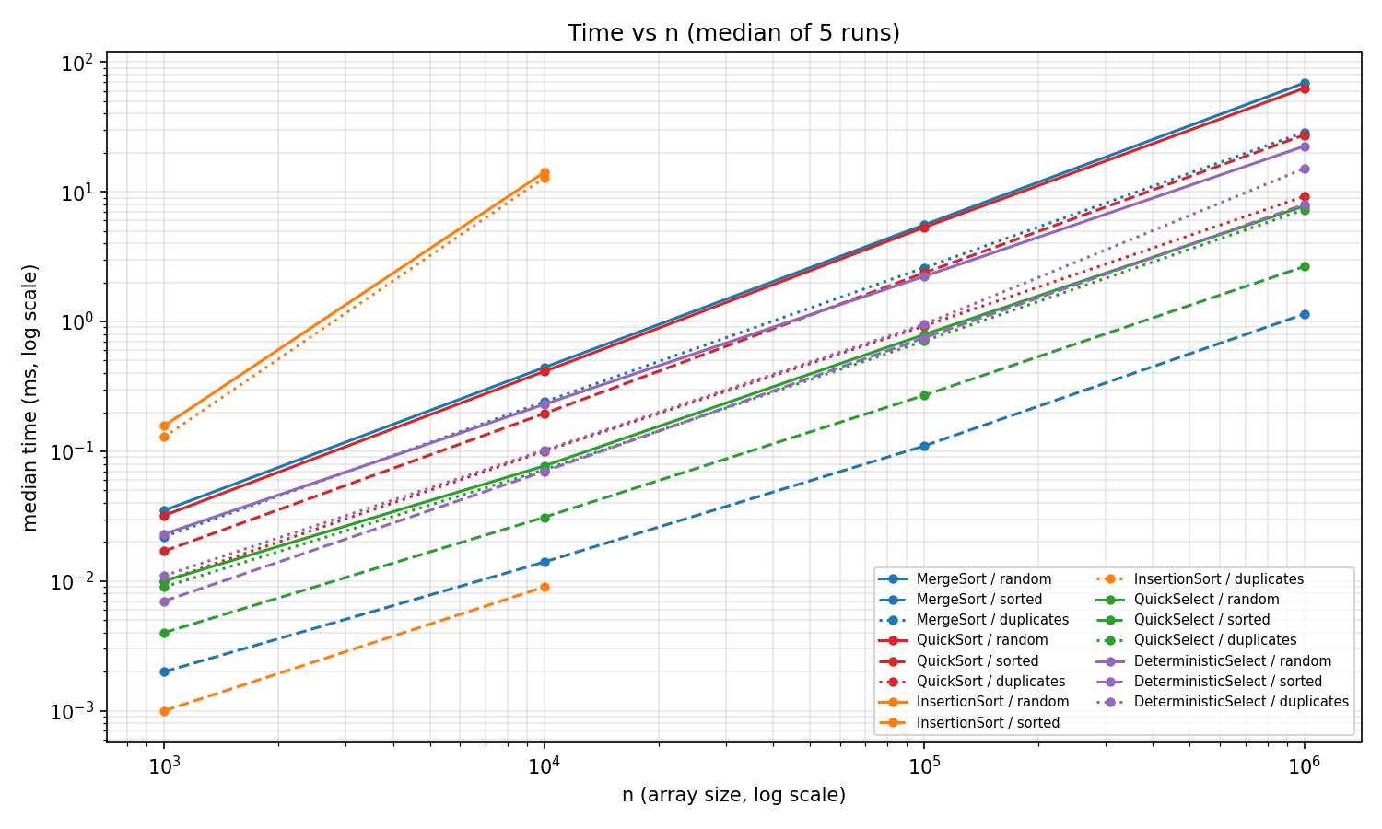
Time vs n
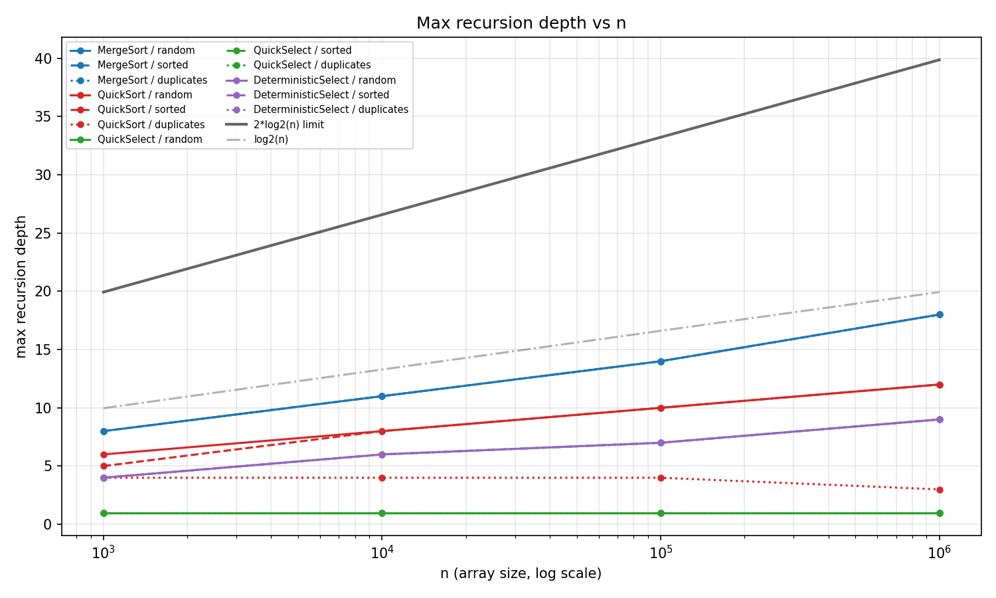
Depth vs n
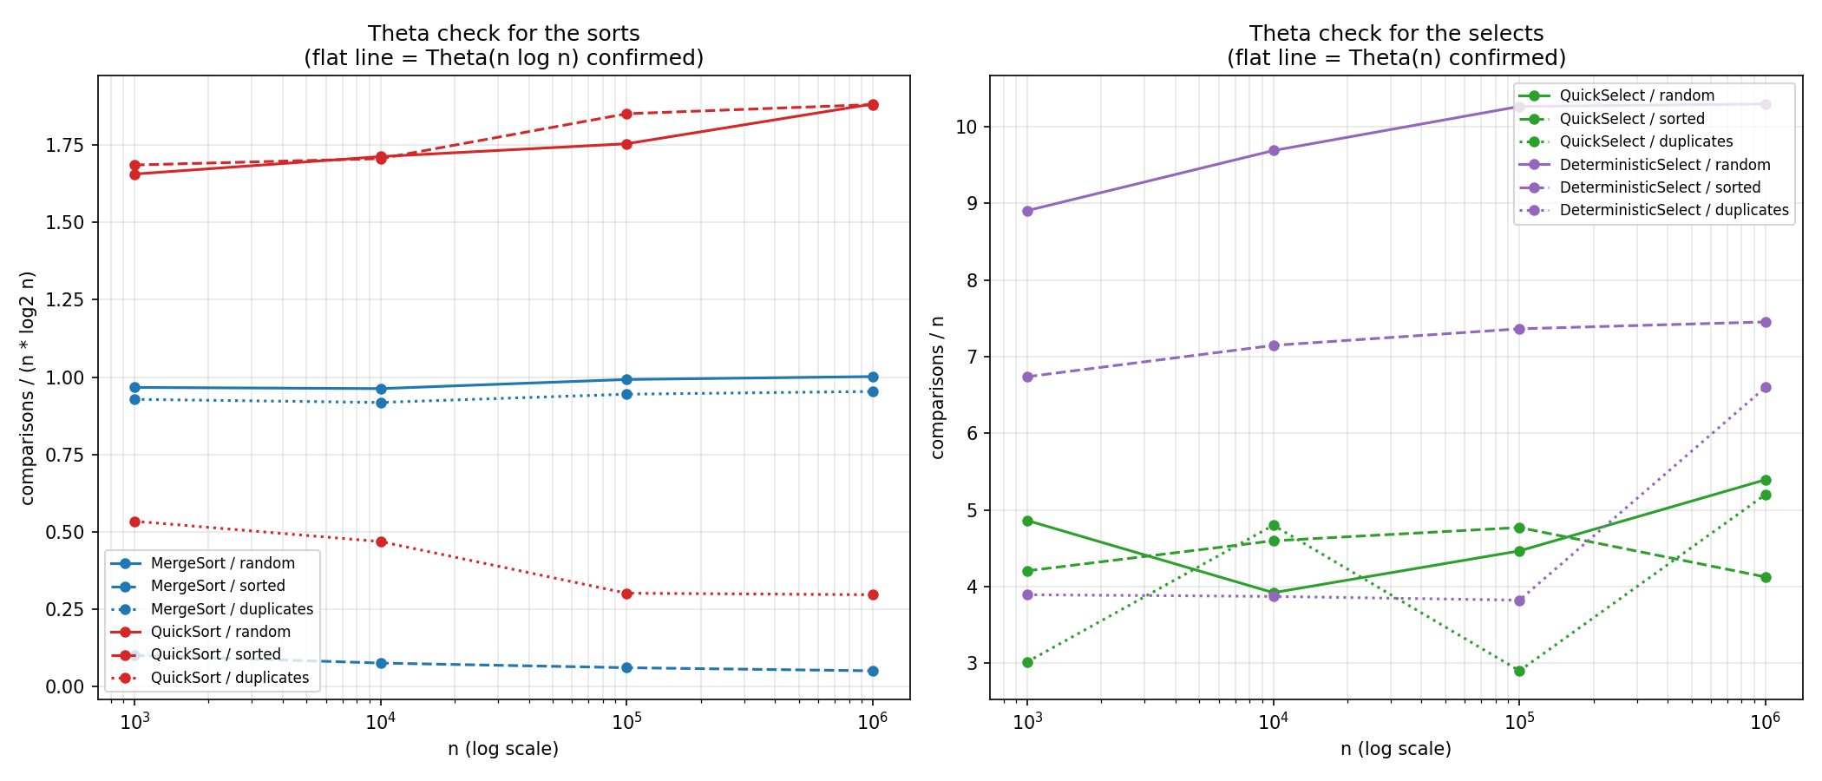
Ratio vs n

5. Θ verification from the ratio plot
The definition: f(n) = Θ(g(n)) iff there exist c₁, c₂, n₀ > 0 such that
c₁·g(n) ≤ f(n) ≤ c₂·g(n) for all n ≥ n₀. So if we plot
comparisons / g(n) and the curve flattens, the ratio is trapped between two
constants and Θ is confirmed.

Sorts — ratio = comparisons / (n · log₂ n)
Algorithm / input | n=10³ | n=10⁴ | n=10⁵ | n=10⁶ | Verdict
MergeSort / random | 0.967 | 0.963 | 0.992 | 1.002 | flat → Θ(n log n)
MergeSort / duplicates | 0.928 | 0.918 | 0.945 | 0.953 | flat → Θ(n log n)
MergeSort / sorted | 0.100 | 0.075 | 0.060 | 0.050 | decays → see below
QuickSort / random | 1.656 | 1.713 | 1.754 | 1.883 | flat → Θ(n log n)
QuickSort / sorted | 1.686 | 1.706 | 1.851 | 1.881 | flat → Θ(n log n)
QuickSort / duplicates | 0.534 | 0.468 | 0.301 | 0.296 | settles → O(n log n), effectively Θ(n)

Constants. For the flat series: MergeSort c₁ ≈ 0.9, c₂ ≈ 1.05, n₀ ≈ 10³;
QuickSort c₁ ≈ 1.6, c₂ ≈ 2.0, n₀ ≈ 10³. Both ratios are bounded above and
below by positive constants from the smallest measured size onward, so Θ(n log n)
is confirmed on real data.
The two decaying rows are the interesting ones, and both are expected:
- MergeSort / sorted measures exactly n − 1 comparisons (999 / 9 999 /
99 999 / 999 999). That is the skip-merge optimisation: when a[mid-1] <= a[mid]
the two halves are already ordered end to end and the merge is skipped
entirely. So this input is Θ(n), not Θ(n log n) — the ratio decaying like
1/log₂(n) is precisely the signature of that. The algorithm is still
Θ(n log n) in general; this is a best case the optimisation exposes.
- QuickSort / duplicates drops because the 3-way partition puts every equal
element in final position in one pass. With only 10 distinct values the
recursion bottoms out after ~log₂(10) levels, so the total work approaches
Θ(n·distinct) = Θ(n). This is the payoff for the 3-way partition.

Selects — ratio = comparisons / n
Algorithm / input | n=10³ | n=10⁴ | n=10⁵ | n=10⁶ | Verdict
QuickSelect / random | 4.86 | 3.92 | 4.46 | 5.39 | bounded → Θ(n)
QuickSelect / sorted | 4.20 | 4.60 | 4.77 | 4.12 | bounded → Θ(n)
DeterministicSelect / random | 8.90 | 9.69 | 10.26 | 10.30 | flat → Θ(n)
DeterministicSelect / sorted | 6.74 | 7.15 | 7.36 | 7.45 | flat → Θ(n)

Constants. QuickSelect c₁ ≈ 2.9, c₂ ≈ 5.5, n₀ ≈ 10³;
DeterministicSelect c₁ ≈ 3.8, c₂ ≈ 10.5, n₀ ≈ 10³. The ratio never trends
upward with n — it bounces inside a fixed band — so the comparison count is
linear, not n log n. (If it were Θ(n log n), this ratio would have to double
between n = 10³ and n = 10⁶, since log₂ goes 10 → 20. It does not.)
QuickSelect's bouncing is pivot luck: each run uses a different random seed, and
a single unlucky early pivot shifts the constant noticeably. DeterministicSelect
is visibly smoother, which is exactly what "deterministic" buys.

6. Bonus Task A — QuickSelect vs Median-of-Medians
Measured comparisons and median time for selecting the median (k = n/2):
n | input | QuickSelect cmp | MoM cmp | QuickSelect ms | MoM ms | MoM / QS time
100 000 | random | 446 400 | 1 026 325 | 0.794 | 2.230 | 2.8×
1 000 000 | random | 5 392 898 | 10 295 126 | 7.767 | 22.454 | 2.9×
100 000 | sorted | 476 904 | 736 194 | 0.270 | 0.749 | 2.8×
1 000 000 | sorted | 4 123 860 | 7 451 894 | 2.652 | 7.979 | 3.0×

Explanation of the difference. Median-of-medians performs roughly
2–2.5× more comparisons and runs ~3× slower, even though both are Θ(n).
The extra cost is the price of the guarantee:
- MoM must sort every group of 5 (≈ 7 comparisons per group, so ≈ 1.4n
comparisons) before it can even choose a pivot, and it then pays a recursive
select on the n/5 medians. QuickSelect picks its pivot in O(1).
- MoM's recurrence carries two subproblems (n/5 + 7n/10 = 0.9n per level) versus
QuickSelect's single ~0.5n, so MoM's geometric series converges more slowly:
1/(1 − 0.9) = 10 versus 1/(1 − 0.5) = 2.
- The group sorting also has poor cache behaviour — it touches the array in a
scattered pattern while swapping medians to the front.
When each wins. QuickSelect is the right default: its expected time is
better by a constant factor and its worst case is astronomically unlikely with a
random pivot. MoM earns its cost only when a worst-case guarantee is required —
adversarial input, hard real-time deadlines, or when the pivot source cannot be
trusted to be random. The measurements match this: MoM never wins on time, but
its comparison ratio (≈10.3 at both 10⁵ and 10⁶ on random input) is the
flattest line in the whole study, which is the guarantee made visible.

7. Bonus Task B — Closest Pair of Points
n | time (ms) | comparisons | max depth
1 000 | 0.508 | 11 825 | 10
10 000 | 4.481 | 161 707 | 13
100 000 | 52.899 | 2 032 367 | 17

Time grows by ~8.8× and then ~11.8× for each 10× increase in n — close to the
10 · log(10n)/log(n) factor that Θ(n log n) predicts (≈13.3 and ≈12.5), and far
from the 100× that a quadratic algorithm would show. Depth tracks log₂(n)
(10 ≈ log₂1000, 17 ≈ log₂100000) as expected from halving. Correctness is verified
against the O(n²) brute force on 100 random point sets plus collinear and
duplicate-point edge cases.

8. Discussion — do the measurements match the theory?
Yes, with three informative deviations.
The agreement is strongest where the theory is least input-dependent. MergeSort's
ratio sits at 0.96–1.00 across three orders of magnitude, which is about as clean
a Θ(n log n) confirmation as measurement allows. QuickSort's depth is the other
clear win: on a sorted array of 1 000 000 elements — the classic input that
makes naive QuickSort blow the stack — measured max_depth is 12, against a
theoretical limit of 2·log₂(10⁶) ≈ 39. The smaller-side-first loop works exactly
as designed, and the largeInputsDoNotOverflow test confirms no
StackOverflowError at n = 10⁶.
Deviation 1 — constant factors are not predicted by asymptotics. QuickSort
performs ~1.9 comparisons per n log₂ n versus MergeSort's ~1.0, yet QuickSort
is consistently faster in wall-clock time (62.9 ms vs 69.0 ms on random 10⁶).
Comparisons are the wrong unit for predicting time: QuickSort partitions in place
with sequential access, while MergeSort writes through a separate buffer, so it
moves roughly twice the memory. On modern hardware the cache traffic dominates
the comparison count. This is the clearest lesson in the data — two algorithms in
the same complexity class can trade places depending on constants the notation
deliberately hides.
Deviation 2 — best cases the notation hides. MergeSort on sorted input is
Θ(n), not Θ(n log n), because of the skip-merge check; it is 60× faster than on
random input at n = 10⁶ (1.14 ms vs 68.97 ms). Likewise QuickSort on duplicates
runs in 9.2 ms versus 62.9 ms on random data. Neither contradicts the analysis —
both are legitimate best cases — but both show why the ratio plot is necessary:
a single measurement at one n could not distinguish them from a wrong bound.
Deviation 3 — measurement noise at small n. Below n ≈ 10⁴ the timings are
unstable and the select ratios bounce (QuickSelect/duplicates swings 2.9–5.2).
Four effects are responsible:
- JVM warm-up. The first runs execute in the interpreter before C2 compiles
the hot loops; this is why the harness warms up and reports the median of 5
rather than the mean, which a single slow first run would skew badly.
- Garbage collector. MergeSort's 4 MB buffer at n = 10⁶ can trigger a young
collection mid-run, adding a millisecond that has nothing to do with the
algorithm.
- CPU cache. At n = 10³ the whole array fits in L1 and timing is dominated by
loop overhead; by n = 10⁶ (4 MB) it exceeds L2, so memory latency dominates.
This is why per-element cost rises faster than log n suggests.
- Cutoff size. The 15-element cutoff removes the bottom levels of the
recursion, where overhead per element is highest; it changes the constant, not
the asymptotics, but at n = 10³ that constant is most of the runtime.
Conclusion. Every measured curve lands in its predicted complexity class, and
the two places where the ratio is not flat both turn out to be optimisations
behaving correctly rather than analysis errors. The asymptotics predict the
shape; the constants — cache behaviour, buffer traffic, pivot luck — decide which
algorithm actually wins.

