Assignment 06 — Visitor Pattern: Advanced File System
Report: design, Clean Code justification, sample outputs and tests
Student | Darkhan Tynyyshtyk
Group | SE-2523
Course | ShP-2216 Software Design Patterns · Java 17 · Maven · JUnit 5
GitHub repository | https://github.com/<your-username>/Assignment6_Visitor_Pattern
Run | mvn test (28 tests) · mvn -q compile exec:java (demo)

1. Purpose and design choices
The project is an in-memory hierarchical file system (FileNode, DirectoryNode) with three independent operations implemented as visitors: TotalSizeVisitor, SearchVisitor and StatisticsVisitor. The elements store data and know how to accept a visitor. All operation logic lives in the visitors, so a new operation never requires editing the element classes.
- Object model (R1). Element is the common interface (name(), parent(), accept(Visitor)). A package-private, sealed AbstractElement holds name validation and the parent link. FileNode has a size ≥ 0. DirectoryNode keeps children in a TreeMap<String, AbstractElement>, so children are always iterated in name order and nesting is unlimited.
- Double dispatch (R2). Step 1: element.accept(visitor) runs the accept of the runtime element type (dynamic dispatch on the element). Step 2: inside FileNode.accept the call visitor.visit(this) has a static argument type FileNode, so the compiler binds the visit(FileNode) overload, and the JVM runs it on the runtime visitor type (dynamic dispatch on the visitor). DirectoryNode.accept does the same for visit(DirectoryNode). There is no instanceof, getClass(), reflection or cast anywhere in src/main.
- Traversal owner (R7): the visitor, centralised in one base class. TreeVisitor<R>.visit(DirectoryNode) reports the directory to onDirectory and then calls child.accept(this) for every child (pre-order DFS, name order). Concrete visitors only override onFile / onDirectory and never iterate children. The model forbids cycles and shared children, so every reachable node is visited exactly once. Empty and deeply nested directories need no special case.
- Paths and depth. The traversal root has depth 0, and each level adds 1. TreeVisitor keeps a Deque of names from the root's child down to the current node and joins it with / (the root's own name is not included). A file used directly as the root is reported by its own name. SearchVisitor.result() sorts with String.compareTo, so the output never depends on insertion order.
- Controlled state. Visitor instances are reusable (but not thread-safe). When an idle visitor receives its first visit call, TreeVisitor.enter() calls resetState(). Each top-level run, through run(root) or root.accept(v), therefore starts clean, and results never depend on earlier runs.
- Tree integrity (R6). FileNode rejects negative sizes (constructor and resize) with IllegalArgumentException. DirectoryNode.attach checks for a cycle, a second parent and a duplicate sibling name before changing anything, and throws TreeIntegrityException. A rejected change therefore leaves the tree exactly as it was. Moving a node is remove(name) followed by add(node).

2. Clean Code practices (with references to the code)
Practice | Where in the code | Justification (one sentence)
Meaningful naming | SearchVisitor.minSizeInclusive, TreeVisitor.pathFromRoot, DirectoryNode.rejectSecondParent() | Each name states the rule it implements (inclusive threshold, path relative to the root, one-parent invariant), so no extra comment is needed.
Single Responsibility | FileNode / DirectoryNode (data + accept), TreeVisitor (traversal), each concrete visitor (one operation), NameCriterion (name matching) | Every class has exactly one reason to change; for example, changing search rules touches only SearchVisitor / NameCriterion.
Small methods | DirectoryNode.attach() = three guard calls + two statements; rejectCycle, rejectSecondParent, rejectDuplicateName check one invariant each | Short methods with one level of abstraction read like the specification and are trivial to test separately.
Encapsulation | DirectoryNode.children() returns List.copyOf(...); AbstractElement.attachTo/detach are package-private in a sealed class | No caller can modify the child collection or the parent link without going through the validating public API.
No type-checking chains | Visitor.visit(FileNode) / visit(DirectoryNode) overloads; TreeVisitor.currentContext is also overloaded by type | Double dispatch replaces if (x instanceof FileNode) … else …, so adding an operation never means editing a type switch.

3. Traversal and extension trade-offs
- Why the visitor owns the traversal. Path and depth are visitor state (pathFromRoot, currentDepth), so keeping the traversal next to that state avoids passing a context object through the elements. Putting the loop once in TreeVisitor (Template Method) removes the usual drawback of visitor-owned traversal, which is duplicated loops. The cost is that every operation uses pre-order DFS. A post-order or breadth-first operation would need its own base class or an external walker. Very deep trees (thousands of levels) could also overflow the call stack.
- Extension boundary (R8). Adding an operation is cheap. The commit feat(visitor): add StatisticsVisitor… adds three new files (StatisticsVisitor, TreeStatistics, StatisticsVisitorTest) and changes zero lines in the model package or in any accept method (see the dashed boundary in the UML).
- Trade-off of a new element type. Adding, for example, a SymlinkNode is expensive. Visitor needs a new visit(SymlinkNode) method, so TreeVisitor and every concrete visitor (or at least a default hook) must change, and the sealed … permits list must be extended. Visitor therefore fits when the set of element types is stable and operations are added often, which is the case for a file system. If element types changed often, plain polymorphic methods on the elements would be the better choice.

4. Sample output (own data: "city-hall" archive, 12 files, 9 directories)
$ mvn -q compile exec:java
=== 1. TotalSizeVisitor
city-hall total : 82,926,328 bytes
budget subtree : 6,098,576 bytes
=== 2. SearchVisitor (name glob = "*.log", size >= 1048576 B)
budget/2025/audit.log
logs/access.log
logs/archive/access-2025.log
-- same search started at budget/ (paths are relative to the chosen root):
2025/audit.log
=== 3. StatisticsVisitor
city-hall : TreeStatistics[fileCount=12, directoryCount=9, maxDepth=4]
budget : TreeStatistics[fileCount=5, directoryCount=3, maxDepth=2]
city-hall (same instance, run again) : TreeStatistics[fileCount=12, directoryCount=9, maxDepth=4]
=== 4. Rejected mutations (tree stays unchanged)
REJECTED negative size -> File size must be >= 0, got -10
REJECTED duplicate sibling 'readme.txt' -> Duplicate name: 'city-hall' already contains 'readme.txt'
REJECTED second parent for 'budget' -> 'budget' already belongs to 'city-hall'; remove it there first
REJECTED cycle: city-hall inside budget -> Cycle: 'city-hall' cannot be placed inside itself or its descendant 'budget'
total after rejected changes : 82,926,328 bytes

Changing the search configuration without editing the code: mvn -q compile exec:java -Dexec.args='"*.pdf" 2200000' prints only budget/2025/q1-report.pdf (q2-report.pdf has 2 150 000 B < 2 200 000 B), and 2025/q1-report.pdf when the search starts at budget/.

5. Test summary
Test class | Checkpoints | Tests | What is asserted (own fixture SampleTrees.campus(): 8 files, 7 dirs, depth 3, 915 060 B)
DoubleDispatchTest | T1 | 2 | Each element type reaches its own overload, also through the Element interface type.
TotalSizeVisitorTest | T2, T6, T7 | 6 | 915 060 B over 3 levels; subtrees 12 200 B / 5 120 B; empty trees = 0; rerun gives the same total; resize is reflected.
SearchVisitorTest | T3, T4, T6, T7 | 8 | Name AND size; inclusive threshold (2048 matches, 2049 does not); root-relative sorted paths from 3 roots; insertion order irrelevant; no match → [].
StatisticsVisitorTest | T5, T6, T7 | 5 | (8, 7, 3) for the whole tree; depth relative to the chosen root; empty dir = (0, 1, 0); run order irrelevant.
TreeIntegrityTest | T8 | 7 | Negative size, duplicate name, second parent, cycles and invalid names rejected with the tree unchanged; 50-level nesting works; children() read-only.

$ mvn test
[INFO] Tests run: 6, Failures: 0, Errors: 0, Skipped: 0 -- in kz.aitu.filesystem.TotalSizeVisitorTest
[INFO] Tests run: 7, Failures: 0, Errors: 0, Skipped: 0 -- in kz.aitu.filesystem.TreeIntegrityTest
[INFO] Tests run: 8, Failures: 0, Errors: 0, Skipped: 0 -- in kz.aitu.filesystem.SearchVisitorTest
[INFO] Tests run: 2, Failures: 0, Errors: 0, Skipped: 0 -- in kz.aitu.filesystem.DoubleDispatchTest
[INFO] Tests run: 5, Failures: 0, Errors: 0, Skipped: 0 -- in kz.aitu.filesystem.StatisticsVisitorTest
[INFO] Tests run: 28, Failures: 0, Errors: 0, Skipped: 0
[INFO] BUILD SUCCESS

6. Repository and sources
GitHub: https://github.com/<your-username>/Assignment6_Visitor_Pattern · incremental commits: model → TotalSizeVisitor → SearchVisitor → StatisticsVisitor (added last, without touching the elements) → demo → README.
Sources: E. Freeman, E. Robson, Head First Design Patterns, 2nd ed.; Refactoring.Guru — Visitor; Lecture 9 (Visitor, double dispatch).

Appendix — UML class diagram
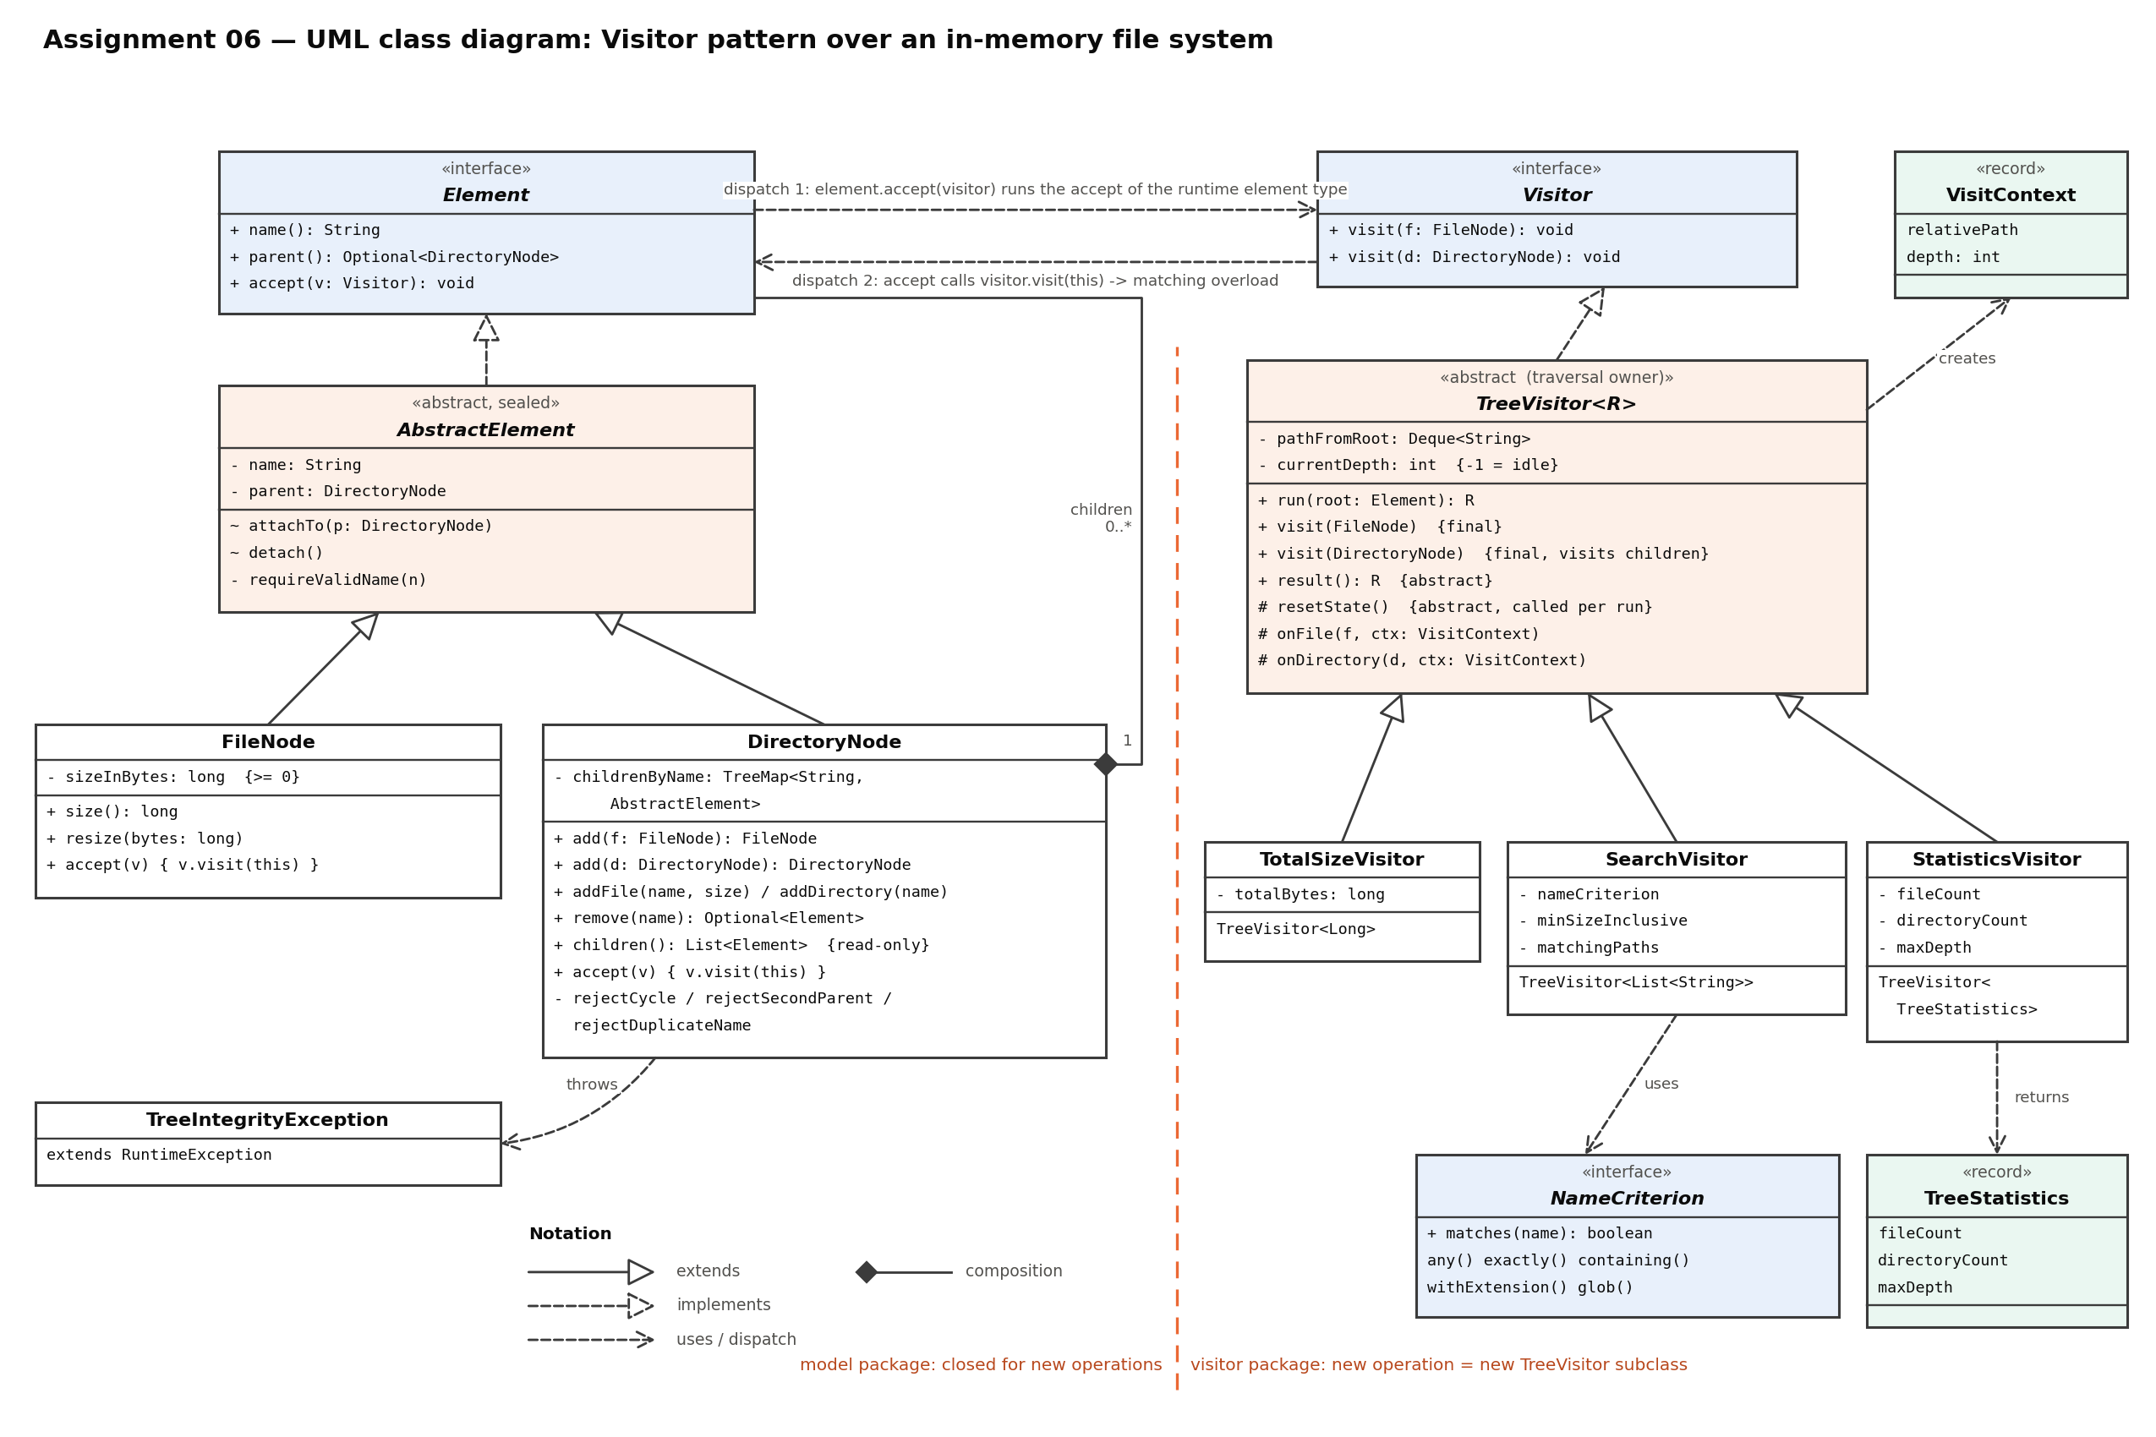
Interfaces Element and Visitor, both elements (FileNode, DirectoryNode), the traversal base class TreeVisitor<R> and the three visitors. The dashed orange line is the extension boundary: new operations are added on the right without changing the model on the left.

