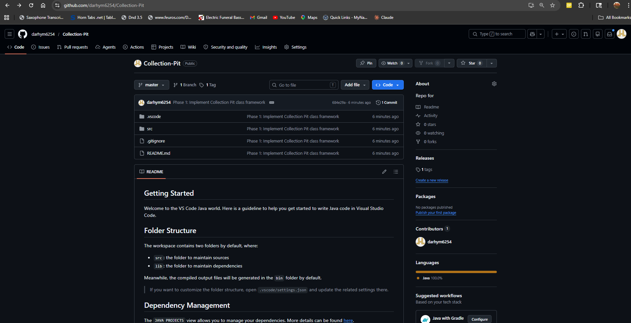
https://github.com/darhym6254/Collection-Pit

