Guided Practice – Circling Back Lab Report
Use this template to document your work as you complete your assignment.

Your Information
Your Name: Daryl Hymel
Assignment Title: Circling Back
GitHub Repository: https://github.com/darhym6254/SDC260-Web-Dev-Class

Development Summary
Briefly summarize the work you completed for this guided practice. Include how JavaScript is used to display market information dynamically.
I completed the Rustic Harvest Farmer’s Market page by linking JavaScript and using loops to dynamically display vendors, produce, events, tips, reviews, and statistics. I also added a vendor card with my student ID and program name.

Code Explanation
- Explain how arrays and objects are used to organize the farmer's market data.

Arrays store simple lists like events, tips, and reviews. Arrays of objects store related information for vendors and produce, while a single object stores the market statistics and works well with a for...in loop.

- Explain how template literals are used to create HTML content from JavaScript data.

Each loop uses a template literal to build an HTML card. JavaScript values are inserted with ${ }, and innerHTML += adds each completed card to the page.

Code Evidence
Insert screenshots that show the completed code for this assignment. Make sure your screenshots are legible and contain the computer system date and time.

Screenshot 1: Completed HTML code
Paste your screenshot below this line:
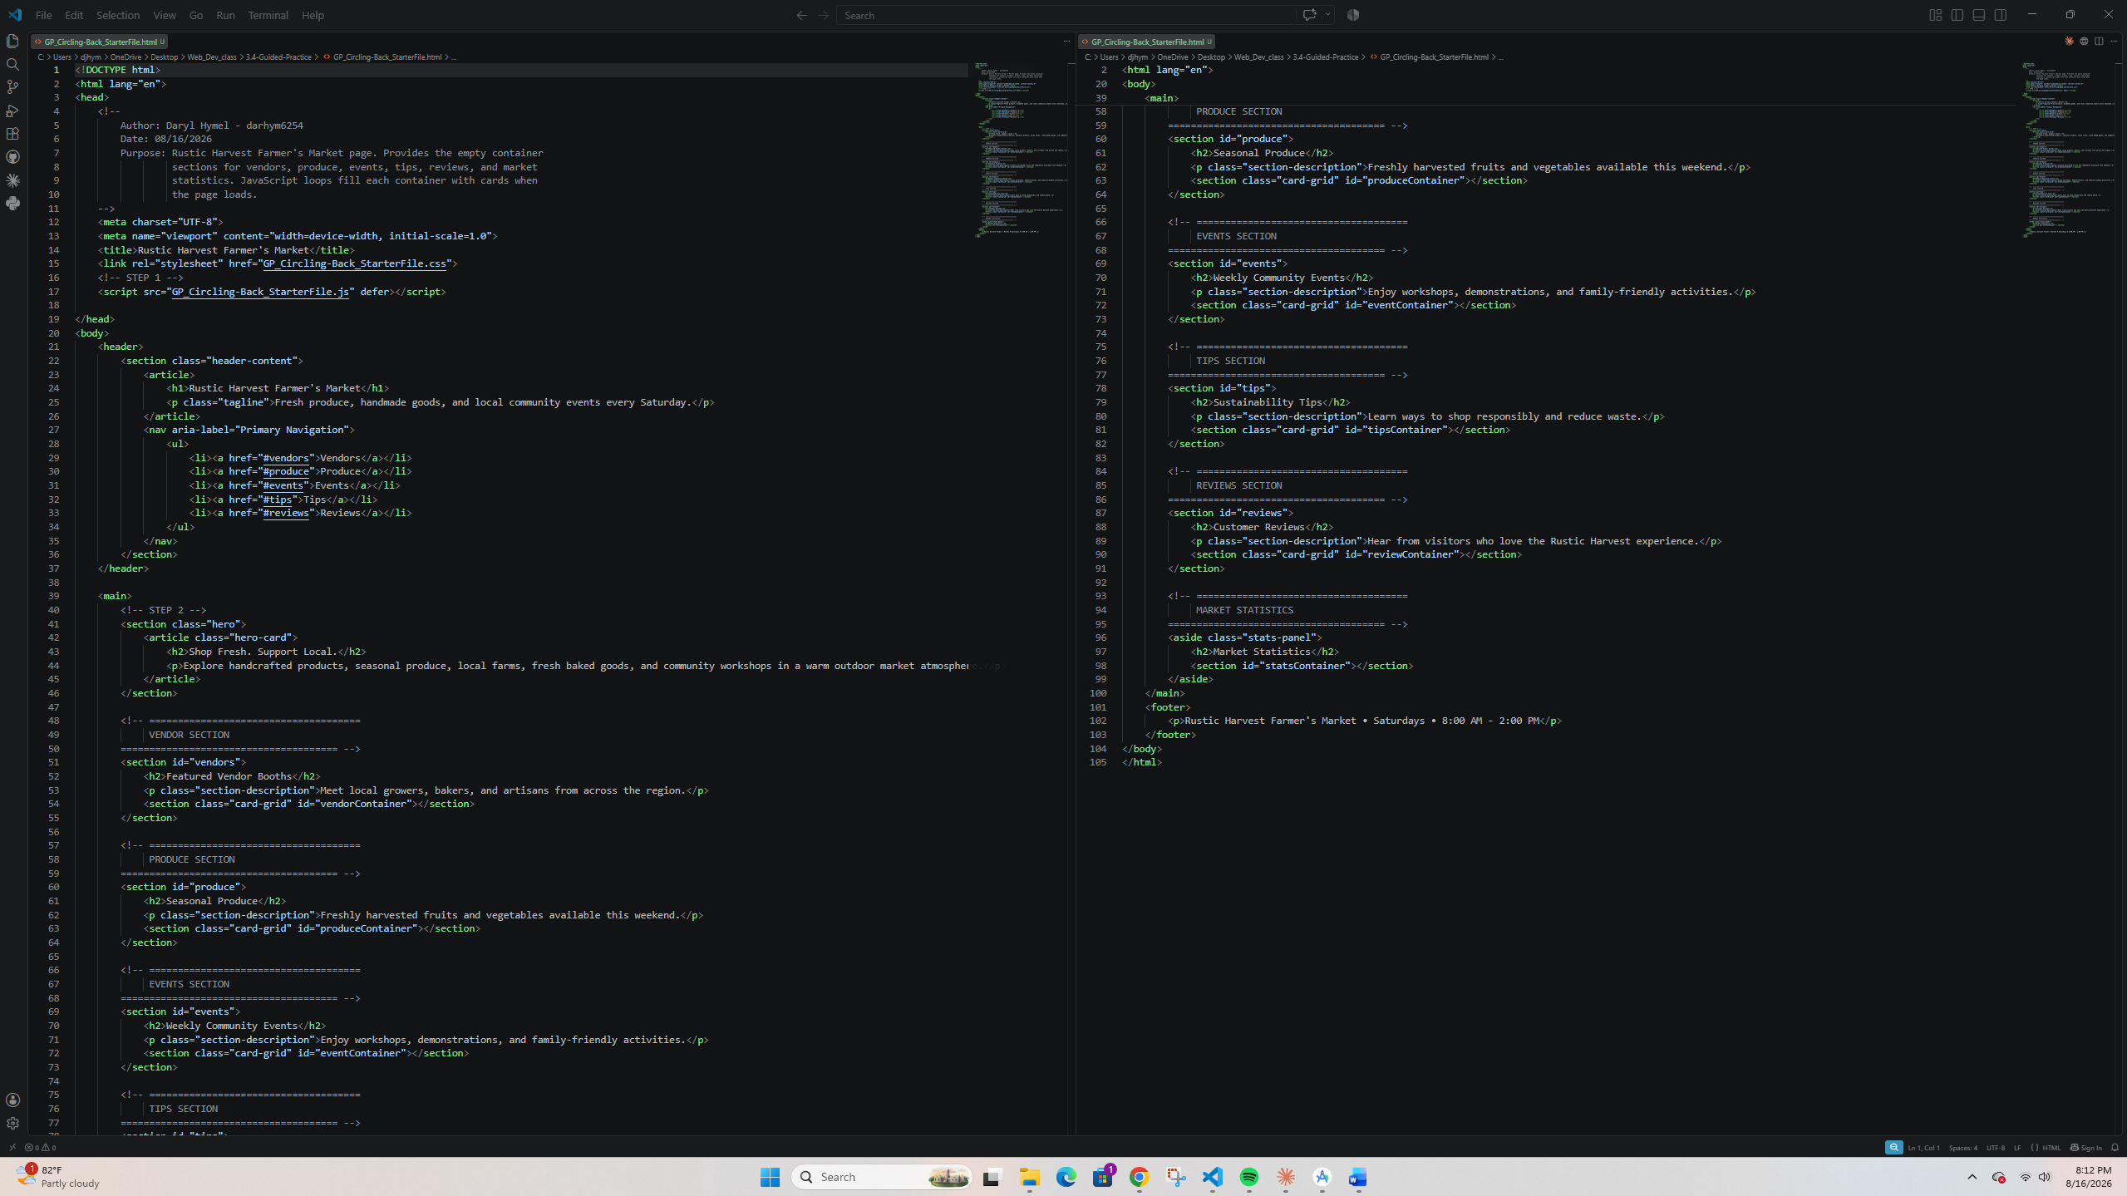

Screenshot 2: Completed JavaScript Code
Paste your screenshot below this line:
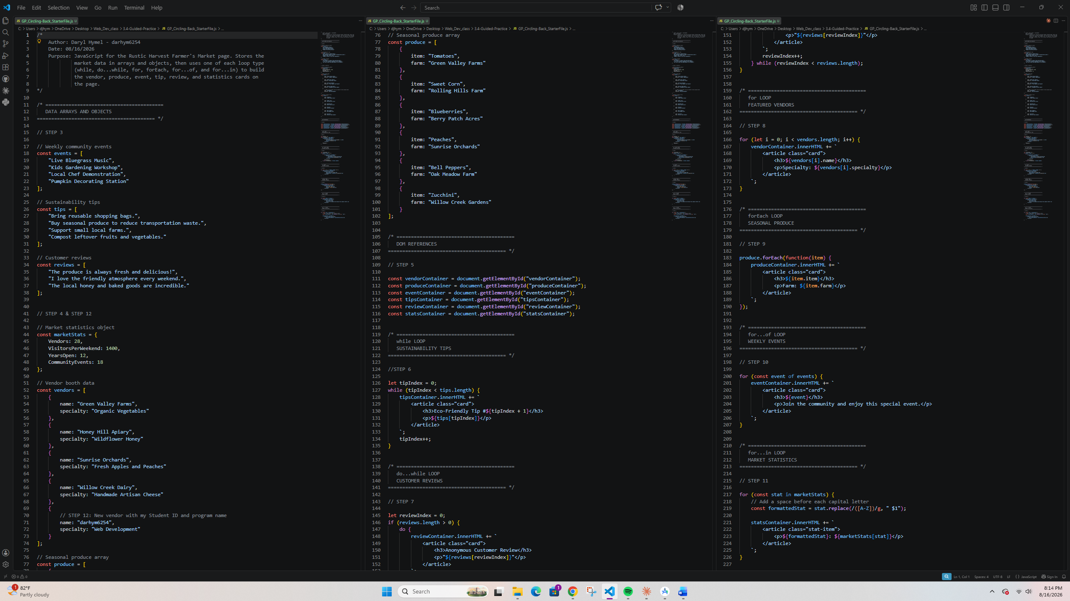

Screenshot 3: Rendered Web Page in Browser
Paste your screenshot below this line:
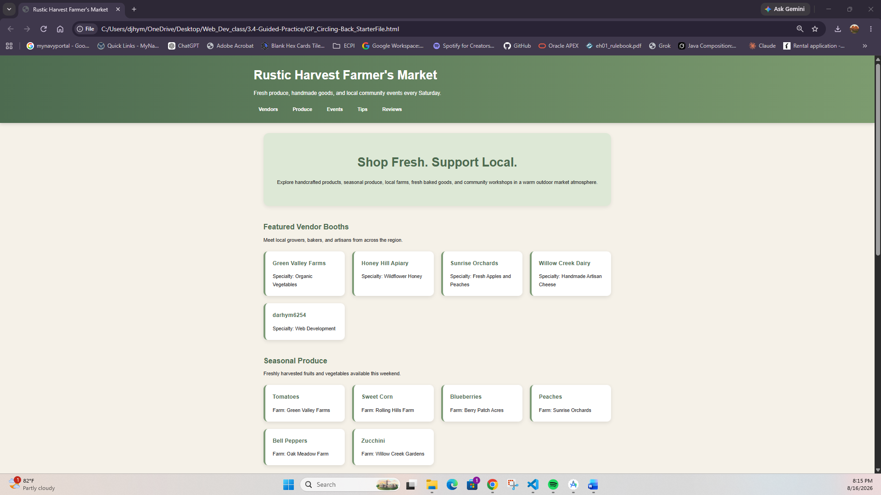
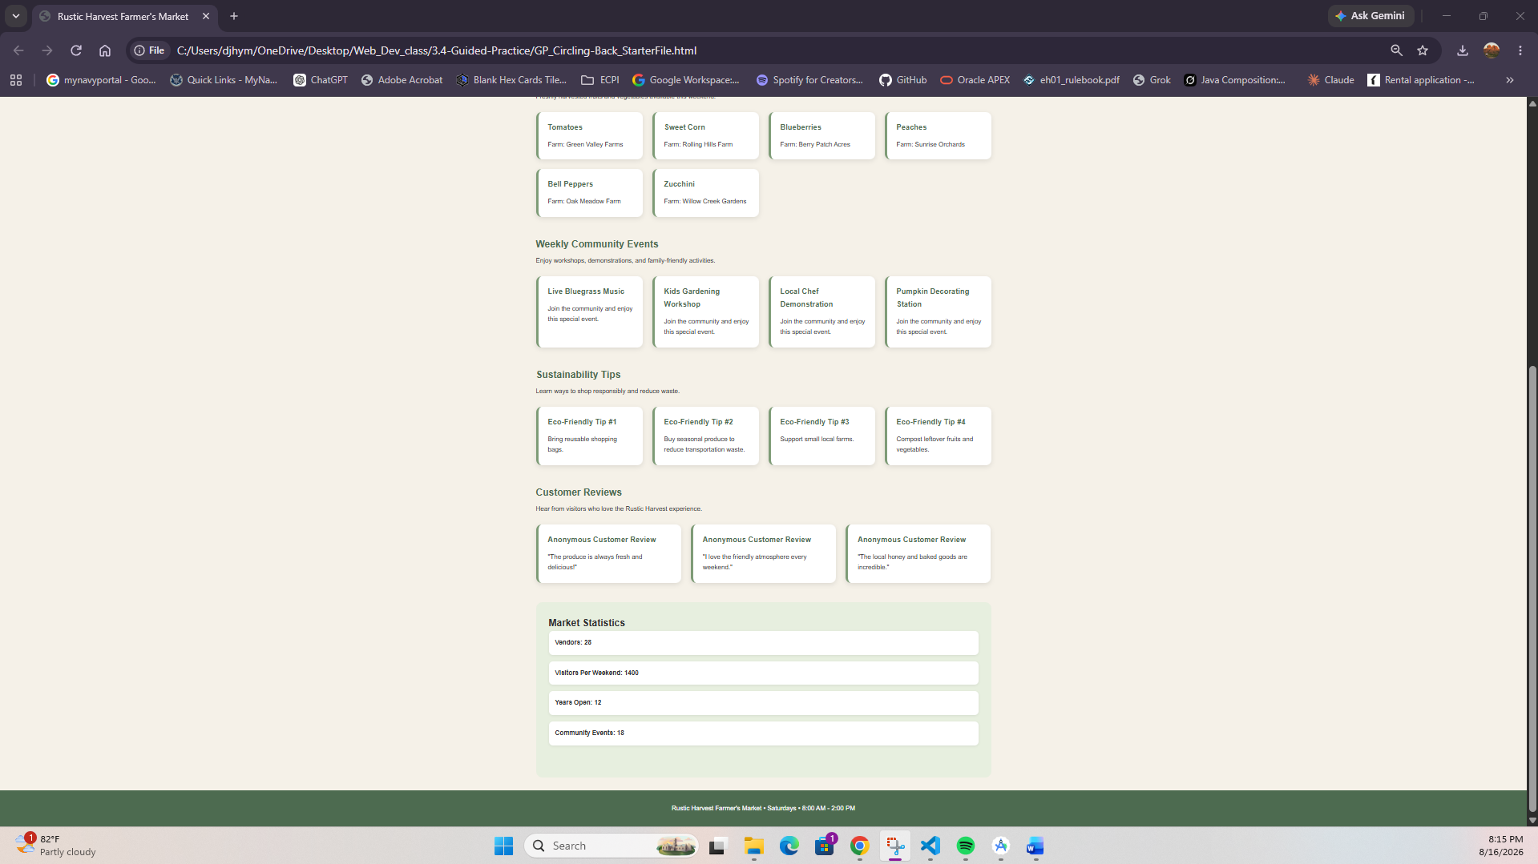

Reflection
In a few sentences, describe which JavaScript loop was easiest to understand, which loop was most challenging, and how loops can help developers display repeated content on a web page.
The standard for loop was easiest because the start, stop, and count are clear. The for...in loop was harder because it uses property names to access values. Loops make coding easier by letting one template display multiple items automatically.

