Guided Practice – Planting Sessions Lab Report
Use this template to document your work as you complete your assignment.

Your Information
Your Name: Daryl Hymel
Assignment Title: 4.5 Guided Practice - Storing Locally
GitHub Repository: https://github.com/darhym6254/SDC260-Web-Dev-Class

Development Summary

Briefly summarize the work you completed for this guided practice. Include how JavaScript is used to display glass products, update product stock, maintain the shopping cart, and preserve cart data using local storage.
I built the Molten Dreams Glassworks store and connected the CSS and JavaScript files. I added three products and finished the JavaScript for displaying products, managing stock, and adding items to the cart. Local storage keeps the cart, products, and reservation timer saved between pages and refreshes. The cart also has a 15-minute reservation timer that clears the cart and returns the items to stock when time runs out.

Code Explanation
Answer each prompt in complete sentences.
1. Explain how localStorage is used to save the product inventory, cart contents, and cart end time.
The saveData function uses localStorage.setItem to store three things: the products array with the current stock, the cart array, and the cartEndTime timestamp. The arrays are turned into strings with JSON.stringify before saving. When either page loads, it reads them back with localStorage.getItem and JSON.parse, so both pages share the same inventory, cart, and timer.

2. Explain how the cart timer works and what happens when the 15-minute reservation period expires.
The timer starts when the first item is added and saves a 15-minute end time in local storage. It updates every second, so the countdown stays accurate even after refreshing or switching pages. When time runs out, the cart is cleared, the reserved items return to stock, the user gets an alert, and the cart page redirects back to the home page.

3. Explain how JavaScript updates the product cards, stock availability, cart contents, or cart total on the page.
The displayProducts function builds the product cards with the product details, price, stock, and Add to Cart button. Out-of-stock items are grayed out, disabled, and show an OUT OF STOCK message. When an item is added, the stock updates, the cart count changes, and the cart page displays the selected items and total price.

4. Explain how localStorage is different from sessionStorage for this shopping cart experience.
localStorage keeps data even after the browser is closed, while sessionStorage clears when the tab closes. Using localStorage also lets both the home and cart pages share the same cart and reservation data, so the shopper does not lose their cart when leaving or refreshing the page.

Code Evidence
Insert screenshots that show the completed code for this assignment. Make sure your screenshots are legible and contain the computer system date and time.

Screenshot 1: Completed index.html Code
Paste your screenshot below this line:
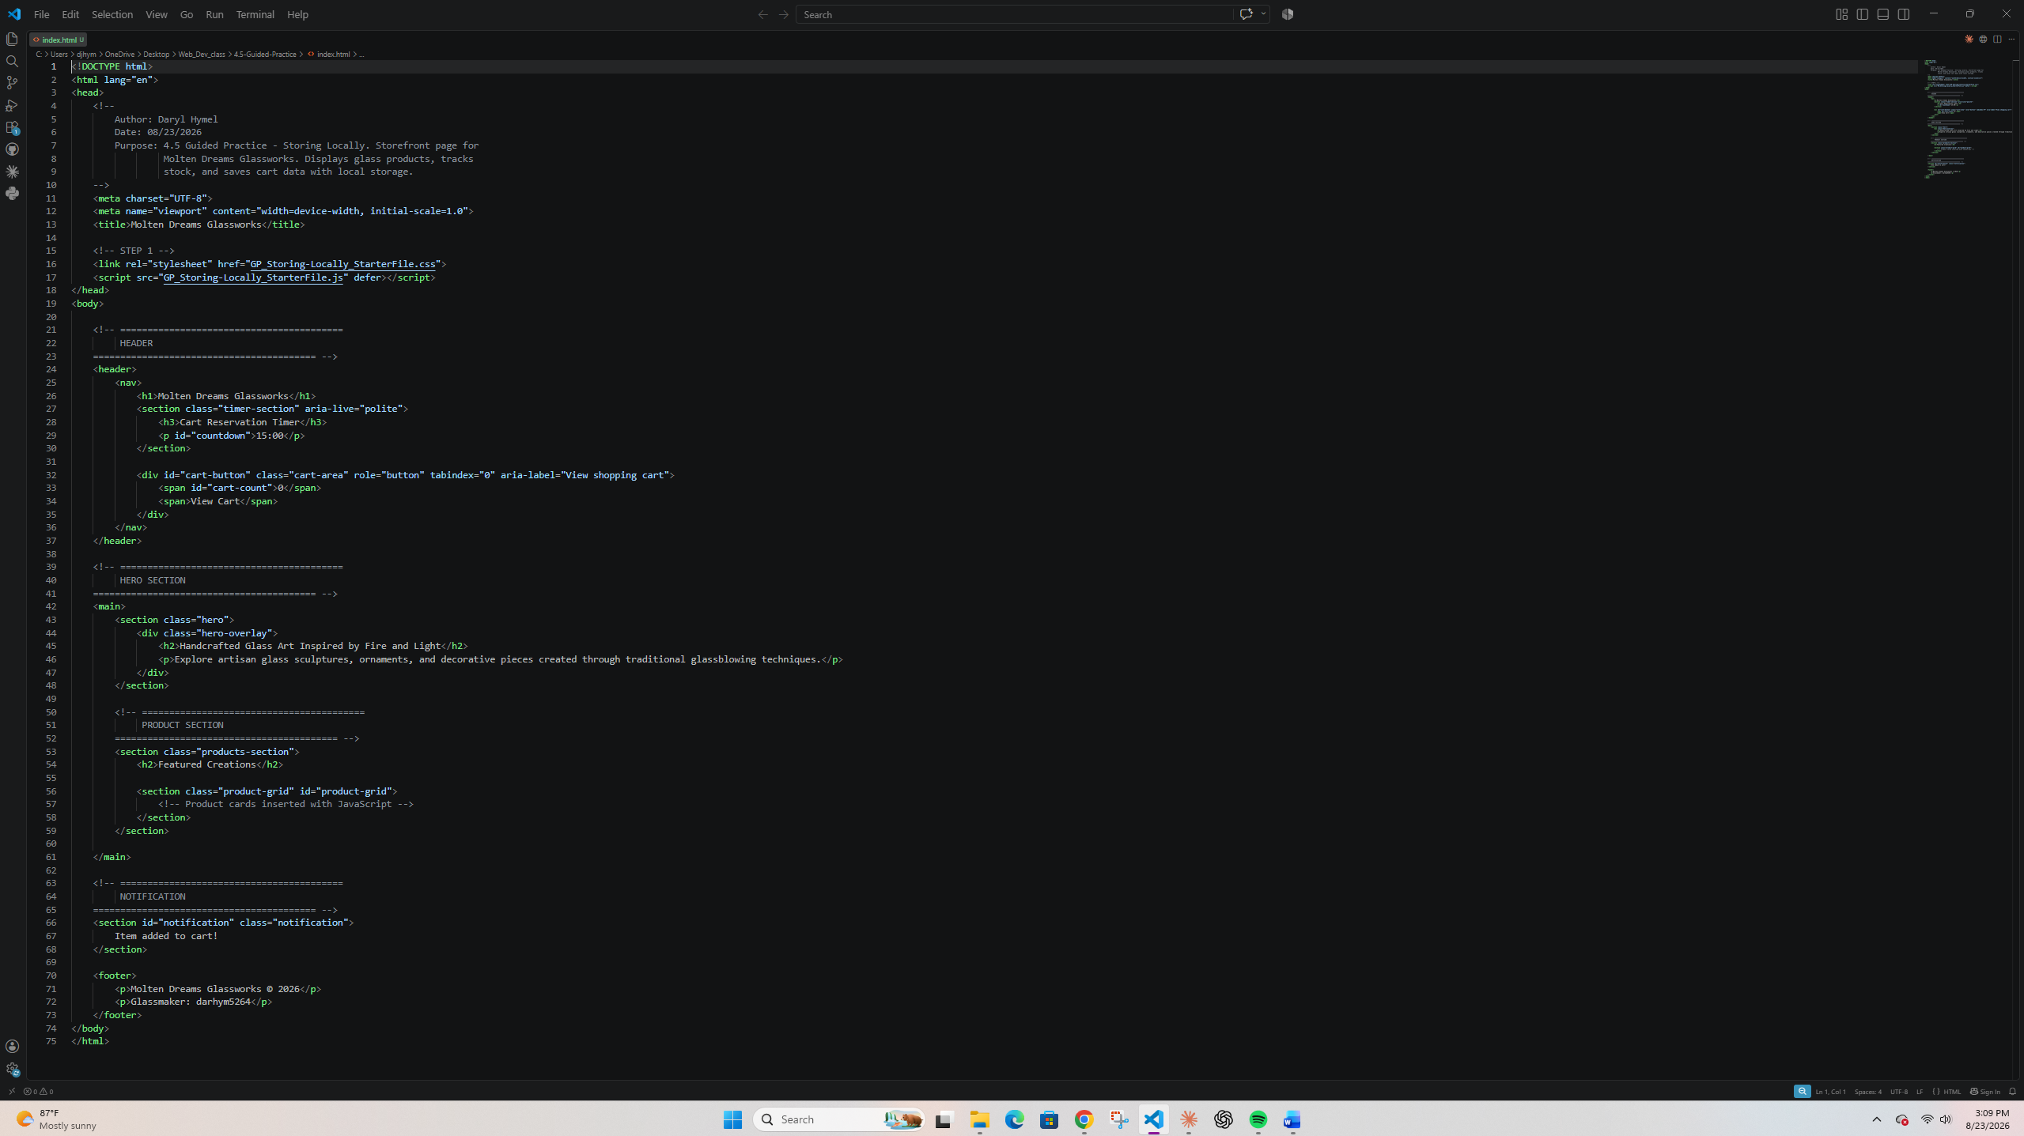

Screenshot 2: Completed cart.html Code
Paste your screenshot below this line:
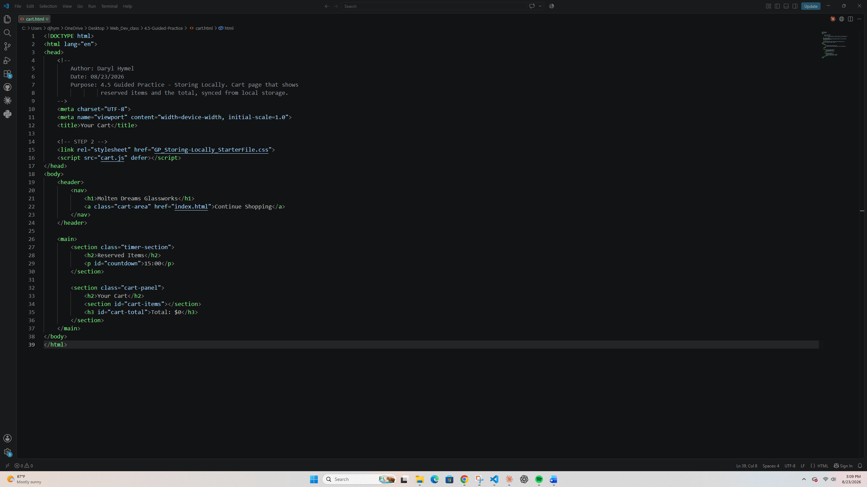

Screenshot 3: Completed GP_Storing-Locally JavaScript Code
Paste your screenshot below this line:
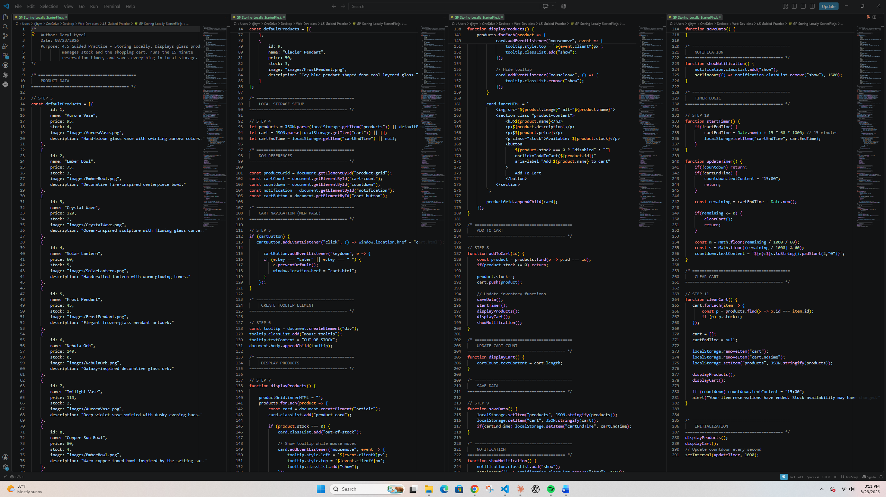

Screenshot 4: Completed cart.js Code
Paste your screenshot below this line:
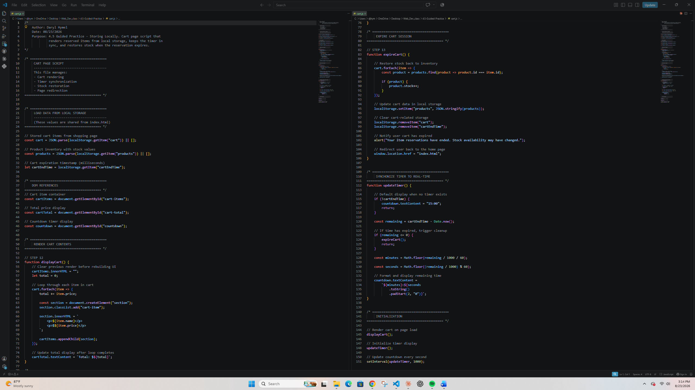

Screenshot 5: Product Array with Three New Products
Paste your screenshot below this line:
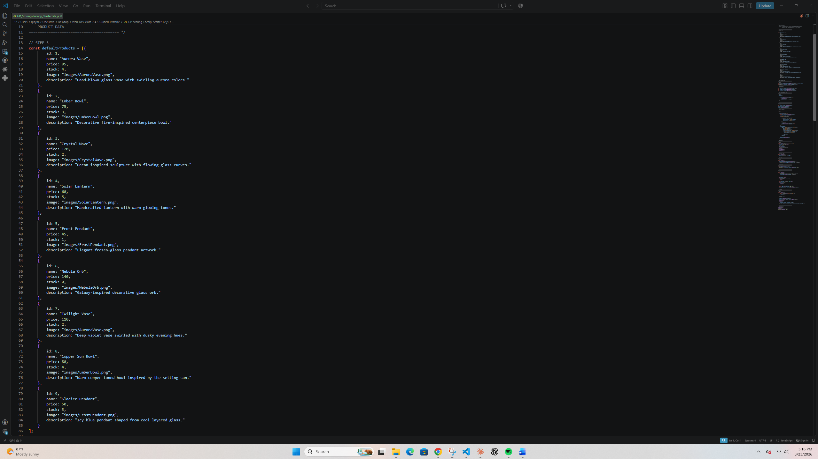

Web Page Evidence
Insert screenshots that show the completed web page in the browser. Make sure your screenshots are legible and contain the computer system date and time.
Screenshot 6: Rendered Glass Studio Storefront
Paste your screenshot below this line:
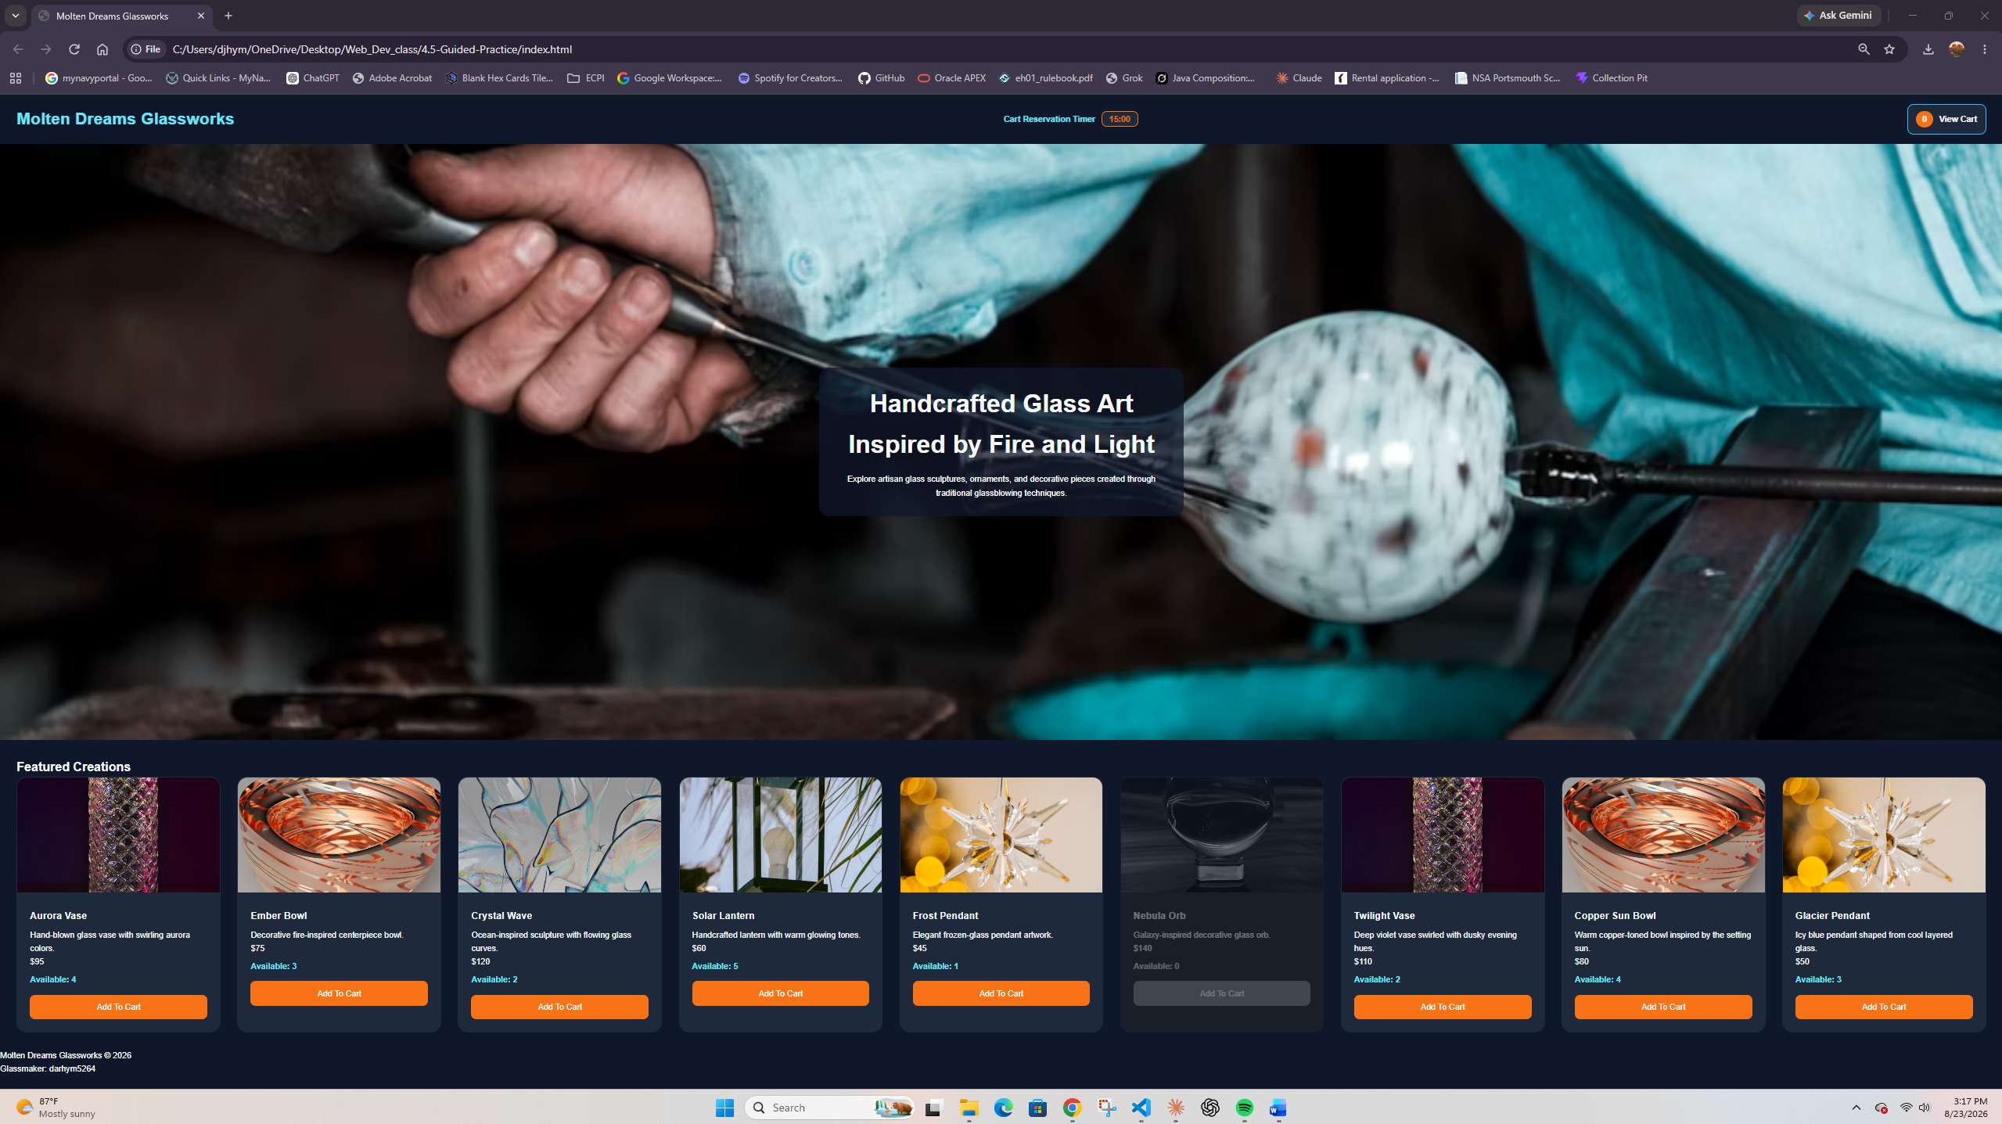

Screenshot 7: Product Stock Changes After Items Are Added to Cart
Paste your screenshot below this line:
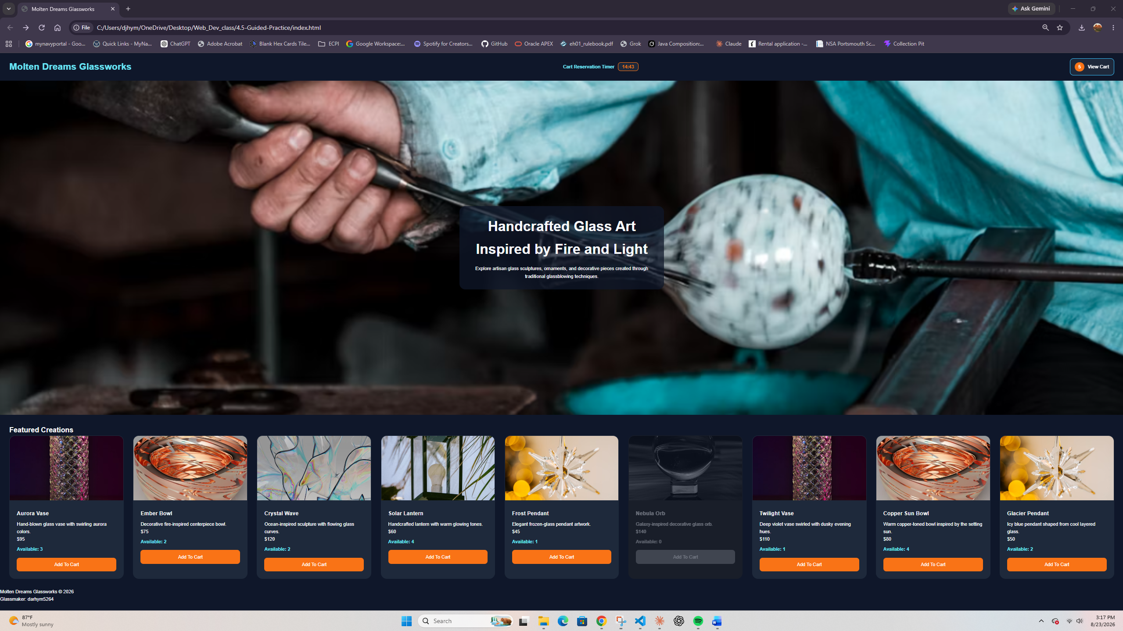
Screenshot 8: Cart Page Showing Products and Total
Paste your screenshot below this line:
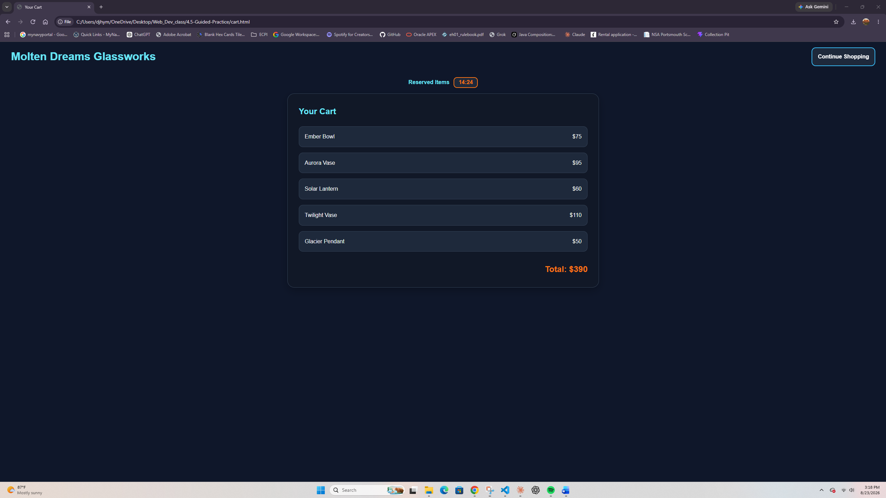

Screenshot 9: Timer or Reservation Message Display
Paste your screenshot below this line:
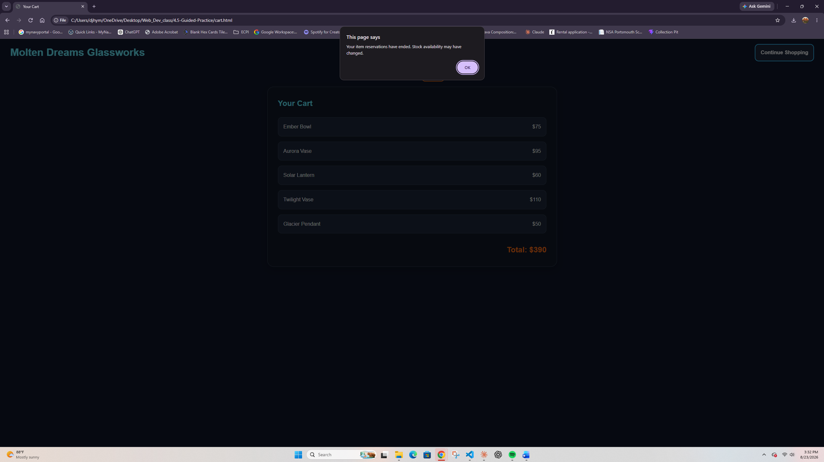

Local Storage Evidence
Use the browser Developer Tools Console to test the session storage data.
Screenshot 10: Console Showing Local Storage Data
Paste your screenshot below this line:
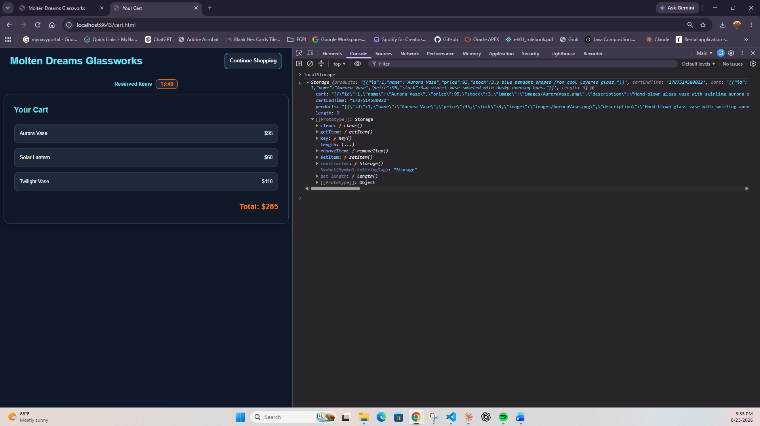

Testing Notes
Briefly describe how you tested the shopping cart and session storage functionality.
Include the following:
1. What happened when you added products to the cart?
The cart count in the header went up, a notification popped up saying the item was added, and the 15 minute reservation timer started counting down.

2. What happened to product stock after items were added to the cart?
The Available number on each card dropped by one every time I added it. When Frost Pendant hit zero its card grayed out, the button was disabled, and the OUT OF STOCK tooltip appeared.

3. What happened when you refreshed the page?
The cart count, stock numbers, and timer all came back exactly where they were, because everything reloads from local storage.

4. What happened when you opened the cart page?
The cart page listed every item I added with its price, showed the correct total, and the countdown matched the timer on the home page.

5. What happened when the timer expired or the cart was cleared?
An alert said the reservations had ended, the cart emptied, the stock went back to its original amounts, and the timer reset to 15:00.

Reflection
In a few sentences, explain how local storage can improve the user experience on an e-commerce website. Then explain one security or usability concern developers should consider when storing cart data in the browser.
Local storage improves the shopping experience by keeping the cart saved after refreshes or closing the browser. It also lets different pages share the same cart data. However, users can edit local storage through developer tools, so a real store should always verify prices, stock, and totals on the server before checkout.

