Assessment – Storage Central Lab Report
Use this template to document your work as you complete your assignment.

Your Information
Your Name: Daryl Hymel
Assignment Title: 4.6 Performance Assessment - Storage Central
GitHub Repository: https://github.com/darhym6254/SDC260-Web-Dev-Class

Development Summary
Briefly summarize the storefront you created. Include the handmade craft theme, shopping cart features, and how localStorage, sessionStorage, and cookies are used in your project.
I built Willow and Pine Crafts, a handmade store with six products. Each product shows an image, description, price, stock count, and Add to Cart button. The cart lets users change quantities, view the total, clear the cart, or checkout. localStorage saves the cart and stock, sessionStorage tracks items added during the current session, and a cookie remembers the shopper’s last purchase for the welcome message.

Code Evidence
Insert screenshots that show the completed code for this assignment. Make sure your screenshots show the relevant code clearly and include the computer system date and time.

Screenshot 1: Completed HTML Code
Paste your screenshot below this line:
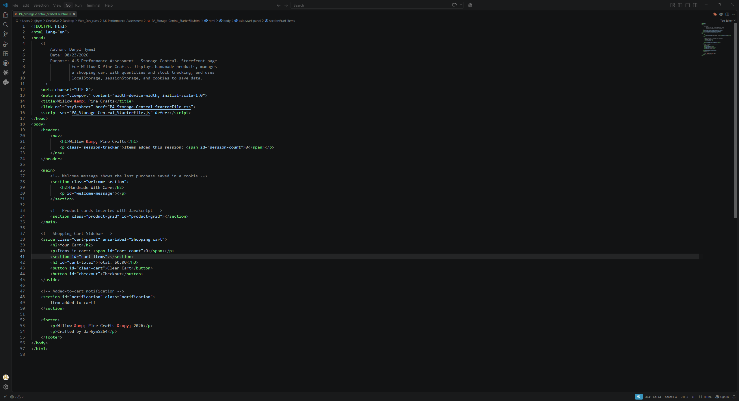

Screenshot 2 – Completed CSS Code JavaScript Code
Paste your screenshot below this line:
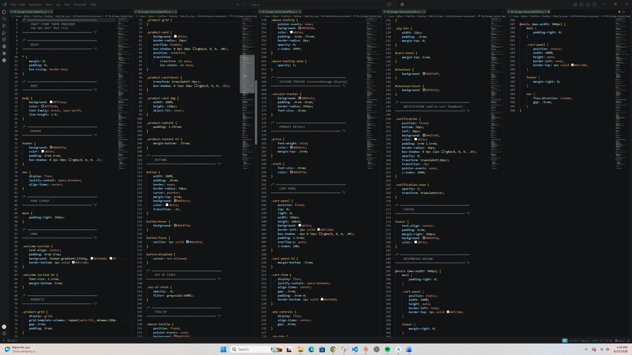

Screenshot 3 – Completed JavaScript Code
Paste your screenshot below this line:
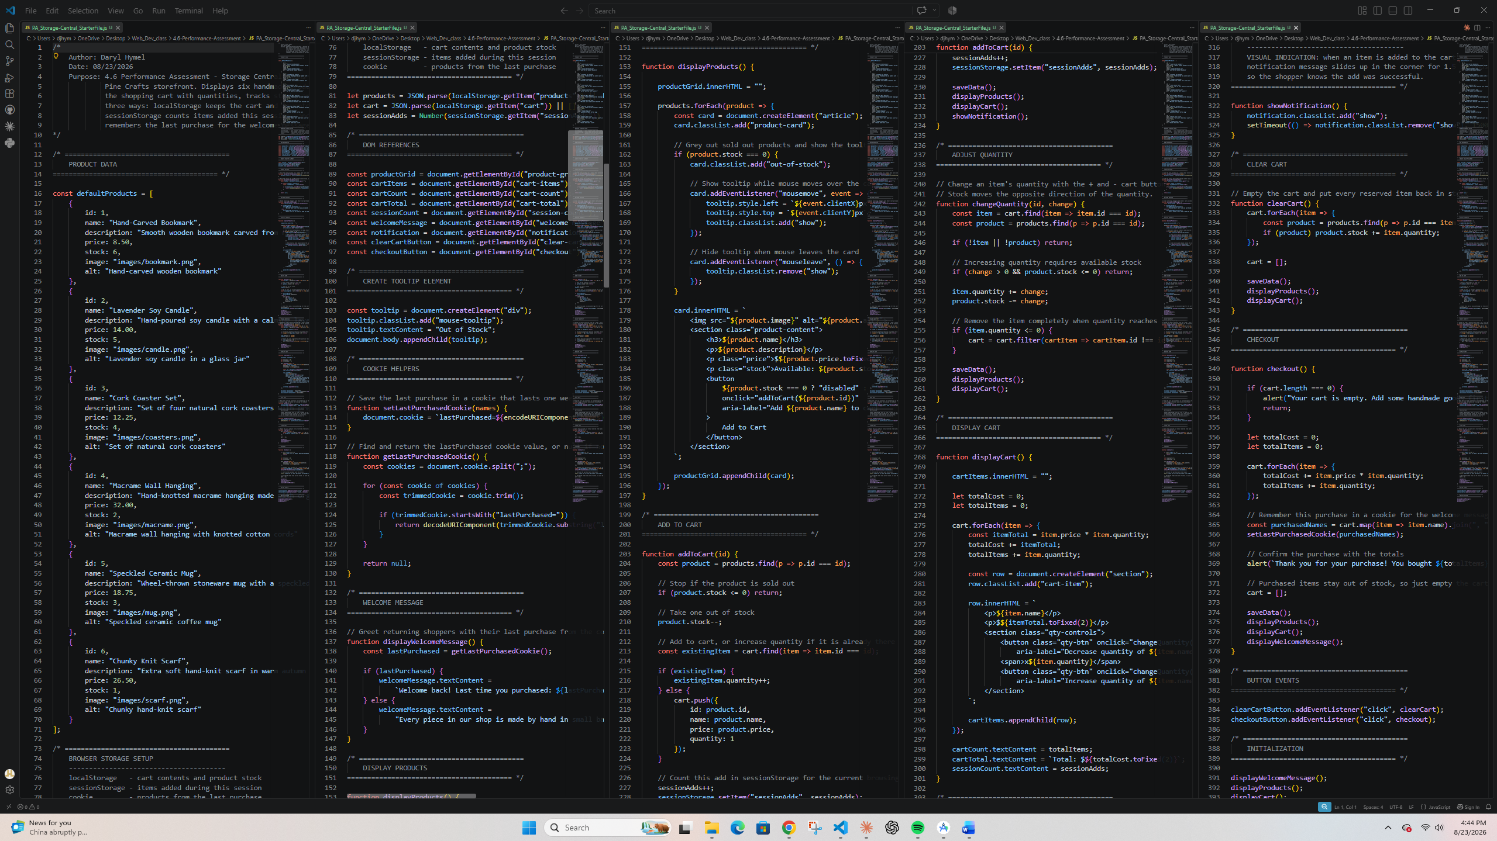
Screenshot 4: Product Data and Stock Management Code
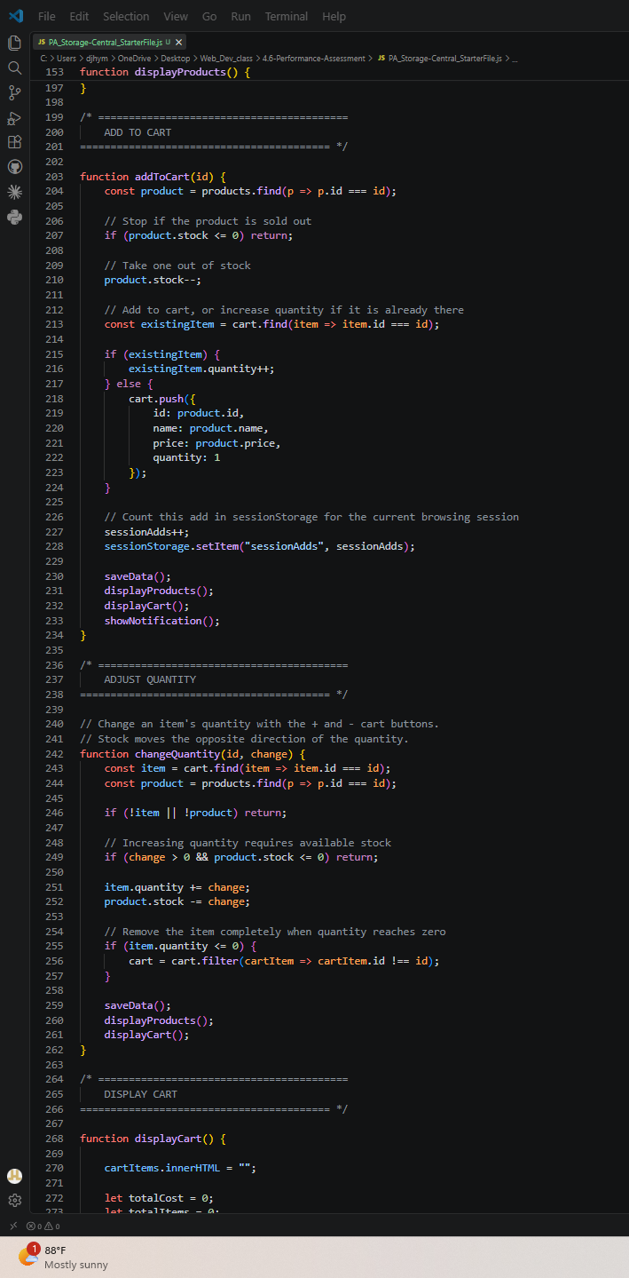
Paste your screenshot below this line:
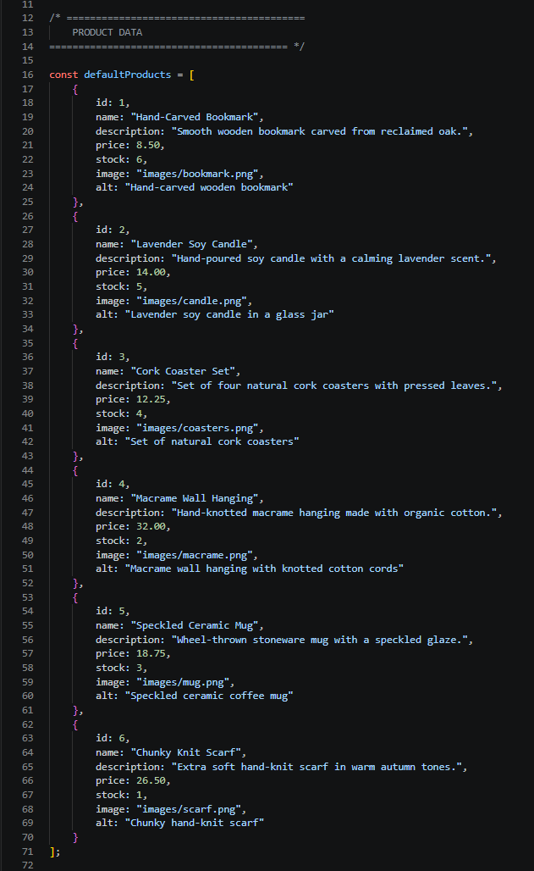

Web Page Evidence

Screenshot 5: Rendered Storefront with At Least Six Products
Paste your screenshot below this line:
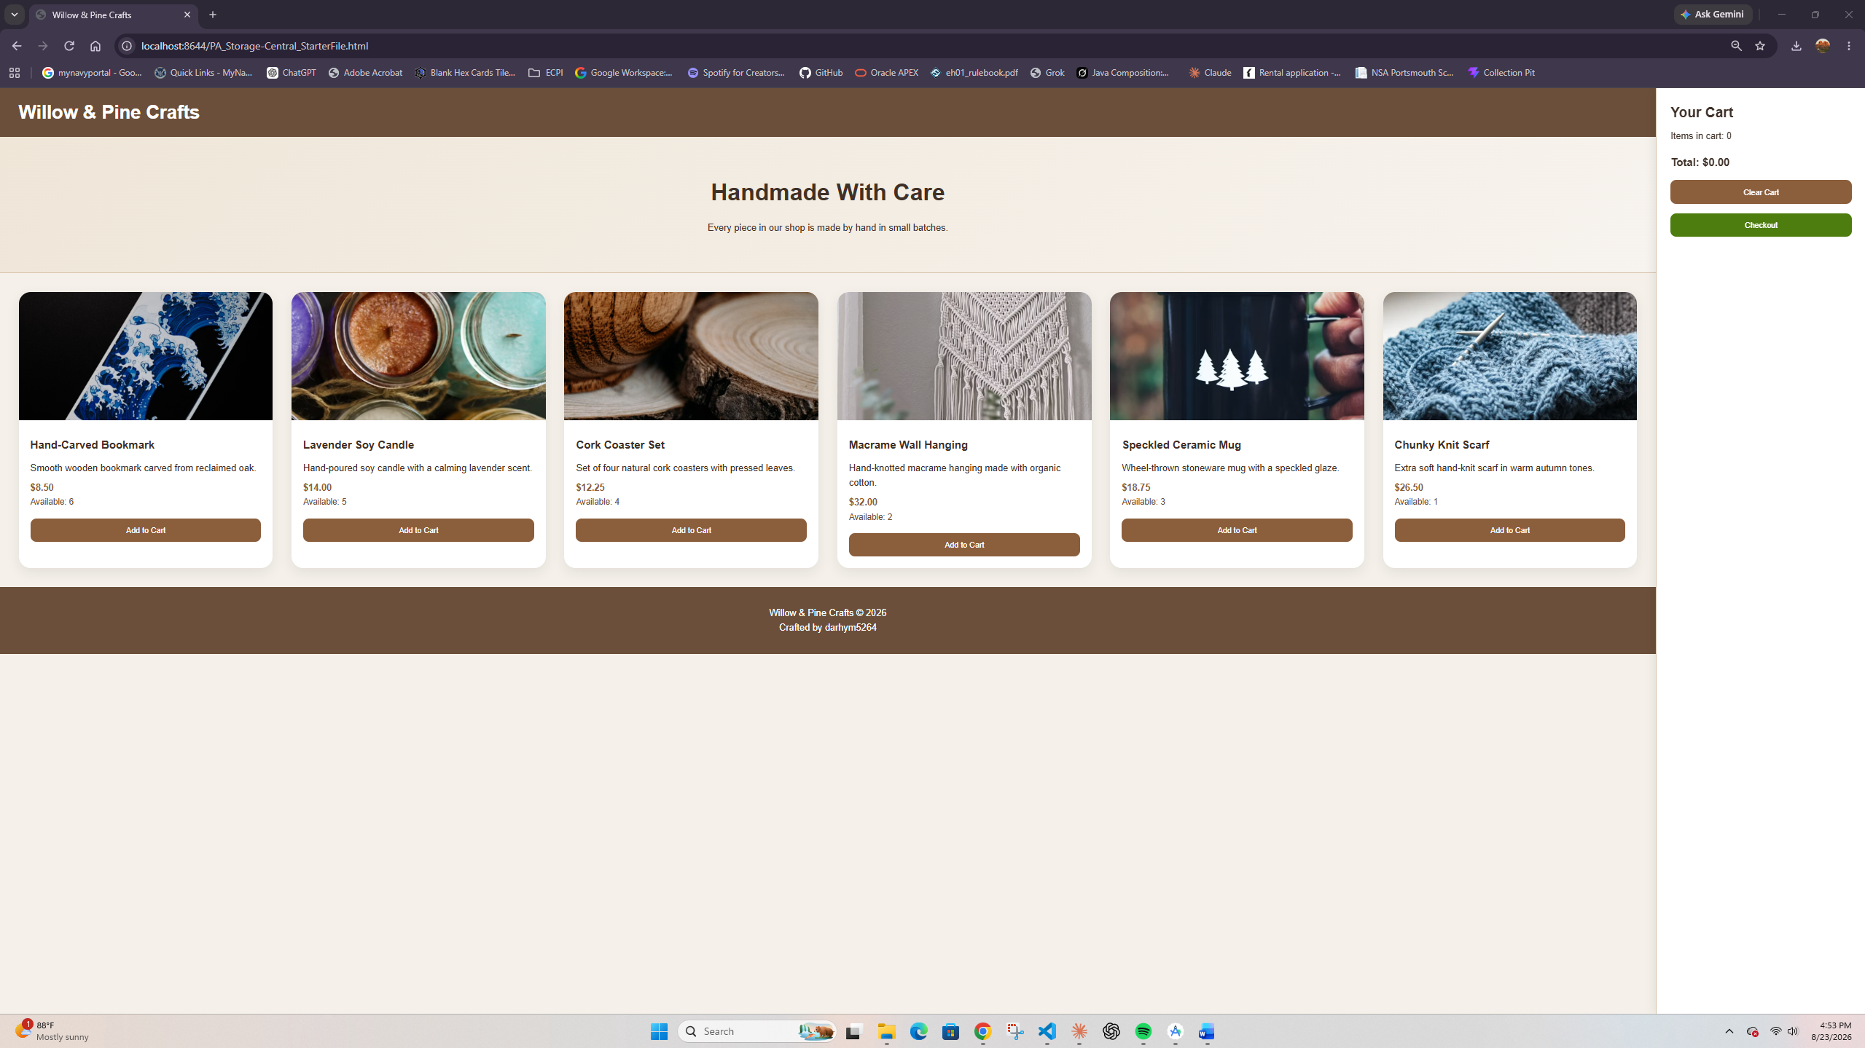

Screenshot 6: Shopping Cart with Selected Items, Quantities, and Total Cost
Paste your screenshot below this line:
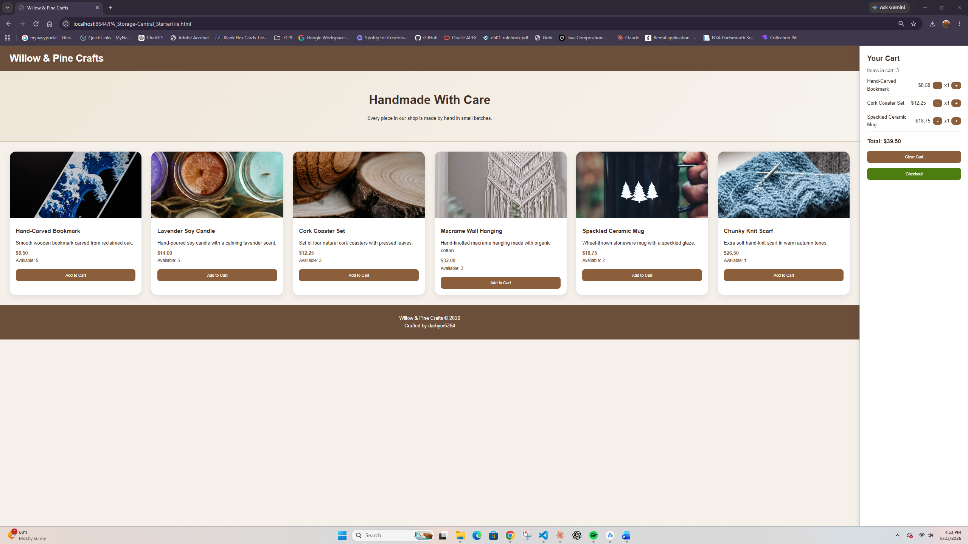

Screenshot 7: Out-of-Stock Product State or Visual Add-to-Cart Feedback
Paste your screenshot below this line:
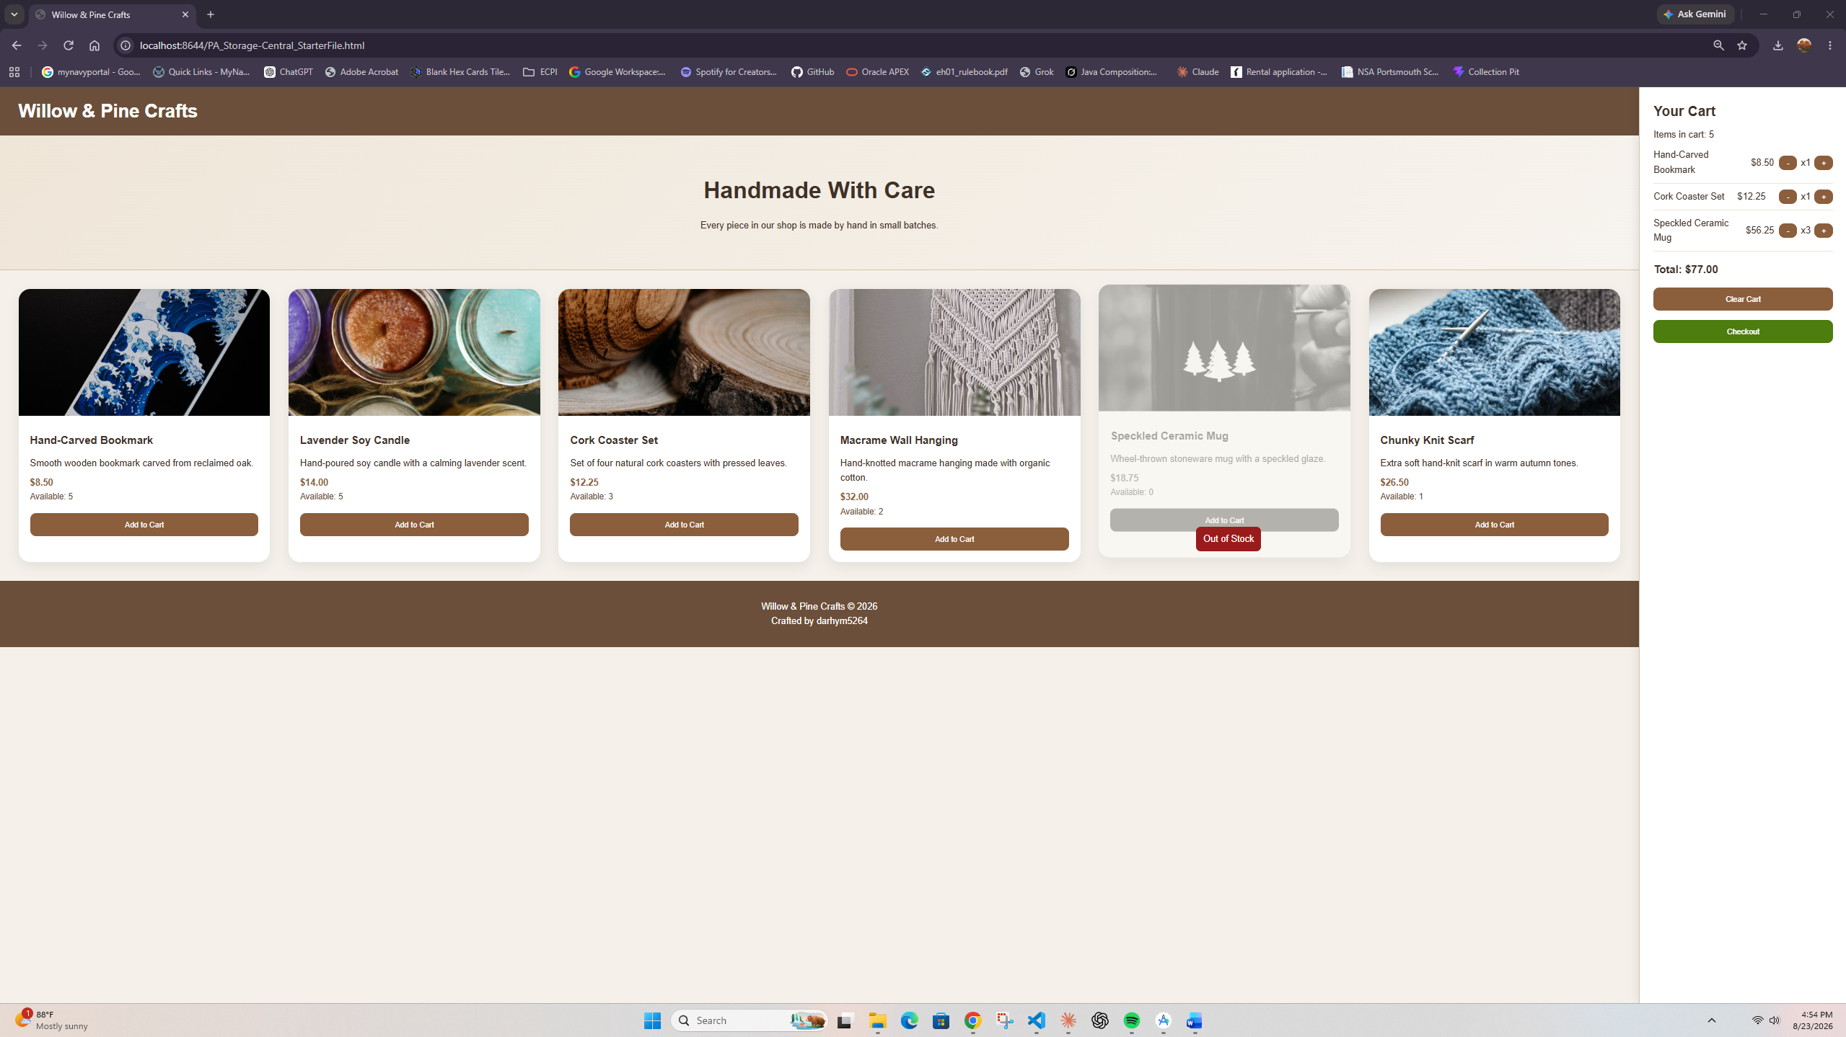

Screenshot 8: Checkout Alert or Completed Checkout Evidence
Paste your screenshot below this line:
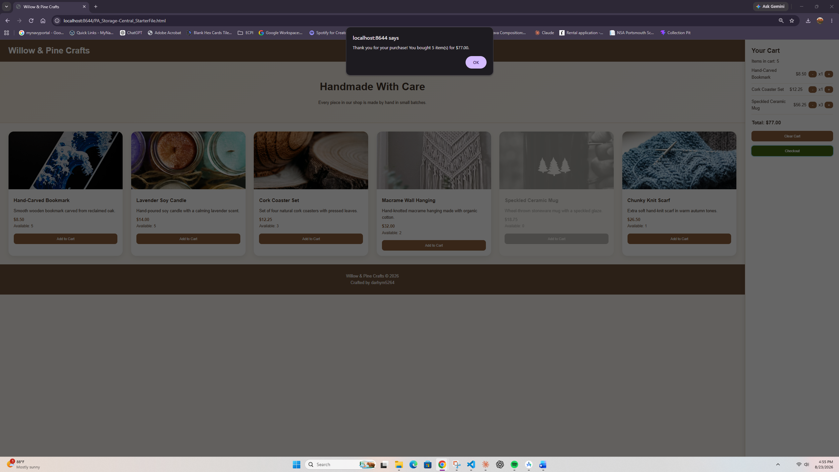

Browser Storage Evidence
Use the browser Developer Tools Console to verify that each browser storage method is working. Include screenshots that show data for each storage method.

Screenshot 9: Console Showing localStorage Data
Paste your screenshot below this line:
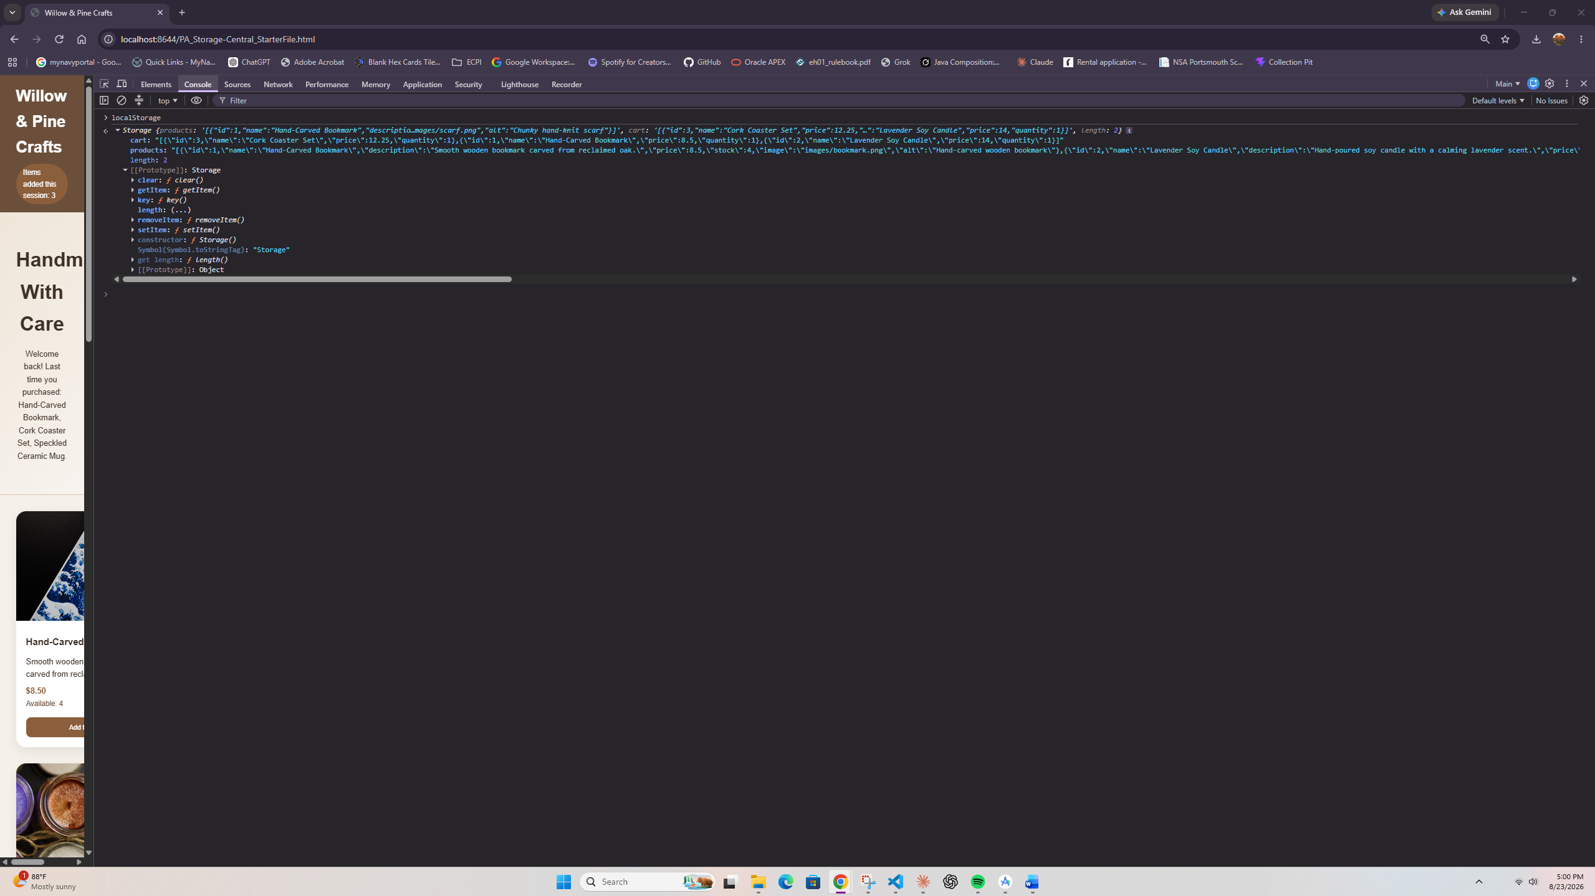

Screenshot 10: Console Showing sessionStorage Data
Paste your screenshot below this line:
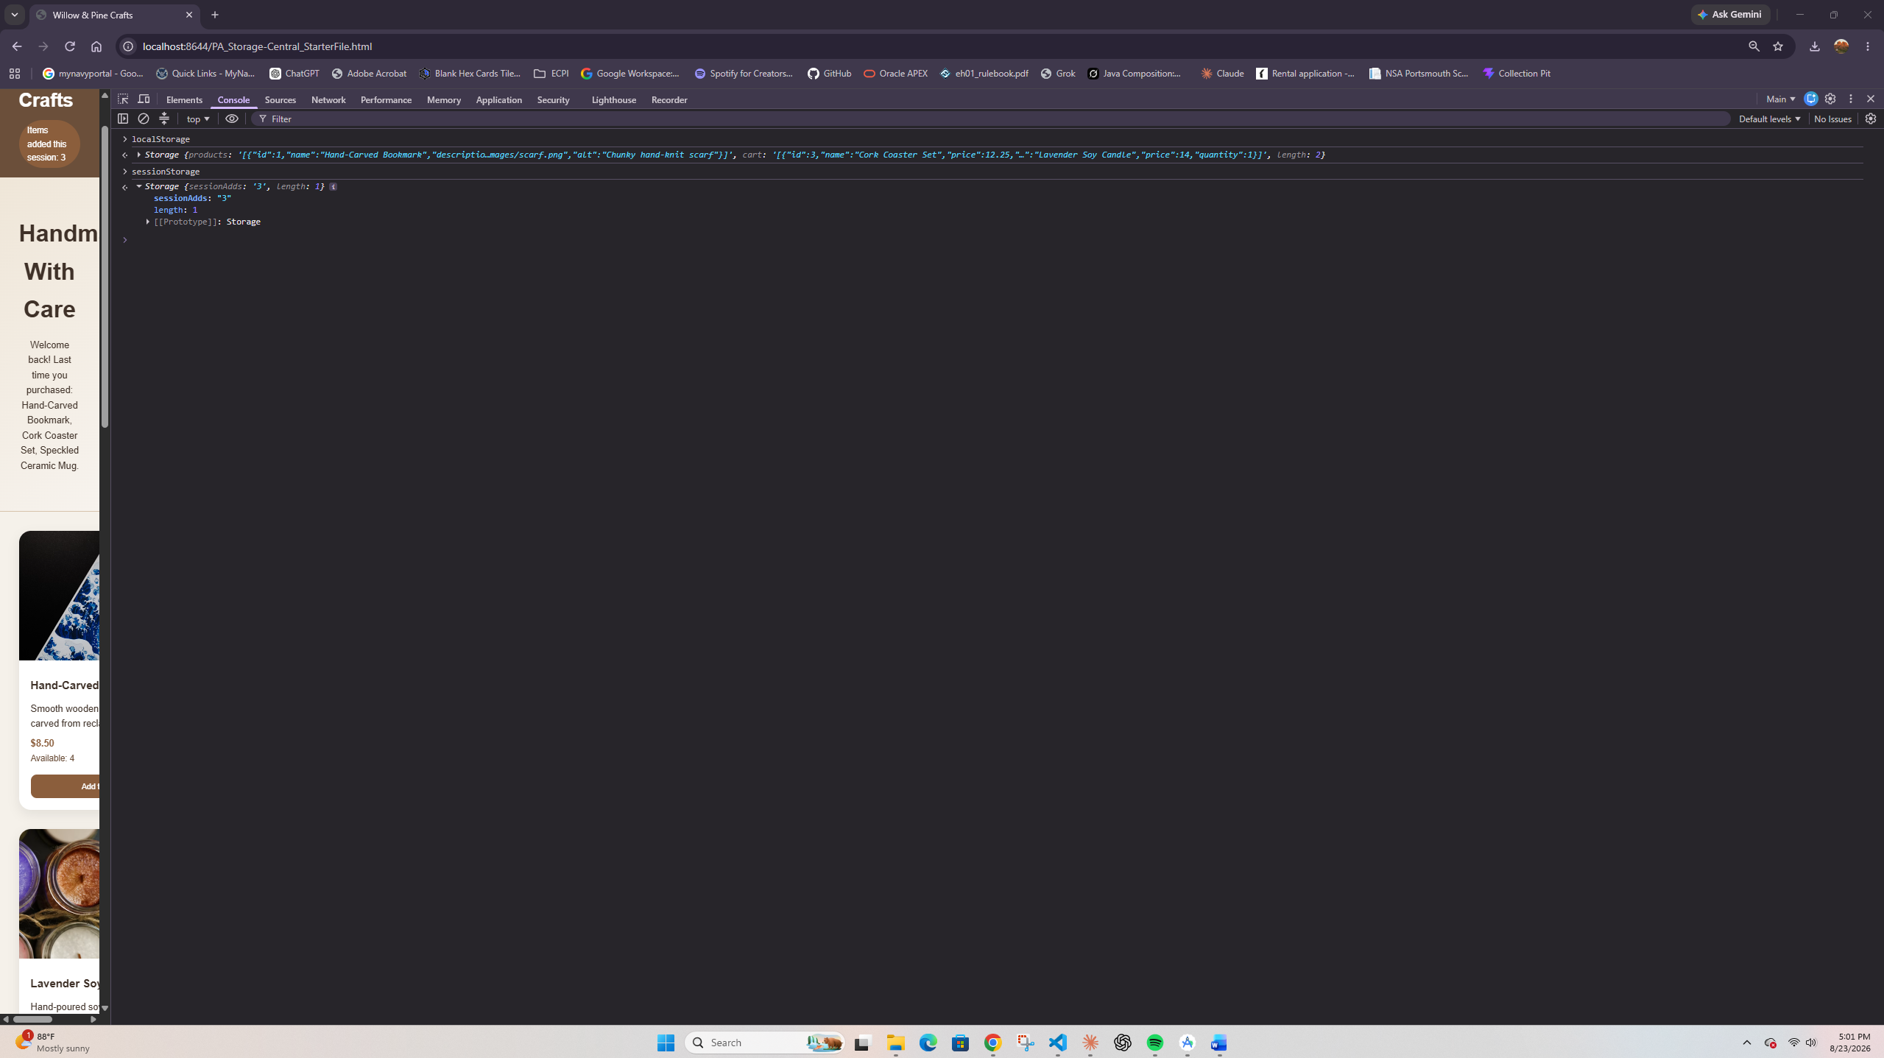

Screenshot 11: Console Showing document.cookie Data
Paste your screenshot below this line:
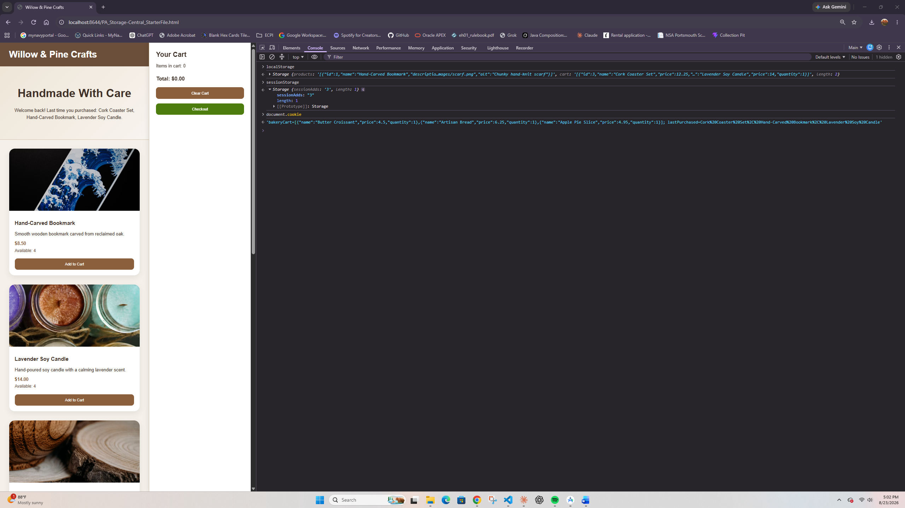

Testing Notes
- What happened to the cart data after you refreshed the page?
The cart came back exactly as I left it, with the same items, quantities, and total, because the cart is loaded from localStorage every time the page loads.

2. What happened to the local storage and cookie data after you closed the page and navigated back to it?
Both were still there. The cart and stock numbers reloaded from localStorage and the welcome message still greeted me with my last purchase from the cookie, since both types of storage survive closing the tab.

3. How did sessionStorage track the number of items added during the current browsing session?
Every time I clicked Add to Cart, a counter in sessionStorage went up by one and the header updated to show it. The count survived refreshing the page, but when I closed the tab and came back it reset to zero, because sessionStorage only lasts for the current browsing session.

4. How did the stock quantity change when items were added to or removed from the cart?
Adding an item lowered the Available number on the card by one, and removing an item or lowering its quantity put the stock back. When the scarf hit zero stock its card greyed out, the button was disabled, and an Out of Stock tooltip followed the cursor over it.

5. What visual indication did you use to show that a product was added to the cart?
A green notification message slides up in the bottom corner saying "Item added to cart!" for about a second and a half whenever a product is added. I also left a comment in the JavaScript describing it, as the assignment asked.

