Guided Practice – Styling Starter Pack Lab Report
Use this template to document your work as you complete your assignment.

Your Information
Your Name: Daryl Hymel - darhym6254
Assignment Title: 1.6 Guided Practice - Styling Starter Pack
GitHub Repository: https://github.com/darhym6254/SDC260-Web-Dev-Class/tree/main/1.6-Guided-Practice

Development Summary
Briefly describe the work you completed. In your response, mention how you used inline CSS, internal CSS, and an external stylesheet.
For this assignment, I created a page with three card packs using different CSS methods. The first card uses inline CSS for its background and border. Internal CSS controls the shared layout and styling for all three cards. An external stylesheet gives the third card its gradient, border, and shadow. This showed how inline, internal, and external CSS can be used for different styling needs.

Code Evidence
Insert screenshots that show the completed code for this assignment. Make sure your screenshots are legible and contain the computer system date and time.

Screenshot 1: Completed HTML code
Paste your screenshot below this line:
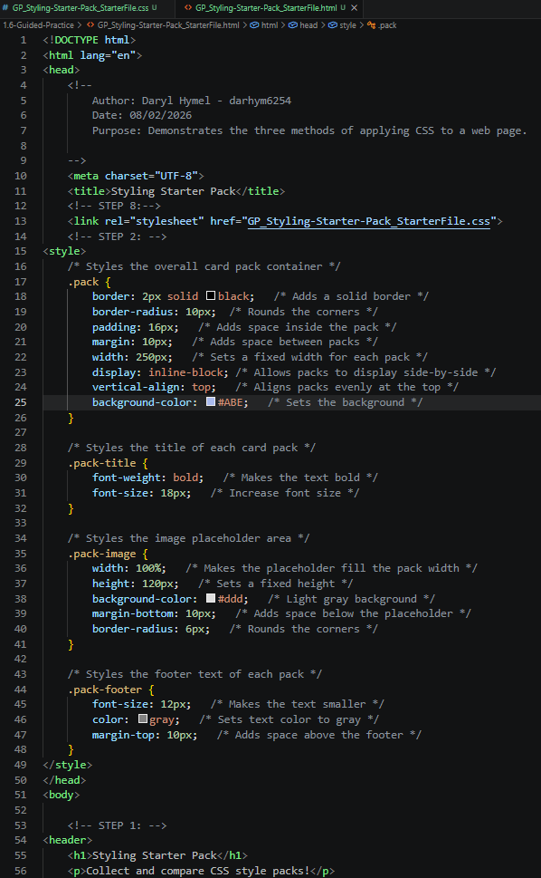

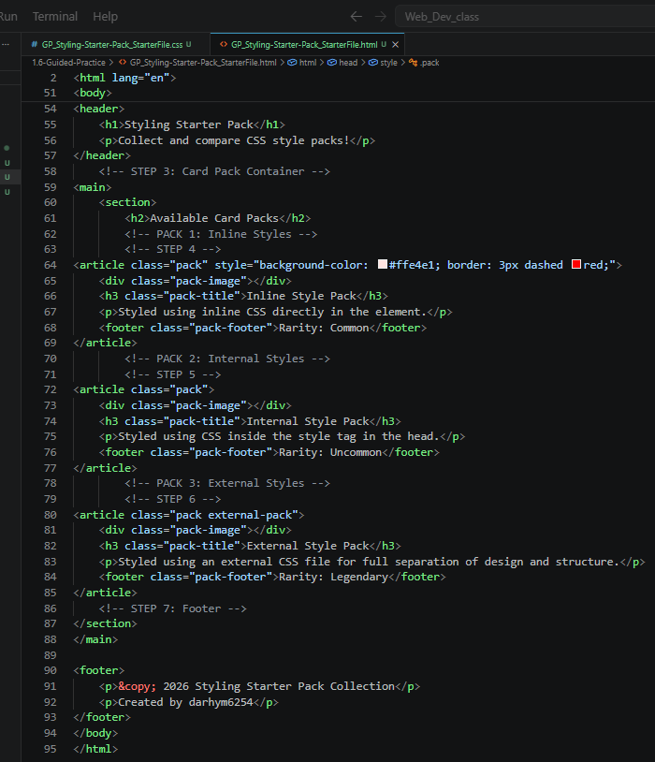

Screenshot 2: Completed CSS Code
Paste your screenshot below this line:
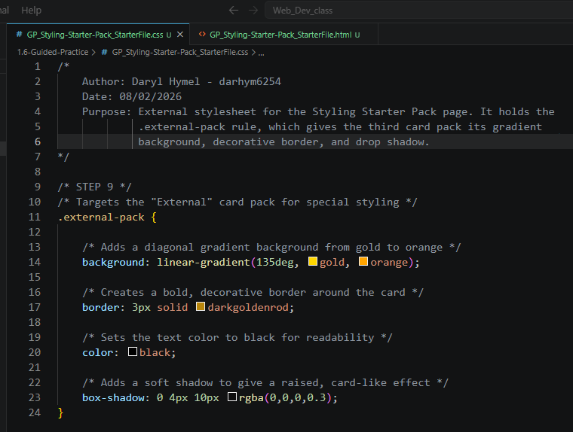

Rendered Web Page Evidence
Insert a screenshot of the completed web page as it appears in your browser. The three card packs should display different stylings.

Screenshot 3: Rendered Web Page
Insert a screenshot of the completed Styling Starter Pack page in the browser.
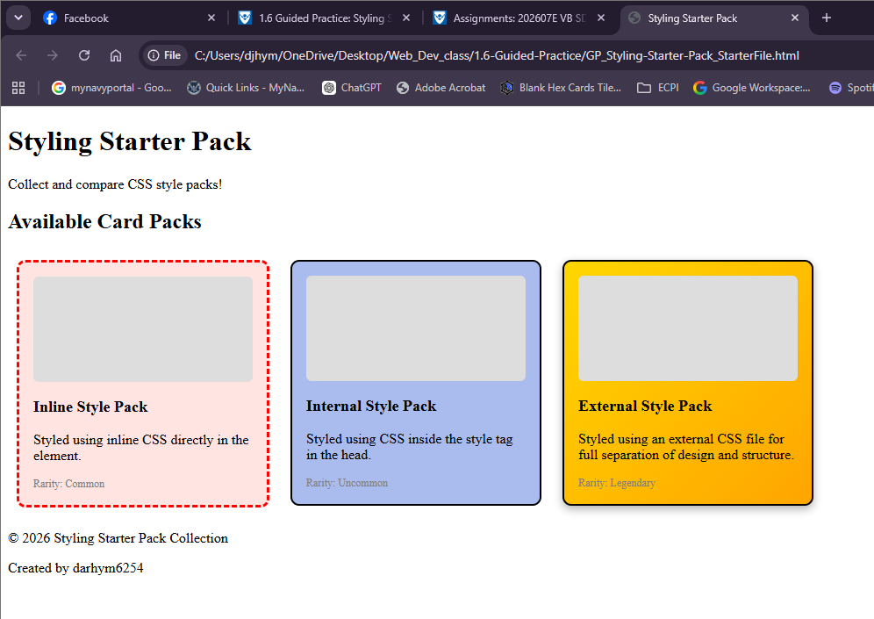

Reflection
Answer the questions below in complete sentences.
- Which CSS method did you find easiest to understand: inline, internal, or external? Why?
Inline CSS was the easiest for me because the styling is written directly on the element. I could quickly see the pink background and dashed red border without checking another file. However, it is less reusable because the same style would need to be repeated on each element.

- Why is an external stylesheet often preferred for larger websites?
An external stylesheet keeps a website’s design rules in one file. This makes the HTML cleaner and allows one change to update every linked page. It also helps keep the site consistent and can improve loading speed because the browser can reuse the stylesheet.

