Assessment – Flow Control Lab Report
Use this template to document your work as you complete your assignment.

Your Information
Your Name: Daryl Hymel
Assignment Title: Flow Control
GitHub Repository: https://github.com/darhym6254/SDC260-Web-Dev-Class

Development Summary
Briefly describe what you completed for this assessment. Include a summary of the control structure used to recommend trails based on user selections.
I completed the Greenway Park Trail Recommender by linking the CSS and JavaScript, building the Trail Finder form, and adding three new trails. A for...of loop displays the trails, while an if / else if statement recommends a trail based on pets and experience level.

Trail Recommendation Testing
Test each condition and record the result that appeared in the Results area. Mark Pass only after the expected trail appears.
Test Case | Expected Recommendation | Actual Result | Pass
Pets: Yes; Experience: Low | River Walk | Recommended Trail: River Walk | ☒
Pets: Yes; Experience: Medium | Forest Loop | Recommended Trail: Forest Loop | ☒
Pets: Yes; Experience: High | Forest Loop | Recommended Trail: Forest Loop | ☒
Pets: No; Experience: Low | Lake Side Path | Recommended Trail: Lake Side Path | ☒
Pets: No; Experience: Medium | Forest Loop | Recommended Trail: Forest Loop | ☒
Pets: No; Experience: High | Rock Ridge Trail | Recommended Trail: Rock Ridge Trail | ☒

Code Evidence
Insert screenshots that show the completed code for this assignment. Make sure your screenshots are legible and contain the computer system date and time.

Screenshot 1: HTML Code
Paste your screenshot below this line:


Screenshot 2 – JavaScript Code
Paste your screenshot below this line:


Screenshot 3 – Rendered Webpage
Paste your screenshot below this line:
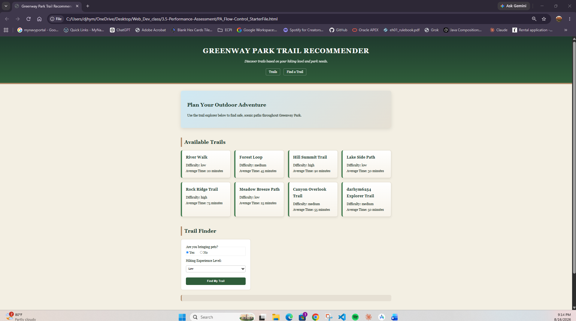

Reflection
- How did your loop display the trail cards on the page?
A for...of loop goes through each trail and uses a template literal to create a card with the trail’s name, difficulty, and time. innerHTML += then adds each card to the page.
- Which conditional statement was the most important for the trail recommendation tool, and why?
The most important else if combines && and || to handle visitors with pets and medium or high experience. The final else makes sure everyone still gets a trail recommendation.

- Describe one issue you encountered or one part of the code you checked carefully.
I used event.preventDefault() to stop the form from reloading and erasing the result. I then tested all six combinations to make sure the correct trail recommendation appeared.

