Assessment – Frontend Foundations Lab Report
Use this template to document your work as you complete your assignment.

Your Information
Your Name: Daryl Hymel - darhym6254
Assignment Title: 1.8 Performance Assessment - Frontend Foundations
GitHub Repository: https://github.com/darhym6254/SDC260-Web-Dev-Class/tree/main/1.8-Performance-Assessment

Development Summary
Briefly describe the webpage you enhanced. Describe the main content you added, and how the form supports user interaction.
I enhanced the Collectable Books and Comics page. The starter file already had its layout rules written, but it had no colors, the external stylesheet was never connected, and the sign up section had no form in it.
I added a link tag to connect the external stylesheet, an internal style to center the header text, and the sign up form. I also filled in the head comments in both files and replaced the YEAR and STUDENT_ID placeholders in the footer.
The form gives visitors something to do on the page instead of just reading it. It has a name field, an email field, a dropdown with five genres, and a submit button. Each field has a label connected to it, so clicking the label selects that field. I used type="email" so the browser checks the address format on its own before the form is sent.

CSS Styling Decisions
Describe how you used internal and external CSS. Include at least one example of an internal style and at least three examples of external CSS rules you added or modified.
I split the two stylesheets by job. The internal style block handles layout and spacing, like widths, padding, and margins. The external stylesheet handles the display rules and all of the colors, since those are the parts I would reuse if the site had more pages.
Internal example: the .hero rule uses text-align: center to center the header text.
External example 1: body uses background-color: linen so the page has a warm background instead of plain white.
External example 2: .book-card uses border-left-color: crimson, which colors the left border that the internal CSS left without a color.
External example 3: button uses background-color: crimson so the submit button stands out in the form.
External example 4: footer uses background-color: darkmagenta so the bottom of the page matches the banner at the top.
I put the link tag after the style block on purpose. Both files use class selectors with the same specificity, so the one that loads last wins. Loading the external file last is what makes the crimson border show up.
Selector or Element | CSS Properties Used | Purpose of Styling
.hero (internal style block) | padding, margin-bottom, text-align: center | Adds space inside the banner and centers the header text. This is the internal style the assignment asks for.
body (external) | background-color: linen; color: darkslategray | Gives the page a warm background instead of plain white.
.hero (external) | background-color: darkmagenta; color: white | Makes the top banner a dark block with white text so the title stands out.
.book-card (external) | background-color: white; color: black; border-left-color: crimson | Puts each book on a white card and colors the left border that the internal CSS left blank.
.stats (external) | background-color: teal; color: white | Puts the collection numbers on a colored panel so they read as separate from the cards.
form (external) | background-color: whitesmoke; color: darkslategray; gap: 10px | Groups the sign up fields on a light panel and adds space between them.
button (external) | background-color: crimson; color: white | Makes the submit button the brightest thing in the form so it is easy to find.
footer (external) | background-color: darkmagenta; color: white | Closes the page with the same dark color used in the banner at the top.

Code Evidence
Insert screenshots that show the completed code for this assignment. Make sure your screenshots are legible and contain the computer system date and time.

Screenshot 1: Completed HTML Code
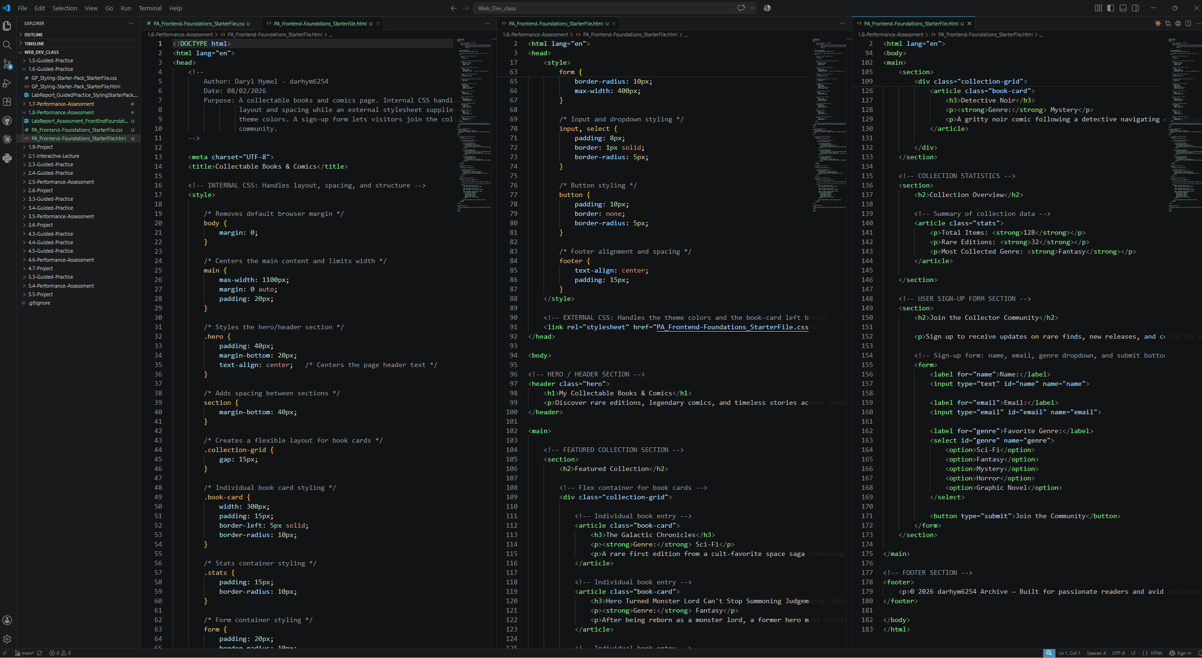
Paste your screenshot below this line:

Screenshot 2: Completed External CSS Code
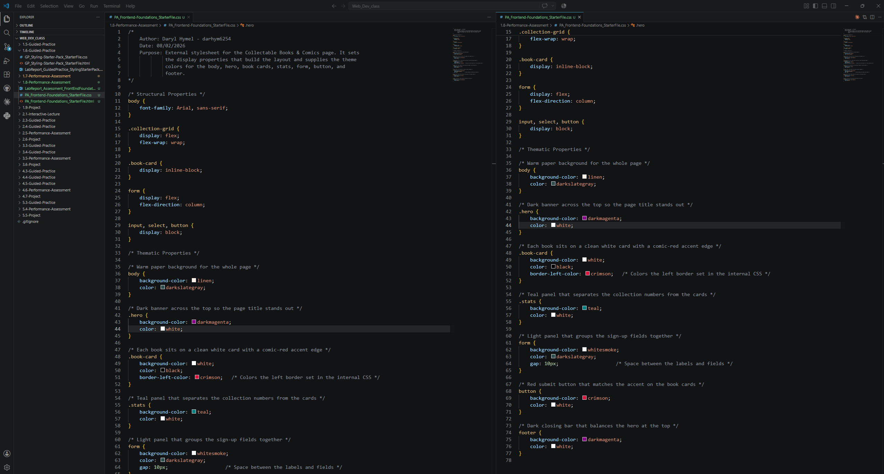
Paste your screenshot below this line:

Screenshot 3: Rendered Webpage in Browser
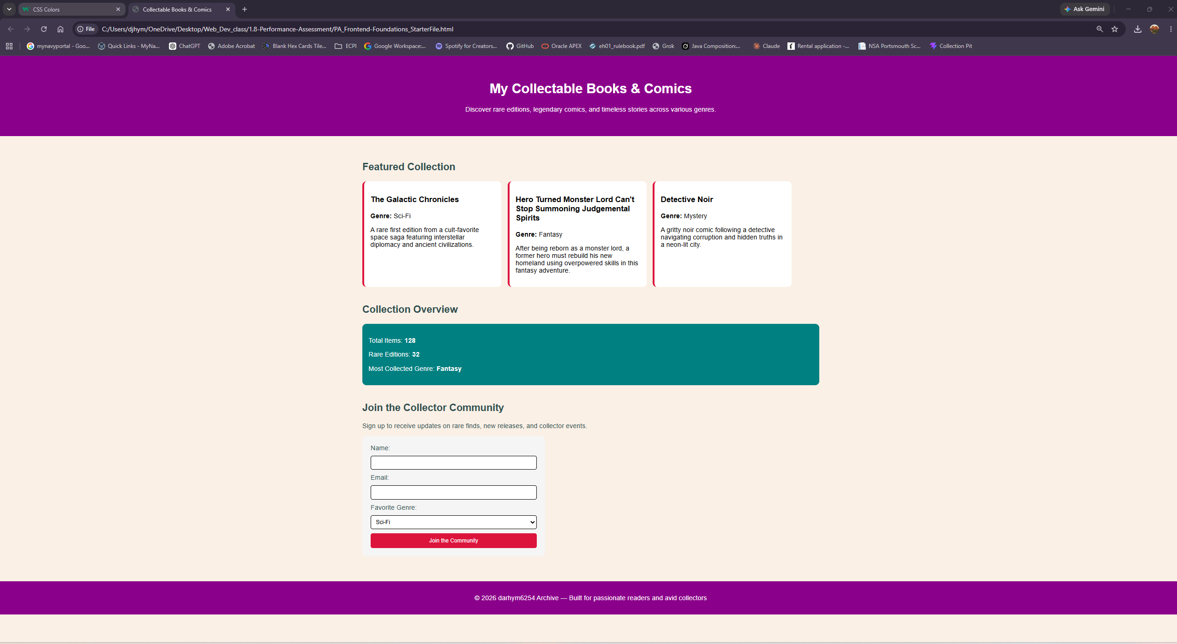
Insert a screenshot showing the finished webpage as it appears in a browser.

Reflection
In 3-5 sentences, explain what you learned about using HTML forms and CSS to improve page structure, usability, and visual design.
Building the form showed me that structure and usability go together. Connecting each label to its input with for and id means clicking the label selects the field, which makes the form easier to use. Using type="email" instead of type="text" let the browser check the address for me, so picking the right attribute saved me from writing extra code. Splitting layout and colors into two files made both easier to work with, because I could change every color on the page without touching any of the spacing rules.

