Guided Practice – Cookie Collection Lab Report
Use this template to document your work as you complete your assignment.

Your Information
Your Name: Daryl Hymel
Assignment Title: 4.3 Guided Practice - Cookie Collection
GitHub Repository: https://github.com/darhym6254/SDC260-Web-Dev-Class

Development Summary
Briefly summarize the work you completed for this guided practice. Include the files you edited, how cookies are used to store cart data, and how JavaScript updates the cart on the page.
I finished the Golden Crumb Bakery webpage. I connected the CSS and JavaScript files to the HTML and added a floating shopping cart. I also added a bounce animation and three new products. Using JavaScript, I made the product cards and added features that let users add or remove items from the cart. The cart is saved in a cookie called bakeryCart, so the items stay there even after the page is refreshed.

Code Explanation
Answer each prompt in complete sentences.
- Explain how the cart data is saved in a cookie and why this allows the cart to remain after the page is refreshed or reopened.
Whenever the cart changes, the saveCartToCookies function saves it in a cookie called bakeryCart for one week. Since the browser stores the cookie, the cart stays saved after refreshing or reopening the tab. When the page loads, loadCartFromCookies reads the cookie and restores the items in the cart.
- Explain how JavaScript updates the product grid, cart item list, cart count, and total on the webpage.
The displayProducts function goes through the products and creates a card for each one with its image, name, description, price, and an Add to Cart button. The updateCartDisplay function refreshes the cart list, calculates the total price and number of items, and updates the page so it always matches the cart.
- Describe what appeared when you typed document.cookie in the browser Console. What did the stored data show?
When I typed document.cookie in the Console, I saw the bakeryCart cookie with the cart information saved as a JSON string. It included the name, price, and quantity of each item I added to the cart.

- Explain why JSON.stringify() and JSON.parse() are needed when storing and loading the cart array.
Cookies can only store text, so JSON.stringify changes the cart array into a string before saving it. When the page loads, JSON.parse turns that string back into an array that JavaScript can use. Without these steps, the cart data would only be plain text.
- Describe one accessibility or usability feature included in the cart or product display, such as meaningful alt text or aria-labels.
Each product image has alt text so screen readers can describe it. The cart is labeled “Shopping cart,” and each Remove button says which item it removes, making the page easier to understand and use.

Code Evidence
Insert screenshots that show the completed code for this assignment. Make sure your screenshots are legible and contain the computer system date and time.

Screenshot 1: Completed HTML code
Paste your screenshot below this line:
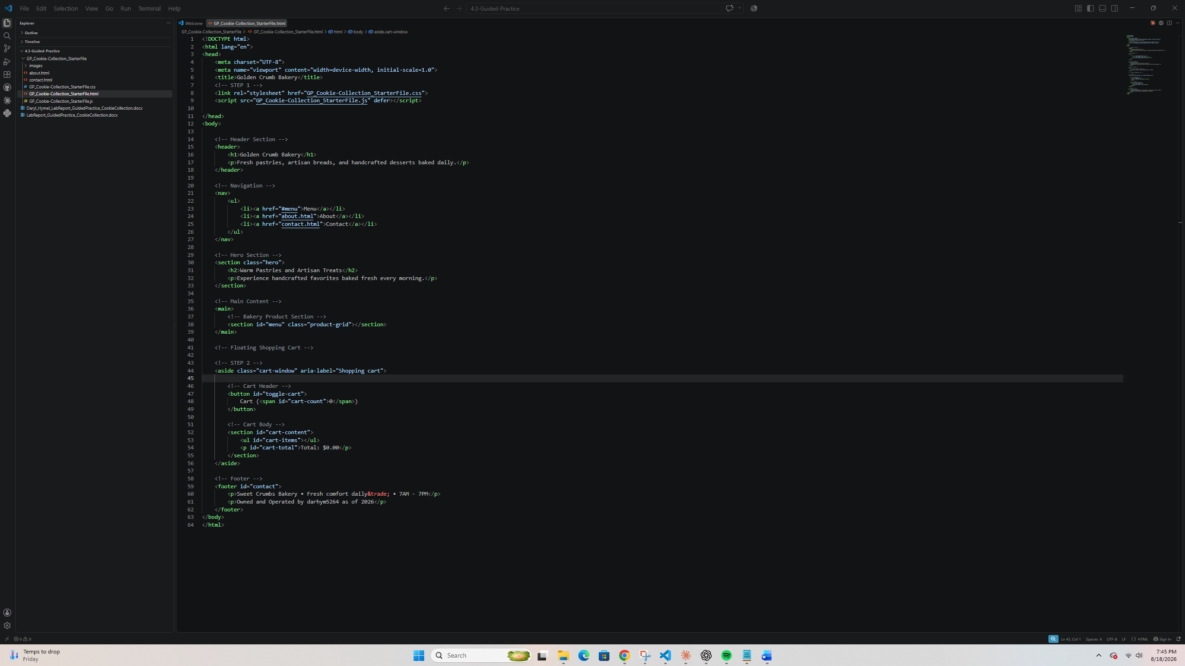

Screenshot 2: CSS Code
Paste your screenshot below this line:
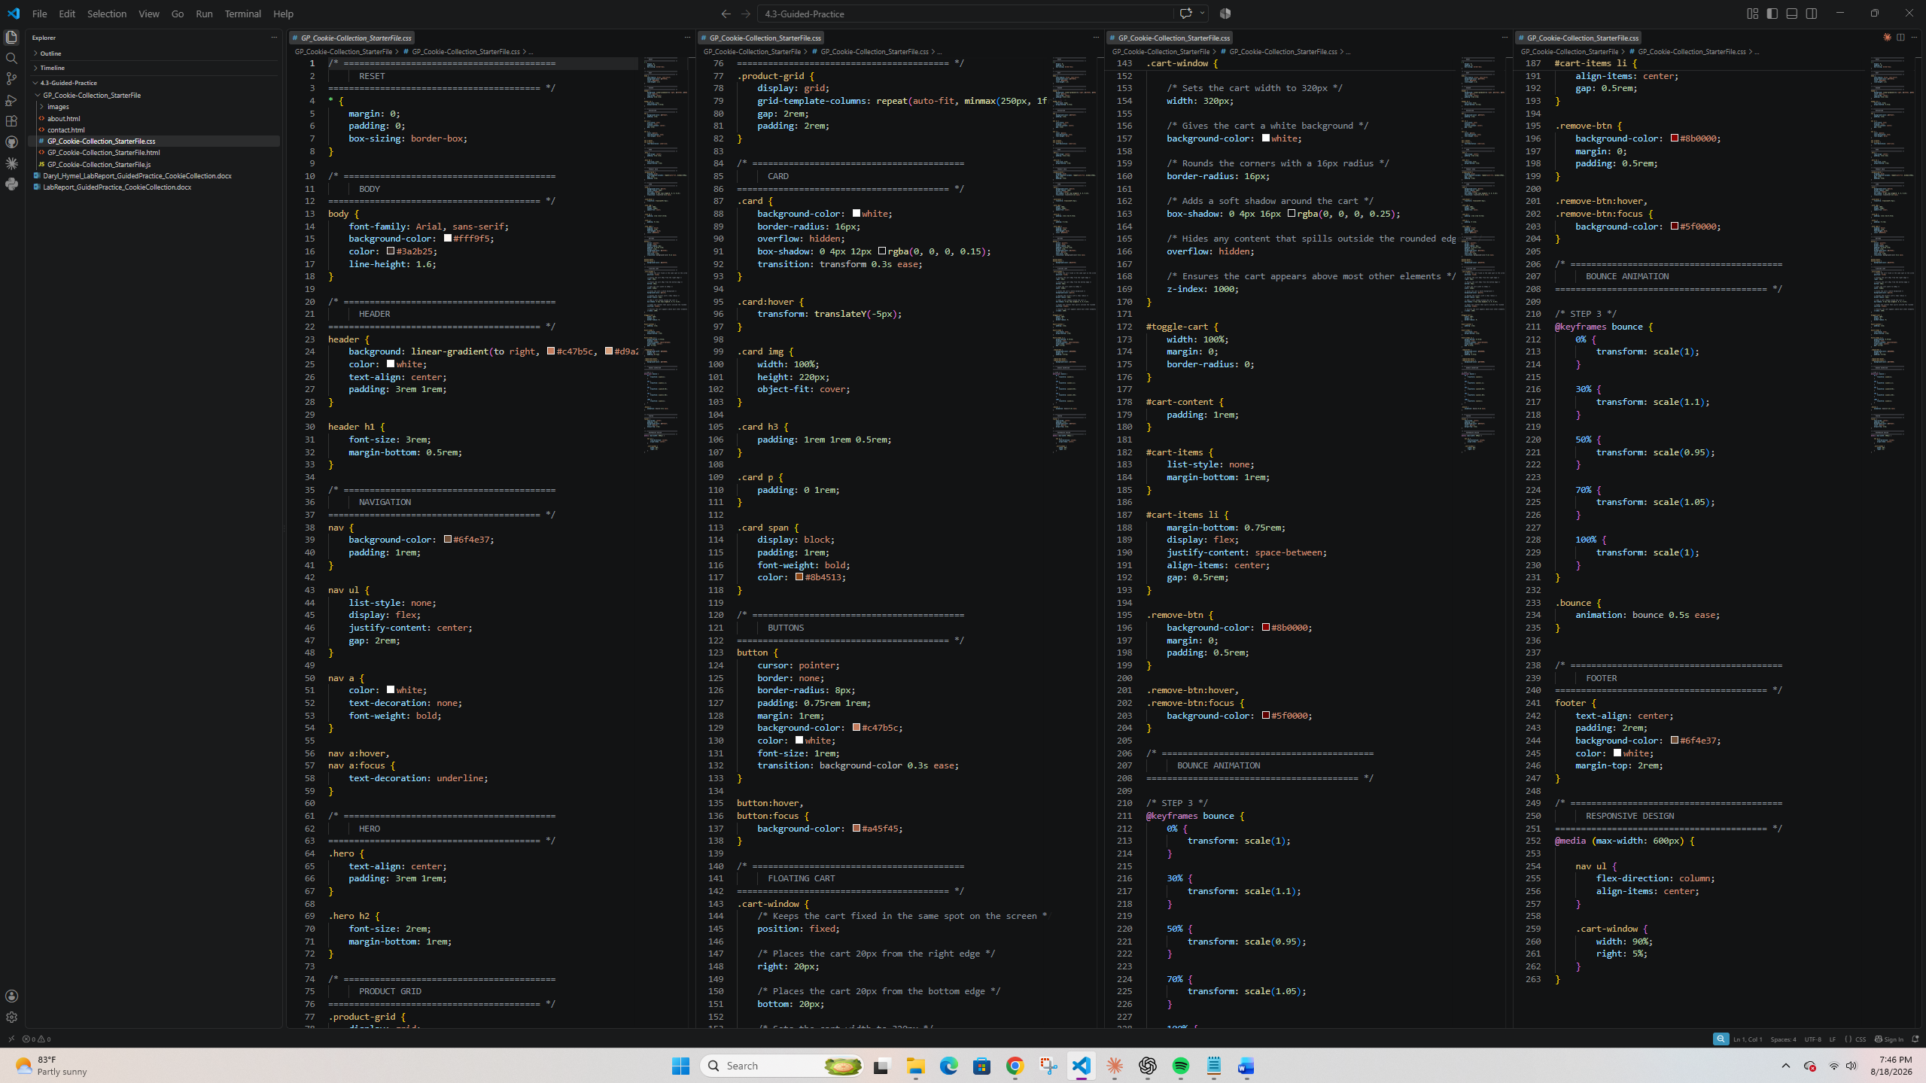

Screenshot 3: JavaScript Product and Cart Code
Paste your screenshot below this line:
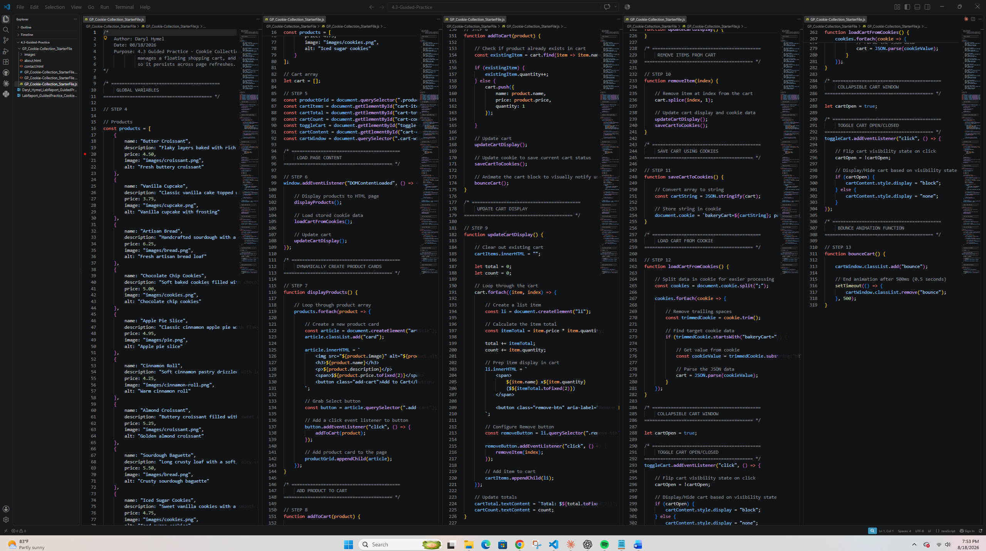

Screenshot 4: Cookies Save and Load Code
Paste your screenshot below this line:
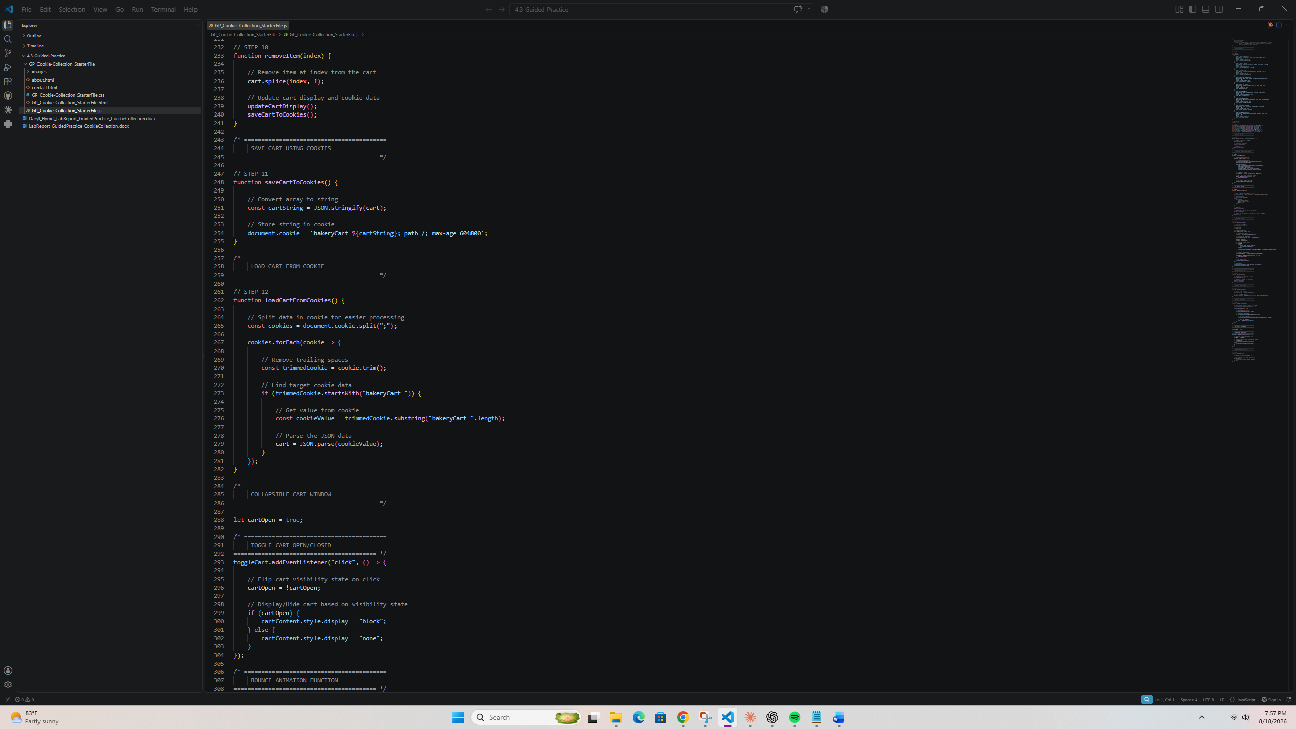

Screenshot 5: Browser Console Cookie Data
Paste your screenshot below this line:
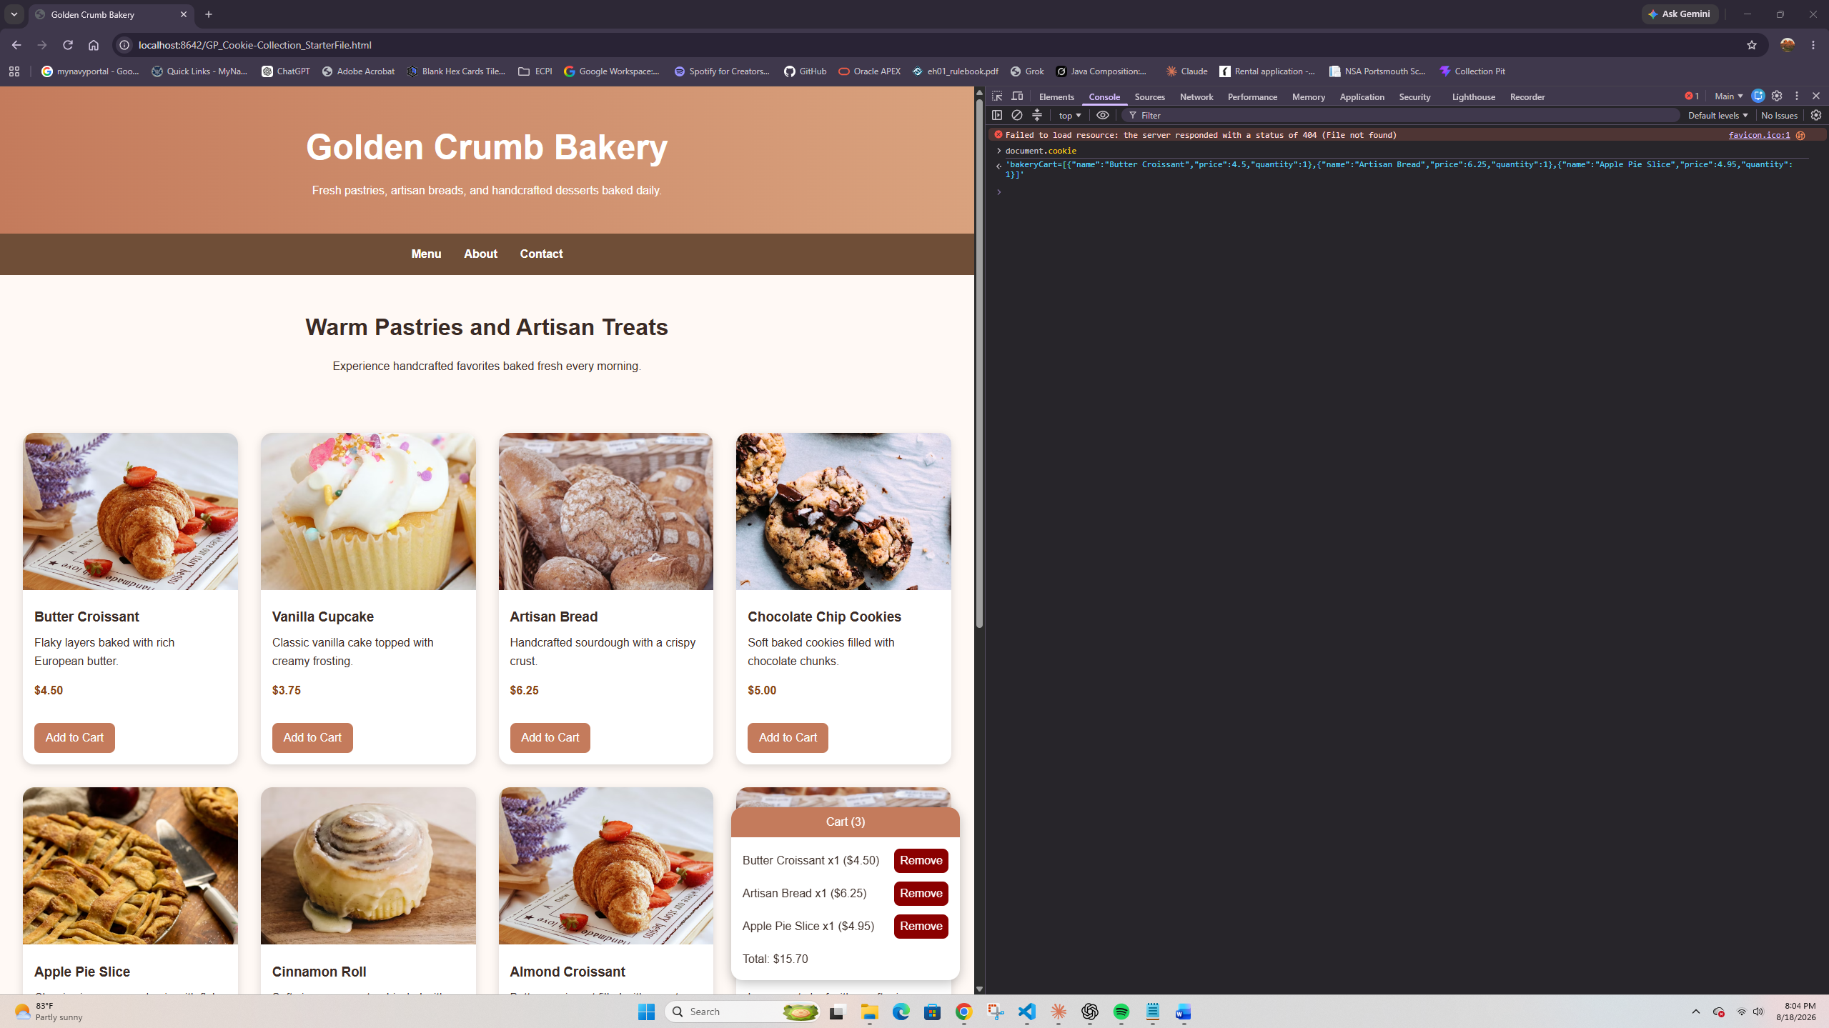

Screenshot 6: Rendered Web Page in Browser
Paste your screenshot below this line:
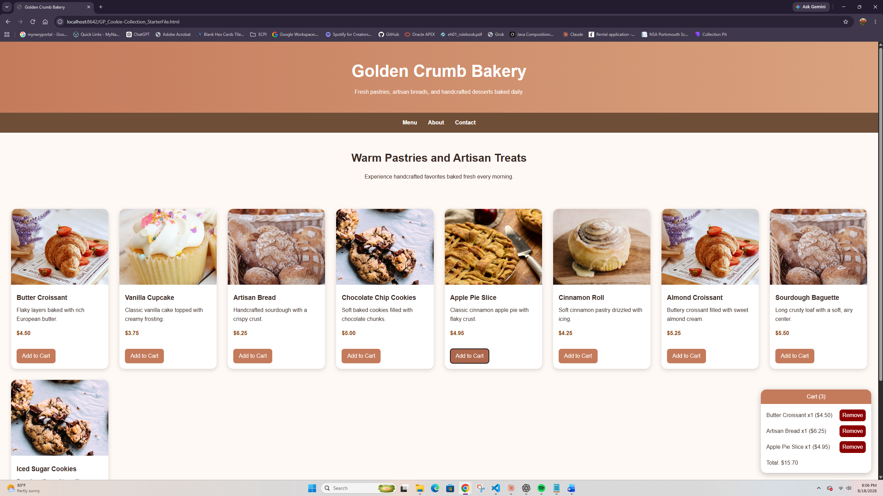

Reflection
In a few sentences, describe what part of persistent cart storage was easiest to understand, what was most challenging, and how checking the Console helped you confirm that the cookie was working.
The easiest part was saving the cart because it only took a few lines using JSON.stringify and document.cookie. Loading the cart was harder because I had to find the correct cookie before using JSON.parse. Checking document.cookie in the Console helped me confirm that the cart updated whenever I added or removed an item.

