Davikis Dice
E-Commerce Website Proposal
Daryl Hymel (darhym6254)
SDC260 1.9 Project: Blueprints to Browsers
August 2, 2026
Repository: github.com/darhym6254/davikis-dice-shop

Overview
Davikis Dice is a small shop that hand pours resin dice for tabletop roleplaying games. This proposal covers the plan for building its online store, from what the shop sells through to the schedule for putting the site together.
The shop sells standard seven piece dice sets and single dice, but what sets it apart is the odd shapes almost nobody else casts. Dice like the d3, d7, d15, d24, and d30 come up constantly in homebrew rules and in systems other than D&D, and players usually have to go without them or fake the roll with math. Davikis makes them, which gives the shop a group of customers that larger dice sellers are ignoring.
Because everything is made by hand, stock is small and many sets are one of a kind. The site has to show real inventory counts and make it clear when a set will never be made again, since that scarcity is a large part of why someone buys.
The site will be built over five weeks.

Business Model

Business Type
A one person handmade goods business selling directly to customers. Every die is mixed, poured, cured, sanded, and inked by hand, so production is slow and inventory stays small. Many sets are one of a kind and will not be repeated.

Products
- Seven piece RPG sets in soft edge ($25) or sharp edge ($45)
- Single standard dice ($5)
- Single odd sided dice such as d3, d15, and d24 ($8)
Everything is cast resin. Accessories like dice trays and bags are a reasonable addition later, but the shop launches with dice only.

Target Audience
Tabletop RPG players roughly 15 to 75 years old, in two groups:
- Players who want dice that match their character. A druid wants mossy green with dried flowers set in the resin, a warlock wants something that looks cursed. These customers buy full sets and care that a set is unique.
- Game masters who need odd sided dice for homebrew rules or for games other than D&D. These customers buy singles, they are hard to serve anywhere else, and they are the reason this shop can compete with much bigger sellers.

Purchasing Workflow
Buying is a straightforward five step flow, with a few details that come from the products being handmade.
Step | What happens
1 | The customer browses the Shop page and filters by dice type, edge, or price.
2 | They open a Product Detail page showing photos, the full description, and the live stock count.
3 | They add the item to the cart. The site will not let them add more than the stock count allows.
4 | The Cart page shows a subtotal and lets them change quantities or remove items.
5 | Checkout collects shipping and payment details and confirms the order.

Product Data Model
Every product is stored with the same set of fields, whether it is a full set or a single die. Keeping one record shape means the Shop page, the Product Detail page, and the Cart can all read the same data without special cases. The two sample products below show the fields filled in.
Field | Type | Sample 1 | Sample 2
product_id | text | DD-SET-041 | DD-SGL-107
name | text | Swamp Witch | Ember Core d24
type | text | set | single
composition | text | d4, d6, d8, d10, d%, d12, d20 | d24
edge | text | sharp | sharp
color_scheme | text | deep green, gold | translucent orange, copper
inclusions | text | real dried flowers | copper flakes
ink_color | text | gold | black
price | number | 45.00 | 8.00
stock_quantity | number | 1 | 0
one_of_a_kind | boolean | true | false
made_to_order | boolean | false | true
images | list | swamp-witch-1.jpg, swamp-witch-2.jpg | ember-d24-1.jpg
description | text | Short paragraph for the product page | Short paragraph for the product page
date_added | date | 2026-07-18 | 2026-06-30
These two samples were picked because between them they exercise every field. Swamp Witch is unique with one in stock, so it vanishes from the shop when it sells. Ember Core d24 is out of stock but still buyable, because made to order singles are cast when someone orders one.

Site Map
The site has six pages, arranged around the single path a visitor takes from landing on the homepage to placing an order.
Page | Purpose
Home | Featured sets, the shop pitch, and the way into the Shop
Shop | All products, filterable by type, edge, color, and price
Product Detail | One product with full photos, stock count, and add to cart
About / Process | Who Davikis is and how the dice are made
Cart | Review and adjust items before buying
Checkout | Shipping details, payment, and order confirmation

Navigation Path
Home > Shop > Product Detail > Cart > Checkout

The homepage directs users to the Shop through featured products or the main Shop button. Both options lead to the same Product Detail page and add-to-cart process. The About page is separate but available from the header to help customers learn more about the maker. The header also links to Home, Shop, Odd Dice, About, and Cart. Odd Dice is a filtered Shop view rather than a separate page.

Feature Roadmap
Development is split into five sections. One week pushes Each week depends on the one before it, since the cart cannot be written before product pages exist and testing cannot happen until there is something to test.

Week 1: Planning and Foundation
The proposal, the repository, and a static homepage that sets the page structure and brand colors.
Task | Estimated Time
Write the project proposal | 3 hours
Create the repository, README, and index.html | 1 hour
Build the semantic HTML structure of the homepage | 2 hours
Choose the palette and run contrast checks | 1 hour
Deliverable: proposal document and a working homepage prototype.

Week 2: Visual Design and Responsive Layout
All styling moves into an external stylesheet and the homepage starts working on phones and tablets.
Task | Estimated Time
Move all styling into an external stylesheet | 1 hour
Build the product grid using flexbox | 2 hours
Add mobile and tablet breakpoints | 3 hours
Build and style the Product Detail page | 2 hours

Week 3: Shop Interactivity
The Shop page starts responding to what the visitor does instead of showing one fixed list.
Task | Estimated Time
Filter the shop by dice type and edge | 4 hours
Sort products by price and by newest | 2 hours
Add a search box that matches on product name | 2 hours
Show a sold out badge when stock reaches zero | 1 hour

Week 4: Cart and Storage
A real cart that survives closing the browser, plus a checkout summary.
Task | Estimated Time
Add to cart and remove from cart | 3 hours
Save the cart to local storage so it survives a refresh | 2 hours
Build the checkout summary with subtotal and shipping | 3 hours
Stop customers adding more than the stock count allows | 1 hour
Deliverable: a working cart that remembers items between visits.

Week 5: Launch
The last page gets built and the whole site is tested and deployed.
Task | Estimated Time
Build the order confirmation page | 2 hours
Accessibility pass for contrast and keyboard navigation | 2 hours
Test every page in two browsers | 2 hours
Fix bugs and deploy the site | 3 hours
Total estimated build time is about 29 hours across five weeks, or roughly six hours a week.

Brand Theme
The brand idea is an arcane workshop. Davikis Dice should feel like a place where objects are made rather than a warehouse where products are held. The dice are treated as small artifacts, and the site stays dark and quiet so the products carry the color instead of the page.
A dark background is also a practical choice. Most of these dice are translucent resin with things suspended inside them, and they photograph far better against a dark ground than against white. The gold accent reads as brass and workshop tooling, which suits a maker brand better than a bright commercial color would.

Color Palette
The palette was generated in Coolors, then every text and background pair was checked in the WebAIM Contrast Checker.
Hex | Name | Used For | Contrast on #1A1526
#1A1526 | Void Purple | Page background | n/a
#2A2138 | Cast Shadow | Product cards and panels | n/a
#F2EDE4 | Parchment | Primary body text | 15.27 to 1
#E0B65C | Brass | Headings, prices, buttons | 9.34 to 1
#B9AEC4 | Ash Violet | Secondary text and borders | 8.41 to 1
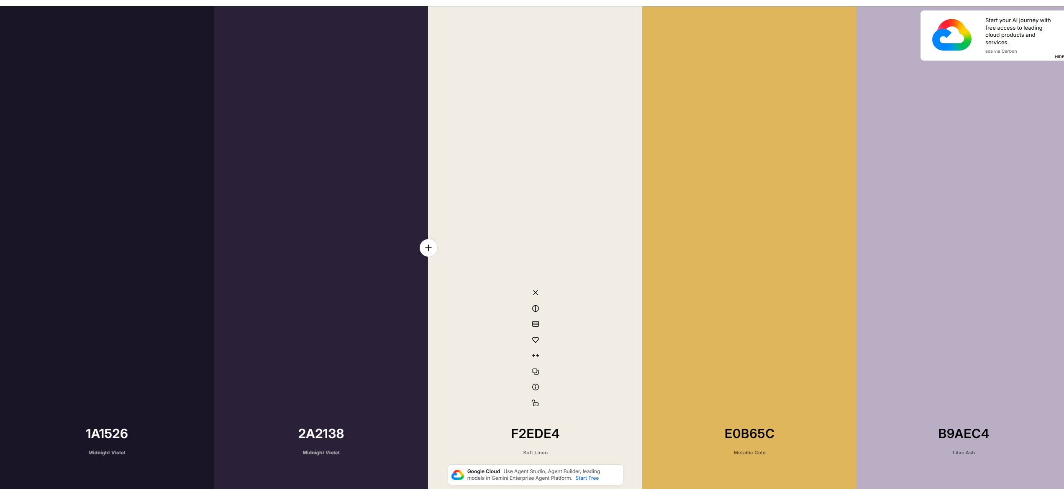
Palette generated in Coolors
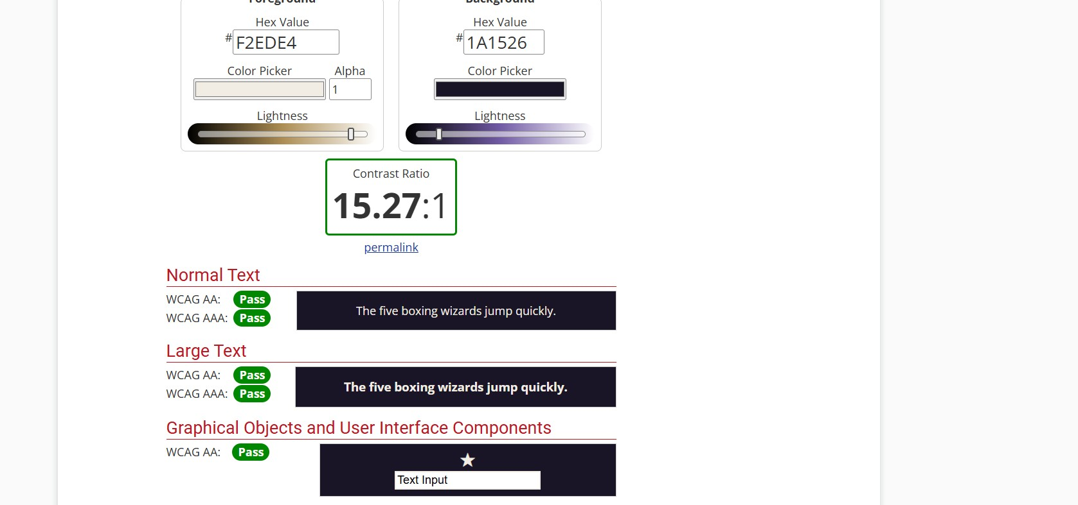
WebAIM Contrast Checker: Parchment #F2EDE4 on Void Purple #1A1526, 15.27 to 1

Homepage Design Plan
The homepage prototype was created with HTML and CSS so the layout could be tested in a browser and reused later in the project. It follows the site map by guiding visitors from the hero section to the Shop. Featured product cards show how items will appear, including stock information for limited handmade sets. The Odd Dice section highlights the shop’s unique products, while the About section explains how the dice are made. The prototype also uses the chosen brand colors and accessibility contrast ratios.
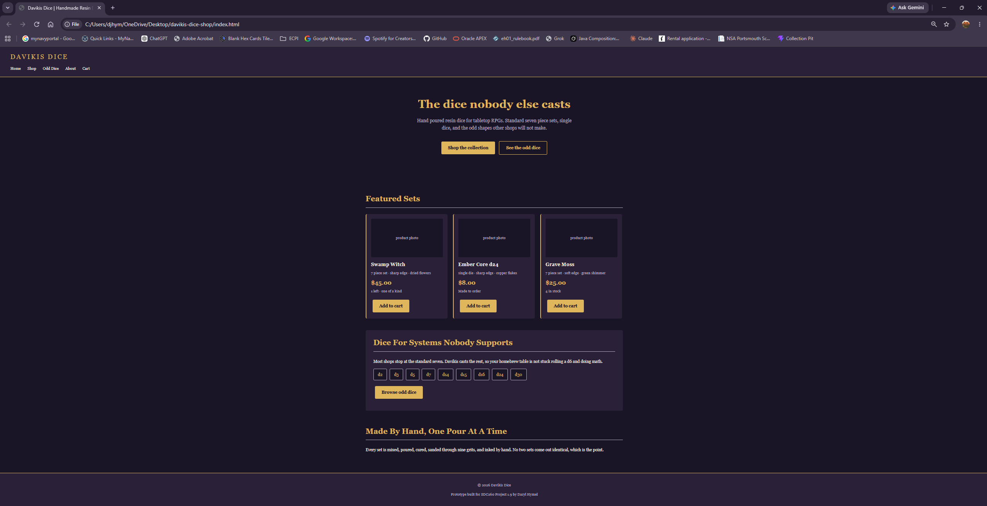

Repository
Repository for this project is at https://github.com/darhym6254/davikis-dice-shop

