Guided Practice - Monstrous Adaptability Lab Report
Use this template to document your work as you complete your assignment.

Your Information
Your Name: Daryl Hymel
Assignment Title: Monstrous Adaptability
GitHub Repository: https://github.com/darhym6254/Monstrous-Adaptability

Development Summary
Briefly describe the work you completed. In your response, mention the creature cards you added and where you stored the image files.
I completed the Mythical Creature Bestiary by connecting the external stylesheet, adding three new creature cards, and using Flexbox for the card layout. The new creatures are the Siren, Bloodhorn, and Solar Phoenix, with the Solar Phoenix introducing a new celestial type styled with an amber border. I also organized all images in an images folder, used relative file paths, and improved the alt text so each image is clearly described.

Code Evidence
Insert screenshots that show the completed code for this assignment. Make sure your screenshots are legible and contain the computer system date and time.

Screenshot 1: Completed HTML code
Paste your screenshot below this line:
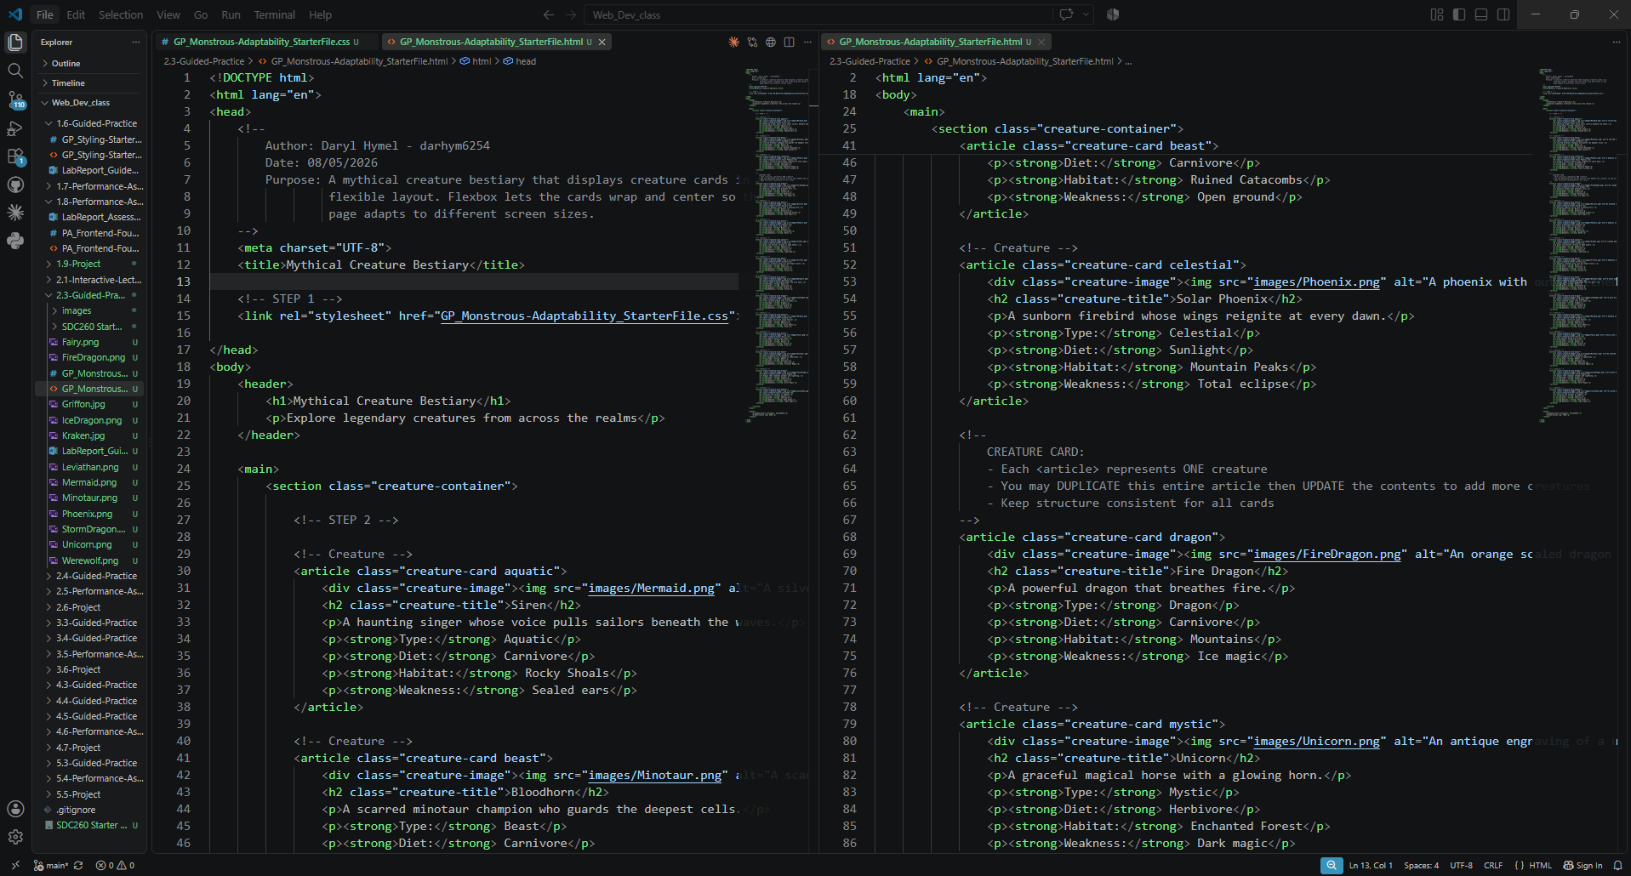
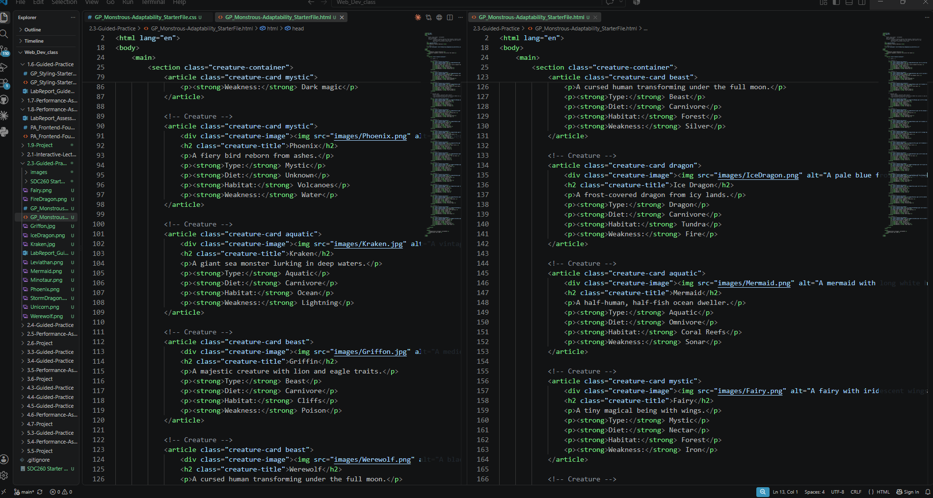
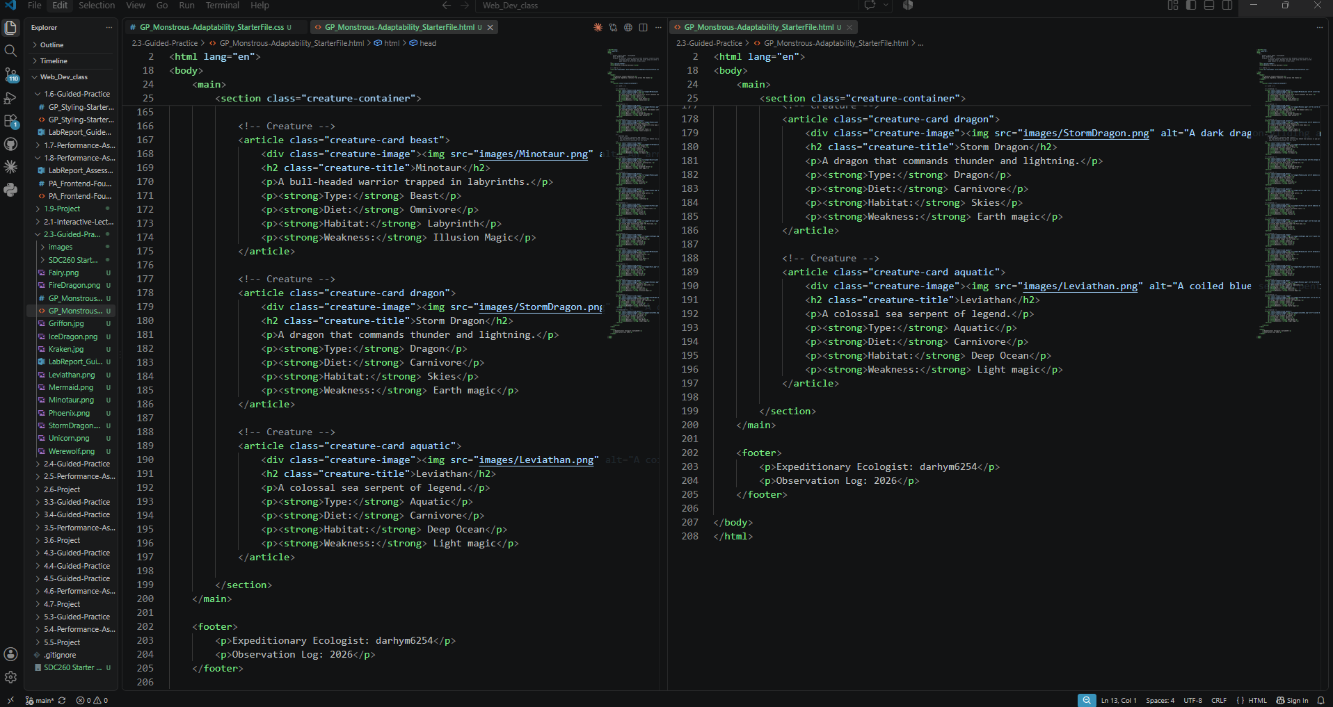

Screenshot 2: Completed CSS Code
Paste your screenshot below this line:
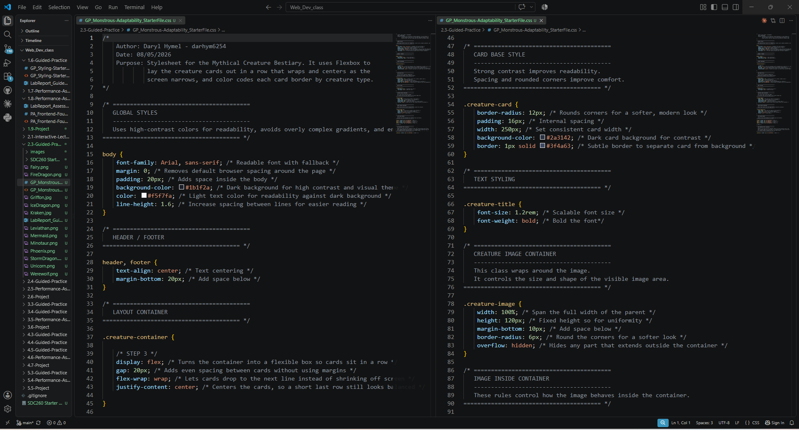
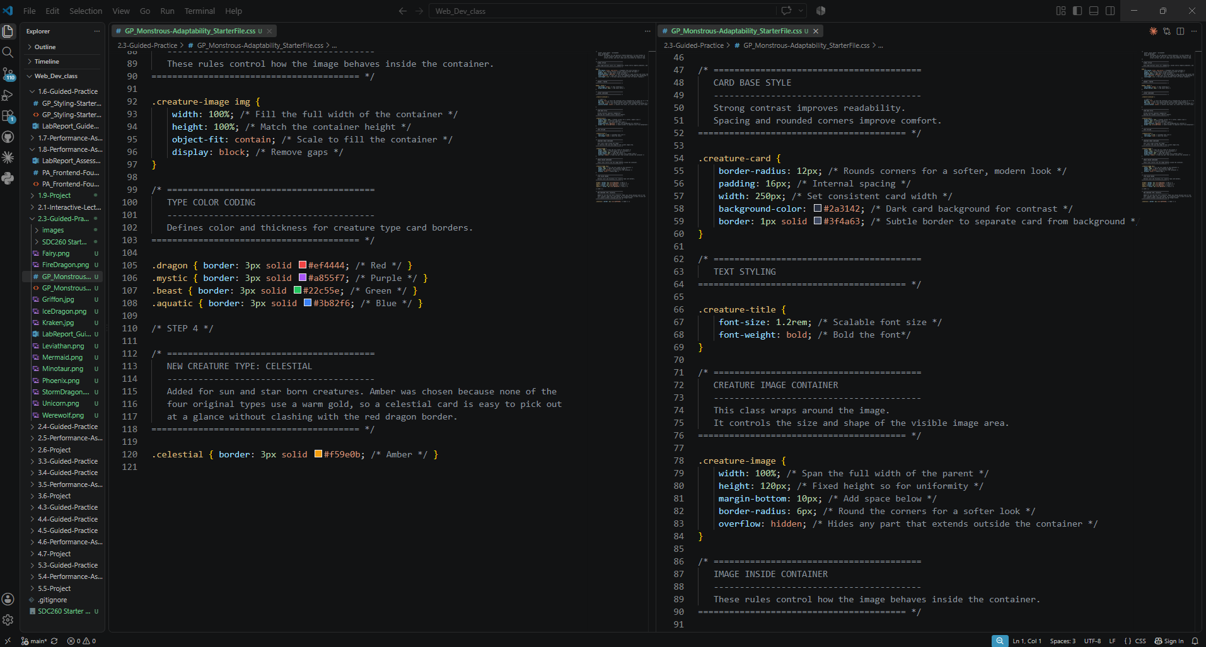

Image File Evidence
List the image files you added to the images folder. The file names listed here should match the file names used in your HTML image paths.
Creature Name | Image File Name | Alt Text Summary
Siren | Mermaid.png | Mermaid with long white hair and a green scaled tail swimming through sunlit water
Bloodhorn | Minotaur.png | Armored minotaur gripping a glowing rune carved axe in a torchlit stone dungeon
Solar Phoenix | Phoenix.png | Phoenix with outstretched flaming wings rising above mountains at sunrise
Kraken | Kraken.jpg | Vintage engraving of a kraken dragging sailing ships under the water with its tentacles
Griffin | Griffon.jpg | Medieval manuscript drawing of a griffin with an eagle head and wings on a lion body

Rendered Web Page Evidence
Insert a screenshot of the completed web page as it appears in your browser. The bestiary should show the new creature cards, visible images, and a flexible layout that wraps or centers appropriately.

Screenshot 3: Rendered Web Page
Paste your screenshot below this line:
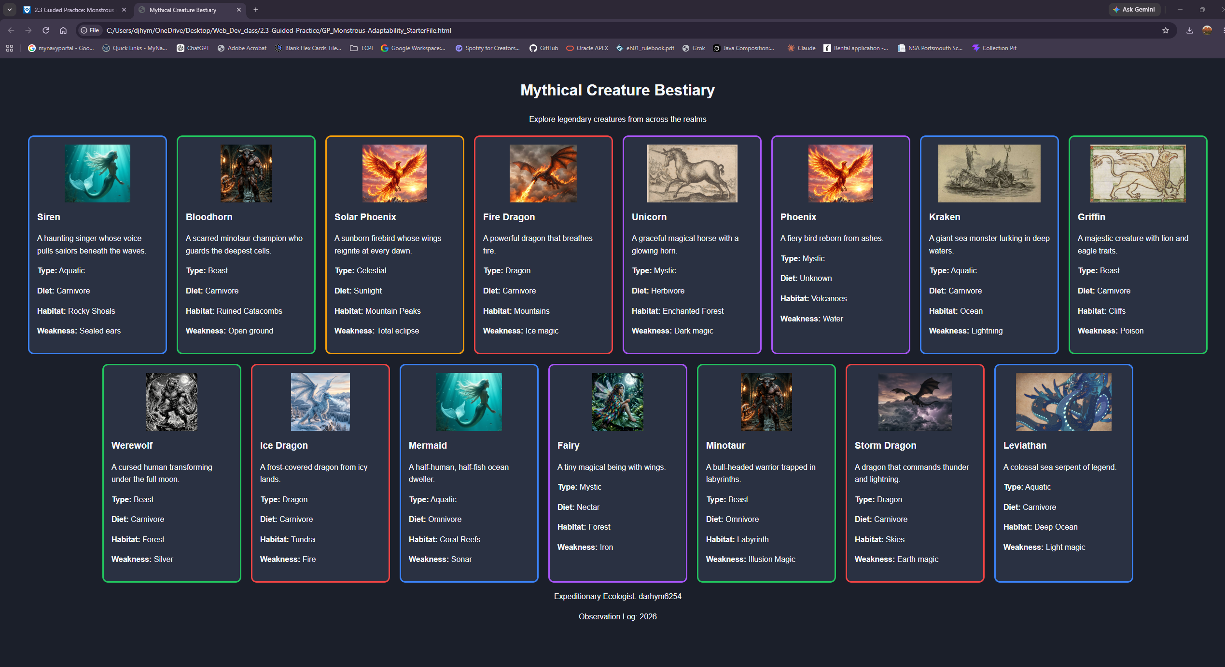

Reflection
1. How did Flexbox properties such as gap, flex-wrap, and justify-content help organize the bestiary layout?
Using Flexbox changed the creature cards from a vertical stack into a row layout. The gap adds even spacing, flex-wrap moves cards to a new line when space runs out, and centers each row. Together, these settings let the layout to work on both wide and narrow screens without creating separate designs.
2. Why is it important for each creature image to have an accurate file path and meaningful alt text?
Correct file paths are important because a wrong path or incorrect capitalization can prevent an image from loading. Alt text improves accessibility by describing the image for users and appears when an image fails to load. Instead of repeating each creature’s name, I wrote descriptions of what each image actually shows, including whether it is historical artwork or a modern illustration.

