Guided Practice - Legendary Layouts Lab Report
Use this template to document your work as you complete your assignment.

Your Information
Your Name: Daryl Hymel
Assignment Title: Legendary Layouts
GitHub Repository: https://github.com/darhym6254/SDC260-Web-Dev-Class

Development Summary
Briefly describe the work you completed. In your response, mention the quest listings you added.
I completed the Adventurer Job Board by connecting the external stylesheet, adding three new quests, and using CSS Grid for the layout. The new quests include one easy, one medium, and one hard job, bringing the board to nine listings arranged in three rows of three. A media query changes the layout to one column on screens under 768 pixels, making the page work on both desktop and mobile devices.

Quest Listing Evidence
List the three new quests you added to the job board.
Quest Title | Quest Description Summary | Reward | Difficulty
Lighthouse Gone Dark | Find out why the coastal lighthouse stopped burning last week | 175 Gold | Easy
Cursed Well Cleansing | Break the curse that has poisoned a farming village's only well | 300 Gold | Medium
Wyvern Nest Removal | Clear a wyvern nest from the quarry cliffs before work resumes | 450 Gold | Hard

Code Evidence
Insert screenshots that show the completed code for this assignment. Make sure your screenshots are legible and contain the computer system date and time.

Screenshot 1: Completed HTML Code
Paste your screenshot below this line:

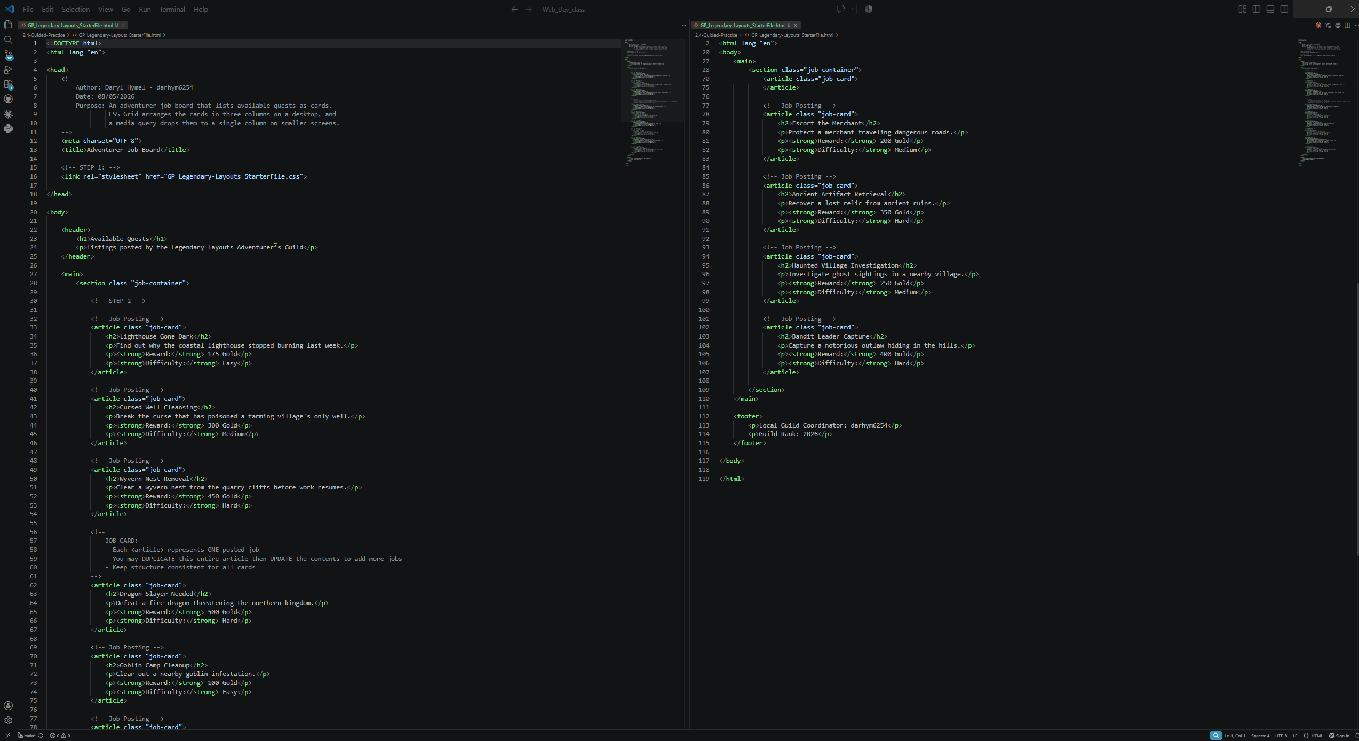

Screenshot 2: Completed CSS Code
Paste your screenshot below this line:
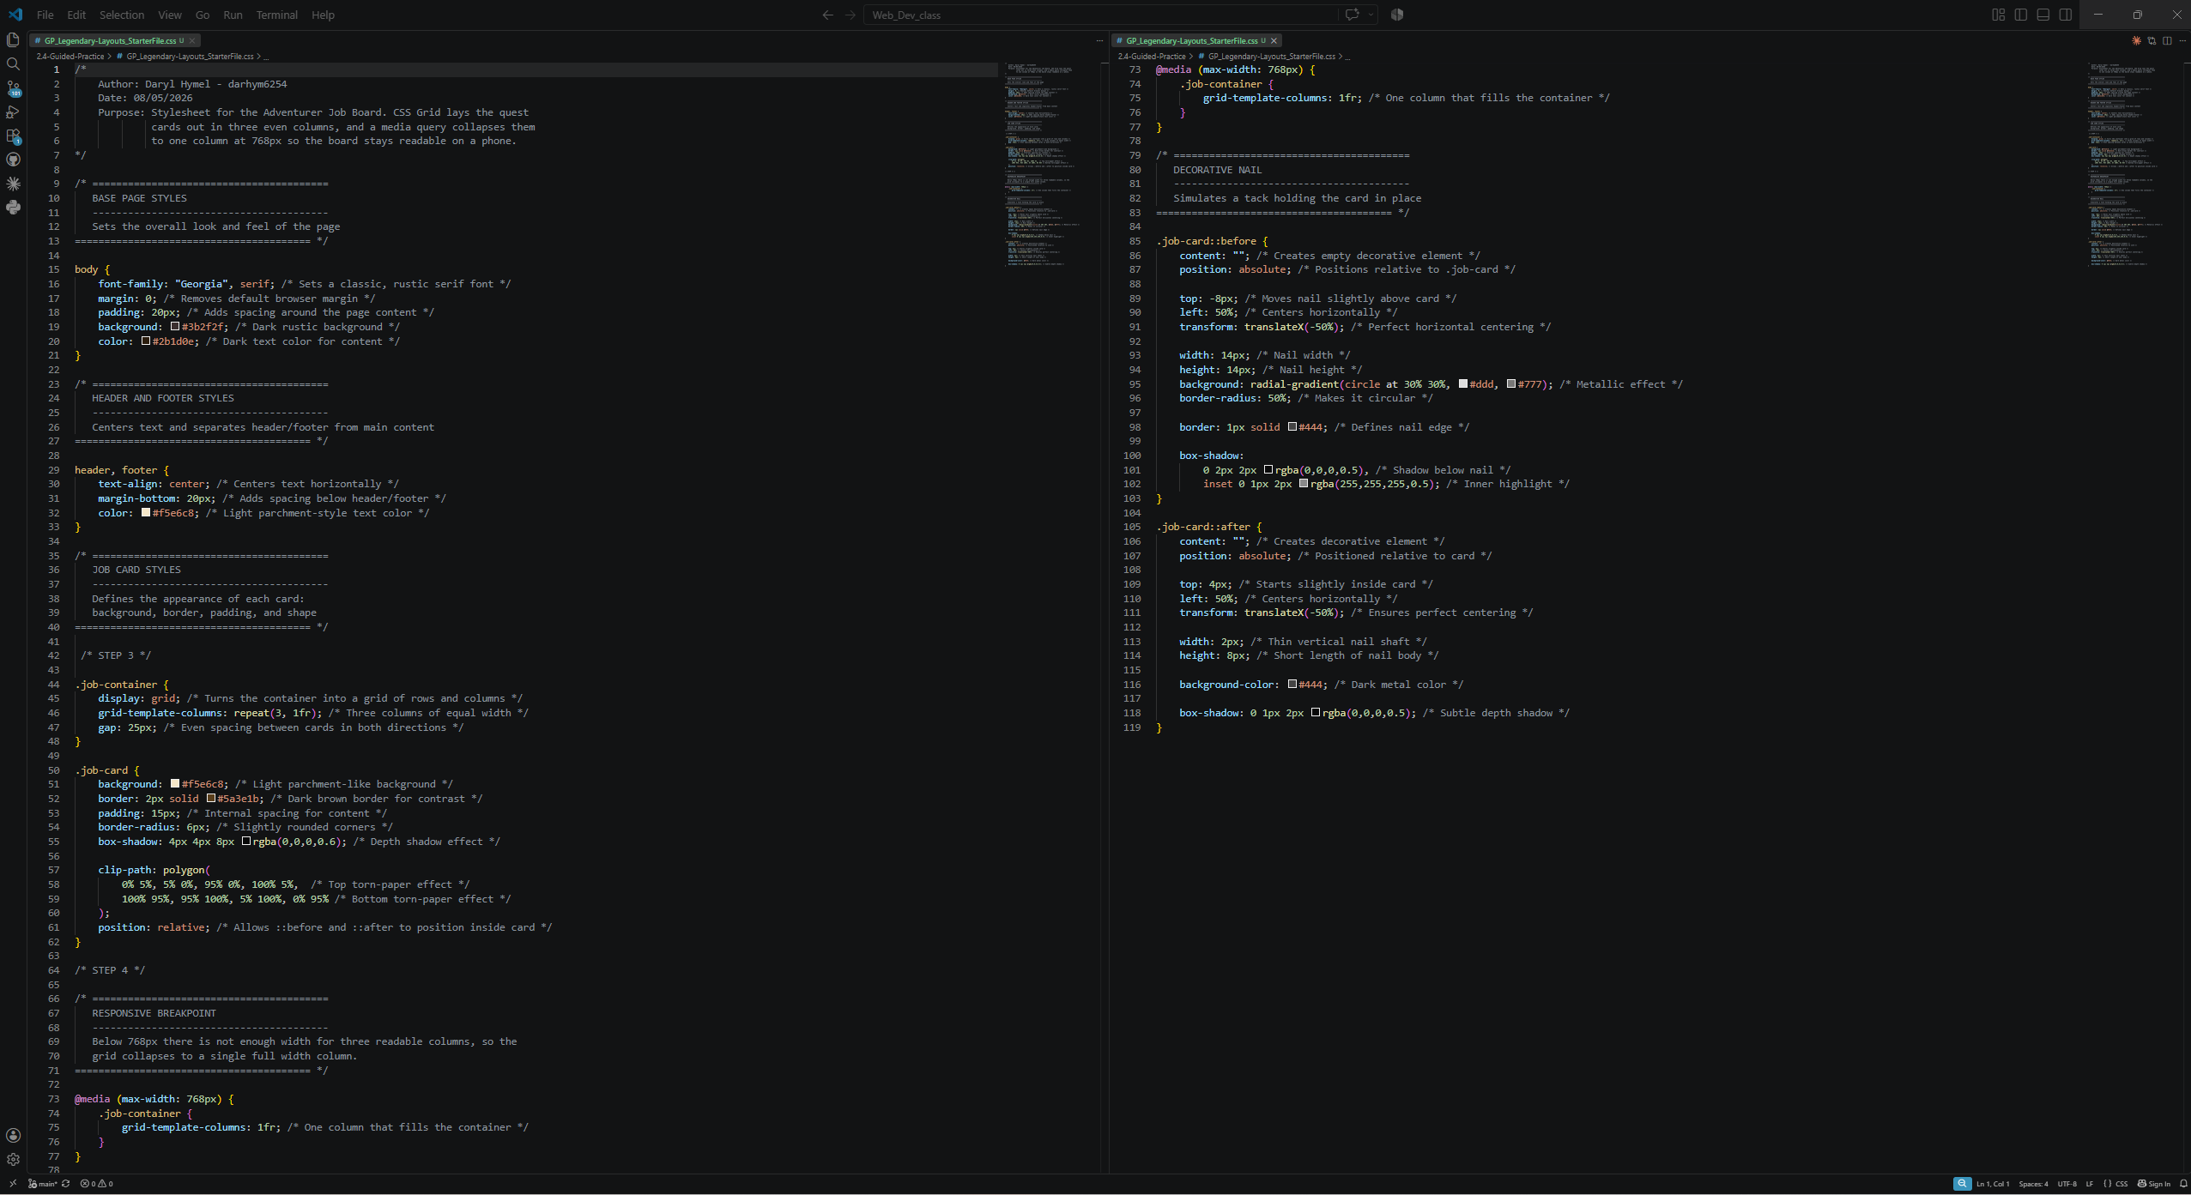

Rendered Web Page Evidence
Insert screenshots of the completed web page as it appears in your browser. Include one screenshot at a wider desktop size and one screenshot after resizing the browser window to a smaller/mobile width.

Screenshot 3: Desktop/Fullscreen Layout
Paste your screenshot below this line:
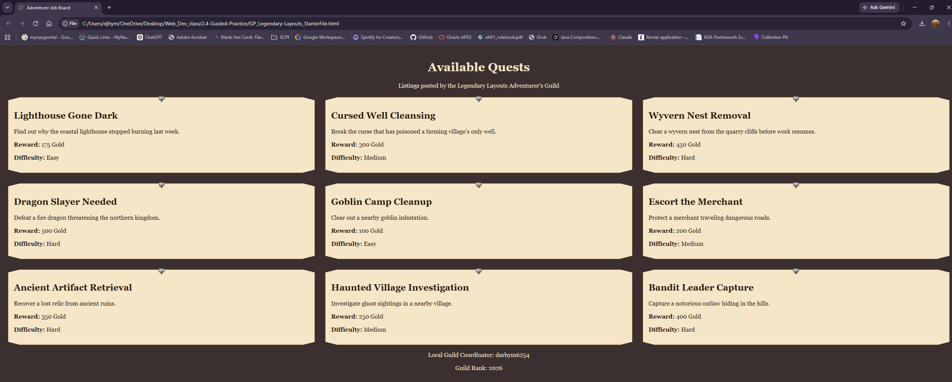

Screenshot 4: Mobile/Windowed Layout
Paste your screenshot below this line:
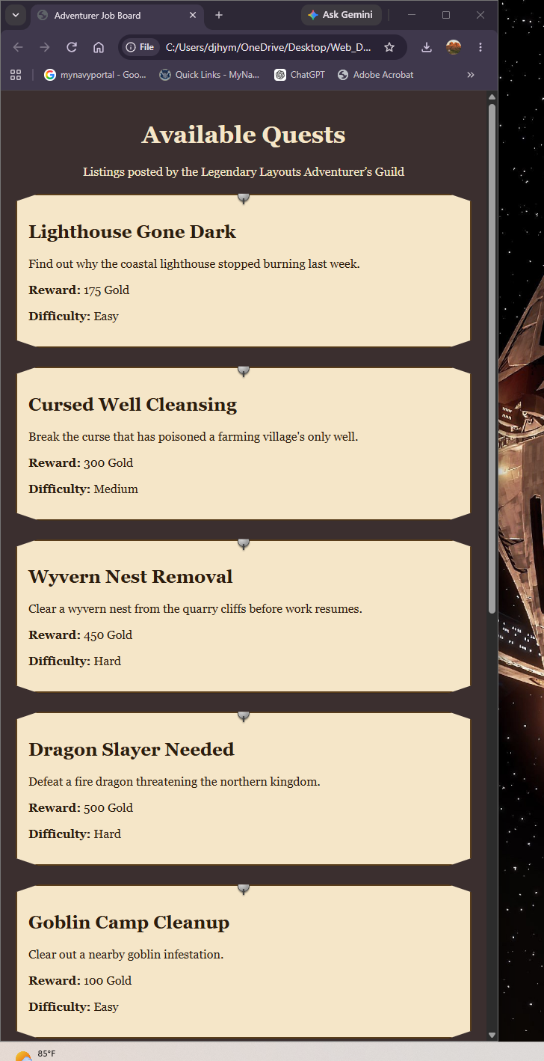

Responsive Design Check
1. What changed when you resized the browser window below the media query breakpoint?
Above 768 pixels, the nine quest cards appear in three equal columns. Below 768 pixels, the media query changes the grid to one column, causing the cards to stack and fill the container width. Their parchment design stays the same, while the 25-pixel gap becomes vertical spacing between the cards.
2. Why does changing grid-template-columns to 1fr improve readability on smaller screens?
On small screens, three columns make the quest cards too narrow and difficult to read. Changing the grid to 1fr creates one full-width column, allowing titles and descriptions to display normally while users scroll down through the listings.

Reflection
1. How does CSS Grid organize features on a web page?
CSS Grid organizes the quest cards into automatic rows and columns. By setting the container to three equal columns with a 25-pixel gap, every card is positioned without adding individual widths or margins. New quests automatically create another row, so the layout continues working as more content is added.
2. What causes media queries to activate?
A media query applies CSS rules only when its condition is met. With max-width: 768px, the browser switches to the mobile layout whenever the screen is 768 pixels wide or smaller and updates automatically as the window is resized. Media queries can also respond to conditions like orientation or printing.

