Assessment – Responsive Recipes Lab Report
Use this template to document your work as you complete your assignment.

Your Information
Your Name: Daryl Hymel
Assignment Title: Responsive Recipes
GitHub Repository: https://github.com/darhym6254/SDC260-Web-Dev-Class

Development Summary
Briefly describe the work you completed. In your response, mention the potion recipes you added and whether you used Flexbox or CSS Grid.
I connected the HTML file to an external stylesheet, added three new potion recipes, and used CSS Grid to organize the page. The new recipes bring the total to five potions, with each one including a name, effect, and ingredient table. The layout uses a mobile-first design with one column by default, two columns at 768 pixels, and three columns at 1024 pixels. I also kept the protected CSS rules unchanged and used the existing color variables.

Potion Recipe Evidence
List the three additional potion recipes you added to the webpage. Each recipe should include a unique name, a brief effect description, and an ingredient table with quantities.
Potion Name | Effect Description Summary | Ingredients Included | Quantity Details Included?
Elixir of Ironhide | Hardens the skin against blades and blunt force for one hour | Basilisk Scale, Iron Root, Ogre Fat | Yes, 2 fragments / 1 handful ground / 3 spoonfuls
Draught of Swift Winds | Doubles running speed until the drinker next stops to rest | Falcon Feather, Storm Salt, Mint Sprig | Yes, 5 primary feathers / 1 pinch / 2 sprigs bruised
Philter of Second Sight | Reveals hidden doors, illusions, and creatures in total darkness | Owl Eye, Moon Dew, Silver Thistle | Yes, 1 preserved in brine / 2 vials at midnight / 4 blossoms

Layout and Responsiveness Evidence
- Did you use Flexbox or CSS Grid for the main layout? Explain why that layout method was appropriate for this recipe page.
I used CSS Grid because the potion cards need to align evenly in rows and columns. Grid lets me set the exact number of equal columns without assigning widths to each card. It also keeps cards in the same row at an equal height, so the ingredient tables stay aligned even when the descriptions are different lengths.
- What layout or spacing changes occur at the 768px breakpoint?
At 768 pixels, the layout changes from one column to two so the potion cards appear side by side. The spacing also increases from 1rem to 1.5rem to keep the cards visually separate. The card design, tables, and colors stay the same.
- What layout or spacing changes occur at the 1024px breakpoint?
At 1024 pixels, the layout changes to three columns with a 2rem gap. The main content is limited to 1200 pixels, centered, and given more padding. This keeps the layout organized and prevents text from stretching too wide on large screens.
- How did you confirm that the page remained readable across mobile, tablet, and desktop screen sizes?
I tested the page at desktop, tablet, and mobile widths to make sure the grid changed correctly. I checked that the potion names, descriptions, tables, and cards stayed readable without overlapping or creating horizontal scrolling. The mobile layout uses one full-width column because the ingredient tables need more space.

Code Evidence
Insert screenshots that show the completed code for this assignment. Make sure your screenshots are legible and contain the computer system date and time.

Screenshot 1: Completed HTML Code
Paste your screenshot below this line:
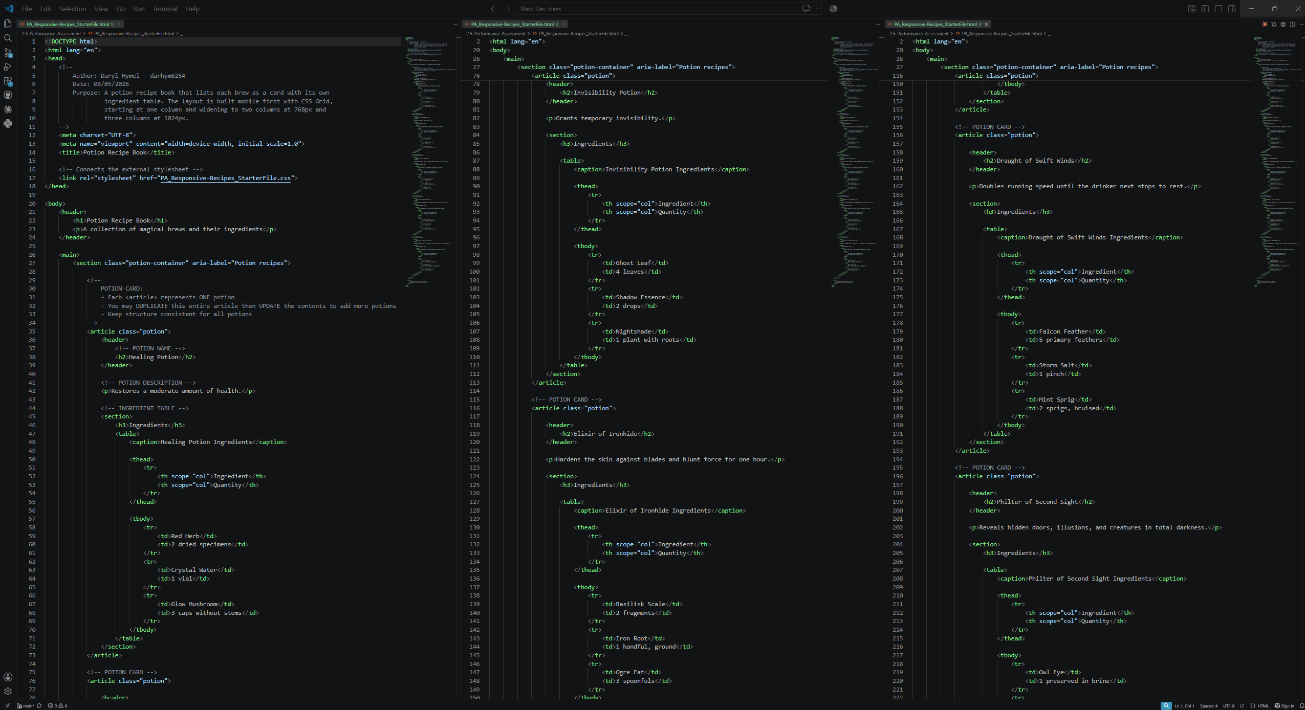
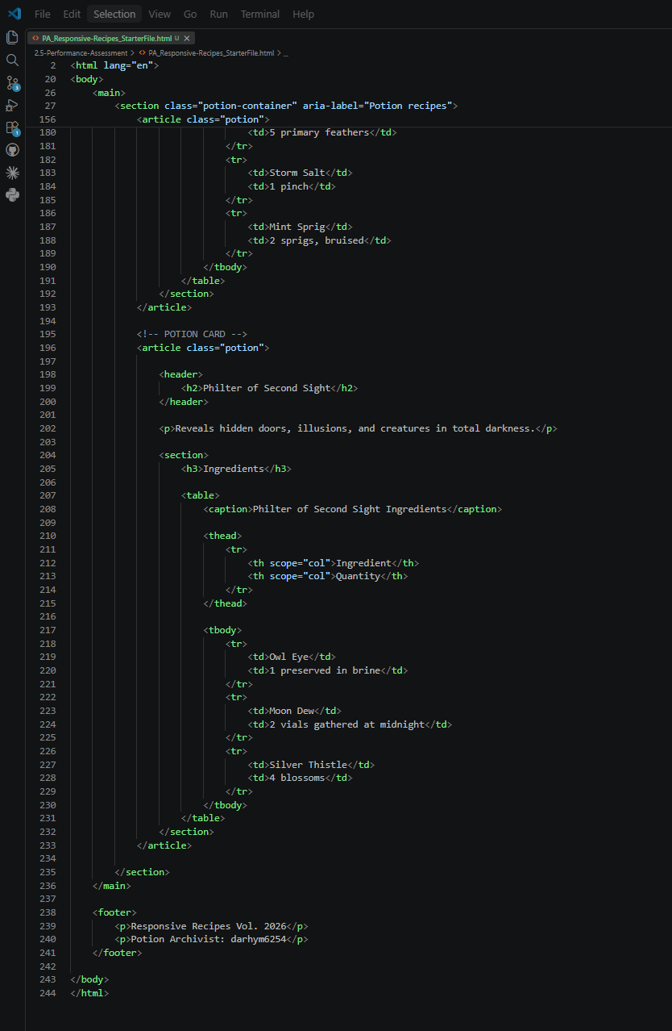

Screenshot 2: Completed CSS Code
Paste your screenshot below this line:
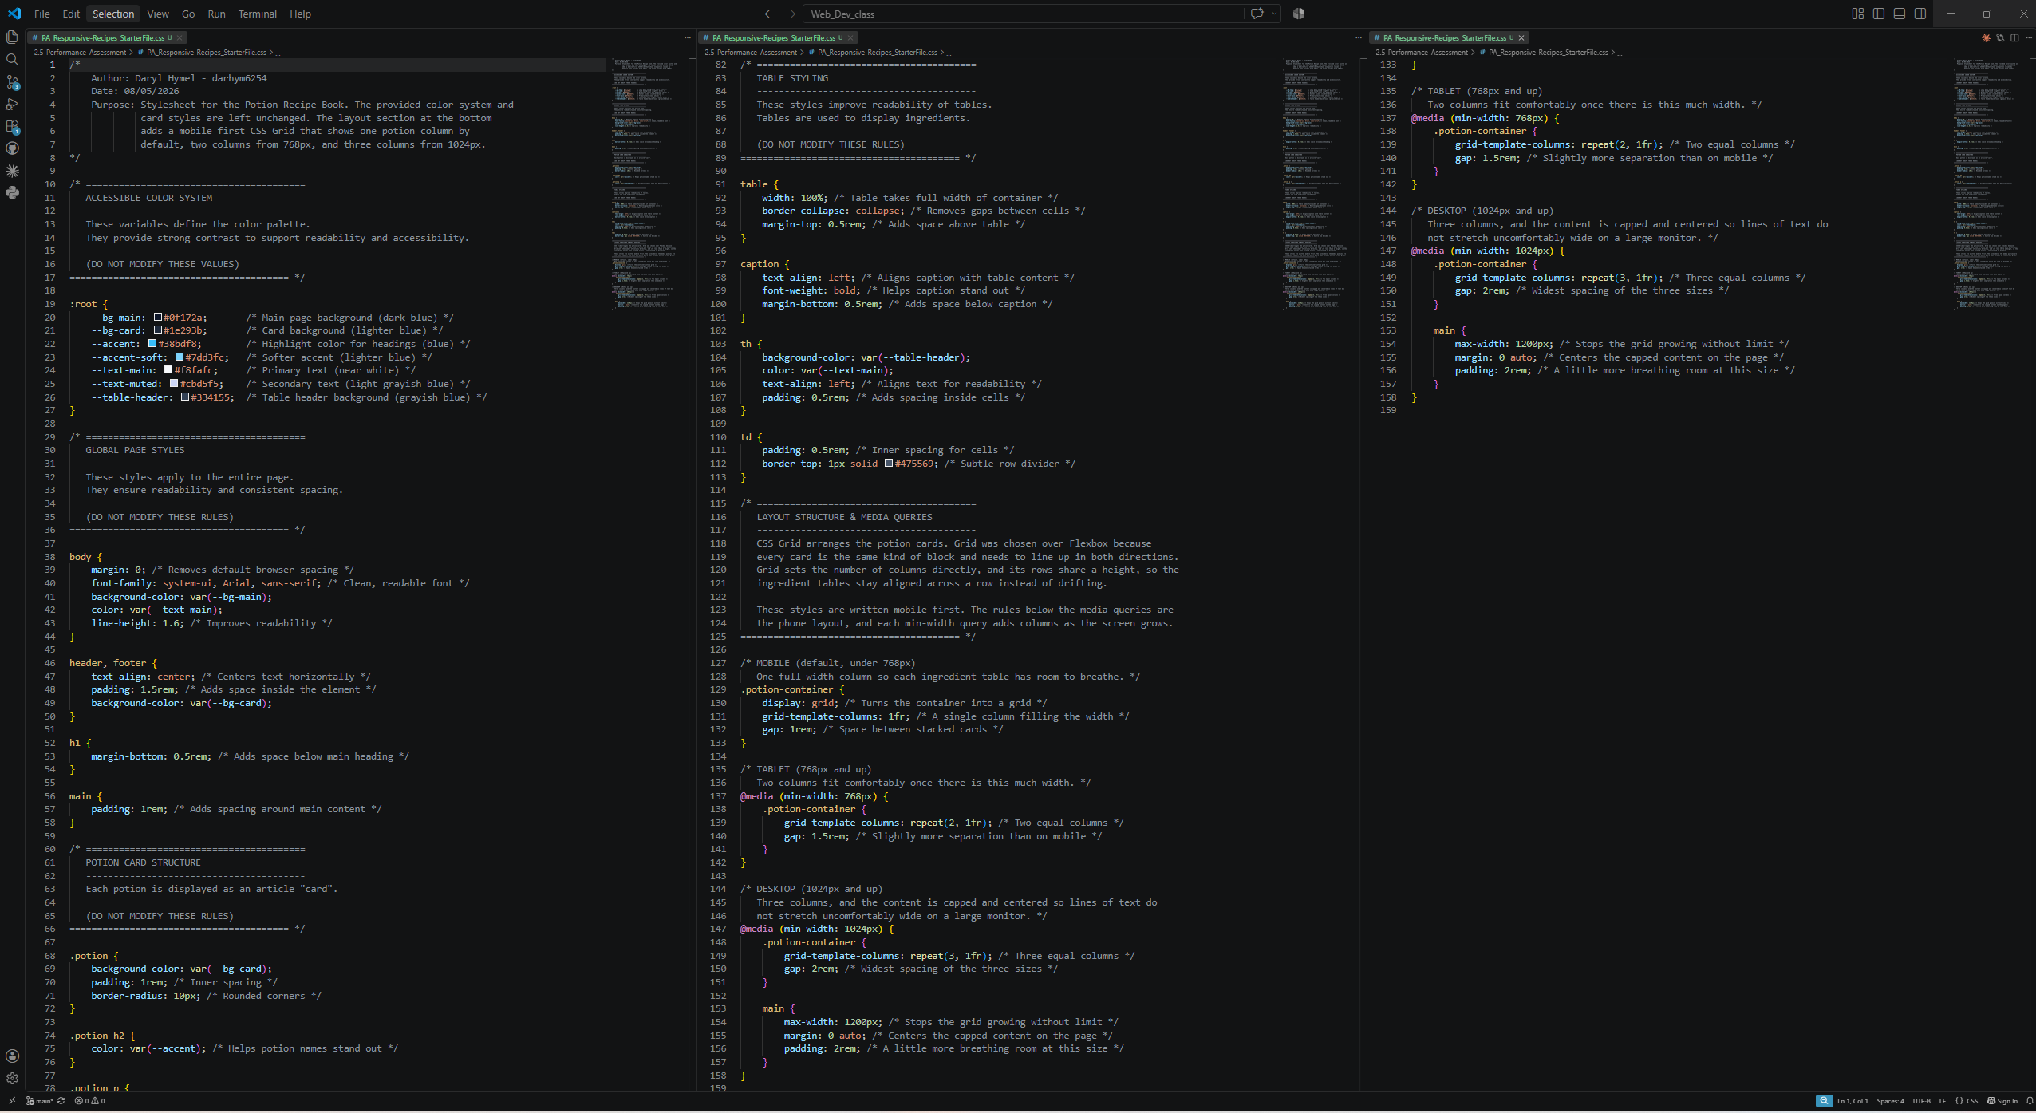

Rendered Web Page Evidence
Insert screenshots of the completed web page as it appears in your browser. Include evidence that the page adjusts for mobile, tablet, and desktop screen sizes.

Screenshot 3: Mobile/Small Windowed Layout
Paste your screenshot below this line:
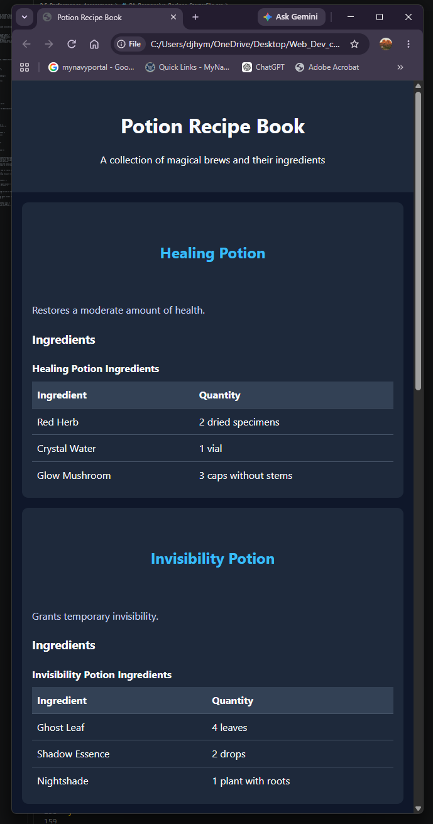

Screenshot 4: Tablet/Medium Windowed Layout
Paste your screenshot below this line:
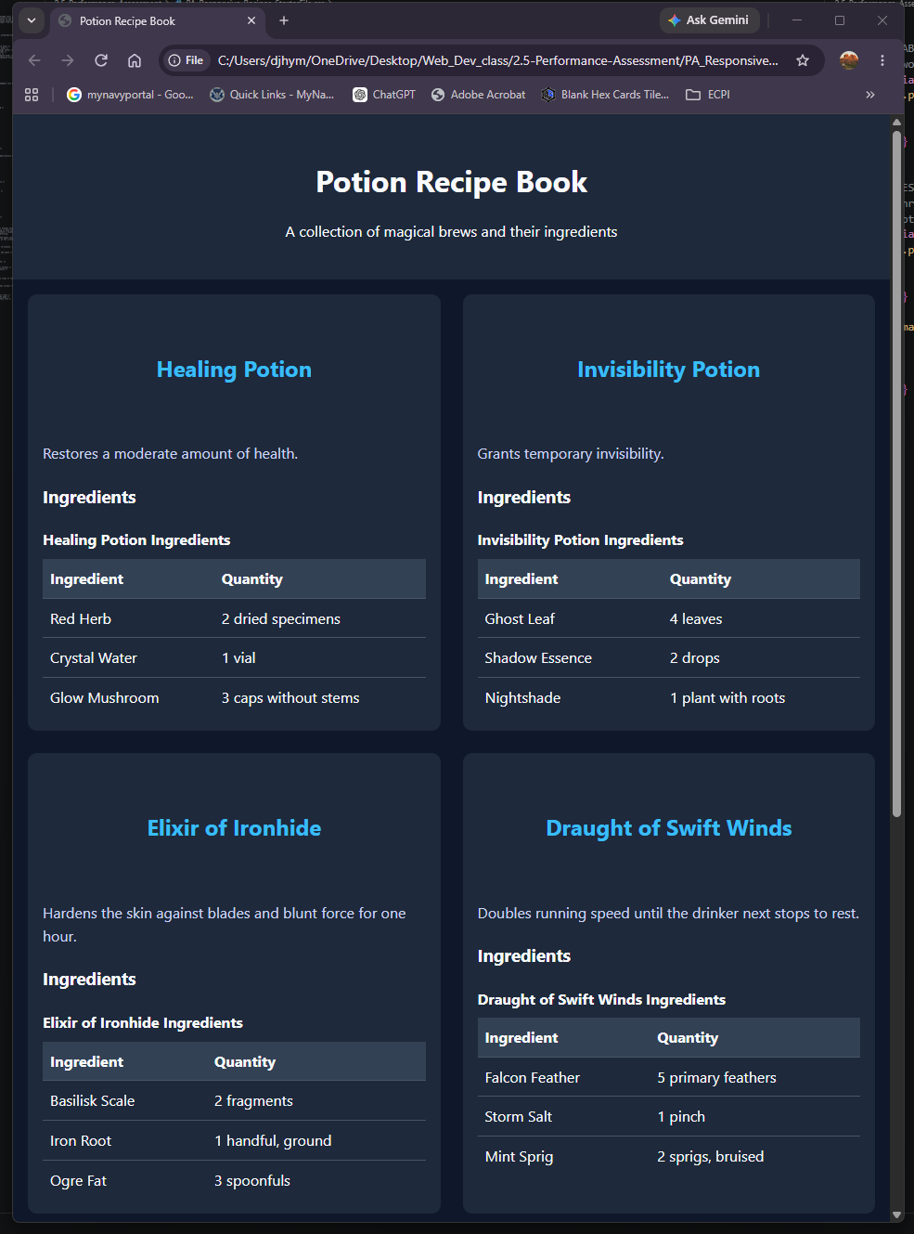

Screenshot 6: Desktop/Fullscreen Layout
Paste your screenshot below this line:
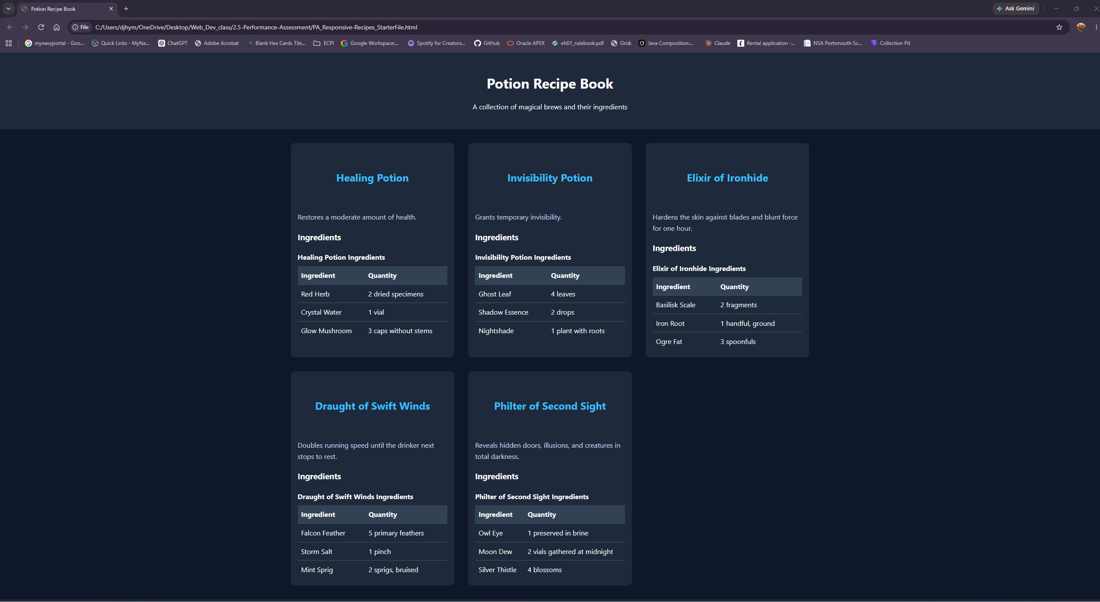

Reflection
In 2-3 sentences, answer the reflection questions below.
1. What was the most challenging part of making the recipe page responsive?
The hardest part was adjusting to a mobile-first approach. Since min-width breakpoints build from the phone layout upward, it felt backward at first. Once I understood it, the process became easier because each breakpoint only adds changes for larger screens instead of fixing a desktop layout for smaller ones.
2. What would you improve about the page if you had more time?
I would improve the ingredient tables for very small screens, add a filter for specific ingredients, and use repeat(auto-fit, minmax()) so the grid can choose the number of columns automatically instead of relying on fixed breakpoints.

