
Bucharest University of Economic Studies
Faculty of Cybernetics, Statistics and Economic Informatics
Specialization: Economic Informatics (in English)

BACHELOR’S THESIS

Coordinator:
Conf. univ. dr. Mihai DOINEA

Graduate:
Daria-Elena TOMA

Bucharest
2026

Bucharest University of Economic Studies
Faculty of Cybernetics, Statistics and Economic Informatics
Specialization: Economic Informatics (in English)

An Intelligent Mobile Diary App – A Mobile App for Activity Logging and Narrative Generation

BACHELOR’S THESIS

Coordinator:
Conf. univ. dr. Mihai DOINEA

Graduate:
Daria-Elena TOMA

Bucharest
2026
Contents

CHAPTER I. INTRODUCTION
For most people, going on a trip is associated with taking a break from their regular routine which, over time, can become quite stressful and repetitive. Taking into consideration each individual’s own character or likings, vacations can be seen as either the exploration of a new culture or part of the world, driven by curiosity, or they can be perceived as a way of complete relaxation, where no one must worry about anything. In any case, I think capturing these moments is important for everyone.
In the last years, phones have evolved from just a way of communication to a multifunctional device that almost anyone carries with them. One essential functionality is capturing moments through images or videos.
In the context of a vacation, people usually take a lot of photos which are a nice memory for when they get back, after some time passes. The problem is that pictures can become “lost” inside the Gallery app, and creating subfolders for many items can turn into a tiring and meticulous task. I myself have been faced with this problem many times.
Given this, and combined with my own tendency to create and capture memories in a beautiful and tidy way, either by taking a lot of pictures when I am somewhere I don’t get the chance to be anytime I want or by writing my own thoughts, I have come up with the theme of my thesis, which is an Android-based Application that captures these media items (pictures, videos, or audio) in the time interval that the user sets, and which stores them in customizable and individual “diary” pages. In addition to this, each item comes with a notes section, giving the user the option to elaborate on a certain part of the trip, either on their own or with the help of AI-generated text. Another feature of the application is an automated to-do list for landmarks, which gets checked off whenever the user takes a photo at the chosen location.
In the practical sense, the application uses automated data capture through a foreground service that scans the device for new files every two minutes, while also collecting location points every 90 minutes and monitoring steps through the device’s built-in Step Sensor, with a fallback to GPS-estimated steps. Moreover, from the data persistence point of view, the app ensures data integrity via Room database and Internal Storage. Expanding the idea that the user involvement should be minimal, the user interface has an intuitive characteristic, allowing effortless browsing through chronologically ordered trip diaries.
From a theoretical perspective, the effectiveness of using generative AI to create a bridge between discrete media items and cohesive narrative diary entries and the impact of prompt engineering automated outputs were studied. Additionally, I tried exploring the optimization of background lifecycles in order to maintain continuous data collection while complying with mobile operating system’s battery and resource constraints; while also looking into the security implications of private storage and data sandboxing (the apps can’t communicate with each other). The foreground service survival on newer Android SDK restrictions is also something worth mentioning

  - Current state of research
While looking at the current apps built specifically for travel documentation, I have found 3 categories that are worth mentioning: automated location tracking apps, Gallery management and manual diary apps. Each category has its own advantages, since they are built to solve specific problems, specifically location tracking, organization of media, or journaling. For example, the Day One [1] diary app has highly customizable features, allowing users to manually add photos, location or text templates. On the other hand, it requires meticulous manual entry. Apps like Polarsteps [2] give user the possibility to capture routes automatically, but again, adding other media is done by the user instead of it being automatic.

Taking this into consideration, while also thinking about my own journeys, I have found that developing an app that combines all those three categories into one and which seems simple on the surface, but essentially does all the work in background would be an interesting idea that could become helpful to travellers, who would not have to worry about manually adding certain photos to a diary or organize them in certain ways, but to be able to just focus on enjoying their trips and be present, leaving all the work to the app itself. To take it even further, the narrative generation using the Gemini Flash [3] model, the app not only stores data and organizes it, it also interprets it, highlighting the undemanding nature of the app.
+Service persistence
Dissertation Structure

CHAPTER II. AUTOMATED ACTIVITY TRACKING AND NARRATIVE GENERATION

  - Problem Addressed by Voy (Information Fragmentation, siloed data, semantic gap)

- Android file systemmedia + telemetry
- Android security model preventing different apps from talking to eachother
- Semantic gap: if the user logs during the trip vs when they get home-memory decay
- Otjher apps
- Evolution of automated narrative generation
- Ambient intelligence
1.1.1 Application Sandbox
Android is a widely used Operating System based on Linux, developed primarily for smartphones and tablets. Initially, Android was supposed to become an advanced operating system for digital cameras. However, in 2005 it was bought by Google, highlighting its entry into the rapidly growing smartphone market. Due to this, most devices use a version that delivers additional closed-source software, primarily Google Mobile Services [4] , containing apps like Google Chrome or Google Pay.
Android seeks to provide security to its user’s data, system resources, and to isolate app data from the system and other apps. This is done through the security system at the Linux Kernel level, app-defined and user-granted permissions, and mandatory app sandbox.
The Application Sandbox [5] represents the process of isolating apps from each other and the system by assigning a unique user-ID (UID) to each Android app. Prior to Android 4.3 version, the sandboxes were defined through this UID.
Starting from version Android 4.3, Security-Enhanced Linux (SELinux) [6] has been used to provide even further security, by enforcing mandatory access control (MAC) [7] over all processes. SELinux can operate in two modes: Enforcing, where permission denials are logged and enforced and Permissive, where permission denials are logged but not enforced.
Starting from Android 5.0, SELinux has been in enforcing mode on all domains (over 60). This means that a central policy decides access and no process can override it and anything not explicitly permitted is denied.
1.1.2 Application storage
By default, the system provides two main locations where apps can store their files: Internal Storage and External Storage. The internal storage provides locations for persistent data and for cache data. Other apps are not allowed to reach these files. The external storage also has these directories, which can be accessed by apps with the right permissions, although if the app has files which are specified to be used by other apps, they should be stored in the shared storage of the external storage.
In the context of a digital travel journal, multimedia items represent the core, but they are not the only parts that should be present in one. For example, location points or certain perspectives raised by them become just as important as the captured media itself.
In Android, Multimedia files (images, video, audio) are stored in dedicated folders in shared storage. This implies that other authorized applications such as the Gallery can access these files without bypassing Android’s sandboxing system. Location, on the other hand, is temporarily stored in volatile memory or application cache, becoming lost or overwritten after some time.
Due to the dissimilarity of the storage location of these puzzle pieces of the journal, the user gets scattered data across the device, impossible to assemble into one element.

1.1.3 Interaction Fatigue
In the context of Human-Computer Interaction (HCI), Interaction Fatigue is represented by the physical and psychological exhaustion felt by an individual expected to perform repetitive actions to achieve a result. Expecting a traveller to manually enter data, which usually presents itself in a large number, shifts their state from immersion to administration, meaning instead of them being fully involved in the present moment, enjoying and observing their surroundings, state heavily triggered by traveling, the user is forced to detach and focus instead of data collection.
In contrast, if the logging is delayed, the user falls victim to memory degradation: the emotional context is forgotten, precise timeline is distorted, data remains, but its semantic meaning deteriorates.
2.2 SEMANTIC GAP
The semantic gap represents the difference between how a computer processes data and how that data is perceived by humans. While humans instinctively apply a subjective approach to things they perceive, thus being able to give meaning to them, computers process data strictly through mathematical and logical rules established beforehand. For example, a picture can become a very important memory, while the computer only sees pixels.

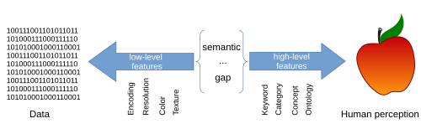
Figure 1.Semantic Gap -https://en.wikipedia.org/wiki/Semantic_gap

Taking into consideration the exponential evolution of technology in the last decade, mobile phones advancements have led to the materialization of numerous applications that aid users in their daily tasks, such as payments, location tracking, phone calls or messages. From a technological perspective, these apps have been curated to do their job perfectly. But in the context of preserving memories, while also considering the emotional importance of captured media stored in a phone, this data can become scattered across the device and lost through thousands of other items.
This highlights even further the bridge between raw data and its semantic value. Initially, filling this gap was done through hardcoded string templates (e.g. “You visited location X, at time Y”), but the problem was they lacked contextual elasticity and they had no emotional depth.
2.2.1 The evolution of Automated Narrative Generation
Artificial Intelligence represents the technology which allows computers to simulate human behaviour.
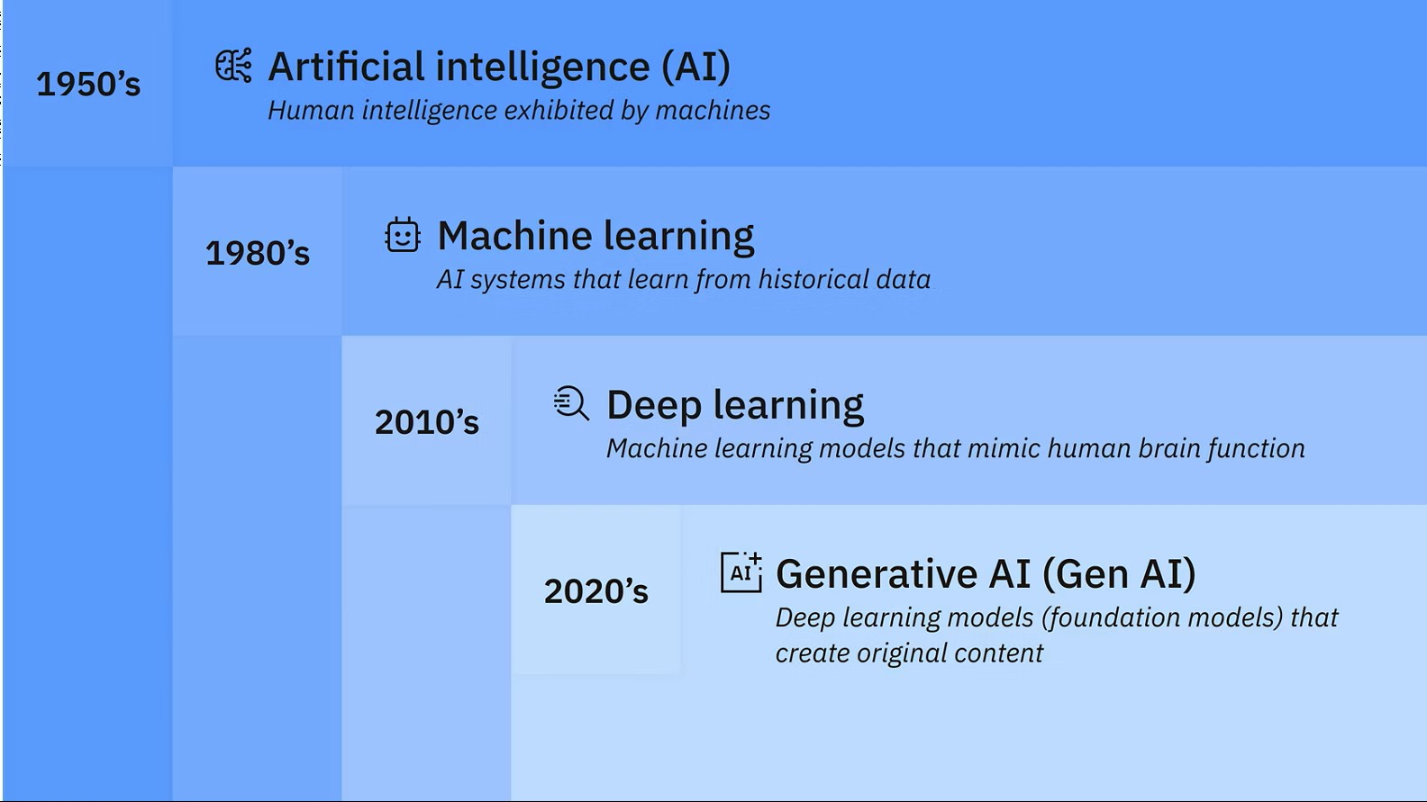
Figure 2.Artificial Intelligence History -https://www.ibm.com/think/topics/artificial-intelligence?

This field of technology officially started in 1956, at a summer conference in Dartmouth College, Hanover, New Hampshire, where Logic Theorist [8] was first introduced by Allen Newell, Herbert A. Simon and Cliff Shaw. Logic Theorist was a computer program designed to solve mathematical problems, using human-like heuristics instead of strict algorithms, being the first one to mimic human behaviour in problem solving. As a result, it solved 38 out of the first 52 theorems in Principia Mathematica [9] , one solution proving to be even shorter than the one Whitehead and Russel proposed.
A significant breakthrough occurred when Machine Learning models were introduced and notably Deep Learning, a subset of Machine Learning which uses multi-layered artificial neural networks to mimic the human way of processing information. The first model built based on neural networks was done by Frank Rosenblatt in 1967, called Mark 1 Perceptron.
Over time, these advancements have led to the rise of Generative AI, capable of formulating text, constructing images, videos or audio files and many more based on multi modal inputs, unlike traditional models, trained mostly for predictions or classifications.
This shift is highlighted by Large Language Models (LLM) [10], neural networks built on massive text corpora with the primary purpose of language generation.
Included in the innovations brought by this shift is the ability to synthesize multimedia elements into valid prose, which can be associated with human-written journal entries.
2.3 PROJECT MOTIVATION
Ever since I was a kid, I have always been a very sensitive person. This manifested through writing a lot of things in one of my many journals and one of the main reasons I did this was to not let myself forget something I then found it touched me. I still remember the night before I turned 12, I was very agitated and started writing how I don’t want to become unlucky that year, with 11 being my lucky number. I have kept that notebook since then. This need to preserve memories has stuck with me until the present days, and although I don’t really write as much as I would like now, I have found other ways to conserve these experiences, and they mostly include my phone: either taking pictures, notes, texting friends. Some would argue that people are becoming more and more dependent on their mobile devices, and while I do not deny it, I believe that they can still be used in a constructive way.
Of course, when travelling, I am compelled to take a lot of pictures and videos, maybe even more than necessary. But I am always bumping into the same problem. I don’t really have a way of managing all these memories and there is no way for me to attribute my thoughts to them, at least not in the way I would do in a regular journal. When I get back from trips, the same thing always happens, the photos get lost in the Gallery, notes pile up in my phone, and the location is not even tracked.
Over time, I have tried different market solutions. I tried apps specifically built for journaling, including Day One, but they require manual input, and on the surface level I am okay with that, but introducing them during the trip feels like a task and it takes away from the need to be present in the moment, and leaving the task to when I get back small details are already forgotten. On the other hand, keeping everything in their designated apps does not feel like a good way to store a trip’s data, or at least it isn’t my preferred way.
2.4 Background Solution

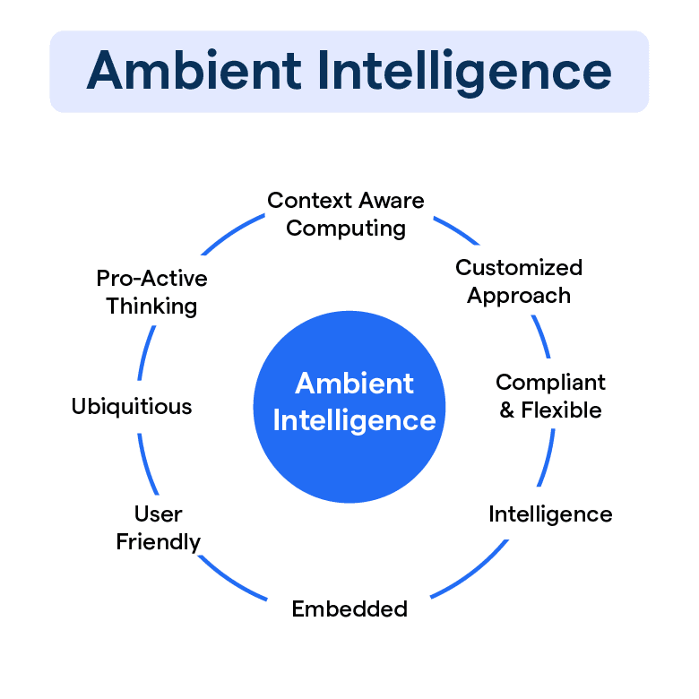
Figure 3. Ambient Intelligence Characteristics - https://botpenguin.com/glossary/ambient-intelligence
Ambient Intelligence [11] is the concept of an environment made of electronic devices aware of the presence of humans and which adapts to this presence. This concept shifts the user interaction from explicit to implicit, meaning the volume of direct user interaction decreases significantly, and the digital system becomes sensitive to the context of users in the environment.
From this point of view, mobile software has evolved in such a way that it contains exceptional capabilities: biometric chips, continuous location tracking, persistent background processing units. However, the consumer application layer is still largely based on manual input.
This becomes the main problem addressed by this thesis: preserving siloed data into one unified diary page, with minimal user input, while also providing tools to turn this into an actual journal, giving the possibility to add notes to each item, associating it with its own story. In the context of travelling, this could be even further amplified by an automated to do list, allowing the user to focus on the moment, rather than organizing captured media or checking off a list.

CHAPTER II. TECHNOLOGIES USED
2.1 Coding environment
The application is structured around long-running background processes which generate continuous data flows. These outputs are then managed by the data persistence layer and therefore rendered by the user interface layer.
For the implementation of the solution, I used Android Studio IDE, the official Integrated Development Environment for Android applications. The first stable version was released in 2014. It was the best choice for the implementation of the solution due to the high efficiency provided by the flexible build system, used to automate the compilation process, the integrated emulator, which simulates a wide range of devices, providing fast testing, and the native support for Jetpack Compose and XML files. Android Studio also provides a native integration for Android SDK, which implies access to the latest API’s or libraries.
The programming language chosen was Java, despite Kotlin being the official recommended language by Android. This choice was motivated by its Object-Oriented design, suitable for implementing the application’s core features and by my familiarity with it, being one of the studied languages in university.
Version control
Another helpful tool I chose for this project is Git, released in 2005 by Linus Torvalds, initially build for version control of the Linux kernel. This helped me manage the source code by tracking every change done to the application. The development process became safer, especially through the ability to revert the project to a previous state whenever new modifications generated errors or unexpected behaviour. In addition to this, I also used GitHub to upload the source code to a remote repository.
For the user login process, the application uses Firebase Authentication, a cloud-based service provided by Google. This provides secure credential management, while reducing the development phase.
The data persistence architecture was built through the Room Persistence Library, which provides an abstraction layer over SQLite databases. The three main components of this architecture are the database, which is the primary access point for the app’s persisted data, the entities and the Data Access Objects (DAO), classes annotated with @Dao which contain methods for accessing the database. For the instantiation of the database the Singleton Pattern was implemented, a creational design pattern which in this context restricts the instantiation to a single, globally accessible object. This was done because instantiating a database is one of the most expensive operations in a mobile app, involving memory allocation and thread coordination. The database repository manages all DAOs, bridging the gap between the application logic and the database. For reading the database, this repository uses LiveData, which is an observable that automatically notifies the user interface when there are changes to the database, for example, when a new trip is created and inserted into the database. On the other hand, writing operations (for example: INSERT, UPDATE, DELETE) are done on a background thread through an ExecutorService, preventing these operations from blocking the User Interface thread.
In order to represent the geographic data visually, the application implements the Google Static Maps API, which inserts a non-interactive image directly into the app via standard HTTP requests. The security of the key was done through the Google Cloud Console, restricting it to the specific application package to prevent non-authorized usage.
For the automation of the landmark checklist, the application communicates with Overpass API, which transforms user input data into exact geographic coordinates, through an asynchronous network query, which filters nodes, ways and relations mapped with their English name and indexed in the web repository Wikidata. This process is done entirely on a background thread, isolating the network processing overhead from the user interface operations (Main UI Thread).
PROCESS PRIORITY
An Android service is a component of the application that performs operations in the background without providing a user interface. A service can belong to one of three categories: Foreground, Background, or Bound. Despite the intuitive definition, a service does not run on a different thread unless explicitly told to do so. From the Linux Kernel perspective, these services are organized into a strict hierarchy. Classic Background services have a low priority, meaning that whenever the device deals with low memory, the Low Memory Killer scans these processes and targets the least important ones, terminating these background services.
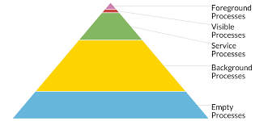
Figure 4. Process Priority in Android - https://medium.com/androiddevelopers/who-lives-and-who-dies-process-priorities-on-android-cb151f39044f

To ensure that this doesn’t happen, choosing a Foreground service instead of the standard Background service is imperative. Due to the mandatory persistent notification, the system considers that the user is actively aware of it and thus elevates its priority to the level of a visible activity.
In the application, the foreground service was initialized through the mandatory startForeground() method, which associates the service with a non-dismissible notification and allows the continuity of the long-running operations such as media scanning or location tracking for a trip.
Another feature of the application which tries to ensure the continuity of the service is the implementation of Shared Preferences, which is a way of storing in a file low amount of data in key-value pairs. By using this API, essential information, stored at the beginning of every trip, like trip state (ACTIVE or FINISHED), user or trip id, the start time of the trip, or the time of the media last scan are stored, which allows the application to rebuild a session unexpectedly killed by the OS.
MVMV

