mkdir restler_bin

git clone <https://github.com/microsoft/restler-fuzzer.git>

python3 ./build-restler.py --dest_dir <Full Path for restler_bin dir>

cd <Path to restler-fuzzer dir>

python3 restler-quick-start.py --api_spec_path <Full path to openapi.yml> --restler_drop_dir <Full path to restler_bin dir>

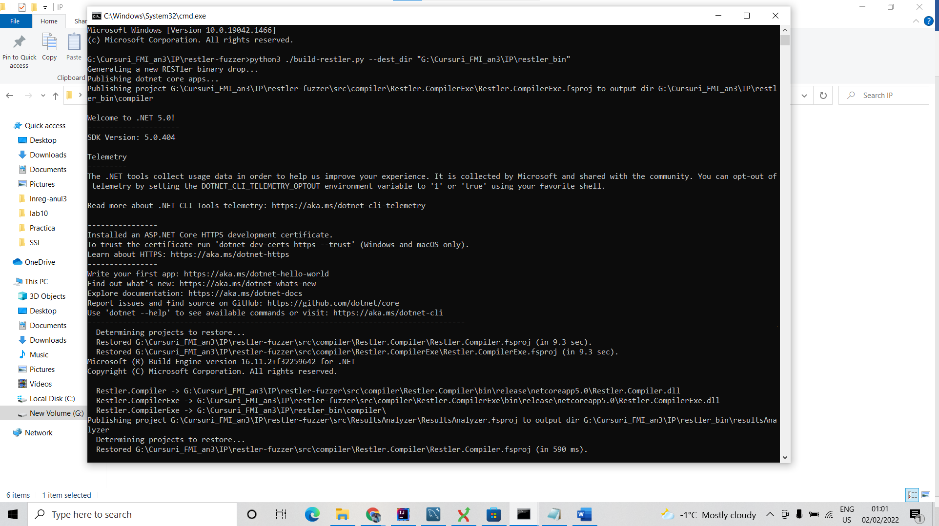

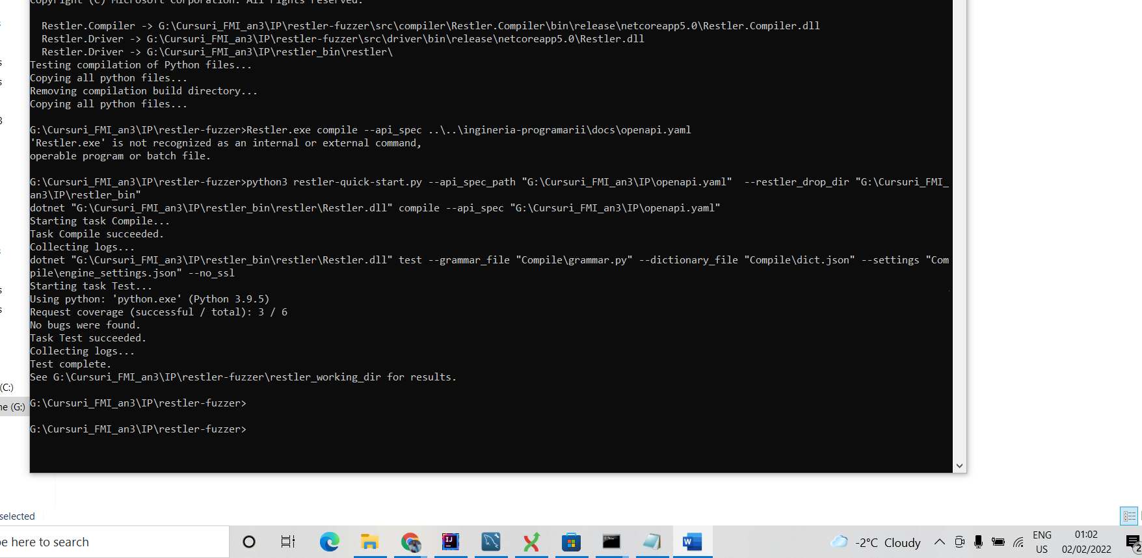

G:\Cursuri_FMI_an3\IP\restler-fuzzer>>>

python3 restler-quick-start.py --api_spec_path "G:\Cursuri_FMI_an3\IP\openapi.yaml" --restler_drop_dir "G:\Cursuri_FMI_an3\IP\restler_bin"

>>>

G:\Cursuri_FMI_an3\IP\restler-fuzzer>python3 restler-quick-start.py --api_spec_path "G:\Cursuri_FMI_an3\IP\openapi.yaml" --restler_drop_dir "G:\Cursuri_FMI_an3\IP\restler_bin"

dotnet "G:\Cursuri_FMI_an3\IP\restler_bin\restler\Restler.dll" compile --api_spec "G:\Cursuri_FMI_an3\IP\openapi.yaml"

Starting task Compile...

Task Compile succeeded.

Collecting logs...

dotnet "G:\Cursuri_FMI_an3\IP\restler_bin\restler\Restler.dll" test --grammar_file "Compile\grammar.py" --dictionary_file "Compile\dict.json" --settings "Compile\engine_settings.json" --no_ssl

Starting task Test...

Using python: 'python.exe' (Python 3.9.5)

Request coverage (successful / total): 3 / 6

No bugs were found.

Task Test succeeded.

Collecting logs...

Test complete.

See G:\Cursuri_FMI_an3\IP\restler-fuzzer\restler_working_dir for results.