Q2 –Yixin

* + Whether we should make longer or shorter movie?
    - It depends on the object – to maximize profit? Or to increase rating, thus improve reputation, which will bring us benefits in the long run?
    - It also depends on the movie genre.
    - The graph below shows the 1) correlation coefficient between runtime and profit, 2) correlation coefficient between runtime and rating of difference 3) genre. 4) The size of the dots correlates the number of observations of each genre. The larger size, the more reliable the conclusion.

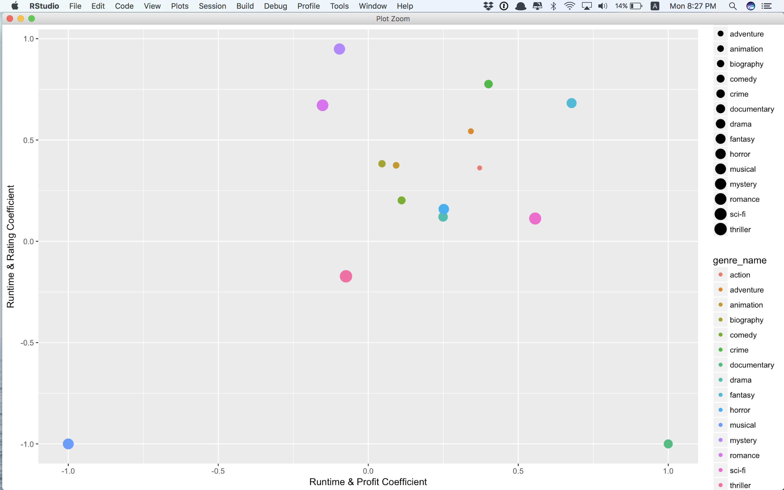

**1**

**2**

**3**

**4**

|  |  |  |  |  |
| --- | --- | --- | --- | --- |
|  | ***genre name*** | ***time rating*** | ***time profit*** | ***type*** |
| **1** | action | 0.36 | 0.37 | 1 |
| **2** | adventure | 0.54 | 0.34 | 1 |
| **3** | animation | 0.38 | 0.09 | 1 |
| **4** | biography | 0.38 | 0.05 | 1 |
| **5** | comedy | 0.2 | 0.11 | 1 |
| **6** | crime | 0.78 | 0.4 | 1 |
| **8** | drama | 0.12 | 0.25 | 1 |
| **9** | fantasy | 0.68 | 0.68 | 1 |
| **10** | horror | 0.16 | 0.25 | 1 |
| **14** | sci-fi | 0.11 | 0.56 | 1 |
| **12** | mystery | 0.95 | -0.1 | 2 |
| **13** | romance | 0.67 | -0.15 | 2 |
| **7** | documentary | -1 | 1 | 3 |
| **11** | musical | -1 | -1 | 4 |
| **15** | thriller | -0.17 | -0.07 | 4 |

* + Zone 1: runtime has consistent and positive effects on both revenue and rating
    - E.g. for fantasy movie, long runtime benefits for both revenue and rating.
  + Zone 4: runtime has consistent and negative effects on both profit and rating
    - E.g. For thriller genre, long runtime hurts both rating and profit.
  + Zone 2: runtime has positive effects on profits but negative effects on rating
    - E.g for romance movie, long runtime results in higher rating, but it kind of hurt profit.
  + Zone 3: runtime has negative effects on profits but positive effects on rating
    - E.g. for documentary movie, long runtime brings profits, but it hurts rating.
* Ps: I decided not to put examples here because for single cases, it’s hard to convince the audience that the difference of rating/profit is resulted by runtime.