Proiect SGBD

Baze de date – Gări România

-Mechie Daria-Elena

-grupa 241

1)Prezentati pe scurt baza de date.

Această bază de date va gestiona gările din România, respectiv toate călătoriile interne. Fiecare oraș are o gară, orașele aparținând unei regiuni. Fiecare gară are angajații săi. Sunt angajați șoferii(sau „mecanicii de locomotivă”), șefii de tren și care vor reprezenta echipajul necesar unei călătorii. Un șofer și șefii de tren pot fi angajați unei singure companii de transport pe șine, iar o companie deține diferite modele de trenuri. Gările nu dețin propriile trenuri, așadar nu există nicio legătură între acestea, decât chiria plătită de companii pentru a-și desfășura activitatea în gara respectivă.

Pasagerii pot să-și rezerve locuri în diferite clase la care doresc să călătorească. Prețul biletelor diferă de la o clasă la alta. Informațiile pe care călătorii le vor cunoaște sunt următoarele: gara de la locul plecării, gara de la locul sosirii, trenul condus, data și ora plecării, respectiv sosirii.

2) Diagrama entitate-relație ERD

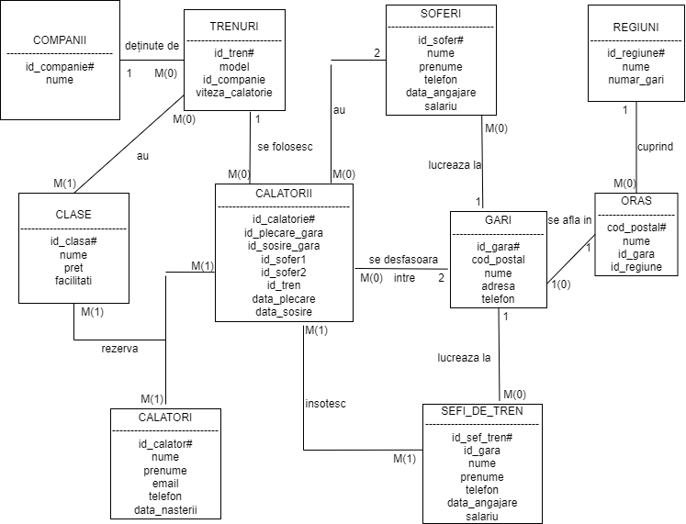

3) Diagrama conceptuală

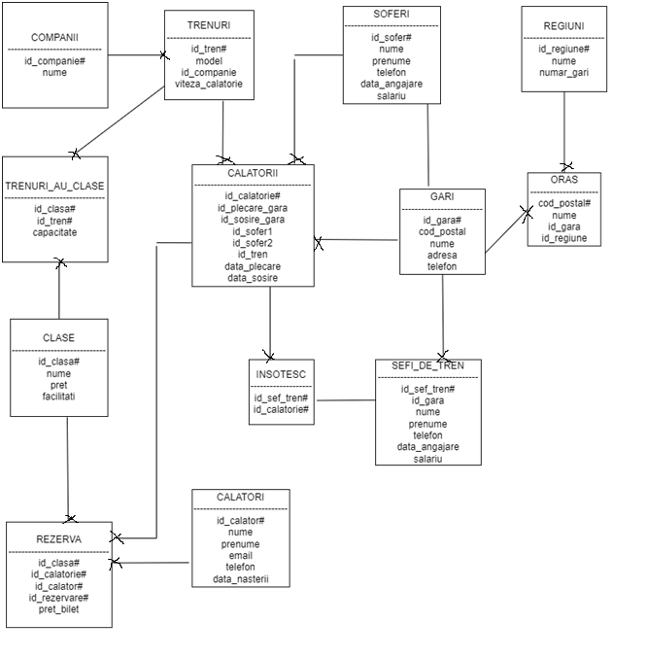

4)Implementarea diagramei conceptuale in Oracle

--cream tabelele din diagrama conceptuala

create table COMPANII

(id_companie number(4) CONSTRAINT companii_pk PRIMARY KEY,

nume varchar2(30) NOT NULL);

create table TRENURI

(id_tren number(4) CONSTRAINT trenuri_pk PRIMARY KEY,

model varchar2(30) NOT NULL,

id_companie number(4) NOT NULL,

capacitate number(3),

viteza_calatorie number(4));

create table GARI

(id_gara varchar2(3) CONSTRAINT gari_pk PRIMARY KEY,

cod_postal varchar2(6) NOT NULL,

nume varchar2(55) NOT NULL,

adresa varchar2(50),

telefon varchar2(10));

create table SOFERI

(id_sofer number(4) CONSTRAINT soferi_pk PRIMARY KEY,

id_gara varchar2(3),

nume varchar2(30) NOT NULL,

prenume varchar2(30),

telefon varchar2(10) NOT NULL,

data_angajare date DEFAULT sysdate,

salariu number(6),

CONSTRAINT soferi_gara_fk FOREIGN KEY(id_gara)

REFERENCES GARI(id_gara));

create table REGIUNI

(id_regiune varchar2(3) CONSTRAINT regiuni_pk PRIMARY KEY,

nume varchar2(15) NOT NULL,

numar_gari number(2));

create table ORAS

(cod_postal varchar2(6) CONSTRAINT oras_pk PRIMARY KEY,

nume varchar2(15) NOT NULL,

id_gara varchar2(3),

id_regiune varchar2(3));

create table SEFI_DE_TREN

(id_sef_tren number(4) CONSTRAINT sef_tren_pk PRIMARY KEY,

id_gara varchar2(3),

nume varchar2(30) NOT NULL,

prenume varchar2(30),

telefon varchar2(10) NOT NULL,

data_angajare date DEFAULT sysdate,

salariu number(6),

CONSTRAINT sef_tren_gara_fk FOREIGN KEY(id_gara)

REFERENCES GARI(id_gara));

create table CLASE

(id_clasa number(2) CONSTRAINT clase_pk PRIMARY KEY,

nume varchar2(20) NOT NULL,

pret number(4),

facilitati varchar2(60));

CREATE TABLE CALATORI

(id_calator number(6) CONSTRAINT calatori_pk PRIMARY KEY,

nume varchar2(30) NOT NULL,

prenume varchar2(30),

email varchar2(30),

telefon varchar2(10) NOT NULL,

data_nasterii date);

CREATE TABLE CALATORII

(id_calatorie number(6) CONSTRAINT calatorii_pk PRIMARY KEY,

id_plecare_gara varchar2(3) NOT NULL,

id_sosire_gara varchar2(3) NOT NULL,

id_sofer1 number(4) NOT NULL,

id_sofer2 number(4) NOT NULL,

id_tren number(4) NOT NULL,

data_plecare date,

data_sosire date,

CONSTRAINT calatorii_gara_fk1 FOREIGN KEY(id_plecare_gara)

REFERENCES GARI(id_gara),

CONSTRAINT calatorii_gara_fk2 FOREIGN KEY(id_sosire_gara)

REFERENCES GARI(id_gara),

CONSTRAINT calatorii_soferi_fk1 FOREIGN KEY(id_sofer1)

REFERENCES SOFERI(id_sofer),

CONSTRAINT calatorii_soferi_fk2 FOREIGN KEY(id_sofer2)

REFERENCES SOFERI(id_sofer),

CONSTRAINT valid_data_sosire CHECK(data_sosire > data_plecare),

CONSTRAINT distinct_gara CHECK (id_plecare_gara != id_sosire_gara),

CONSTRAINT distinct_sofer CHECK (id_sofer1 != id_sofer2)

);

--dupa ce am creat tabelul ORASE, marcam cheia externa in GARI

ALTER TABLE GARI

ADD CONSTRAINT gari_orase_fk FOREIGN KEY(cod_postal)

REFERENCES ORAS(cod_postal);

--odata creat tabelul TRENURI , marcam cheia externa in CALATORII

ALTER TABLE CALATORII

ADD CONSTRAINT calatorii_trenuri_fk FOREIGN KEY(id_tren)

REFERENCES TRENURI(id_tren);

--odata creat tabelul TRENURI , marcam cheia externa din CALATORII in TRENURI

ALTER TABLE TRENURI

ADD CONSTRAINT trenuri_companii_fk FOREIGN KEY(id_companie)

REFERENCES COMPANII(id_companie);

CREATE TABLE TRENURI_AU_CLASE

(id_clasa number(2),

id_tren number(4),

capacitate number(3),

CONSTRAINT trenuri_au_clase_clase_fk FOREIGN KEY(id_clasa)

REFERENCES CLASE(id_clasa),

CONSTRAINT trenuri_au_clase_trenuri_fk FOREIGN KEY(id_tren)

REFERENCES TRENURI(id_tren),

CONSTRAINT trenuri_au_clase_pk PRIMARY KEY(id_clasa, id_tren));

CREATE TABLE REZERVA

(id_clasa number(2),

id_calatorie number(6),

id_calator number(6),

id_rezervare number(8),

pret_bilet number(4),

CONSTRAINT rezerva_clase_fk FOREIGN KEY(id_clasa)

REFERENCES CLASE(id_clasa),

CONSTRAINT rezerva_calatorii_fk FOREIGN KEY(id_calatorie)

REFERENCES CALATORII(id_calatorie),

CONSTRAINT rezerva_calatori_fk FOREIGN KEY(id_calator)

REFERENCES CALATORI(id_calator),

CONSTRAINT rezerva_pk PRIMARY KEY(id_clasa, id_calatorie, id_calator, id_rezervare));

--primary key in REZERVA

CREATE TABLE INSOTESC

(id_sef_tren number(4),

id_calatorie number(6),

CONSTRAINT insotesc_sef_tren_fk1 FOREIGN KEY(id_sef_tren)

REFERENCES SEFI_DE_TREN(id_sef_tren),

CONSTRAINT insotesc_calatorii_fk FOREIGN KEY(id_calatorie)

REFERENCES CALATORII(id_calatorie),

CONSTRAINT insotesc_pk PRIMARY KEY(id_sef_tren, id_calatorie));

5)Adaugarea informatiilor in tabelele create.

INSERT INTO REGIUNI

VALUES ('MUN', 'Muntenia', 1);

INSERT INTO REGIUNI

VALUES ('TRA', 'Transilvania', 2);

INSERT INTO REGIUNI

VALUES ('MOL', 'Moldova', 1);

INSERT INTO REGIUNI

VALUES ('DOB', 'Dobrogea', 1);

INSERT INTO REGIUNI

VALUES ('BAN', 'Banat', 1);

INSERT INTO REGIUNI

VALUES ('OLT', 'Oltenia', 1);

INSERT INTO REGIUNI

VALUES ('CRI', 'Crisana', 1);

INSERT INTO REGIUNI

VALUES ('MAR', 'Maramures', 0);

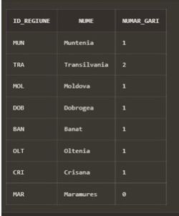

INSERT INTO ORAS

VALUES (010856, 'Bucuresti', 'BUC', 'MUN');

INSERT INTO ORAS

VALUES (500009, 'Brasov', 'BRV', 'TRA');

INSERT INTO ORAS

VALUES (700028, 'Iasi', 'IAS', 'MOL');

INSERT INTO ORAS

VALUES (900001, 'Constanta', 'CND', 'DOB');

INSERT INTO ORAS

VALUES (300013, 'Timisoara', 'TIM', 'BAN');

INSERT INTO ORAS

VALUES (310010, 'Arad', 'ARD', 'CRI');

INSERT INTO ORAS

VALUES (210235, 'Targu-Jiu', 'TGJ', 'OLT');

INSERT INTO ORAS

VALUES (331005, 'Hunedoara', 'HND', 'TRA');

INSERT INTO ORAS

VALUES (110001, 'Pitesti', NULL, 'MUN');

INSERT INTO ORAS

VALUES (530002, 'Miercurea-Ciuc', NULL, 'TRA');

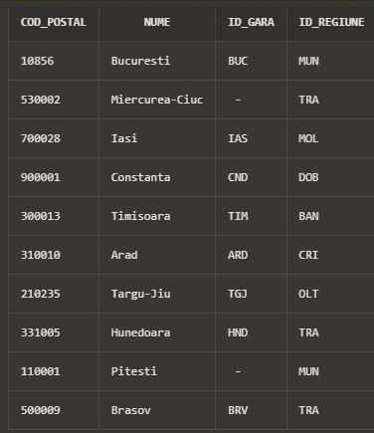

INSERT INTO GARI

VALUES('BUC', 010856, 'Gara de Nord Bucuresti', 'Strada Garii de Nord', '0353621448');

INSERT INTO GARI

VALUES('BRV', 500009, 'Gara din Brasov', 'Strada Mihai Eminescu 1-3', '0253698112');

INSERT INTO GARI

VALUES('IAS', 700028, 'Gara de la Iasi', 'Strada Andrei Neagu 67-69', '0252641203');

INSERT INTO GARI

VALUES('CND', 900001, 'Lucian Blaga train station', 'Strada Ovazului Dulce 15', '0247156893');

INSERT INTO GARI

VALUES('TIM', 300013, 'Aurel Vlaicu gara de sud', 'Strada Apusului 78', '0241587320');

INSERT INTO GARI

VALUES('ARD', 310010, 'Arad Gara Vest', 'Calea Popicelor Vesele', '0234567891');

INSERT INTO GARI

VALUES('TGJ', 210235, 'Gara din GORJ', 'Strada Republicii 27', '0764474671');

INSERT INTO GARI

VALUES('HND', 331005, 'Hunedoara train ', 'Soseaua Floare Albastra 16-22', '0798654175');

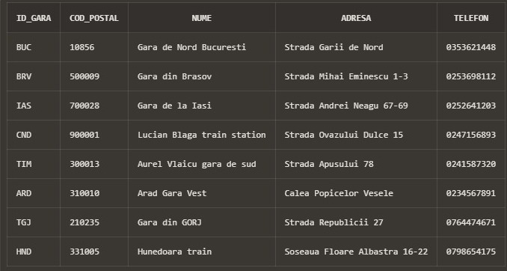

INSERT INTO SOFERI

VALUES (SEQ_SOFERI.NEXTVAL, 'BUC', 'Andreescu', 'Andrei', '0765448912', to_date('01-06-2017','DD-MM-YYYY'), 102300);

INSERT INTO SOFERI

VALUES (SEQ_SOFERI.NEXTVAL, 'BUC', 'Diaconu', 'Alex', '0746158799', to_date('20-08-2018','DD-MM-YYYY'), 140340);

INSERT INTO SOFERI

VALUES (SEQ_SOFERI.NEXTVAL, 'TIM', 'Popovici', 'Maria', '0713665284', to_date('27-02-2017','DD-MM-YYYY'), 600000);

INSERT INTO SOFERI

VALUES (SEQ_SOFERI.NEXTVAL, 'TIM', 'Haiduc', 'Luiza', '0771205664', to_date('16-09-2020','DD-MM-YYYY'), 308600);

INSERT INTO SOFERI

VALUES (SEQ_SOFERI.NEXTVAL, 'BRV', 'Adrianescu', 'David', '0786221540', to_date('30-11-2011','DD-MM-YYYY'), 401030);

INSERT INTO SOFERI

VALUES (SEQ_SOFERI.NEXTVAL, 'BRV', 'Minici', 'Marian', '0756332014', to_date('13-10-2015','DD-MM-YYYY'), 387510);

INSERT INTO SOFERI

VALUES (SEQ_SOFERI.NEXTVAL, 'BRV', 'Popescu', 'Razvan', '0253661479', to_date('30-05-2021','DD-MM-YYYY'), 275500);

INSERT INTO SOFERI

VALUES (SEQ_SOFERI.NEXTVAL, 'IAS', 'Cristescu', 'Iosif', '0714630175', to_date('21-02-2019','DD-MM-YYYY'), 250789);

INSERT INTO SOFERI

VALUES (SEQ_SOFERI.NEXTVAL, 'IAS', 'Mirea', 'Antonia', '0711247965', to_date('01-01-2015','DD-MM-YYYY'), 650990);

INSERT INTO SOFERI

VALUES (SEQ_SOFERI.NEXTVAL, 'CND', 'Paun', 'Robert', '0741226985', to_date('03-11-2019','DD-MM-YYYY'), 372999);

INSERT INTO SOFERI

VALUES (SEQ_SOFERI.NEXTVAL, 'CND', 'Aulescu', 'Matei', '0753210559', to_date('01-04-2022','DD-MM-YYYY'), 35000);

INSERT INTO SOFERI

VALUES (SEQ_SOFERI.NEXTVAL, 'CND', 'Aristid', 'Mihaela', '077232146', to_date('12-08-2021','DD-MM-YYYY'), 99999);

INSERT INTO SOFERI

VALUES (SEQ_SOFERI.NEXTVAL, 'TGJ', 'Ghita', 'Cosmin', '0792578600', to_date('21-07-2016','DD-MM-YYYY'), 500000);

INSERT INTO SOFERI

VALUES (SEQ_SOFERI.NEXTVAL, 'TGJ', 'Bonescu', 'Vlad', '0353621004', to_date('13-05-2011','DD-MM-YYYY'), 450770);

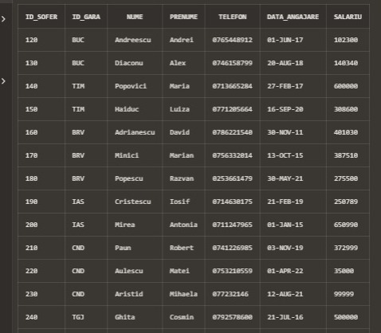

INSERT INTO SEFI_DE_TREN

VALUES (SEQ_SEFI_DE_TREN.NEXTVAL, 'BUC', 'Ionescu', 'Gabriela', '0745669823', to_date('20-12-2009','DD-MM-YYYY'), 80000);

INSERT INTO SEFI_DE_TREN

VALUES (SEQ_SEFI_DE_TREN.NEXTVAL, 'BUC', 'Marinescu', 'Stefania', '0703126445', to_date('30-08-2013','DD-MM-YYYY'), 80000);

INSERT INTO SEFI_DE_TREN

VALUES (SEQ_SEFI_DE_TREN.NEXTVAL, 'BUC', 'Usurelu', 'Horia', '0723665801', to_date('29-02-2018','DD-MM-YYYY'), 60000);

INSERT INTO SEFI_DE_TREN

VALUES (SEQ_SEFI_DE_TREN.NEXTVAL, 'BRV', 'Raducanu', 'Mihnea', '0765231002', to_date('23-05-2019','DD-MM-YYYY'), 80500);

INSERT INTO SEFI_DE_TREN

VALUES (SEQ_SEFI_DE_TREN.NEXTVAL, 'BRV', 'Avramescu', 'Antonela', '0713247889', to_date('24-02-2022','DD-MM-YYYY'), 15000);

INSERT INTO SEFI_DE_TREN

VALUES (SEQ_SEFI_DE_TREN.NEXTVAL, 'TIM', 'Danaricu', 'Radu', '0465322102', to_date('13-05-2019','DD-MM-YYYY'), 17000);

INSERT INTO SEFI_DE_TREN

VALUES (SEQ_SEFI_DE_TREN.NEXTVAL, 'TIM', 'Enescu', 'Florentiu', '0253620112', to_date('30-12-2014','DD-MM-YYYY'), 90000);

INSERT INTO SEFI_DE_TREN

VALUES (SEQ_SEFI_DE_TREN.NEXTVAL, 'IAS', 'Nedelcu', 'Aleandru', '0788654123', to_date('28-06-2020','DD-MM-YYYY'), 12000);

INSERT INTO SEFI_DE_TREN

VALUES (SEQ_SEFI_DE_TREN.NEXTVAL, 'IAS', 'Stoian', 'Traianis', '0735662147', to_date('07-07-2017','DD-MM-YYYY'), 3500);

INSERT INTO SEFI_DE_TREN

VALUES (SEQ_SEFI_DE_TREN.NEXTVAL, 'CND', 'Lemnaru', 'Anaisa', '0741223569', to_date('11-12-2020','DD-MM-YYYY'), 33999);

INSERT INTO SEFI_DE_TREN

VALUES (SEQ_SEFI_DE_TREN.NEXTVAL, 'CND', 'Cotiga', 'Camelia', '0700005925', to_date('10-10-2011','DD-MM-YYYY'), 85000);

INSERT INTO SEFI_DE_TREN

VALUES (SEQ_SEFI_DE_TREN.NEXTVAL, 'TGJ', 'Mechie', 'LEONARD', '0768320556', to_date('16-10-2009','DD-MM-YYYY'), 42000);

INSERT INTO SEFI_DE_TREN

VALUES (SEQ_SEFI_DE_TREN.NEXTVAL, 'HND', 'Vilceanu', 'Dragos', '0748326995', to_date('12-12-2012','DD-MM-YYYY'), 76000);

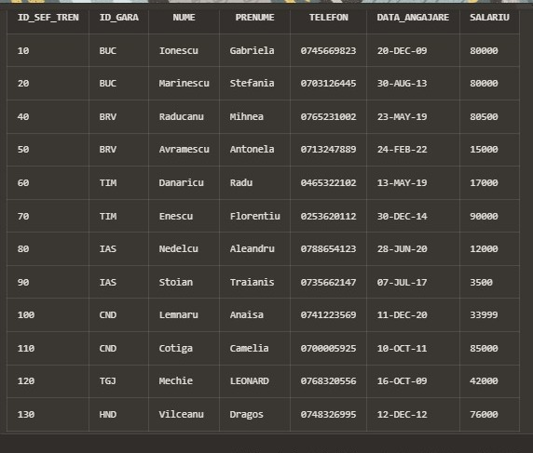

INSERT INTO COMPANII

VALUES (120, 'Softrans');

INSERT INTO COMPANII

VALUES (121, 'Regio Calatori');

INSERT INTO COMPANII

VALUES (122, 'Astra Trans Carpatic');

INSERT INTO COMPANII

VALUES (123, 'CFR');

INSERT INTO COMPANII

VALUES (124, 'Interrail');

INSERT INTO COMPANII

VALUES (125, 'InterRegional');

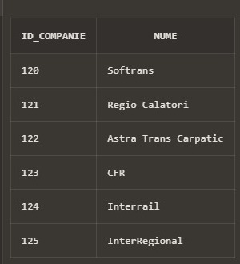

INSERT INTO TRENURI

VALUES (1000, 'ROCO_HO 2000', 120, 139, 200);

INSERT INTO TRENURI

VALUES (1001, 'MARKLIN-HO 123', 120, 150, 150);

INSERT INTO TRENURI

VALUES (1002, 'MARKLIN-HO 125', 120, 200, 130);

INSERT INTO TRENURI

VALUES (1003, 'ACME-HO 67', 120, 100, 175);

INSERT INTO TRENURI

VALUES (1004, 'MARKLIN-HO 127', 121, 150, 155);

INSERT INTO TRENURI

VALUES (1005, 'ACME-HO 68', 121, 137, 200);

INSERT INTO TRENURI

VALUES (1006, 'LIMA-HO 45', 121, 190, 190);

INSERT INTO TRENURI

VALUES (1007, 'LIMA-HO 46', 122, 191, 195);

INSERT INTO TRENURI

VALUES (1008, 'ROCO-HO 1200', 122, 241, 170);

INSERT INTO TRENURI

VALUES (1009, 'PIKO-HO 556', 123, 191, 200);

INSERT INTO TRENURI

VALUES (1010, 'PIKO-HO 600', 124, 180, 220);

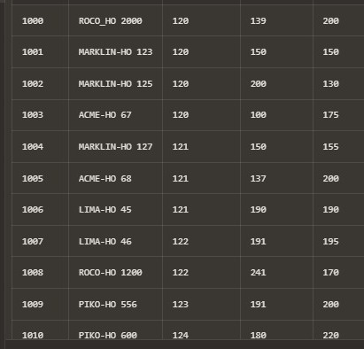

INSERT INTO CALATORII

VALUES (SEQ_CALATORII.NEXTVAL, 'BUC', 'BRV', 130, 140, 1006, to_date('11-12-2021 07:00','DD-MM-YYYY HH24:MI'), to_date('11-12-2021 07:55','DD-MM-YYYY HH24:MI'));

INSERT INTO CALATORII

VALUES (SEQ_CALATORII.NEXTVAL, 'BUC', 'IAS', 130, 140, 1002, to_date('24-12-2021 09:00','DD-MM-YYYY HH24:MI'), to_date('24-12-2021 10:05','DD-MM-YYYY HH24:MI'));

INSERT INTO CALATORII

VALUES (SEQ_CALATORII.NEXTVAL, 'BUC', 'TIM', 130, 140, 1000, to_date('25-12-2021 12:00','DD-MM-YYYY HH24:MI'), to_date('25-12-2021 13:00','DD-MM-YYYY HH24:MI'));

INSERT INTO CALATORII

VALUES (SEQ_CALATORII.NEXTVAL, 'BUC', 'TIM', 130, 140, 1010, to_date('01-01-2022 21:30','DD-MM-YYYY HH24:MI'), to_date('01-01-2022 22:30','DD-MM-YYYY HH24:MI'));

INSERT INTO CALATORII

VALUES (SEQ_CALATORII.NEXTVAL, 'BRV', 'IAS', 130, 140, 1003, to_date('02-01-2022 16:00','DD-MM-YYYY HH24:MI'), to_date('02-01-2022 16:55','DD-MM-YYYY HH24:MI'));

INSERT INTO CALATORII

VALUES (SEQ_CALATORII.NEXTVAL, 'BRV', 'CND', 150, 160, 1008, to_date('02-01-2022 23:55','DD-MM-YYYY HH24:MI'), to_date('03-01-2022 00:30','DD-MM-YYYY HH24:MI'));

INSERT INTO CALATORII

VALUES (SEQ_CALATORII.NEXTVAL, 'IAS', 'TGJ', 130, 140, 1009, to_date('04-01-2022 13:00','DD-MM-YYYY HH24:MI'), to_date('04-01-2022 14:10','DD-MM-YYYY HH24:MI'));

INSERT INTO CALATORII

VALUES (SEQ_CALATORII.NEXTVAL, 'IAS', 'BUC', 120, 130, 1002, to_date('05-01-2022 05:30','DD-MM-YYYY HH24:MI'), to_date('05-01-2022 06:40','DD-MM-YYYY HH24:MI'));

INSERT INTO CALATORII

VALUES (SEQ_CALATORII.NEXTVAL, 'TGJ', 'IAS', 150, 160, 1004, to_date('20-03-2022 19:30','DD-MM-YYYY HH24:MI'), to_date('20-03-2022 20:40','DD-MM-YYYY HH24:MI'));

INSERT INTO CALATORII

VALUES (SEQ_CALATORII.NEXTVAL, 'TGJ', 'BRV', 150, 160, 1001, to_date('22-03-2022 09:45','DD-MM-YYYY HH24:MI'), to_date('22-03-2022 10:45','DD-MM-YYYY HH24:MI'));

INSERT INTO CALATORII

VALUES (SEQ_CALATORII.NEXTVAL, 'TIM', 'BUC', 150, 160, 1005, to_date('30-03-2022 07:40','DD-MM-YYYY HH24:MI'), to_date('30-03-2022 08:55','DD-MM-YYYY HH24:MI'));

INSERT INTO CALATORII

VALUES (SEQ_CALATORII.NEXTVAL, 'TIM', 'CND', 150, 160, 1007, to_date('05-04-2022 12:00','DD-MM-YYYY HH24:MI'), to_date('05-04-2022 13:45','DD-MM-YYYY HH24:MI'));

INSERT INTO CALATORII

VALUES (SEQ_CALATORII.NEXTVAL, 'BUC', 'ARD', 130, 140, 1003, to_date('11-06-2022 05:55','DD-MM-YYYY HH24:MI'), to_date('11-06-2022 07:20','DD-MM-YYYY HH24:MI'));

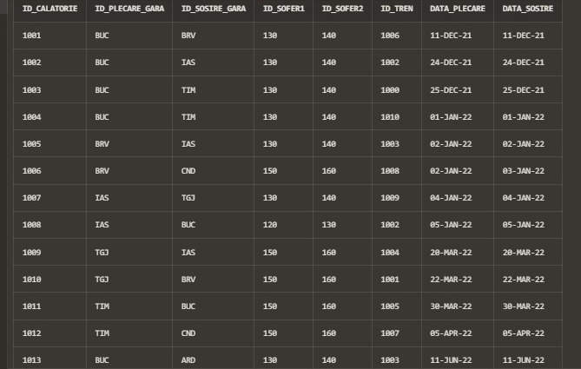

INSERT INTO CLASE

VALUES (01, 'Economica', NULL , 'masuta retractabila');

INSERT INTO CLASE

VALUES (20, 'Business', 100, 'scaune ajustabile si masuta rabatabila');

INSERT INTO CLASE

VALUES (30, 'Cuseta', 200, 'paturi');

INSERT INTO CLASE

VALUES (40, 'Business+', 300, 'business + pachetel');

INSERT INTO CLASE

VALUES (50, 'Clasa intai', 1000, 'clasa intai + pachetel');

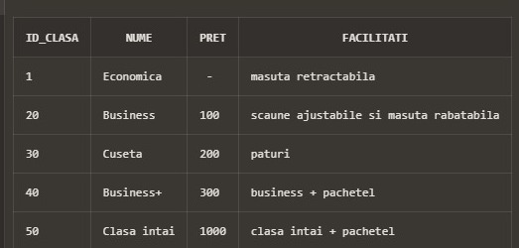

INSERT INTO CALATORI

VALUES (SEQ_CALATORI.NEXTVAL, 'Peptan', 'Vlad', 'vladp@yahoo.com', '0758723669', to_date('13-05-2002','dd-mm-yyyy'));

INSERT INTO CALATORI

VALUES (SEQ_CALATORI.NEXTVAL, 'Paraschiv', 'Ioana', 'pioana@gmail.com', '0789654112', to_date('20-06-1975','dd-mm-yyyy'));

INSERT INTO CALATORI

VALUES (SEQ_CALATORI.NEXTVAL, 'Caraiman', 'Andrei', 'andreic@yahoo.com.com', '0741023558', to_date('05-02-1992','dd-mm-yyyy'));

INSERT INTO CALATORI

VALUES (SEQ_CALATORI.NEXTVAL, 'Foanene', 'Bogdan', 'bogdif@yahoo.com', '0741203569', to_date('10-11-2001','dd-mm-yyyy'));

INSERT INTO CALATORI

VALUES (SEQ_CALATORI.NEXTVAL, 'Antonescu', 'Luca', 'lucaa@yahoo.com', '0712365478', to_date('21-08-2000','dd-mm-yyyy'));

INSERT INTO CALATORI

VALUES (SEQ_CALATORI.NEXTVAL, 'Brenciu', 'Tudor', 'tbre@yahoo.com', '0756223001', to_date('14-03-1984','dd-mm-yyyy'));

INSERT INTO CALATORI

VALUES (SEQ_CALATORI.NEXTVAL, 'Girbaciu', 'Iani', 'ianig@yahoo.com', '0789445123', to_date('14-07-1995','dd-mm-yyyy'));

INSERT INTO CALATORI

VALUES (SEQ_CALATORI.NEXTVAL, 'Buju', 'David', 'bujud@gmail.com', '0712345614', to_date('22-01-2003','dd-mm-yyyy'));

INSERT INTO CALATORI

VALUES (SEQ_CALATORI.NEXTVAL, 'Popica', 'Luana', 'popilu@gmail.com', '0745661230', to_date('27-08-2011','dd-mm-yyyy'));

INSERT INTO CALATORI

VALUES (SEQ_CALATORI.NEXTVAL, 'Bilgar', 'Bianca', 'bibib@yahoo.com', '0741220365', to_date('10-12-1994','dd-mm-yyyy'));

INSERT INTO CALATORI

VALUES (SEQ_CALATORI.NEXTVAL, 'Popeanga', 'Mariuta', 'popim@yahoo.com', '0746552398', to_date('12-08-1980','dd-mm-yyyy'));

INSERT INTO CALATORI

VALUES (SEQ_CALATORI.NEXTVAL, 'Gheorghidiu', 'Stefan', 'stefi.g@yahoo.com', '0788895412', to_date('03-03-1971','dd-mm-yyyy'));

INSERT INTO CALATORI

VALUES (SEQ_CALATORI.NEXTVAL, 'Boboc', 'Geanina', 'geani@yahoo.com', '0721330256', to_date('18-11-2000','dd-mm-yyyy'));

INSERT INTO CALATORI

VALUES (SEQ_CALATORI.NEXTVAL, 'Constantinescu', 'Mircea', 'ctm.c@yahoo.com', '0456852013', to_date('28-06-1974','dd-mm-yyyy'));

INSERT INTO CALATORI

VALUES (SEQ_CALATORI.NEXTVAL, 'Mursoi', 'Maria', 'marim@gmail.com', '0145698745', to_date('10-11-2001','dd-mm-yyyy'));

INSERT INTO CALATORI

VALUES (SEQ_CALATORI.NEXTVAL, 'Andreescu', 'Miruna', 'a.miru@yahoo.com', '0023478965', to_date('12-01-1972','dd-mm-yyyy'));

INSERT INTO CALATORI

VALUES (SEQ_CALATORI.NEXTVAL, 'Tiberiu', 'Andra', 'tibi.a@yahoo.com', '0321559864', to_date('22-01-1995','dd-mm-yyyy'));

INSERT INTO CALATORI

VALUES (SEQ_CALATORI.NEXTVAL, 'Stoenescu', 'Andreea', 'stoea@gmail.com', '0123654781', to_date('21-09-1977','dd-mm-yyyy'));

INSERT INTO CALATORI

VALUES (SEQ_CALATORI.NEXTVAL, 'Broscoteanu', 'Elena', 'brelena@gmail.com', '0123547896', to_date('31-12-1973','dd-mm-yyyy'));

INSERT INTO CALATORI

VALUES (SEQ_CALATORI.NEXTVAL, 'Rusu', 'Cristian', 'cristianrusuD@gmail.com', '0740332698', to_date('14-01-1963','dd-mm-yyyy'));

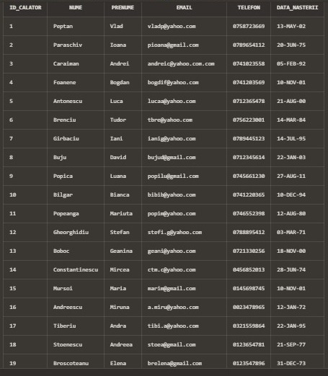

INSERT INTO GARI

VALUES('BUC', 010856, 'Gara de Nord Bucuresti', 'Strada Garii de Nord', '0353621448');

INSERT INTO GARI

VALUES('BRV', 500009, 'Gara din Brasov', 'Strada Mihai Eminescu 1-3', '0253698112');

INSERT INTO GARI

VALUES('IAS', 700028, 'Gara de la Iasi', 'Strada Andrei Neagu 67-69', '0252641203');

INSERT INTO GARI

VALUES('CND', 900001, 'Lucian Blaga train station', 'Strada Ovazului Dulce 15', '0247156893');

INSERT INTO GARI

VALUES('TIM', 300013, 'Aurel Vlaicu gara de sud', 'Strada Apusului 78', '0241587320');

INSERT INTO GARI

VALUES('ARD', 310010, 'Arad Gara Vest', 'Calea Popicelor Vesele', '0234567891');

INSERT INTO GARI

VALUES('TGJ', 210235, 'Gara din GORJ', 'Strada Republicii 27', '0764474671');

INSERT INTO GARI

VALUES('HND', 331005, 'Hunedoara train ', 'Soseaua Floare Albastra 16-22', '0798654175');

select * from GARI;

ALTER TABLE ORAS

ADD CONSTRAINT orase_regiuni_fk FOREIGN KEY(id_regiune)

REFERENCES REGIUNI(id_regiune);

ALTER TABLE ORAS

ADD CONSTRAINT orase_gari_fk FOREIGN KEY(id_gara)

REFERENCES GARI(id_gara);

select * from oras;

--- din proiectl trecut trebuia create secvente pentru inserarea inregistrarilor in tabele

CREATE SEQUENCE SEQ_SOFERI

INCREMENT by 10

START WITH 120

MAXVALUE 9990

NOCYCLE;

CREATE SEQUENCE SEQ_SEFI_DE_TREN

INCREMENT by 10

START WITH 10

MAXVALUE 9990

NOCYCLE;

CREATE SEQUENCE SEQ_CALATORI

INCREMENT by 1

START WITH 1

MAXVALUE 999999

NOCYCLE;

CREATE SEQUENCE SEQ_CALATORII

INCREMENT by 1

START WITH 1001

MAXVALUE 999999

NOCYCLE;

INSERT INTO SOFERI

VALUES (SEQ_SOFERI.NEXTVAL, 'BUC', 'Andreescu', 'Andrei', '0765448912', to_date('01-06-2017','DD-MM-YYYY'), 102300);

INSERT INTO SOFERI

VALUES (SEQ_SOFERI.NEXTVAL, 'BUC', 'Diaconu', 'Alex', '0746158799', to_date('20-08-2018','DD-MM-YYYY'), 140340);

INSERT INTO SOFERI

VALUES (SEQ_SOFERI.NEXTVAL, 'TIM', 'Popovici', 'Maria', '0713665284', to_date('27-02-2017','DD-MM-YYYY'), 600000);

INSERT INTO SOFERI

VALUES (SEQ_SOFERI.NEXTVAL, 'TIM', 'Haiduc', 'Luiza', '0771205664', to_date('16-09-2020','DD-MM-YYYY'), 308600);

INSERT INTO SOFERI

VALUES (SEQ_SOFERI.NEXTVAL, 'BRV', 'Adrianescu', 'David', '0786221540', to_date('30-11-2011','DD-MM-YYYY'), 401030);

INSERT INTO SOFERI

VALUES (SEQ_SOFERI.NEXTVAL, 'BRV', 'Minici', 'Marian', '0756332014', to_date('13-10-2015','DD-MM-YYYY'), 387510);

INSERT INTO SOFERI

VALUES (SEQ_SOFERI.NEXTVAL, 'BRV', 'Popescu', 'Razvan', '0253661479', to_date('30-05-2021','DD-MM-YYYY'), 275500);

INSERT INTO SOFERI

VALUES (SEQ_SOFERI.NEXTVAL, 'IAS', 'Cristescu', 'Iosif', '0714630175', to_date('21-02-2019','DD-MM-YYYY'), 250789);

INSERT INTO SOFERI

VALUES (SEQ_SOFERI.NEXTVAL, 'IAS', 'Mirea', 'Antonia', '0711247965', to_date('01-01-2015','DD-MM-YYYY'), 650990);

INSERT INTO SOFERI

VALUES (SEQ_SOFERI.NEXTVAL, 'CND', 'Paun', 'Robert', '0741226985', to_date('03-11-2019','DD-MM-YYYY'), 372999);

INSERT INTO SOFERI

VALUES (SEQ_SOFERI.NEXTVAL, 'CND', 'Aulescu', 'Matei', '0753210559', to_date('01-04-2022','DD-MM-YYYY'), 35000);

INSERT INTO SOFERI

VALUES (SEQ_SOFERI.NEXTVAL, 'CND', 'Aristid', 'Mihaela', '077232146', to_date('12-08-2021','DD-MM-YYYY'), 99999);

INSERT INTO SOFERI

VALUES (SEQ_SOFERI.NEXTVAL, 'TGJ', 'Ghita', 'Cosmin', '0792578600', to_date('21-07-2016','DD-MM-YYYY'), 500000);

INSERT INTO SOFERI

VALUES (SEQ_SOFERI.NEXTVAL, 'TGJ', 'Bonescu', 'Vlad', '0353621004', to_date('13-05-2011','DD-MM-YYYY'), 450770);

select * from SOFERI;

INSERT INTO SEFI_DE_TREN

VALUES (SEQ_SEFI_DE_TREN.NEXTVAL, 'BUC', 'Ionescu', 'Gabriela', '0745669823', to_date('20-12-2009','DD-MM-YYYY'), 80000);

INSERT INTO SEFI_DE_TREN

VALUES (SEQ_SEFI_DE_TREN.NEXTVAL, 'BUC', 'Marinescu', 'Stefania', '0703126445', to_date('30-08-2013','DD-MM-YYYY'), 80000);

INSERT INTO SEFI_DE_TREN

VALUES (SEQ_SEFI_DE_TREN.NEXTVAL, 'BUC', 'Usurelu', 'Horia', '0723665801', to_date('29-02-2018','DD-MM-YYYY'), 60000);

INSERT INTO SEFI_DE_TREN

VALUES (SEQ_SEFI_DE_TREN.NEXTVAL, 'BRV', 'Raducanu', 'Mihnea', '0765231002', to_date('23-05-2019','DD-MM-YYYY'), 80500);

INSERT INTO SEFI_DE_TREN

VALUES (SEQ_SEFI_DE_TREN.NEXTVAL, 'BRV', 'Avramescu', 'Antonela', '0713247889', to_date('24-02-2022','DD-MM-YYYY'), 15000);

INSERT INTO SEFI_DE_TREN

VALUES (SEQ_SEFI_DE_TREN.NEXTVAL, 'TIM', 'Danaricu', 'Radu', '0465322102', to_date('13-05-2019','DD-MM-YYYY'), 17000);

INSERT INTO SEFI_DE_TREN

VALUES (SEQ_SEFI_DE_TREN.NEXTVAL, 'TIM', 'Enescu', 'Florentiu', '0253620112', to_date('30-12-2014','DD-MM-YYYY'), 90000);

INSERT INTO SEFI_DE_TREN

VALUES (SEQ_SEFI_DE_TREN.NEXTVAL, 'IAS', 'Nedelcu', 'Aleandru', '0788654123', to_date('28-06-2020','DD-MM-YYYY'), 12000);

INSERT INTO SEFI_DE_TREN

VALUES (SEQ_SEFI_DE_TREN.NEXTVAL, 'IAS', 'Stoian', 'Traianis', '0735662147', to_date('07-07-2017','DD-MM-YYYY'), 3500);

INSERT INTO SEFI_DE_TREN

VALUES (SEQ_SEFI_DE_TREN.NEXTVAL, 'CND', 'Lemnaru', 'Anaisa', '0741223569', to_date('11-12-2020','DD-MM-YYYY'), 33999);

INSERT INTO SEFI_DE_TREN

VALUES (SEQ_SEFI_DE_TREN.NEXTVAL, 'CND', 'Cotiga', 'Camelia', '0700005925', to_date('10-10-2011','DD-MM-YYYY'), 85000);

INSERT INTO SEFI_DE_TREN

VALUES (SEQ_SEFI_DE_TREN.NEXTVAL, 'TGJ', 'Mechie', 'LEONARD', '0768320556', to_date('16-10-2009','DD-MM-YYYY'), 42000);

INSERT INTO SEFI_DE_TREN

VALUES (SEQ_SEFI_DE_TREN.NEXTVAL, 'HND', 'Vilceanu', 'Dragos', '0748326995', to_date('12-12-2012','DD-MM-YYYY'), 76000);

select * from SEFI_DE_TREN;

INSERT INTO COMPANII

VALUES (120, 'Softrans');

INSERT INTO COMPANII

VALUES (121, 'Regio Calatori');

INSERT INTO COMPANII

VALUES (122, 'Astra Trans Carpatic');

INSERT INTO COMPANII

VALUES (123, 'CFR');

INSERT INTO COMPANII

VALUES (124, 'Interrail');

INSERT INTO COMPANII

VALUES (125, 'InterRegional');

select * from COMPANII;

INSERT INTO TRENURI

VALUES (1000, 'ROCO_HO 2000', 120, 139, 200);

INSERT INTO TRENURI

VALUES (1001, 'MARKLIN-HO 123', 120, 150, 150);

INSERT INTO TRENURI

VALUES (1002, 'MARKLIN-HO 125', 120, 200, 130);

INSERT INTO TRENURI

VALUES (1003, 'ACME-HO 67', 120, 100, 175);

INSERT INTO TRENURI

VALUES (1004, 'MARKLIN-HO 127', 121, 150, 155);

INSERT INTO TRENURI

VALUES (1005, 'ACME-HO 68', 121, 137, 200);

INSERT INTO TRENURI

VALUES (1006, 'LIMA-HO 45', 121, 190, 190);

INSERT INTO TRENURI

VALUES (1007, 'LIMA-HO 46', 122, 191, 195);

INSERT INTO TRENURI

VALUES (1008, 'ROCO-HO 1200', 122, 241, 170);

INSERT INTO TRENURI

VALUES (1009, 'PIKO-HO 556', 123, 191, 200);

INSERT INTO TRENURI

VALUES (1010, 'PIKO-HO 600', 124, 180, 220);

SELECT * FROM TRENURI;

INSERT INTO CALATORII

VALUES (SEQ_CALATORII.NEXTVAL, 'BUC', 'BRV', 130, 140, 1006, to_date('11-12-2021 07:00','DD-MM-YYYY HH24:MI'), to_date('11-12-2021 07:55','DD-MM-YYYY HH24:MI'));

INSERT INTO CALATORII

VALUES (SEQ_CALATORII.NEXTVAL, 'BUC', 'IAS', 130, 140, 1002, to_date('24-12-2021 09:00','DD-MM-YYYY HH24:MI'), to_date('24-12-2021 10:05','DD-MM-YYYY HH24:MI'));

INSERT INTO CALATORII

VALUES (SEQ_CALATORII.NEXTVAL, 'BUC', 'TIM', 130, 140, 1000, to_date('25-12-2021 12:00','DD-MM-YYYY HH24:MI'), to_date('25-12-2021 13:00','DD-MM-YYYY HH24:MI'));

INSERT INTO CALATORII

VALUES (SEQ_CALATORII.NEXTVAL, 'BUC', 'TIM', 130, 140, 1010, to_date('01-01-2022 21:30','DD-MM-YYYY HH24:MI'), to_date('01-01-2022 22:30','DD-MM-YYYY HH24:MI'));

INSERT INTO CALATORII

VALUES (SEQ_CALATORII.NEXTVAL, 'BRV', 'IAS', 130, 140, 1003, to_date('02-01-2022 16:00','DD-MM-YYYY HH24:MI'), to_date('02-01-2022 16:55','DD-MM-YYYY HH24:MI'));

INSERT INTO CALATORII

VALUES (SEQ_CALATORII.NEXTVAL, 'BRV', 'CND', 150, 160, 1008, to_date('02-01-2022 23:55','DD-MM-YYYY HH24:MI'), to_date('03-01-2022 00:30','DD-MM-YYYY HH24:MI'));

INSERT INTO CALATORII

VALUES (SEQ_CALATORII.NEXTVAL, 'IAS', 'TGJ', 130, 140, 1009, to_date('04-01-2022 13:00','DD-MM-YYYY HH24:MI'), to_date('04-01-2022 14:10','DD-MM-YYYY HH24:MI'));

INSERT INTO CALATORII

VALUES (SEQ_CALATORII.NEXTVAL, 'IAS', 'BUC', 120, 130, 1002, to_date('05-01-2022 05:30','DD-MM-YYYY HH24:MI'), to_date('05-01-2022 06:40','DD-MM-YYYY HH24:MI'));

INSERT INTO CALATORII

VALUES (SEQ_CALATORII.NEXTVAL, 'TGJ', 'IAS', 150, 160, 1004, to_date('20-03-2022 19:30','DD-MM-YYYY HH24:MI'), to_date('20-03-2022 20:40','DD-MM-YYYY HH24:MI'));

INSERT INTO CALATORII

VALUES (SEQ_CALATORII.NEXTVAL, 'TGJ', 'BRV', 150, 160, 1001, to_date('22-03-2022 09:45','DD-MM-YYYY HH24:MI'), to_date('22-03-2022 10:45','DD-MM-YYYY HH24:MI'));

INSERT INTO CALATORII

VALUES (SEQ_CALATORII.NEXTVAL, 'TIM', 'BUC', 150, 160, 1005, to_date('30-03-2022 07:40','DD-MM-YYYY HH24:MI'), to_date('30-03-2022 08:55','DD-MM-YYYY HH24:MI'));

INSERT INTO CALATORII

VALUES (SEQ_CALATORII.NEXTVAL, 'TIM', 'CND', 150, 160, 1007, to_date('05-04-2022 12:00','DD-MM-YYYY HH24:MI'), to_date('05-04-2022 13:45','DD-MM-YYYY HH24:MI'));

INSERT INTO CALATORII

VALUES (SEQ_CALATORII.NEXTVAL, 'BUC', 'ARD', 130, 140, 1003, to_date('11-06-2022 05:55','DD-MM-YYYY HH24:MI'), to_date('11-06-2022 07:20','DD-MM-YYYY HH24:MI'));

SELECT * FROM CALATORII;

INSERT INTO CLASE

VALUES (01, 'Economica', NULL , 'masuta retractabila');

INSERT INTO CLASE

VALUES (20, 'Business', 100, 'scaune ajustabile si masuta rabatabila');

INSERT INTO CLASE

VALUES (30, 'Cuseta', 200, 'paturi');

INSERT INTO CLASE

VALUES (40, 'Business+', 300, 'business + pachetel');

INSERT INTO CLASE

VALUES (50, 'Clasa intai', 1000, 'clasa intai + pachetel');

select * from CLASE;

INSERT INTO CALATORI

VALUES (SEQ_CALATORI.NEXTVAL, 'Peptan', 'Vlad', 'vladp@yahoo.com', '0758723669', to_date('13-05-2002','dd-mm-yyyy'));

INSERT INTO CALATORI

VALUES (SEQ_CALATORI.NEXTVAL, 'Paraschiv', 'Ioana', 'pioana@gmail.com', '0789654112', to_date('20-06-1975','dd-mm-yyyy'));

INSERT INTO CALATORI

VALUES (SEQ_CALATORI.NEXTVAL, 'Caraiman', 'Andrei', 'andreic@yahoo.com.com', '0741023558', to_date('05-02-1992','dd-mm-yyyy'));

INSERT INTO CALATORI

VALUES (SEQ_CALATORI.NEXTVAL, 'Foanene', 'Bogdan', 'bogdif@yahoo.com', '0741203569', to_date('10-11-2001','dd-mm-yyyy'));

INSERT INTO CALATORI

VALUES (SEQ_CALATORI.NEXTVAL, 'Antonescu', 'Luca', 'lucaa@yahoo.com', '0712365478', to_date('21-08-2000','dd-mm-yyyy'));

INSERT INTO CALATORI

VALUES (SEQ_CALATORI.NEXTVAL, 'Brenciu', 'Tudor', 'tbre@yahoo.com', '0756223001', to_date('14-03-1984','dd-mm-yyyy'));

INSERT INTO CALATORI

VALUES (SEQ_CALATORI.NEXTVAL, 'Girbaciu', 'Iani', 'ianig@yahoo.com', '0789445123', to_date('14-07-1995','dd-mm-yyyy'));

INSERT INTO CALATORI

VALUES (SEQ_CALATORI.NEXTVAL, 'Buju', 'David', 'bujud@gmail.com', '0712345614', to_date('22-01-2003','dd-mm-yyyy'));

INSERT INTO CALATORI

VALUES (SEQ_CALATORI.NEXTVAL, 'Popica', 'Luana', 'popilu@gmail.com', '0745661230', to_date('27-08-2011','dd-mm-yyyy'));

INSERT INTO CALATORI

VALUES (SEQ_CALATORI.NEXTVAL, 'Bilgar', 'Bianca', 'bibib@yahoo.com', '0741220365', to_date('10-12-1994','dd-mm-yyyy'));

INSERT INTO CALATORI

VALUES (SEQ_CALATORI.NEXTVAL, 'Popeanga', 'Mariuta', 'popim@yahoo.com', '0746552398', to_date('12-08-1980','dd-mm-yyyy'));

INSERT INTO CALATORI

VALUES (SEQ_CALATORI.NEXTVAL, 'Gheorghidiu', 'Stefan', 'stefi.g@yahoo.com', '0788895412', to_date('03-03-1971','dd-mm-yyyy'));

INSERT INTO CALATORI

VALUES (SEQ_CALATORI.NEXTVAL, 'Boboc', 'Geanina', 'geani@yahoo.com', '0721330256', to_date('18-11-2000','dd-mm-yyyy'));

INSERT INTO CALATORI

VALUES (SEQ_CALATORI.NEXTVAL, 'Constantinescu', 'Mircea', 'ctm.c@yahoo.com', '0456852013', to_date('28-06-1974','dd-mm-yyyy'));

INSERT INTO CALATORI

VALUES (SEQ_CALATORI.NEXTVAL, 'Mursoi', 'Maria', 'marim@gmail.com', '0145698745', to_date('10-11-2001','dd-mm-yyyy'));

INSERT INTO CALATORI

VALUES (SEQ_CALATORI.NEXTVAL, 'Andreescu', 'Miruna', 'a.miru@yahoo.com', '0023478965', to_date('12-01-1972','dd-mm-yyyy'));

INSERT INTO CALATORI

VALUES (SEQ_CALATORI.NEXTVAL, 'Tiberiu', 'Andra', 'tibi.a@yahoo.com', '0321559864', to_date('22-01-1995','dd-mm-yyyy'));

INSERT INTO CALATORI

VALUES (SEQ_CALATORI.NEXTVAL, 'Stoenescu', 'Andreea', 'stoea@gmail.com', '0123654781', to_date('21-09-1977','dd-mm-yyyy'));

INSERT INTO CALATORI

VALUES (SEQ_CALATORI.NEXTVAL, 'Broscoteanu', 'Elena', 'brelena@gmail.com', '0123547896', to_date('31-12-1973','dd-mm-yyyy'));

INSERT INTO CALATORI

VALUES (SEQ_CALATORI.NEXTVAL, 'Rusu', 'Cristian', 'cristianrusuD@gmail.com', '0740332698', to_date('14-01-1963','dd-mm-yyyy'));

select * from CALATORI;

INSERT INTO TRENURI_AU_CLASE

VALUES (30, 1000, 100);

INSERT INTO TRENURI_AU_CLASE

VALUES (20, 1000, 49);

INSERT INTO TRENURI_AU_CLASE

VALUES (40, 1001, 141);

INSERT INTO TRENURI_AU_CLASE

VALUES (20, 1004, 61);

INSERT INTO TRENURI_AU_CLASE

VALUES (20, 1006, 40);

INSERT INTO TRENURI_AU_CLASE

VALUES (30, 1006, 49);

INSERT INTO TRENURI_AU_CLASE

VALUES (20, 1007, 26);

INSERT INTO TRENURI_AU_CLASE

VALUES (20, 1008, 100);

INSERT INTO TRENURI_AU_CLASE

VALUES (30, 1008, 20);

INSERT INTO TRENURI_AU_CLASE

VALUES (40, 1008, 10);

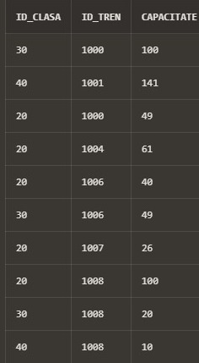

INSERT INTO REZERVA

VALUES (30, 1001, 1, 100001, 300);

INSERT INTO REZERVA

VALUES (20, 1007, 8, 100004, 200);

INSERT INTO REZERVA

VALUES (40, 1002, 5, 100008, 250);

INSERT INTO REZERVA

VALUES (40, 1006, 6, 100009, 250);

INSERT INTO REZERVA

VALUES (20, 1011, 8, 100005, 200);

INSERT INTO REZERVA

VALUES (30, 1003, 2, 100012, 300);

INSERT INTO REZERVA

VALUES (30, 1004, 3, 100013, 300);

INSERT INTO REZERVA

VALUES (40, 1011, 10, 100014, 250);

INSERT INTO REZERVA

VALUES (20, 1009, 7, 100015, 200);

INSERT INTO REZERVA

VALUES (20, 1005, 9, 100016, 200);

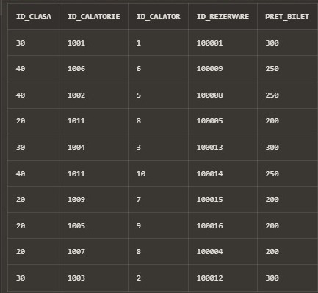

INSERT INTO INSOTESC

VALUES (10, 1001);

INSERT INTO INSOTESC

VALUES (20, 1001);

INSERT INTO INSOTESC

VALUES (10, 1003);

INSERT INTO INSOTESC

VALUES (10, 1004);

INSERT INTO INSOTESC

VALUES (50, 1006);

INSERT INTO INSOTESC

VALUES (80, 1007);

INSERT INTO INSOTESC

VALUES (90, 1007);

INSERT INTO INSOTESC

VALUES (100, 1011);

INSERT INTO INSOTESC

VALUES (60, 1011);

INSERT INTO INSOTESC

VALUES (70, 1011);

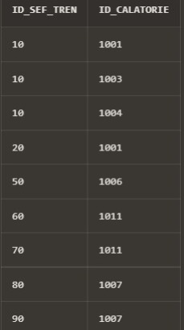

6) Formulați în limbaj natural o problemă pe care să orezolvați folosind unsubprogram stocatindependent care să utilizeze douătipuridiferite de colecțiistudiate. Apelați subprogramul.

Pentru fiecare gara sa se afiseze numele acesteia si salariul mediu al soferilor ce lucreaza acolo.

/

CREATE OR REPLACE PROCEDURE ex6 IS

-- Vom crea un tip de date inregistrare pentru a pastra

-- codul garii, numele acesteia si salariul mediu

TYPE gari_record IS RECORD

(cod gari.id_gara%TYPE,

nume gari.nume%TYPE,

salariu_mediu soferi.salariu%TYPE);

-- Datele pentru toate garile vor fi salvate intr-un tablou imbricat ce contine o coloana de tip inregistrare creat mai sus

TYPE tablou_imbricat IS TABLE OF gari_record;

-- Vom folosi un vector pentru salvarea si calcularea fiecarui salariu mediu al soferilor in functie de gara

TYPE vector IS VARRAY(8) OF soferi.salariu%TYPE;

-- Cu ajutorul unui ciclu cursor vom parcurge toate codurile de gari

CURSOR c IS

SELECT id_gara

FROM gari;

t tablou_imbricat := tablou_imbricat();

r gari_record;

v vector := vector();

BEGIN

FOR i IN c LOOP

-- Initial vom salva codul si numele garilor in variabila de tip inregistrare declarata mai sus

SELECT id_gara, nume

INTO r.cod, r.nume

FROM gari

WHERE i.id_gara = id_gara;

-- Calculam salariul mediu in functie de gara si il salvam intr-un element din vector

v.EXTEND;

SELECT AVG(salariu)

INTO v(v.LAST)

FROM soferi

WHERE id_gara = i.id_gara;

-- Copiem valoarea salariului mediu in

-- campul specific din variabila de tip inregistrare

r.salariu_mediu := v(v.LAST);

-- Adaugam variabila de tip inregistrare curenta in

-- tabloul imbricat pentru a pastra toate valorile

t.EXTEND;

t(t.LAST) := r;

-- Afisam rezultatele in consola de output

DBMS_OUTPUT.PUT_LINE ('La gara ' || t(t.LAST).nume ||

' salariul mediu al soferilor este de ' || t(t.last).salariu_mediu);

END LOOP;

END ex6;

/

execute ex6;

7) --Sa se defineasca o procedura care primeste ca parametru numele unui sef de tren si

--returneaza calatoriile pe care le a condus plus calatorii care au participat pentru fiecare calatorie

--(tipuri de cursor: cursor clasic, ciclu cursor)

CREATE OR REPLACE PROCEDURE sef_de_tren_insoteste

(nume_sef sefi_de_tren.NUME%TYPE,

prenume_sef sefi_de_tren.PRENUME%TYPE)

IS

salariu_sef sefi_de_tren.salariu%TYPE;

sef_id sefi_de_tren.id_sef_tren%TYPE;

calatorie_id calatorii.id_calatorie%TYPE;

calatorie_idd calatorii.id_calatorie%TYPE;

CURSOR c_calatorii IS --CURSOR CLASIC PENTRU ID-URILE calatoriilor

SELECT DISTINCT id_calatorie

FROM insotesc

WHERE id_sef_tren = (SELECT id_sef_tren

FROM sefi_de_tren

WHERE upper(nume)=upper(nume_sef) AND upper(prenume)=upper(prenume_sef)

);

CURSOR c_calatori(calatorie_id_calatori calatorii.id_calatorie%TYPE) IS --CURSOR CICLU CU PARAMETRU PENTRU ID-UL calatoriei, CU calatorii ei

SELECT nume

FROM calatori

WHERE id_calator IN (SELECT id_calator

FROM rezerva

WHERE id_calatorie = calatorie_id_calatori

);

BEGIN

SELECT salariu

INTO salariu_sef

FROM sefi_de_tren

WHERE upper(nume)=upper(nume_sef) AND upper(prenume)=upper(prenume_sef);

DBMS_OUTPUT.PUT_LINE('Seful de tren ' || '(' || salariu_sef || ') ' || nume_sef || ' ' || prenume_sef || ' a insotit: ');

OPEN c_calatorii;

LOOP FETCH c_calatorii INTO calatorie_id; --se incarca id-urile calatoriilor pe rand

EXIT WHEN c_calatorii%NOTFOUND;

SELECT id_calatorie

INTO calatorie_idd

FROM calatorii

WHERE id_calatorie = calatorie_id;

DBMS_OUTPUT.PUT_LINE('Calatoria: ' || calatorie_idd || ' contine :');

FOR calator IN c_calatori(calatorie_id) LOOP --ciclu cursor pentru afisarea calatorilor

DBMS_OUTPUT.PUT_LINE(' ' || calator.nume);

END LOOP;

END LOOP;

--caz in care seful de tren nu a insotit nimic

IF c_calatorii%ROWCOUNT = 0 THEN

DBMS_OUTPUT.PUT_LINE('Seful de tren nu a insotit nimic pana acum');

END IF;

CLOSE c_calatorii; --inchidere cursor

EXCEPTION

WHEN TOO_MANY_ROWS THEN --cazul in care exista mai multi sefi de tren cu numele dat

RAISE_APPLICATION_ERROR(-20001, 'Exista mai multi sefi de tren cu acest nume');

WHEN NO_DATA_FOUND THEN --nu exista sef de tren cu numele dat

RAISE_APPLICATION_ERROR(-20000, 'Nu exista niciun sef de tren cu acest nume');

END sef_de_tren_insoteste;

/

select * from sefi_de_tren;

select * from insotesc;

execute sef_de_tren_insoteste('Ionescu', 'Gabriela');

-- Seful de tren (80000) Ionescu Gabriela a insotit:

-- Calatoria: 1004 contine:

-- Caraiman

-- Calatoria: 1001 contine:

-- Peptan

-- Calatoria: 1003 contine:

-- Paraschiv

execute sef_de_tren_insoteste('Mechie', 'LEONARD'); --Seful de tren nu a insotit nimic pana acum

8)Dupa citirea numelui unui calator sa se returneze pretul total al rezervarii facute de acesta (pretul biletului + pretul aditional pentru clasa, daca este cazul) In cazul in care un pasager are mai multe rezervari, se va returna suma tuturor preturilor totale

/

CREATE OR REPLACE FUNCTION ex8(nume_calator calatori.nume%TYPE)

RETURN REZERVA.pret_bilet%TYPE IS

pret_total REZERVA.pret_bilet%TYPE;

nr NUMBER;

BEGIN

-- Numaram cati calatori exista cu numele dat ca parametru

SELECT COUNT(*) INTO nr

FROM calatori WHERE INITCAP(nume_calator) = INITCAP(nume);

-- Tratam cazul in care nu exista niciun pasager si cazul in care exista mai multe pasageri cu acelasi nume

IF nr = 0

THEN RAISE_APPLICATION_ERROR(-20000, 'Nu exista niciun calator cu acest nume');

ELSIF nr > 1

THEN RAISE_APPLICATION_ERROR(-20001, 'Exista mai multi calatori cu acest nume');

END IF;

-- numaram cate rezervari exista pt calatorul dat

SELECT COUNT(*) INTO nr

FROM calatori RIGHT OUTER JOIN REZERVA USING (id_calator)

WHERE INITCAP(nume_calator) = INITCAP(nume);

IF nr = 0

THEN RAISE_APPLICATION_ERROR(-20002, 'Nu exista nicio rezervare pe acest nume');

END IF;

-- Functia de SUM va trata cazul in care exista o singura rezervare si cazul in care exista mai multe

SELECT SUM(pret_bilet + NVL(pret, 0))

INTO pret_total

FROM REZERVA JOIN CLASE USING (id_clasa) JOIN calatori USING (id_calator)

WHERE INITCAP(nume_calator) = INITCAP(calatori.nume);

-- Sunt folosite 3 tabele pentru a accesa detalii despre pretul aditional al

-- clasei, numele pasagerilor si pretul biletului trecut in rezervare

RETURN pret_total;

END ex8;

/

select * from rezerva;

select ex8('Buju') from dual;

select ex8(’Popescu’) from dual;

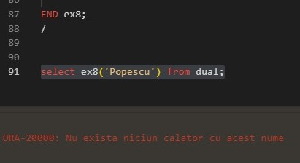 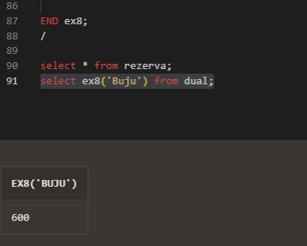

9) Se da numele unui sofer ca parametru. Sa se afiseze numarul de calatorii la care acesta a participat, numele garii la care lucreaza si numele orasului si al regiunii in care se afla aeroportul.

CREATE OR REPLACE PROCEDURE ex9 (nume_sofer soferi.nume%TYPE) IS

v_nr NUMBER(4);

v_gara gari.nume%TYPE;

v_oras oras.nume%TYPE;

v_regiune regiuni.nume%TYPE;

BEGIN

-- Vom folosi un RIGHT JOIN intre calatorii si soferi pentru a include si soferii care nu au facut nicio calatorie dar apartin unei gari.

-- Conditia de JOIN intre aceastea verifica daca soferul a fost fie soferul 1 fie soferul 2

-- In continuare se face JOIN simplu cu tabelele GARI, ORAS si REGIUNI pentru a putea accesa si selecta numele acestora

SELECT COUNT(id_calatorie), g.nume, o.nume, r.nume

INTO v_nr, v_gara, v_oras, v_regiune

FROM CALATORII c RIGHT JOIN soferi s ON (s.id_sofer = c.id_sofer1 OR

s.id_sofer = c.id_sofer2) JOIN gari g ON (s.id_gara = g.id_gara)

JOIN ORAS o ON (o.id_gara = s.id_gara) JOIN REGIUNI r USING (id_regiune)

WHERE INITCAP(nume_sofer) = INITCAP(s.nume)

GROUP BY g.nume, o.nume, r.nume;

-- Afisam in consola datele selectate mai sus

DBMS_OUTPUT.PUT_LINE('Nume sofer: ' || INITCAP(nume_sofer));

DBMS_OUTPUT.PUT_LINE('Numar de calatorii: ' || v_nr);

DBMS_OUTPUT.PUT_LINE('Numele garii: ' || v_gara);

DBMS_OUTPUT.PUT_LINE('Orasul garii in care lucreaza: ' || v_oras);

DBMS_OUTPUT.PUT_LINE('Regiunea in care se afla gara: ' || v_regiune);

EXCEPTION

WHEN TOO_MANY_ROWS

THEN RAISE_APPLICATION_ERROR(-20003, 'Exista mai multi soferi cu acest nume');

WHEN NO_DATA_FOUND

THEN RAISE_APPLICATION_ERROR(-20004, 'Nu exista soferi cu acest nume');

END ex9;

/

EXECUTE ex9('Diaconu');

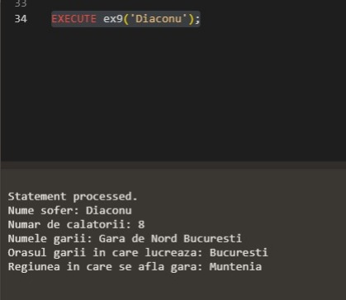

10) trigger care interzice stergerea datelor din tabelul insotesc(LMD)

select * from insotesc;

/

CREATE OR REPLACE TRIGGER ex

BEFORE DELETE ON insotesc

BEGIN

RAISE_APPLICATION_ERROR(-20005, 'Nu e posibila stergerea datelor din tabelul insotesc');

END;

/

DELETE FROM insotesc

WHERE id_calatorie = 1011;

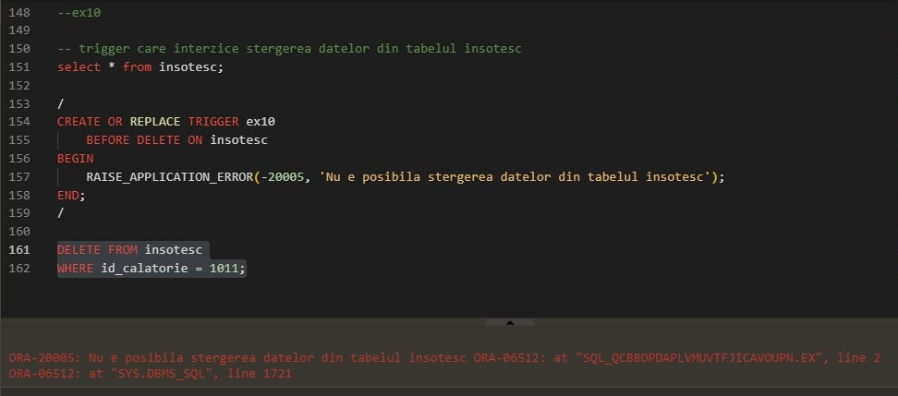

11) trigger care interzice cresterea pretului unui bilet cu mai mult de 50(LMD)

select * from rezerva;

/

CREATE OR REPLACE TRIGGER ex11

BEFORE UPDATE ON REZERVA

FOR EACH ROW

BEGIN

IF(:NEW.pret_bilet - :OLD.pret_bilet > 50)

THEN RAISE_APPLICATION_ERROR(-20006, 'Pretul nu poate fi marit!');

END IF;

END;

/

UPDATE REZERVA

SET pret_bilet = pret_bilet + 52

WHERE id_rezervare = 100016;

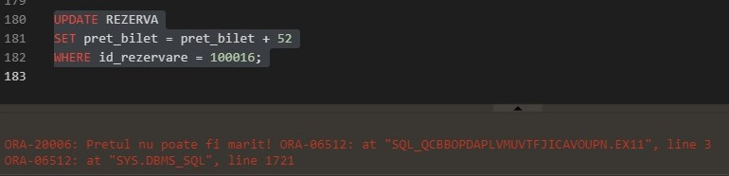

12)trigger care afiseaza un mesaj de fiecare data cand este rulata o comanda LDD

/

CREATE OR REPLACE TRIGGER exc12

AFTER CREATE OR ALTER OR DROP ON SCHEMA

BEGIN

DBMS_OUTPUT.PUT_LINE('A FOST EFECTUATA O COMANDA LDD');

END;

/

ALTER TABLE soferi

ADD nr_copii NUMBER(2);

select * from soferi;

ALTER TABLE soferi

DROP COLUMN nr_copii;

