Scalar (Скаляр)

Just a simple number, ex.:

Vector (Вектор)

A set of numbers that can identify a point in space.

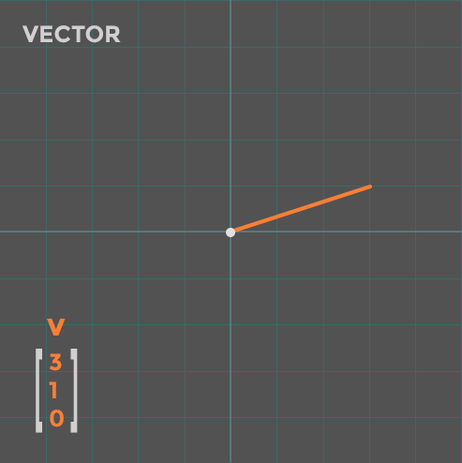

Matrix (Матрица)

A matrix is a 2-D set of numbers size of m*n. Ex.:

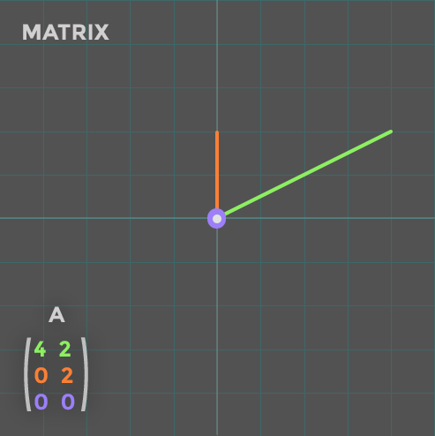

Tensor (Тензор)

An array of numbers arranged on a regular grid with a variable number of axes. Ex.: 3-D matrix:

**A**, elements –

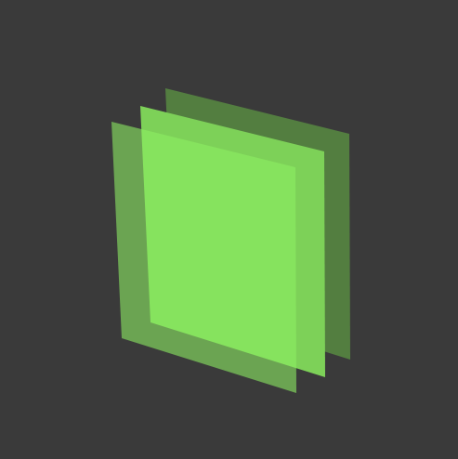

Types of Vectors